A
Major Project
On

CALIBRATION OF INTRINSIC AND EXTRINSIC PARAMETERS OF CAMERA

Submitted in Partial fulfillment of the requirement
for the award of the degree of

MASTER OF ENGINEERING
(Electronics and Communication)

Submitted by
Mansi Jhamb
( Roll No. 19/E&C/05)
Under the Guidance of
Smt. S.INDU
(Sr. Lecturer)
Department of Electronics and Communication



DEPARTMENT OF ELECTRONICS & COMMUNICATION ENGINEERING
DELHI COLLEGE OF ENGINEERING
BAWANA ROAD, DELHI -110042
(UNIVERSITY OF DELHI)

2005-2008

CERTIFICATE

This is certified that the major project report entitled “Calibration Of Intrinsic and Extrinsic Parameters Of Camera” is an authentic work of Mansi Jhamb , Roll No. 19/E&C/05, a student of Delhi College of Engineering. This work was completed under my direct supervision and guidance and forms a part of the Master of Engineering (Electronics and Communication) course and curriculum. She has completed her work with utmost sincerity and diligence. The work embodied in this major project has not been submitted for the award of any other degree to the best of my knowledge and belief.

Date:

Prof.P.R.CHADDHA Smt. S.INDU
H.O.D Sr.Lecturer
Deptt. of Electronics &Communication Project Guide
Delhi College of Engineering, Delhi. Deptt. of Electronics & Communication
Delhi College of Engineering.

ACKNOWLEDGEMENT

I am highly grateful to my supervisor, Smt. S. Indu, for her support and encouragement. I am greatly indebted to her for the many occasions in which she has gone out of her way to assist me in the timely completion of this dissertation. She has been an ongoing inspiration for me not only in terms of academic endeavors, but her charismatic personality has also made my studies a much more interesting and rewarding experience.
I would also like to take the opportunity to present my sincere regards to our Head Of Department Shri P.R. Chaddha for his support and encouragement.
I am also thankful to my friends for their unconditional support and motivation during this work.

Date: ( Mansi Jhamb )
Roll no. 19/E&C/05
M.E. (Electronics and Communication)
Deptt. of Electronics and Communication
Delhi College of Engineering, Delhi-42

ABSTRACT

An efficient and flexible technique to calibrate a camera is implemented in MATLAB7.0. It is well suited for use without specialized knowledge of 3D geometry or computer vision. The technique only requires the camera to observe a planar pattern shown at a few different orientations. Either the camera or the planar pattern can be freely moved. The motion need not be known. Radial lens distortion is modeled. The proposed procedure consists of a closed-form solution, followed by a nonlinear refinement based on the maximum likelihood criterion. Computer simulations have been used to test the proposed technique, and very good results have been obtained. Compared with classical techniques which use expensive equipment such as two or three orthogonal planes, the proposed technique is easy to use and flexible. It advances 3D computer vision one step from laboratory environments to real world use.

LIST OF FIGURES

 | Figure No. |  | Title Of Figure |  | Page No.
 | 1 |  | Public Security |  | 1
 | 1.1 |  | Original View |  | 4
 | 1.2 |  | Close View |  | 5
 | 1.3 |  | Close Up View |  | 5
 | 4.1 |  | Calibration |  | 18
 | 5.1 |  | Images |  | 30
 | 5.2 |  | Extracted Grid |  | 42
 | 5.3 |  | Image Points |  | 50

LIST OF TABLES

 | Table No. |  | Title Of Table |  | Page No.
 | 1 |  | Results Of Intrinsic Calibration |  | 45

INTRODUCTION

The Big Picture
Crime and anti-social behavior represent a significant threat and cost for society. For
example, in the INDIA anti-social behavior alone accounts for around 5 billion of taxpayers’ money annually. The Delhi and Bombay bombings highlighted the vulnerability of public transport systems to terrorist attacks. Increasingly, Closed Circuit Television (figure1) is seen as a guardian technology to aid police and security operators respond to these challenges. Public and transport camera systems are being enlarged or upgraded with infrastructures of cameras, digital networks, and digital storage, search and retrieval.
Figure 1: The Indian approach to public security.
Pan-tilt-zoom cameras (stationary, but rotating and zooming) are often used in surveillance applications. The main advantage of a PTZ camera is that one camera can be used for the surveillance of a large area, yet it can also be used to closely look at the points of interest. Pan-Tilt-Zoom (PTZ) cameras are increasingly popular as they provide a highly flexible and increasingly cheap alternative to fixed cameras and can adopt a range of roles: mimicking fixed-view cameras, tracking assigned or self-acquired targets, or obtaining high-resolution imagery through zoom. Passive systems are often composed of fixed cameras recording continually, and generally providing low-resolution video for criminal investigations after the event. Active, manned systems are composed of PTZ cameras, and generally only follow unfolding events that are observed to be important by the operator.

CAMERA AS A VISUAL SENSOR

Surveillance systems with multiple cameras have become increasingly important. The space relationship between cameras offers useful information for surveillance applications, such as object tracking or 3- D positioning.
Wireless networks of visual sensors have recently emerged as a new type of sensor-based intelligent system, with performance and complexity challenges that go beyond that of existing wireless sensor networks. The goal of the visual sensor network examined is to provide a user with visual information from any arbitrary viewpoint within the monitored field. This can be accomplished by synthesizing image data from a selection of cameras whose fields of view over- lap with the desired field of view.
In visual sensor networks, the camera-nodes can be simply stuck on walls or objects prior to use without the need for preplanning of the cameras placement, thereby obtaining arbitrary positions/directions. Furthermore, camera nodes are powered by batteries, and therefore, they do not require a constant power supply. This makes visual sensor networks suitable for use in applications where temporary monitoring is needed and in applications that require fast deployment and removal of the camera network. For example, a visual sensor network can be quickly deployed in a room that is temporarily used for an exhibition or lecture. These networks can be used for monitoring remote areas, which may be outside and thus not contain any fixed infrastructure. In emergency situations, these visual sensor networks can provide valuable information from inaccessible areas affected by some disaster (e.g., flood, fire, and earthquake) and hazardous areas.

Give Your Guard a Break!
Security cameras are a cost-effective means to keep large areas under 24/7 surveillance.
One can use the powerful optical zoom of PTZ camera to zoom in on interesting objects while they are on-camera to get the detail one needs.

1.1 Application Scenarios

Close View is particularly suitable for:

1. Large Outside Areas such as Parking Lots or Car Dealerships

2. Large Inside Areas such as Warehouses or Factories

3. Secure Critical Infrastructure on Campuses and Military Bases

4. Entrance and Exit Roads

5. Gates and Doorways –Front-end for Face or Car License Plate Recognition

Figure 1.1 Original View from Reference Camera

Figure 1.2 Diagnostic View from Close View

Figure 1.3 Automatic Close-Up View from PTZ Camera

In a visual sensor network system, the user is able to virtually move through the monitored space, and to see images of the monitored space from any desired viewpoint. In order to provide images from arbitrary viewpoints, it is important that the cameras provide coverage of the entire 3D space over time. Each camera “covers” a three dimensional view volume (i.e., field of view). In this work, 3D coverage is considered as follows: a point in 3D space is considered covered by the network if and only if this point is contained in the view volume of at least one camera.

1.2 Need for multiple cameras:
To achieve effective surveillance, a large number of cameras are often used for wide-area coverage. Once suspicious persons/activities have been identified through video analysis, selected cameras ought to be able to obtain close-up views of these suspicious subjects for further scrutiny and identification (e.g., to obtain a close-up view of the license plate of a car or the face of a person). These two requirements, a large field-of-view and selective focus-of attention, place conflicting constraints on the system configurations and camera parameters. The proposed solution is to cover an extended surveillance area by multiple stationary (or master) cameras with wide fields-of-view. The cameras perform a global, wide field-of-view analysis of the motion patterns in the surveillance zone. Based on some pre specified criteria, the cameras identify suspicious behaviors or subjects that need further attention. The stationary cameras will guide the dynamic cameras to focus on the region of interest (e.g., the license plate of a car or the face of a person) for selective attention and analysis.
Nonetheless, as the density of PTZ cameras increases, so too does the potential for these active sensors to automatically cooperate to carry out a range of wide-area tasks on a shared and overlapping ‘ground plane’. Such wide-area tasks may include tracking individuals across large distances, acquiring close-ups of all individuals entering a system, and continually verifying the presence and location of these individuals. At the moment, however, such functionality must be directed by a necessarily limited number of human operators. What is missing are the visual reflexes for automatic vision-driven motion control, and the visually aware planning and tasking machinery which will allow cameras to extract and continually pool knowledge about the scene, and which can plan and negotiate sensor tasks to achieve the sensor community’s goals When there is sufficient coverage, image data from several camera-nodes with overlapped views can be combined together in order to generate an image from any arbitrary viewpoint in the network. However, it is necessary to select the set of camera-nodes that will provide enough images of the scene so that the desired view can be reconstructed.
PTZ (Pan-tilt-zoom) cameras are commonly used in surveillance systems. Even though the use of PTZ cameras provides the capability to conveniently change the view of monitoring or to dynamically follow monitored objects, the calibration of the extrinsic parameters for these PTZ cameras are a target problem.
In recent sensor networks, the advantages of employing PTZ cameras are investigated. Some implementations of such networks are typically restricted to two cameras with one providing a fixed wide view and the second zooming in to acquire face shots [19, 20].
Truly scalable collaborative networks represent a significant challenge. As stated before,
PTZ cameras are able to adopt a variety of roles such as following an object, zooming to acquire high-resolution images, or mimicking fixed view cameras, and, as a result, can support highly dynamic, reconfigurable task-oriented surveillance. Over and above the problems in visual detection, the main challenges are the fusion of information from multiple sensors (data fusion), the fusion of information from different types of sensors (sensor fusion) and issues of integrating information (ground plane calibration, semantic landscapes).

CALIBRATION

Systems that are constituted by one or more cameras usually need a mechanism that, ultimately, relates pixel locations to real world locations. A pixel location is obtained by segmenting the images coming in from a camera and finding interesting regions (e.g. people, cars). Here, the focus is on finding the pixel to real world relation, setting up the equations and resolving the parameters involved. This process is called geometrical camera calibration, or simply, for the sake of brevity, calibration. The parameters obtained from the calibration process can be classified as two types: intrinsic, those that define the camera configuration (internal geometry and optic features); and extrinsic, the rotation and the translation that would map the world coordinate system to the camera coordinate system.

2.1 Need Of Calibration
Camera calibration is the first step towards computational computer vision. Although some information concerning the measuring of scenes can be obtained by using uncalibrated cameras [11], calibration is essential when metric information is required. The use of precisely calibrated cameras makes the measurement of distances in real world from their projections on the image plane possible [14, 21]. Camera calibration is a necessary step in 3D computer vision in order to extract metric information from 2D images. Camera calibration is a necessary step in 3D computer vision due to following reasons:
• A calibrated camera can be used as a quantitative sensor
• It is essential in many applications to recover 3D quantitative measures about the observed scene from 2D images. Such as 3D Euclidean structure
• From a calibrated camera, how far an object is from the camera or the height of the object, etc. e.g., objects avoidance in robot navigation can be measured.

Good calibration is important when we need to:
– Reconstruct a world model.
– Interact with the world: Robot, hand-eye coordination
Extrinsic parameters: the camera’s location and orientation in the world.
Intrinsic parameters: the relationships between pixel coordinates and camera coordinates.
Through the calibration, the cameras can then simultaneously track the same object in a master-slave configuration. A system that can track objects with multiple PTZ cameras in a cooperative fashion is developed [8]. The cameras are geometrically calibrated with respect to a common world coordinate system, which permits them to communicate about object locations in a straightforward manner. The process of calibrating PTZ cameras with respect to a global coordinate system is presented [8]. When all cameras in a system undergo this process, they will be able to map their observations to a coordinate system that is common among them, thereby permitting them to communicate in a sensible way.

2.2 Advantages of Camera Calibration
The usefulness of and need for calibration has long been recognized in the field of machine vision, and a vast amount of literature has dealt with this problem. Especially visual surveillance systems require a proper calibration such that the detection of interesting events, e.g. odd behaviour or disasters, can be related to geographical locations.
For single, stationary cameras the problem of calibration has long been solved. For multi camera systems, cameras can then be calibrated one by one, but this can become very elaborative when the amount of cameras is very high. Therefore, automatic techniques are proposed [15, 16]. However, these techniques usually require the fields of view of the cameras to be partially overlapping in a predefined way.
To overcome this problem, image processing methods can be employed to align images taken from the appropriate cameras to calibrate a series of cameras based on the calibration of one camera. Also, given the overlap assumption, fully automated calibration techniques are possible, but then the cameras typically get calibrated relative to each other and global knowledge about world coordinates is lost. In [4], calibration is fully omitted.
Things become more difficult when cameras are agile, such as PTZ cameras. Firstly, the pan and tilt angles of the camera have to be incorporated in the equations relating pixels to the real world. Also, zoom introduces problems because it affects the focal length, i.e. the size-ratio between objects in the real world and their appearance in the image. Moreover, in multi-camera systems, it is hard to make assumptions about the relations between cameras’ fields of view since this view is now a function of pan, tilt and zoom and encompasses the full 360 degrees around a camera.
For the calibration of multiple PTZ cameras [8]. Ultimately, these cameras have to communicate with each other about an object’s position and appearance to be able to handover targets to each other. Clearly, this can be achieved by calibrating the cameras relative to each other. However, as stated above, this will come with the cost of loosing global knowledge. Therefore, a calibration process is revealed via which both cameras can be related to a common world coordinate system . The ‘recipe’ provided can be used to calibrate any one PTZ camera. As the layout of the surveillance areas is prone to changes, the installer often wants to move a camera from one position to another. In this case, it is important to him to have a simple procedure to determine camera position and orientation in reference to the surveillance area. The knowledge of camera position and orientation is crucial for geometric reasoning. This, in turn, enables the operator to use some useful functionalities, such where the operator clicks on the map, and the camera automatically points to this direction (or in the case of multiple cameras, the closest camera points to this direction), displaying current and entire view space of the camera, etc.
Knowledge of internal camera calibration parameters is also important for a variety of useful tasks, including tracking with a rotating camera, obtaining metric measurements, knowing how much to zoom to achieve a desired view, etc. Again, it is of utmost importance to develop a simple procedure that will enable the installer with little or no technical training to perform calibration of all the cameras covering the surveillance area, or even better, to develop a method that will perform calibration entirely automatically.
The use of precisely calibrated cameras makes the measurement of distances in a real world from their projections on the image plane possible.

2.3 Applications
Some applications of this capability include:
1. Dense reconstruction:
Each image point determines an optical ray passing through the focal point of the
camera towards the scene. The use of more than a single view of a motionless scene (taken from a stereo-scopic system, a single moving camera, or even a structured light emitter) permits crossing both optical rays to get the metric position of the 3D points. Obviously, the correspondence problem has to be previously solved .

2. Visual inspection: Once a dense reconstruction of a measuring object is obtained, the reconstructed object can be compared with a stored model in order to detect any manufacturing imperfections such as bumps, dents or cracks. One potential application is visual inspection for quality control. Computerized visual inspection allows automatic and exhaustive examination of products, as opposed to the slow human inspection
which usually implies a statistical approach .

3. Object localization: When considering various image points from different objects, the relative position among these objects can be easily determined. This has many possible applications such as in industrial part assembly and obstacle avoidance in robot navigation among others.

4. Camera localization: When a camera is placed in the hand of a robot arm or on a mobile robot, the position and orientation of the camera can be computed by locating some known landmarks in the scene. If these measurements are stored, a temporal analysis allows the handler to determine the trajectory of the robot. This information can be used in robot control and path planning.

Aim of my work is to find the intrinsic and extrinsic parameters of camera
STATE OF ART

Camera calibration is a necessary step in 3D computer vision in order to extract metric information from 2D images. Much work has been done, starting in the photogrammetry community and more recently in computer vision [17, 18] to cite a few.
We can classify those techniques roughly into two categories:
- Photogrammetric calibration
- Self calibration.

Photogrammetric calibration. Camera calibration is performed by observing a calibration object whose geometry in 3-D space is known with very good precision. Calibration can be done very efficiently [21]. The calibration object usually consists of two or three planes orthogonal to each other. Sometimes, a plane undergoing a precisely known translation is also used. These approaches require an expensive calibration apparatus, and an elaborate setup.

Self-calibration. Techniques in this category do not use any calibration object. Just by moving a camera in a static scene, the rigidity of the scene provides in general two constraints on the cameras’ internal parameters from one camera displacement by using image information alone. Therefore, if images are taken by the same camera with fixed internal parameters, correspondences between three images are sufficient to recover both the internal and external parameters which allow us to reconstruct 3-D structure up to a similarity [17]. When there are many parameters to estimate, we cannot always obtain reliable results. Other techniques exist: vanishing points for orthogonal directions [30, 18], and calibration from pure rotation. There has been much work in the area of self-calibration, starting with the seminal work of Maybank and Faugeras [27], in which they have shown that the camera calibration parameters can be computed from the three snapshots of the environment, provided that sufficiently many point correspondences between each of the three image pairs can be established. In general, the self-calibration methods that deal with unconstrained camera motion require good initial values and the minimization of the complex cost function, and are, therefore, not always feasible. When some constraints on camera motion are imposed (i.e. purely translational, purely rotational, or purely rotational with known motion parameters), much simpler, and typically more precise procedures for camera calibration are obtained. Bill Triggs [29] developed a self calibration technique from at least 5 views of a planar scene. His technique is more flexible than ours, but has difficulty to initialize. Liebowitz and Zisserman [18] described a technique of metric rectification for perspective images of planes using metric information such as a known angle, two equal though unknown angles, and a known length ratio. They also mentioned that calibration of the internal camera parameters is possible provided such metrically rectified planes, although no algorithm or experimental results were shown.
The methods that have been studied in the calibration work can be classified according to a number of criteria:
- Computation complexity (iterative vs. non-iterative),
- Resolution scheme (one single optimization step vs. multistep) or
- Type of calibration pattern used (planar vs. nonplanar or single view vs. multiple views).

Tsai's method [5]
This method splits the problem into two steps. It allows use of both planar and non-planar
patterns. This method assumes that optical center is located at image center and that skew
is null. In the first step, the distortion is assumed null and a linear approach can be used to solve a subset of parameters: orientation (R), translation (Tx; Ty) and aspect ratio (sx). In the second step, an initial guess of focal length (f) and pattern distance (Tz) can be estimated using a linear technique. Then focal length, pattern distance and distortion coefficient (k1) can be refined by means of an optimization technique. A variant has been proposed that adds two additional steps to the original method. Firstly, an iterative technique is used to refine the parameters returned by the original algorithm. Then, this process is repeated but the optic center is also included. The code created by X. Armangu é and J. Salvi has been used in the experiments to implement this variant of Tsai's method.

Faugeras' method [21]
This method obtains a projection matrix (P) using an optimization procedure where orthogonality of rotation matrix is hold. One non-planar pattern is necessary and lens distortion is not modeled. An initial estimate is necessary for the convergence of the method. In this work, the linear method was used to obtain this estimate. The calibration parameters can be recovered decomposing the projection matrix

Linear method
It is a well-known classic method aimed at minimizing image disparity error. This is obtained minimizing where:
with the vector being the rows of projection matrix. The solution is the eigenvector corresponding to the smallest eigenvalue of , which may be conveniently found using the Singular Value Decomposition (SVD) of L. The result is normalized and each parameter can be obtained using the decomposition of the projection matrix, as in Faugeras' method. In this method one non-planar pattern is necessary and lens distortion is not modeled.

Ahmed's method [26]
This method is based on neural networks, consequently it is very slow. Initial values obtained from the Linear method was used in this research to accelerate the calibration process. Lens distortion is not considered by the algorithm and it needs one non-planar pattern. A two-layer feedforward neural network is used, where world points coordinates are the input and image coordinates are the output. Each level has an associated weight matrix, one for extrinsic parameters (V ) and another for intrinsic parameters (W). The training process of the neural network is repeated until error converges to a minimum. The measure of error depends on two factors: image disparity of each point and non orthonormality of rotation matrix. Weighting matrices are updated following the descent gradient rule. Input and output values of the net are normalized (S1, S2). When the method converges, a projection matrix is obtained as: P = S1WV S2. Parameter values can be extracted from this matrix decomposing the projection matrix, using i.e. the indications of Faugeras' method.

Heikkilä's method [6]
This method consists of four steps, but in this research only the first two have been utilized because the other two are related exclusively to image acquisition. It models both radial and tangential distortion of the lens. Initially, a linear method (DLT algorithm) is used to obtain initial estimates for some parameters (extrinsics, focal and optic center).
From the projective matrix thus obtained, parameter values are extracted using RQ decomposition. Finally, the Levenberg-Marquardt method is used to minimize:

(Image disparity).

The Calibration toolbox v3.0, developed by Janne Heikkilä, has been used in this work.

Batista's method [28]
This method needs only one image of a planar pattern to calibrate a camera. It is a multi step and iterative method that uses a least squares technique at each step. Distortion is modeled using only one coefficient. Initially, this method assumes that distortion and skew are null, aspect ratio is one, the optic center is coincident with image center, and transformation factors and focal length are obtained from the manufacturer. The procedure comprises two loops: the first repeats the three early steps described below and it finishes when aspect ratio converges to one; the second repeats all the steps and it ends when the mean of image disparities goes below a threshold.
This algorithm comprises these four steps:
1) Obtaining rotation angles, assuming that translation is null and using four points forming a rectangle.
2) Translation and aspect ratio can be obtained using all pattern points.
3) Distance and distortion can be calculated using a linear approach. Focal length is resolved using the Gauss lens model.
4) The intrinsic parameters not obtained in previous steps are only allowed to vary in the second loop.

Zhang's method [1]
This method needs at least three different views of a planar pattern. Displacements between these views can be unknown. Lens distortion is modeled using two coefficients.
This method comprises the following steps:
1) Projective matrix P_{i} is calculated from each image. An initial estimate is obtained
using a non-iterative approach. Then the Levenberg-Marquardt technique is used to refine P_{i} where image disparity is minimized.
2) The intrinsic parameters matrix (A) is obtained from the absolute conic which is invariant to object displacements. Two constraints on the intrinsic parameters are imposed for each image and the equation system thus obtained is solved using SVD.
3) Computation of extrinsic parameters (D).
4) An initial estimate of radial distortion coefficients are calculated using a least squares technique.
5) All parameters are refined using an optimization procedure that minimizes mean of image disparity.
Our technique only requires the camera to observe a planar pattern shown at a few (at least two) different orientations. The pattern can be printed on a laser printer and attached to a “reasonable” planar surface (e.g., a hard book cover). Either the camera or the planar pattern can be moved by hand. The motion need not be known. The proposed approach lies between the photogrammetric calibration and self-calibration, because we use 2D metric information rather than 3D or purely implicit one. Both computer simulation and real data have been used to test the proposed technique, and very good results have been obtained. Compared with classical techniques, the proposed technique is considerably more flexible. Compared with self-calibration, it gains considerable degree of robustness. We believe the new technique advances 3D computer vision one step from laboratory environments to the real world.
This work [1] is organized as follows. Chapter 4 describes the basic constraints from observing a single plane and calibration procedure. Starting with a closed form solution, followed by nonlinear optimization, radial lens distortion is also modeled. Chapter 5 provides the experimental results. Computer simulations using MATLAB 7.0 are used to validate the proposed technique.

CALIBRATING CAMERA

The mapping performed by a perspective camera between a 3D point X and its 2D image point x, both represented by their homogenous coordinates, is represented by a 3X4 matrix: the camera projected matrix P: x ~ PX .The matrix P can be written as
P = A[R|t]
4.1 Basic Equations
The constraints on the camera’s intrinsic parameters provided by observing a single plane are examined. Starting with the notation used in this work

Object Space
Image Space
x
c
y
c
M
m
Figure: 4.1 calibration using checker board
Notation
A 2D point is denoted by m = [u,v] ^{T}
A 3D point is denoted by M= [X, Y, Z] ^{T}.
Using to denote the augmented vector by adding 1 as the last element:
.
A camera is modeled by the relationship between a 3D point M and its image projection m given by
(1)
where s is an arbitrary scale factor, (R, t ) called the extrinsic parameters, is the rotation and translation which relates the world coordinate system to the camera coordinate system, and R is 3X3 Rotation Matrix and t is 3X1 translation vector . A, called the camera intrinsic matrix, is given by

With (u_{o}, v_{o)} the coordinates of the principal point, α and β the scale factors in image u and v axes and γ the parameter describing the skewness of the two image axes.

4.2 Homography between the model plane and its image
Without loss of generality, it is assumed that the model plane is on Z = 0 of the world coordinate system, i^{th} column of the rotation matrix R is denoted by r_{i}. From (1),
Here M is used to denote a point on the model plane, but M= [X, Y] ^{T} since Z is always equal to 0.
In turn therefore, a model point M and its image m is related by a homography H:
(2)

4.2.1 Estimation of the Homography Between the Model Plane and its Image
There are many ways to estimate the homography between the model plane and its image. Here, a technique based on maximum likelihood criterion is presented. Let M_{i} and m_{i} be the model and image points, respectively. Ideally, they should satisfy (2). In practice, they don’t because of noise in the extracted image points. Let’s assume that m_{i} is corrupted by Gaussian noise with mean 0 and covariance matrix Λ_{mi}. Then, the maximum likelihood estimation of H is obtained by minimizing the following functional

It is assumed Λ_{mi} =σ²I for all i . This is reasonable if points are extracted independently with the same procedure. In this case, the above problem becomes a nonlinear least-squares one,
i.e., .
The nonlinear minimization is conducted with the Levenberg- Marquardt Algorithm as implemented in Minpack [10]. This requires an initial guess, which can be obtained as follows.
Let . Then equation (2) can be rewritten as

When n points are given, n above equations are obtained, which can be written in matrix equation as Lx=0, where L is a 2n X 9 matrix. As x is defined up to a scale factor, the solution is well known to be the right singular vector of L associated with the smallest singular value (or equivalently, the eigenvector of L^{T}L associated with the smallest eigenvalue). In L, some elements are constant 1, some are in pixels, some are in world coordinates, and some are multiplication of both. This makes L poorly conditioned numerically. Much better results can be obtained by performing simple data normalization, prior to running the above procedure.

4.3 Constraints on the intrinsic parameters
Hence given an image of the model plane, a homography can be estimated. Let’s denote

it by H = [h₁ h₂ h₃] . From (2),
Where λ is an arbitrary scalar. Using the knowledge that r₁ and r₂ are orthonormal,
(3)
These are the two basic constraints on the intrinsic parameters, given one homography. Because a homography has 8 degrees of freedom and there are 6 extrinsic parameters (3 for rotation and 3 for translation), hence 2 constraints on the intrinsic parameters. It is noted that A^{-T}A⁻¹ actually describes the image of the absolute conic [9]. In the next subsection, geometric interpretation is given.

4.4 Geometric Interpretation
Relating (3) to the absolute conic, the model plane, under consideration, is described in the camera coordinate system by the following equation:
Where w = 0 for points at infinity and w = 1 otherwise. This plane intersects the plane at infinity at a line and and are two particular points on that line. Any point on it is a linear combination of these two points, i.e.
Computing the intersection of the above line with the absolute conic. By definition, the point known as the circular point satisfies: i.e.
The solution is where That is, the two intersection points are
Their projection in the image plane is then given, up to a scale factor, by
Point is on the image of the absolute conic, described by [9]. This gives
Requiring that both real and imaginary parts be zero yields (3).

4.5 Solving Camera Calibration
This section provides the details how to effectively solve the camera calibration problem. Starting with an analytical solution, followed by a nonlinear optimization technique based on the maximum likelihood criterion. Finally, lens distortion is considered, giving both analytical and nonlinear solutions.

4.5.1 Closed-form solution
Let
Since that B is symmetric, defined by a 6D vector
Let the i ^{th} column vector of H be
Then,
With

The two fundamental constraints (3), from a given homography, can be rewritten as two homogeneous equations in b:
(4)
If n images of the model plane are observed, by stacking n such equations as (4)
Vb = 0 (5)
where V is a 2n X 6 matrix. If n ≥ 3, in general a unique solution b is defined up to a scale factor. If n = 2 the skewless constraint can be imposed
which is added as an additional equation to (5). If n = 1, only two camera intrinsic parameters can be solved, e.g α and β assuming u₀ and v₀ are known (e.g., at the image center) and γ = 0 .The solution to (5) is well known as the eigenvector of V^{T}V associated with the smallest eigenvalue (equivalently, the right singular vector of V associated with the smallest singular value). Once b is estimated, camera intrinsic matrix A can be computed.
4.5.2 Extraction of the Intrinsic Parameters from Matrix B
Matrix B is estimated up to a scale factor, i.e.,
With λ an arbitrary scale, the intrinsic parameters from matrix B can be uniquely extracted
4.5.3 Extraction Of The Extrinsic Parameters
Once A is known, the extrinsic parameters for each image are readily computed. From (2),
Due to noise in data, the so-computed matrix
does not in general satisfy the properties of a rotation matrix. Appendix A describes
a method to estimate the best rotation matrix from a general 3 X 3 matrix.

4.6 Maximum likelihood estimation
The above solution is obtained through minimizing an algebraic distance which is not physically meaningful. Refining it through maximum likelihood inference, given n images of a model plane and there are m points on the model plane. Assuming that the image points are corrupted by independent and identically distributed noise. The maximum likelihood estimate can be obtained by minimizing the following functional:
(6)
is the projection of point M_{j} in image i, according to equation (2). A rotation R is parameterized by a vector of 3 parameters, denoted by r, which is parallel to the rotation axis and whose magnitude is equal to the rotation angle. R and r are related by the Rodrigues formula [21]. Minimizing (6) is a nonlinear minimization problem, which is solved with the Levenberg-Marquardt Algorithm as implemented in Minpack [10].

It requires an initial guess of A;
which can be obtained using the technique described in the previous subsection.
4.7 Dealing with radial distortion
Up to now, in this work lens distortion of a camera is not considered. However, a camera usually exhibits significant lens distortion, especially radial distortion. In this section, only the first two terms of radial distortion are considered. Based on the reports, it is likely that the distortion function is totally dominated by the radial components, and especially dominated by the first term.
Let (u,v) be the ideal (non-observable distortion-free) pixel image coordinates, and the corresponding real observed image coordinates. The ideal points are the projection of the model points according to the camera model. Similarly, (x,y) and are the ideal (distortion-free) and real (distorted) normalized image coordinates.
where k₁ and k₂ are the coefficients of the radial distortion. The center of the radial distortion is the same as the principal point.
From
It is implied
(7)

4.7.1 Estimating Radial Distortion by Alternation.
As the radial distortion is expected to be small, one would expect to estimate the other five intrinsic parameters, (using the technique described) reasonable well by simply ignoring distortion. One strategy is then to estimate k₁ and k₂ after having estimated the other parameters, which will give the ideal pixel coordinates (u,v). Then, from (7) two equations for each point in each image:
Given m points in n images, stacking all equations together to obtain in total 2mn equations, Or in matrix form as Dk = d, where
.The linear least-squares solution is given by
Once k₁ and k₂ are estimated, refining the estimate of the other parameters by solving (6) with replaced by (7). Alternating these two procedures until convergence.

4.8 Complete Maximum Likelihood Estimation
The convergence of the above alternation technique is slow. A natural extension to (6) is then to estimate the complete set of parameters by minimizing the following functional:
(8)
Where is the projection of point M_{j} in image i according to equation (2), followed by distortion according to (7). This is a nonlinear minimization problem, which is solved with the Levenberg-Marquardt Algorithm as implemented in Minpack [10].

4.9 Summary
The implemented calibration procedure is as follows:
1. A pattern is printed and attached to a planar surface.
2. Taking a few images of the model plane under different orientations by moving either
the plane or the camera.
3. Detecting the feature points in the images.
4. Estimating the five intrinsic parameters and all the extrinsic parameters using the
closed-form solution .
5. Estimating the coefficients of the radial distortion by solving the linear least-squares
6. Refining all parameters by minimizing equation (8).

EXPERIMENTAL RESULTS AND CONCLUSION

5.1 Implementation Of Camera Calibration Algorithm
The proposed algorithm [1] has been tested on computer simulated data using MATLAB 7.0.The approach can be explained in the following steps:

Step 1 : Reading the images
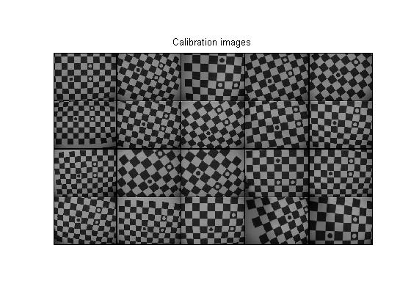
Figure 5.1 Images

Step 2 : Extract the Grid Corners
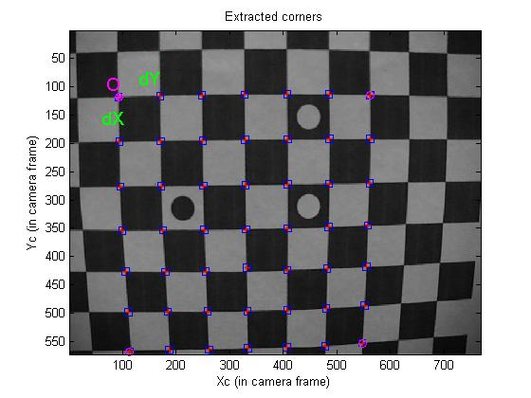
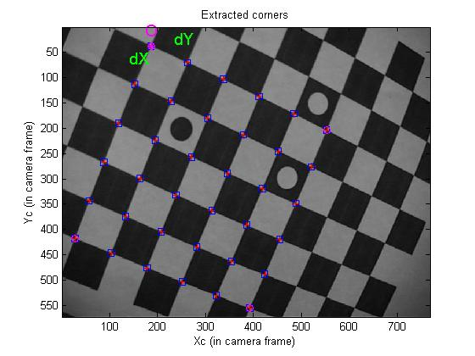

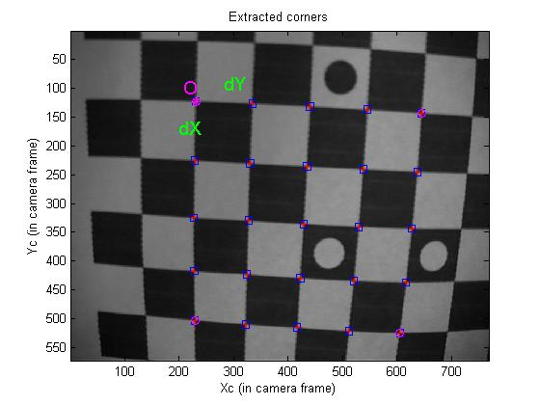
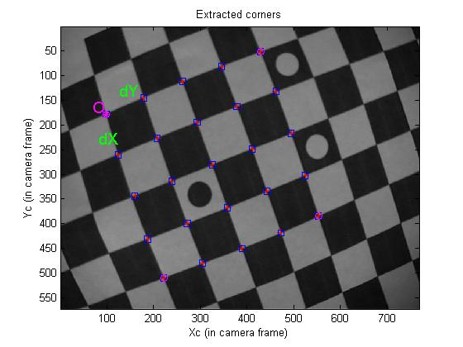

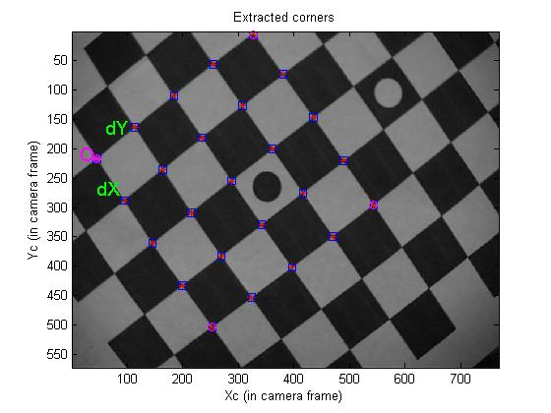

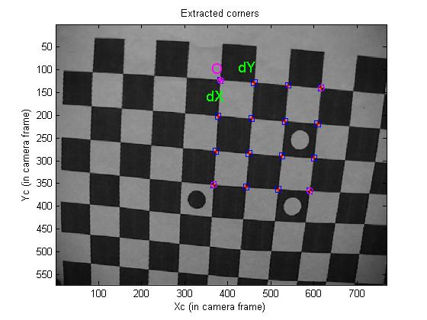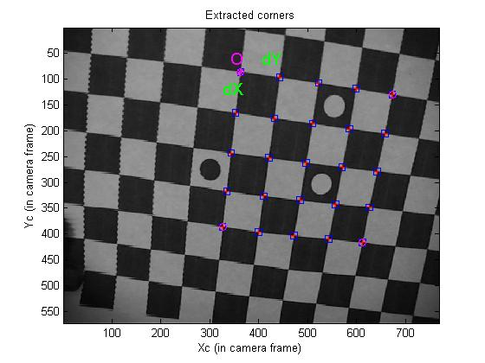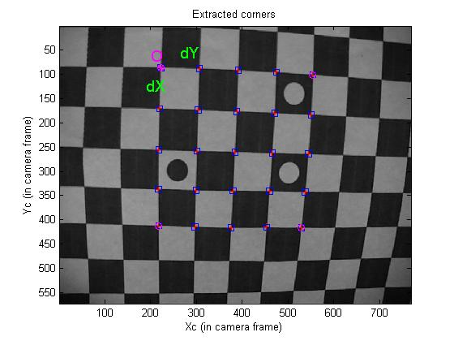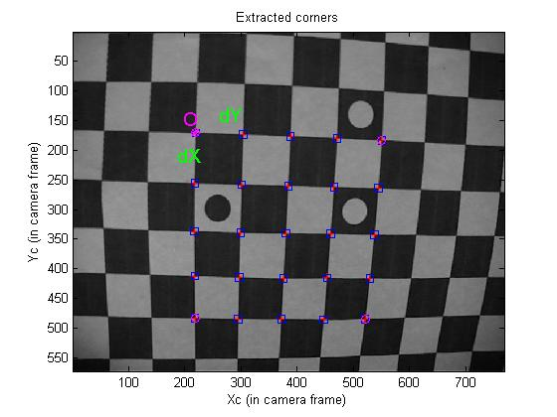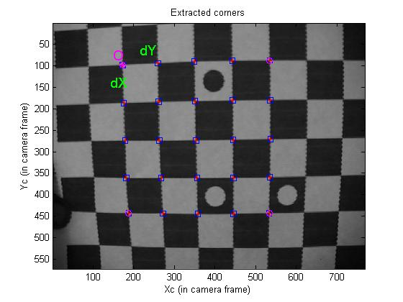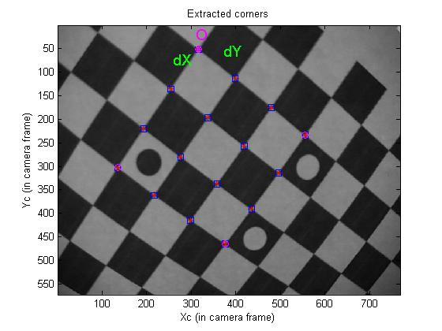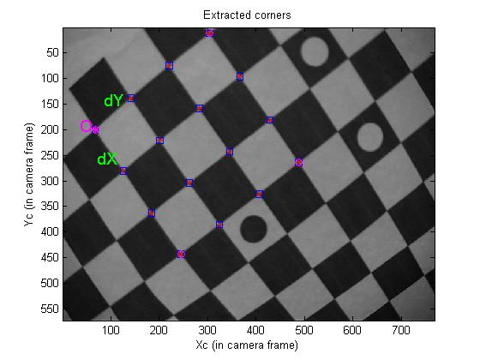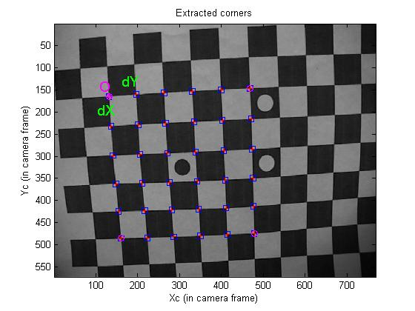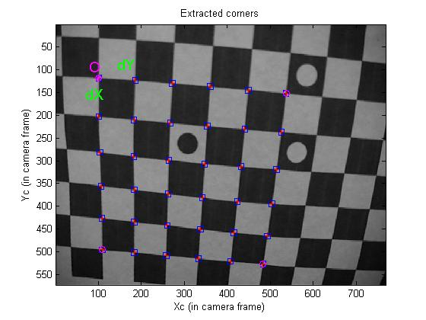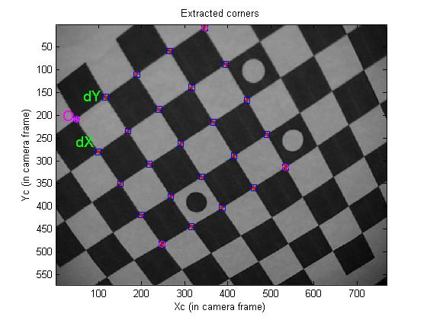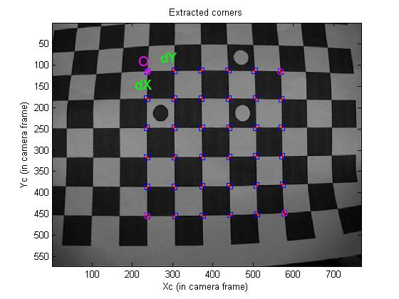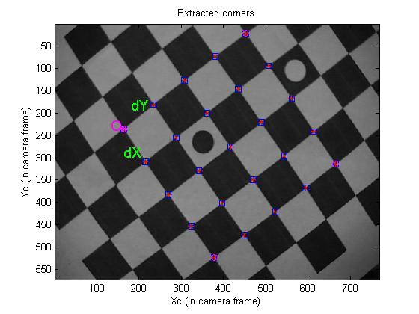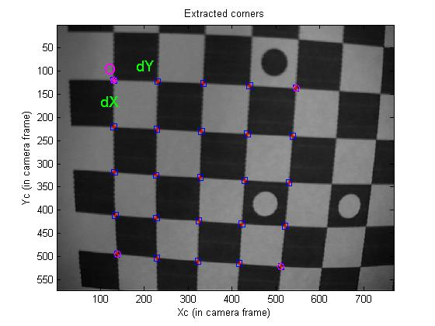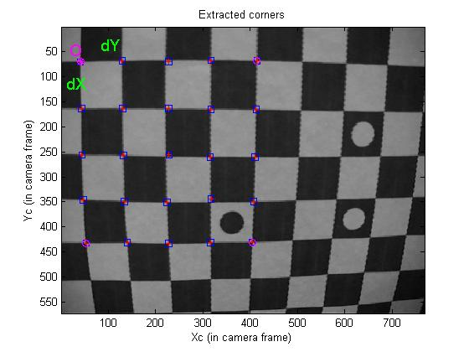

Figure 5.2 : Extracted Grid Corners

Step 3: Calibration
Initialization of the intrinsic parameters –

Set I of images (12345)

Calibration parameters after initialization:

Focal Length: fc = [ 895.54221 895.54221 ]
Principal point: cc = [ 383.50000 285.50000 ]
Skew: alpha_c = [ 0.00000 ] => angle of pixel = 90.00000 degrees
Distortion: kc = [ 0.00000 0.00000 0.00000 0.00000 0.00000 ]

Main calibration optimization procedure - Number of images: 5
Gradient descent iterations: 1...2...3...4...5...6...7...8...9...10...11...12...13...14...done
Estimation of uncertainties...done

Calibration results after optimization (with uncertainties):

Focal Length: fc = [ 979.14001 983.23174 ] ± [ 136.55704 137.36663 ]
Principal point: cc = [ 363.01111 248.39225 ] ± [ 14.55147 24.98218 ]
Skew: alpha_c = [ 0.00000 ] ± [ 0.00000 ] => angle of pixel axes = 90.00000 ± 0.00000 degrees
Distortion: kc = [ -0.55740 1.50664 0.00183 -0.00007 0.00000 ] ± [ 0.17745 1.10780 0.00857 0.00547 0.00000 ]
Pixel error: err = [ 0.60887 0.76052 ]

Set II of images(12345678)

Calibration results after optimization (with uncertainties):

Focal Length: fc = [ 868.18975 873.52565 ] ± [ 82.04576 82.84302 ]
Principal point: cc = [ 360.41020 235.93315 ] ± [ 13.43922 16.58456 ]
Skew: alpha_c = [ 0.00000 ] ± [ 0.00000 ] => angle of pixel axes = 90.00000 ± 0.00000 degrees
Distortion: kc = [ -0.39688 0.90032 0.00397 0.00413 0.00000 ] ± [ 0.09679 0.49561 0.00430 0.00353 0.00000 ]
Pixel error: err = [ 0.65206 0.58817 ]

Set III of images(10 11 12 13 14 15)

Calibration results after optimization (with uncertainties):

Focal Length: fc = [ 853.73283 859.25825 ] ± [ 59.01758 59.56981 ]
Principal point: cc = [ 365.37671 231.06804 ] ± [ 10.16722 13.76276 ]
Skew: alpha_c = [ 0.00000 ] ± [ 0.00000 ] => angle of pixel axes = 90.00000 ± 0.00000 degrees
Distortion: kc = [ -0.39708 0.91963 0.00312 0.00395 0.00000 ] ± [ 0.07435 0.38229 0.00382 0.00301 0.00000 ]
Pixel error: err = [ 0.62565 0.63579 ]

Set IV of images (15 16 17 18 19 20)

Calibration results after optimization (with uncertainties):

Focal Length: fc = [ 923.49851 929.25598 ] ± [ 61.37489 61.74151 ]
Principal point: cc = [ 367.06767 246.46978 ] ± [ 12.77573 17.11001 ]
Skew: alpha_c = [ 0.00000 ] ± [ 0.00000 ] => angle of pixel axes = 90.00000 ± 0.00000 degrees
Distortion: kc = [ -0.36473 0.79328 -0.00060 0.00742 0.00000 ] ± [ 0.07629 0.37320 0.00437 0.00357 0.00000 ]
Pixel error: err = [ 0.87900 0.82522 ]

Images | (12345) | (12345678) | (101112131415) | (151617181920)
Focal Length:  fc | [ 979.14001 983.23174 ] ± [ 136.55704 137.36663 ] | [ 868.18975 873.52565 ] ± [ 82.04576 82.84302 ] | [ 853.73283 859.25825 ] ± [ 59.01758 59.56981 ] | [ 923.49851 929.25598 ] ± [ 61.37489 61.74151 ]
Principal point: cc | [ 363.01111 248.39225 ] ± [ 14.55147 24.98218 ] | [ 360.41020 235.93315 ] ± [ 13.43922 16.58456 ] | [ 365.37671 231.06804 ] ± [ 10.16722 13.76276 ] | [ 367.06767 246.46978 ] ± [ 12.77573 17.11001 ]
Skew:  alpha_c | [ 0.00000 ] => angle of pixel = 90.00000 degrees | [ 0.00000 ] ± [ 0.00000 ] => angle of pixel axes = 90.00000 ± 0.00000 degrees | [ 0.00000 ] ± [ 0.00000 ] => angle of pixel axes = 90.00000 ± 0.00000 degrees | [ 0.00000 ] ± [ 0.00000 ] => angle of pixel axes = 90.00000 ± 0.00000 degrees
Distortion:  Kc | [ -0.55740 1.50664 0.00183 -0.00007 0.00000 ] ± [ 0.17745 1.10780 0.00857 0.00547 0.00000 ] | [ -0.39688 0.90032 0.00397 0.00413 0.00000 ] ± [ 0.09679 0.49561 0.00430 0.00353 0.00000 ] | [ -0.39708 0.91963 0.00312 0.00395 0.00000 ] ± [ 0.07435 0.38229 0.00382 0.00301 0.00000 ] | [ -0.36473 0.79328 -0.00060 0.00742 0.00000 ] ± [ 0.07629 0.37320 0.00437 0.00357 0.00000 ]
Pixel error:  Err | [ 0.60887 0.76052 ] | [ 0.65206 0.58817 ] | [ 0.62565 0.63579 ] | [ 0.87900 0.82522 ]

Table 1 : Results of Intrinsic Calibration

Step 5 : Computation Of Extrinsic Parameters.

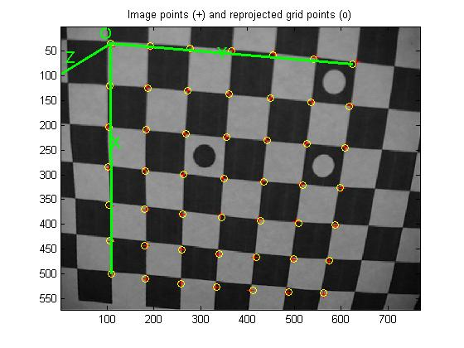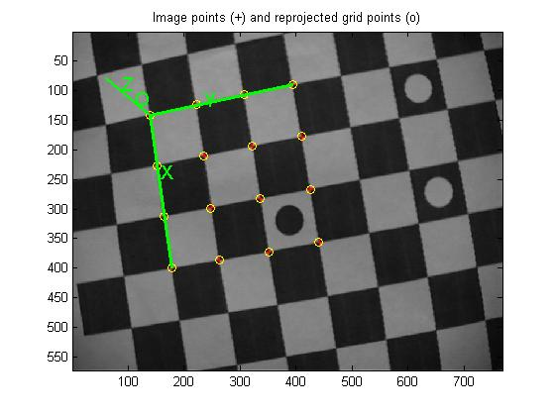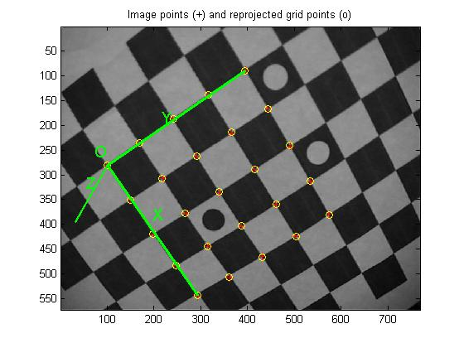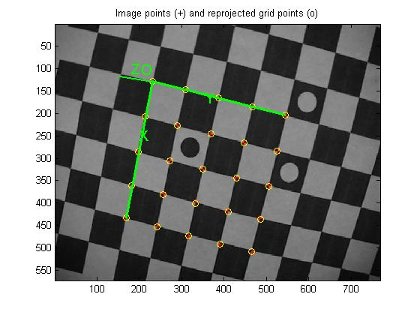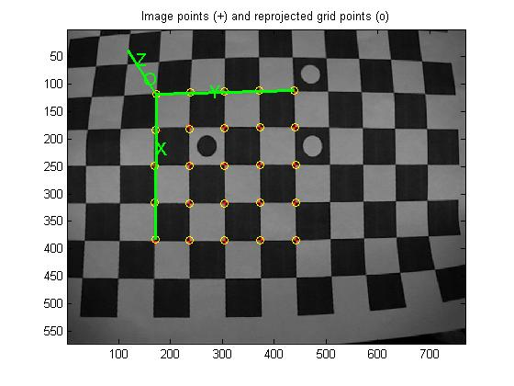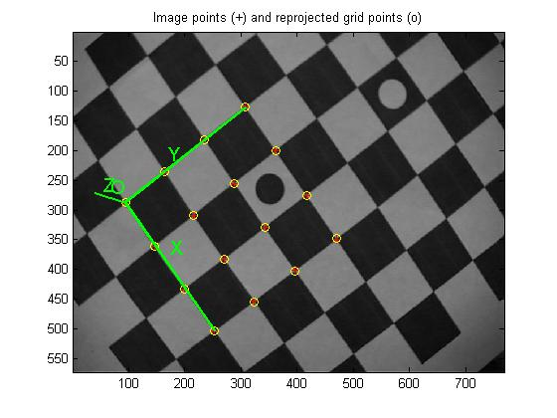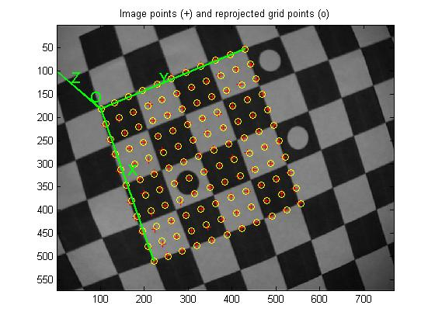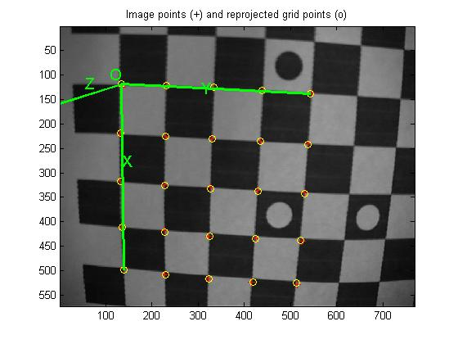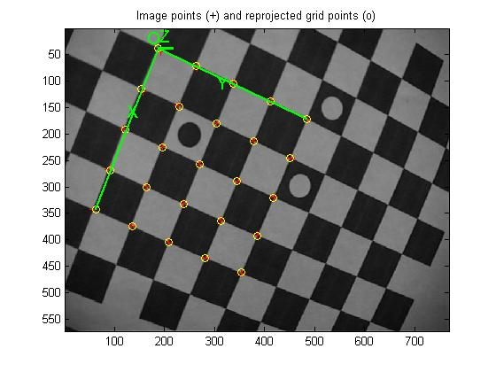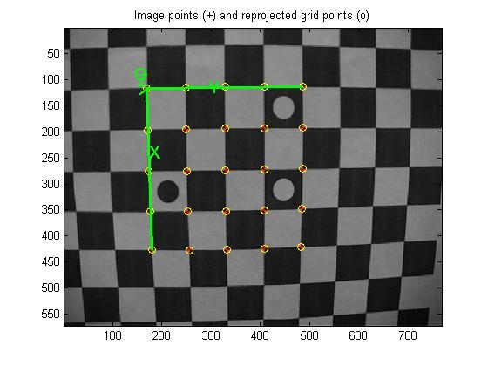
Figure 5.3 : Image Points and Reprojected Grid Points
Extrinsic parameters:

Image 1

Translation vector: Tc_ext = [ -80.515839 -62.995919 545.706053 ]
Rotation vector: omc_ext = [ -2.208068 -2.184353 -0.277331 ]
Rotation matrix: Rc_ext = [ 0.002938 0.993968 0.109628
0.989828 -0.018484 0.141064
0.142240 0.108098 -0.983912 ]
Pixel error: err = [ 0.26181 0.29344 ]

Image 2:

Translation vector: Tc_ext = [ -69.963577 -87.570973 514.740808 ]
Rotation vector: omc_ext = [ 1.664401 2.544357 0.383743 ]
Rotation matrix: Rc_ext = [ -0.407946 0.890887 0.199752
0.910172 0.379601 0.165803
0.071886 0.249447 -0.965717 ]
Pixel error: err = [ 1.90328 2.19396 ]

Image3 :

Translation vector: Tc_ext = [ -73.939561 -48.835270 426.468365 ]
Rotation vector: omc_ext = [ -2.033248 -2.133788 -0.103181 ]
Rotation matrix: Rc_ext = [ -0.039711 0.995100 -0.090545
0.981721 0.055736 0.181980
0.186135 -0.081663 -0.979125 ]
Pixel error: err = [ 1.33195 2.11195 ]

Image 4 :
Translation vector: Tc_ext = [ -242.136446 -87.630609 1233.316503 ]
Rotation vector: omc_ext = [ 2.526073 1.739468 -0.202244 ]
Rotation matrix: Rc_ext = [ 0.351563 0.933571 -0.069639
0.924644 -0.357908 -0.130131
-0.146411 -0.018642 -0.989048 ]
Pixel error: err = [ 2.05488 2.01881 ]

Image 5 :

Translation vector: Tc_ext = [ -97.576055 1.276577 483.191487 ]
Rotation vector: omc_ext = [ 2.755996 1.392584 -0.009367 ]
Rotation matrix: Rc_ext = [ 0.593497 0.804616 0.018809
0.804290 -0.592073 -0.050667
-0.029631 0.045199 -0.998538 ]
Pixel error: err = [ 0.36798 0.47844 ]

Image 6
Translation vector: Tc_ext = [ -95.399521 -75.238029 656.102985 ]
Rotation vector: omc_ext = [ 2.176702 2.156479 -0.192030 ]
Rotation matrix: Rc_ext = [ 0.006657 0.999241 -0.038384
0.990301 -0.011914 -0.138429
-0.138781 -0.037090 -0.989628 ]
Pixel error: err = [ 1.03741 1.12100 ]

Image 7

Translation vector: Tc_ext = [ -57.012761 -58.153169 548.003495 ]
Rotation vector: omc_ext = [ -1.871429 -2.372726 0.002570 ]
Rotation matrix: Rc_ext = [ -0.228571 0.968903 -0.094778
0.969106 0.235720 0.072595
0.092679 -0.075257 -0.992848 ]
Pixel error: err = [ 0.89223 1.44649 ]

Image 8 :

Translation vector: Tc_ext = [ -97.904957 -1.232973 495.628571 ]
Rotation vector: omc_ext = [ -2.547693 -1.396339 -0.210002 ]
Rotation matrix: Rc_ext = [ 0.536126 0.843991 0.015766
0.811293 -0.520335 0.266563
0.233180 -0.130120 -0.963689 ]
Pixel error: err = [ 0.65801 1.04637 ]

Image 9 :
Translation vector: Tc_ext = [ -84.725117 -49.314547 500.912604 ]
Rotation vector: omc_ext = [ 2.385383 2.005192 -0.229380 ]
Rotation matrix: Rc_ext = [ 0.165640 0.980979 -0.101205
0.978493 -0.176274 -0.107143
-0.122945 -0.081281 -0.989079 ]
Pixel error: err = [ 0.84157 0.52737 ]

Image 10

Translation vector: Tc_ext = [ -95.524125 -85.973573 493.425336 ]
Rotation vector: omc_ext = [ -1.967406 -2.127974 -0.273228 ]
Rotation matrix: Rc_ext = [ -0.072029 0.996521 -0.041920
0.953606 0.081123 0.289921
0.292313 -0.019092 -0.956132 ]
Pixel error: err = [ 2.58117 2.20891 ]

CONCLUSION

Twenty (20) images of the plane under different orientations were taken, as shown in Fig. 5.1. A significant lens distortion in the images is observed. The corners were detected as the intersection of straight lines fitted to each square. The calibration algorithm [1] is applied to the different set of images and results are shown above. Hence a flexible technique to easily calibrate a camera is implemented using MATLAB. The technique only requires the camera to observe a planar pattern from a few different orientations. Either the camera or the planar pattern is moved. The motion does not need to be known. Radial lens distortion is modeled. The proposed procedure consists of a closed-form solution, followed by a nonlinear refinement based on maximum likelihood criterion. Computer simulations have been used to test the proposed technique [1] and results have been obtained. Compared with classical techniques which use expensive equipment such as two or three orthogonal planes, the proposed technique gains considerable flexibility.

REFERENCES

[1] Zhengyou Zhang.‘A flexible new technique for camera calibration’. IEEE Transactions on Pattern Analysis and Machine Intelligence, 22(11):1330_1334, November 2002.

[2] J. Salvi, X. Armangué, and J. Batlle. ‘A comparative review of camera calibrating
methods with accuracy evaluation’. Pattern Recognition, pages 1617_1635, June 2002.

[3] Eva Horster. Rainer Lienhart. ‘Calibrating and Optimizing Poses Of Visual Sensors In Distributed Platforms’, Multimedia Computing Lab , University Of Augsburg Germany ,Nov. 2005.

[4] R. Bowden and P. KaewTraKulPong. ‘Towards automated wide area visual surveillance: tracking objects between spatially separated, uncalibrated views’ IEEE Proc.-Vis. Image Signal Process., Vol. 152, No. 2, 2005.

[5] Roger Y. Tsai. ‘A versatile camera calibration technique for high-accuracy 3d
machine vision metrology using off-the-shelf TV cameras and lenses’. IEEE Journal
of Robotics and Automation, RA-3(4):323_344, August 1987.

[6] J. Heikkilä. ‘Geometric camera calibration using circular control points’. IEEE
Transactions on Pattern Analysis and Machine Intelligence, 22(10):1066_1077,
October 2000.

[7] J.Y.Bouget Camera Calibration Toolbox For Matlab.
http://www.vision.caltech.edu/bouget/calib_doc/.

[8] Ivo Everts ‘Cooperative Object Tracking with Multiple PTZ Cameras’, July, 2006.

[9] Q.-T. Luong and O. Faugeras. ‘Self-calibration of a moving camera from point correspondences and fundamental matrices’. The International Journal of Computer Vision, 22(3):261–289, 1997.

[10] J. More. ‘The levenberg-marquardt algorithm, implementation and theory’. In G. A. Watson, editor, Numerical Analysis, Lecture Notes in Mathematics 630. Springer-Verlag, 1977.

[11] R.I. Hartley, ‘Euclidean reconstruction from uncalibrated views’, Second European Workshop on Applications of Invariance in Computer Vision, 1993, pp. 237–257.

[12] A. Bakhtari, M. D. Naish, and M. Eskandari. ‘Active-vision based multi-sensor
surveillance-an implementation’. IEEE Transactions on Systems, Man, and Cybernetics-Part C: Applications and Reviews, January 2005.

[13] P.Remagnino,A.I.Shihab, and G.A. Jones. ‘Distributed intelligence for multi-camera
visual surveillance’. September 2003.

[14] R.M. Haralick, L.G. Shapiro, Computer and Robot Vision, Vol. 2, Addison-Wesley Publishing Company, Reading,MA, 1993

[15] G. Stein, R. Romano, and L. Lee. ‘Monitoring activities from multiple video streams: Establishing a common coordinate frame’. 1999.

[16] A.W. Senior and M. Lu A. Hampapur. ‘Acquiring multi-scale images by pan-tilt zoom control and automatic multi-camera calibration’.: ACM International Workshop on Video Surveillance,2005.

[17] R. I. Hartley. ‘An algorithm for self calibration from several views’. In Proceedings of the IEEE Conference on Computer Vision and Pattern Recognition, pages 908–912, Seattle, WA, June1994. IEEE.

[18] D. Liebowitz and A. Zisserman. ‘Metric rectification for perspective images of planes’. In Proc. IEEE Conference on Computer Vision and Pattern Recognition, pages 482–488, Santa Barbara, California, June 1998.

[19] X. Zhou, R. Collins, and T. Kanade. ‘A master-slave system to acquire biometric imagery of humans at distance’. ACM International Workshop on Video Surveillance,
2003.

[20] L. Marchesotti, S. Piva, and C. Regazzoni. ‘Cooperative multisensor system for
real-time face detection and tracking in uncontrolled conditions’. SPIE Image and
Video Communications and Processing, January 2005.

[21] O. Faugeras. ‘Three-Dimensional Computer Vision: a Geometric Viewpoint’. MIT Press, 1993.

[22] G. Wei and S. Ma. ‘Implicit and explicit camera calibration: Theory and experiments’. IEEE Transactions on Pattern Analysis and Machine Intelligence, 16(5):469–480, 1994.

[23] J. Weng, P. Cohen, and M. Herniou. ‘Camera calibration with distortion models and accuracy evaluation’. IEEE Transactions on Pattern Analysis and Machine Intelligence, 14(10):965–980,Oct. 1992.

[24] Z. Zhang. ‘Motion and structure from two perspective views: From essential parameters to euclidean motion via fundamental matrix’. Journal of the Optical Society of America A,14(11):2938–2950, 1997.

[25] S. Bougnoux. ‘From projective to euclidean space under any practical situation, a criticism of self-calibration’. In Proceedings of the 6th International Conference on Computer Vision, pages 790–796, Jan. 1998.

[26] M. Ahmed, E. Hemayed, and A. Farag. ‘Neurocalibration: a neural network that
can tell camera calibration parameters’. In IEEE International Conference on Computer
Vision, pages 463_468, September 1999.

[27] S. Maybank and O. Faugeras. ‘A theory of a self-calibration of a moving camera’. Intl Journal of Computer Vision, 8(2):123-152, 1992.

[28] J. Batista, H. Araújo, and A.T.de Almeida. ‘Iterative multi-step explicit camera calibration’. In Proc. Sixth International Conference on Computer Vision ICCV98, volume 15, pages 709_714, January 1998.

[29] B. Triggs. ‘Autocalibration from planar scenes’. In Proceedings of the 5th European Conferenceon Computer Vision, pages 89–105, Freiburg, Germany, June 1998.

[30] B. Caprile and V. Torre. ‘Using Vanishing Points for Camera Calibration’. The
International Journal of Computer Vision, 4(2):127–140, Mar. 1990.

Appendix A

Approximating a 3 X 3 Matrix by a Rotation Matrix

The problem considered in this section is to solve the best rotation matrix R to approximate a given 3 X 3 matrix Q. Here, “best” is in the sense of the smallest Frobenius norm of the difference R-Q.
That is, the following problem is being solved:
(A)
Since
problem (A) is equivalent to the one of maximizing trace (R^{T} Q).
Let the singular value decomposition of Q be USV^{T} where S = diag(σ₁,σ₂,σ₃) If we define an orthogonal matrix Z by Z = V^{T}R^{T}U , then
It is clear that the maximum is achieved by setting
because then
This gives the solution to (A).

Appendix B

Matlab Scripts

Following Scripts are used in this work .

1. This script allows entering the image names: Data_calib.m

l_ras = dir('*ras');
s_ras = size(l_ras,1);
l_bmp = dir('*bmp');
s_bmp = size(l_bmp,1);
l_tif = dir('*tif');
s_tif = size(l_tif,1);
l_pgm = dir('*pgm');
s_pgm = size(l_pgm,1);
l_ppm = dir('*ppm');
s_ppm = size(l_ppm,1);
l_jpg = dir('*jpg');
s_jpg = size(l_jpg,1);

s_tot = s_ras + s_bmp + s_tif + s_pgm + s_jpg + s_ppm;

if s_tot < 1,
fprintf(1,'No image in this directory in either ras, bmp, tif, pgm, ppm or jpg format. Change directory and try again.\n');
break;
end;

dir;

Nima_valid = 0;

while (Nima_valid==0),

fprintf(1,'\n');
calib_name = input('Basename camera calibration images (without number nor suffix): ','s');

format_image = '0';

while format_image == '0',

format_image = input('Image format: ([]=''r''=''ras'', ''b''=''bmp'', ''t''=''tif'', ''p''=''pgm'', ''j''=''jpg'', ''m''=''ppm'') ','s');
if isempty(format_image),
format_image = 'ras';
end;
if lower(format_image(1)) == 'm',
format_image = 'ppm';
else
if lower(format_image(1)) == 'b',
format_image = 'bmp';
else
if lower(format_image(1)) == 't',
format_image = 'tif';
else
if lower(format_image(1)) == 'p',
format_image = 'pgm';
else
if lower(format_image(1)) == 'j',
format_image = 'jpg';
else
if lower(format_image(1)) == 'r',
format_image = 'ras';
else
disp('Invalid image format');
format_image = '0';
end;
end;
end;
end;
end;
end;
end;

check_directory;

end;

if (Nima_valid~=0),
ima_read_calib;
if ~isempty(ind_read),

mosaic;

end;

end;

2. Script for reading images: ima_read_calib_no_read

if ~exist('calib_name')|~exist('format_image'),
data_calib_no_read;
return;
end;

check_directory;

if ~exist('n_ima'),
data_calib_no_read;
return;
end;

check_active_images;

images_read = active_images;

if exist('image_numbers'),
first_num = image_numbers(1);
end;

if ~exist('first_num'),
first_num = image_numbers(1);
end;

image_numbers = first_num:n_ima-1+first_num;

no_image_file = 0;
for kk = 1:n_ima,
if (exist(['I_' num2str(kk)])==1),
clear(['I_' num2str(kk)]);
end;
end;

fprintf(1,'\nChecking directory content for the calibration images (no global image loading in memory efficient mode)\n');

one_image_read = 0;

i = 1;

while (i <= n_ima),

if active_images(i),

if ~type_numbering,
number_ext = num2str(image_numbers(i));
else
number_ext = sprintf(['image..' num2str(N_slots) 'd'],image_numbers(i));
end;

ima_name = [calib_name number_ext '.' format_image];

if i == ind_active(1),
fprintf(1,'Found images: ');
end;

if exist(ima_name),

fprintf(1,'xsd...',i);

if ~one_image_read

if format_image(1) == 'p',
if format_image(2) == 'p',
I = double(loadppm(ima_name));
else
I = double(loadpgm(ima_name));
end;
else
if format_image(1) == 'r',
I = readras(ima_name);
else
I = double(imread(ima_name));
end;
end;

if size(I,3)>1,
I = 0.299 * I(:,:,1) + 0.5870 * I(:,:,2) + 0.114 * I(:,:,3);
end;

if size(I,1)~=480,
small_calib_image = 1;
else
small_calib_image = 0;
end;

[Hcal,Wcal] = size(I);
[ny,nx] = size(I);

one_image_read = 1;

end;

else

images_read(i) = 0;

end;

end;

i = i+1;

end;

ind_read = find(images_read);

if ~(exist('map')==1), map = gray(256); end;

active_images = images_read;

fprintf(1,'\ndone\n');

3. Script for extract grid corners: click_calib.m

var2fix = 'dX_default';

fixvariable;

var2fix = 'dY_default';

fixvariable;

var2fix = 'map';

fixvariable;

if ~exist('n_ima'),
data_calib;
end;

check_active_images;

if ~exist(['I_' num2str(ind_active(1))]),
ima_read_calib;
if isempty(ind_read),
disp('Cannot extract corners without images');
return;
end;
end;

fprintf(1,'\nExtraction of the grid corners on the images\n');

if (exist('map')~=1), map = gray(256); end;

if exist('dX'),
dX_default = dX;
end;

if exist('dY'),
dY_default = dY;
end;

if exist('n_sq_x'),
n_sq_x_default = n_sq_x;
end;

if exist('n_sq_y'),
n_sq_y_default = n_sq_y;
end;
if ~exist('dX_default')|~exist('dY_default');
dX_default = 30;
dY_default = 30;

end;

if ~exist('n_sq_x_default')|~exist('n_sq_y_default'),
n_sq_x_default = 10;
n_sq_y_default = 10;
end;

if ~exist('wintx_default')|~exist('winty_default'),
wintx_default = max(round(nx/128),round(ny/96));
winty_default = wintx_default;
clear wintx winty
end;

if ~exist('wintx') | ~exist('winty'),
clear_windows;
end;

if ~exist('dont_ask'),
dont_ask = 0;
end;

if ~dont_ask,
ima_numbers = input('Number(s) of image(s) to process ([] = all images) = ');
else
ima_numbers = [];
end;

if isempty(ima_numbers),
ima_proc = 1:n_ima;
else
ima_proc = ima_numbers;
end;

kk_first = ima_proc(1);
if exist(['wintx_' num2str(kk_first)]),

eval(['wintxkk = wintx_' num2str(kk_first) ';']);

if isempty(wintxkk) | isnan(wintxkk),

disp('Window size for corner finder (wintx and winty):');
wintx = input(['wintx ([] = ' num2str(wintx_default) ') = ']);
if isempty(wintx), wintx = wintx_default; end;
wintx = round(wintx);
winty = input(['winty ([] = ' num2str(winty_default) ') = ']);
if isempty(winty), winty = winty_default; end;
winty = round(winty);

fprintf(1,'Window size = %dx%d\n',2*wintx+1,2*winty+1);

end;

else

disp('Window size for corner finder (wintx and winty):');
wintx = input(['wintx ([] = ' num2str(wintx_default) ') = ']);
if isempty(wintx), wintx = wintx_default; end;
wintx = round(wintx);
winty = input(['winty ([] = ' num2str(winty_default) ') = ']);
if isempty(winty), winty = winty_default; end;
winty = round(winty);

fprintf(1,'Window size = %dx%d\n',2*wintx+1,2*winty+1);

end;

if ~dont_ask,
fprintf(1,'Do you want to use the automatic square counting mechanism (0=[]=default)\n');
manual_squares = input(' or do you always want to enter the number of squares manually (1,other)? ');
if isempty(manual_squares),
manual_squares = 0;
else
manual_squares = ~~manual_squares;
end;
else
manual_squares = 0;
end;

for kk = ima_proc,
if exist(['I_' num2str(kk)]),
click_ima_calib;
active_images(kk) = 1;
else
eval(['dX_' num2str(kk) ' = NaN;']);
eval(['dY_' num2str(kk) ' = NaN;']);

eval(['wintx_' num2str(kk) ' = NaN;']);
eval(['winty_' num2str(kk) ' = NaN;']);

eval(['x_' num2str(kk) ' = NaN*ones(2,1);']);
eval(['X_' num2str(kk) ' = NaN*ones(3,1);']);

eval(['n_sq_x_' num2str(kk) ' = NaN;']);
eval(['n_sq_y_' num2str(kk) ' = NaN;']);
end;
end;
check_active_images;
for kk = 1:n_ima,
if ~exist(['x_' num2str(kk)]),
eval(['dX_' num2str(kk) ' = NaN;']);
eval(['dY_' num2str(kk) ' = NaN;']);

eval(['x_' num2str(kk) ' = NaN*ones(2,1);']);
eval(['X_' num2str(kk) ' = NaN*ones(3,1);']);

eval(['n_sq_x_' num2str(kk) ' = NaN;']);
eval(['n_sq_y_' num2str(kk) ' = NaN;']);
end;

if ~exist(['wintx_' num2str(kk)]) | ~exist(['winty_' num2str(kk)]),

eval(['wintx_' num2str(kk) ' = NaN;']);
eval(['winty_' num2str(kk) ' = NaN;']);

end;
end;

string_save = 'save calib_data active_images ind_active wintx winty n_ima type_numbering N_slots first_num image_numbers format_image calib_name Hcal Wcal nx ny map dX_default dY_default dX dY wintx_default winty_default';

for kk = 1:n_ima,
string_save = [string_save ' X_' num2str(kk) ' x_' num2str(kk) ' n_sq_x_' num2str(kk) ' n_sq_y_' num2str(kk) ' wintx_' num2str(kk) ' winty_' num2str(kk) ' dX_' num2str(kk) ' dY_' num2str(kk)];
end;

eval(string_save);

disp('done');

return;

go_calib_optim;

4.Script for calibration : go_calib_optim

if ~exist('n_ima'),
data_calib;
click_calib;
end;

check_active_images;

check_extracted_images;

check_active_images;

desactivated_images = [];

recompute_extrinsic = (length(ind_active) < 100);
go_calib_optim_iter;

if ~isempty(desactivated_images),

param_list_save = param_list;

fprintf(1,'\nNew optimization including the images that have been deactivated during the previous optimization.\n');
active_images(desactivated_images) = ones(1,length(desactivated_images));
desactivated_images = [];

go_calib_optim_iter;

if ~isempty(desactivated_images),
fprintf(1,['List of images left desactivated: ' num2str(desactivated_images) '\n' ] );
end;

param_list = [param_list_save(:,1:end-1) param_list];

end;

5. Script for computation of the intrinsic and extrinsic parameters: go_calib_optim_iter.m

if ~exist('desactivated_images'),
desactivated_images = [];
end;

if ~exist('est_aspect_ratio'),
est_aspect_ratio = 1;
end;

if ~exist('est_fc');
est_fc = [1;1];
end;

end;

if ~exist('center_optim'),
center_optim = 1;
end;

if exist('est_dist'),
if length(est_dist) == 4,
est_dist = [est_dist ; 0];
end;
end;

if ~exist('est_dist'),
est_dist = [1;1;1;1;0];
end;

if ~exist('est_alpha'),
est_alpha = 0;
end;

center_optim = double(~~center_optim);
est_alpha = double(~~est_alpha);
est_dist = double(~~est_dist);
est_fc = double(~~est_fc);
est_aspect_ratio = double(~~est_aspect_ratio);

fprintf(1,'\n');

if ~exist('nx')&~exist('ny'),
fprintf(1,'WARNING: No image size (nx,ny) available. Setting nx=640 and ny=480. If these are not the right values, change values manually.\n');
nx = 640;
ny = 480;
end;
check_active_images;
quick_init = 0;
rig3D = 0;
for kk = ind_active,
eval(['X_kk = X_' num2str(kk) ';']);
if is3D(X_kk),
rig3D = 1;
end;
end;
if center_optim & (length(ind_active) < 2) & ~rig3D,
fprintf(1,'WARNING: Principal point rejected from the optimization when using one image and planar rig (center_optim = 1).\n');
center_optim = 0;
est_alpha = 0;
end;
if ~exist('dont_ask'),
dont_ask = 0;
end;

if center_optim & (length(ind_active) < 5) & ~rig3D,
fprintf(1,'WARNING: The principal point estimation may be unreliable (using less than 5 images for calibration).\n');
end;

if ~isequal(est_fc,[1;1]),
est_aspect_ratio=1;
end;
if ~est_aspect_ratio,
est_fc=[1;1];
end;

if ~est_aspect_ratio,
fprintf(1,'Aspect ratio not optimized (est_aspect_ratio = 0) -> fc(1)=fc(2). Set est_aspect_ratio to 1 for estimating aspect ratio.\n');
else
if isequal(est_fc,[1;1]),
fprintf(1,'Aspect ratio optimized (est_aspect_ratio = 1) -> both components of fc are estimated (DEFAULT).\n');
end;
end;

if ~isequal(est_fc,[1;1]),
if isequal(est_fc,[1;0]),
fprintf(1,'The first component of focal (fc(1)) is estimated, but not the second one (est_fc=[1;0])\n');
else
if isequal(est_fc,[0;1]),
fprintf(1,'The second component of focal (fc(1)) is estimated, but not the first one (est_fc=[0;1])\n');
else
fprintf(1,'The focal vector fc is not optimized (est_fc=[0;0])\n');
end;
end;
end;

if ~center_optim,
fprintf(1,'Principal point not optimized (center_optim=0). ');
if ~exist('cc'),
fprintf(1,'It is kept at the center of the image.\n');
cc = [(nx-1)/2;(ny-1)/2];
else
fprintf(1,'Note: to set it in the middle of the image, clear variable cc, and run calibration again.\n');
end;
else
fprintf(1,'Principal point optimized (center_optim=1) - (DEFAULT). To reject principal point, set center_optim=0\n');
end;

if ~center_optim & (est_alpha),
fprintf(1,'WARNING: Since there is no principal point estimation (center_optim=0), no skew estimation (est_alpha = 0)\n');
est_alpha = 0;
end;

if ~est_alpha,
fprintf(1,'Skew not optimized (est_alpha=0) - (DEFAULT)\n');
alpha_c = 0;
else
fprintf(1,'Skew optimized (est_alpha=1). To disable skew estimation, set est_alpha=0.\n');
end;

if ~prod(double(est_dist)),
fprintf(1,'Distortion not fully estimated (defined by the variable est_dist):\n');
if ~est_dist(1),
fprintf(1,' Second order distortion not estimated (est_dist(1)=0).\n');
end;
if ~est_dist(2),
fprintf(1,' Fourth order distortion not estimated (est_dist(2)=0).\n');
end;
if ~est_dist(5),
fprintf(1,' Sixth order distortion not estimated (est_dist(5)=0) - (DEFAULT) .\n');
end;
if ~prod(double(est_dist(3:4))),
fprintf(1,' Tangential distortion not estimated (est_dist(3:4)~=[1;1]).\n');
end;
end;

rig3D = 0;
for kk = ind_active,
eval(['X_kk = X_' num2str(kk) ';']);
if is3D(X_kk),
rig3D = 1;
end;
end;

quick_init = 1;
end;

alpha_smooth = 0.4; % set alpha_smooth = 1; for steepest gradient descent

thresh_cond = 1e6;
if ~exist('cc'),
fprintf(1,'Initialization of the principal point at the center of the image.\n');
cc = [(nx-1)/2;(ny-1)/2];
alpha_smooth = 0.4;
end;

if exist('kc'),
if length(kc) == 4;
fprintf(1,'Adding a new distortion coefficient to kc -> radial distortion model up to the 6th degree');
kc = [kc;0];
end;
end;

if ~exist('alpha_c'),
fprintf(1,'Initialization of the image skew to zero.\n');
alpha_c = 0;
alpha_smooth = 0.4;
end;

if ~exist('fc')& quick_init,
FOV_angle = 35;
fprintf(1,['Initialization of the focal length to a FOV of ' num2str(FOV_angle) ' degrees.\n']);
fc = (nx/2)/tan(pi*FOV_angle/360) * ones(2,1);
est_fc = [1;1];
alpha_smooth = 0.4;
end;
if ~exist('fc'),
fprintf(1,'Initialization of the intrinsic parameters using the vanishing points of planar patterns.\n')
init_intrinsic_param;
alpha_smooth = 0.4;
est_fc = [1;1];
end;
if ~exist('kc'),
fprintf(1,'Initialization of the image distortion to zero.\n');
kc = zeros(5,1);
alpha_smooth = 0.4;
end;

if ~est_aspect_ratio,
fc(1) = (fc(1)+fc(2))/2;
fc(2) = fc(1);
end;

if ~prod(double(est_dist)),
kc = kc .* est_dist;
end;

if ~prod(double(est_fc)),
fprintf(1,'Warning: The focal length is not fully estimated (est_fc ~= [1;1])\n');
end;

comp_ext_calib;
init_param = [fc;cc;alpha_c;kc;zeros(5,1)];

for kk = 1:n_ima,
eval(['omckk = omc_' num2str(kk) ';']);
eval(['Tckk = Tc_' num2str(kk) ';']);
init_param = [init_param; omckk ; Tckk];
end;
fprintf(1,'\nMain calibration optimization procedure - Number of images: %d\n',length(ind_active));

param = init_param;
change = 1;

iter = 0;

fprintf(1,'Gradient descent iterations: ');

param_list = param;
while (change > 1e-9)&(iter < MaxIter),

fprintf(1,'%d...',iter+1);

f = param(1:2);
c = param(3:4);
alpha = param(5);
k = param(6:10);

N_points_views_active = N_points_views(ind_active);

JJ3 = sparse([],[],[],15 + 6*n_ima,15 + 6*n_ima,126*n_ima + 225);
ex3 = zeros(15 + 6*n_ima,1);

for kk = ind_active, %1:n_ima,

omckk = param(15+6*(kk-1) + 1:15+6*(kk-1) + 3);

Tckk = param(15+6*(kk-1) + 4:15+6*(kk-1) + 6);

if isnan(omckk(1)),
fprintf(1,'Intrinsic parameters at frame %d do not exist\n',kk);
return;
end;

eval(['X_kk = X_' num2str(kk) ';']);
eval(['x_kk = x_' num2str(kk) ';']);

Np = N_points_views(kk);

if ~est_aspect_ratio,
[x,dxdom,dxdT,dxdf,dxdc,dxdk,dxdalpha] = project_points2(X_kk,omckk,Tckk,f(1),c,k,alpha);
dxdf = repmat(dxdf,[1 2]);
else
[x,dxdom,dxdT,dxdf,dxdc,dxdk,dxdalpha] = project_points2(X_kk,omckk,Tckk,f,c,k,alpha);
end;

exkk = x_kk - x;

A = [dxdf dxdc dxdalpha dxdk]';
B = [dxdom dxdT]';

JJ3(1:10,1:10) = JJ3(1:10,1:10) + sparse(A*A');
JJ3(15+6*(kk-1) + 1:15+6*(kk-1) + 6,15+6*(kk-1) + 1:15+6*(kk-1) + 6) = sparse(B*B');

AB = sparse(A*B');
JJ3(1:10,15+6*(kk-1) + 1:15+6*(kk-1) + 6) = AB;
JJ3(15+6*(kk-1) + 1:15+6*(kk-1) + 6,1:10) = (AB)';

ex3(1:10) = ex3(1:10) + A*exkk(:);
ex3(15+6*(kk-1) + 1:15+6*(kk-1) + 6) = B*exkk(:);

if check_cond,
JJ_kk = B'; %[dxdom dxdT];
if (cond(JJ_kk)> thresh_cond),
active_images(kk) = 0;
fprintf(1,'\nWarning: View #%d ill-conditioned. This image is now set inactive. (note: to disactivate this option, set check_cond=0)\n',kk)
desactivated_images = [desactivated_images kk];
param(15+6*(kk-1) + 1:15+6*(kk-1) + 6) = NaN*ones(6,1);
end;
end;

end;

check_active_images;

selected_variables = [est_fc;center_optim*ones(2,1);est_alpha;est_dist;zeros(5,1);reshape(ones(6,1)*active_images,6*n_ima,1)];
if ~est_aspect_ratio,
if isequal(est_fc,[1;1]) | isequal(est_fc,[1;0]),
selected_variables(2) = 0;
end;
end;
ind_Jac = find(selected_variables)';

JJ3 = JJ3(ind_Jac,ind_Jac);
ex3 = ex3(ind_Jac);

JJ2_inv = inv(JJ3);

fc_current = param(1:2);
cc_current = param(3:4);

if center_optim & ((param(3)<0)|(param(3)>nx)|(param(4)<0)|(param(4)>ny)),
fprintf(1,'Warning: it appears that the principal point cannot be estimated. Setting center_optim = 0\n');
center_optim = 0;
cc_current = c;
else
cc_current = param(3:4);
end;

alpha_current = param(5);
kc_current = param(6:10);

if ~est_aspect_ratio & isequal(est_fc,[1;1]),
fc_current(2) = fc_current(1);
param(2) = param(1);
end;
d;

fprintf(1,'done\n');

check_active_images;

solution = param;

fc = solution(1:2);
cc = solution(3:4);
alpha_c = solution(5);
kc = solution(6:10);

for kk = 1:n_ima,

if active_images(kk),

omckk = solution(15+6*(kk-1) + 1:15+6*(kk-1) + 3);
Tckk = solution(15+6*(kk-1) + 4:15+6*(kk-1) + 6);
Rckk = rodrigues(omckk);

else

omckk = NaN*ones(3,1);
Tckk = NaN*ones(3,1);
Rckk = NaN*ones(3,3);

end;

eval(['omc_' num2str(kk) ' = omckk;']);
eval(['Rc_' num2str(kk) ' = Rckk;']);
eval(['Tc_' num2str(kk) ' = Tckk;']);

end;

N_points_views_active = N_points_views(ind_active);

JJ3 = sparse([],[],[],15 + 6*n_ima,15 + 6*n_ima,126*n_ima + 225);

for kk = ind_active,

omckk = param(15+6*(kk-1) + 1:15+6*(kk-1) + 3);
Tckk = param(15+6*(kk-1) + 4:15+6*(kk-1) + 6);

eval(['X_kk = X_' num2str(kk) ';']);

Np = N_points_views(kk);

%[x,dxdom,dxdT,dxdf,dxdc,dxdk,dxdalpha] = project_points2(X_kk,omckk,Tckk,fc,cc,kc,alpha_c);

if ~est_aspect_ratio,
[x,dxdom,dxdT,dxdf,dxdc,dxdk,dxdalpha] = project_points2(X_kk,omckk,Tckk,fc(1),cc,kc,alpha_c);
dxdf = repmat(dxdf,[1 2]);
else
[x,dxdom,dxdT,dxdf,dxdc,dxdk,dxdalpha] = project_points2(X_kk,omckk,Tckk,fc,cc,kc,alpha_c);
end;

A = [dxdf dxdc dxdalpha dxdk]';
B = [dxdom dxdT]';

JJ3(1:10,1:10) = JJ3(1:10,1:10) + sparse(A*A');
JJ3(15+6*(kk-1) + 1:15+6*(kk-1) + 6,15+6*(kk-1) + 1:15+6*(kk-1) + 6) = sparse(B*B');

AB = sparse(A*B');
JJ3(1:10,15+6*(kk-1) + 1:15+6*(kk-1) + 6) = AB;
JJ3(15+6*(kk-1) + 1:15+6*(kk-1) + 6,1:10) = (AB)';

end;

JJ3 = JJ3(ind_Jac,ind_Jac);

JJ2_inv = inv(JJ3);
param_error = zeros(6*n_ima+15,1);
param_error(ind_Jac) = 3*sqrt(full(diag(JJ2_inv)))*sigma_x;

solution_error = param_error;

if ~est_aspect_ratio & isequal(est_fc,[1;1]),
solution_error(2) = solution_error(1);
end;

fprintf(1,'done\n');

fprintf(1,'\n\nCalibration results after optimization (with uncertainties):\n\n');
fprintf(1,'Focal Length: fc = [ %3.5f %3.5f ] ± [ %3.5f %3.5f ]\n',[fc;fc_error]);
fprintf(1,'Principal point: cc = [ %3.5f %3.5f ] ± [ %3.5f %3.5f ]\n',[cc;cc_error]);
fprintf(1,'Skew: alpha_c = [ %3.5f ] ± [ %3.5f ] => angle of pixel axes = %3.5f ± %3.5f degrees\n',[alpha_c;alpha_c_error],90 - atan(alpha_c)*180/pi,atan(alpha_c_error)*180/pi);
fprintf(1,'Distortion: kc = [ %3.5f %3.5f %3.5f %3.5f %5.5f ] ± [ %3.5f %3.5f %3.5f %3.5f %5.5f ]\n',[kc;kc_error]);
fprintf(1,'Pixel error: err = [ %3.5f %3.5f ]\n\n',err_std);
fprintf(1,'Note: The numerical errors are approximately three times the standard deviations (for reference).\n\n\n')
%fprintf(1,' For accurate (and stable) error estimates, it is recommended to run Calibration once again.\n\n\n')
alpha_c_min = alpha_c - alpha_c_error/2;
alpha_c_max = alpha_c + alpha_c_error/2;

if (alpha_c_min < 0) & (alpha_c_max > 0),
fprintf(1,'Recommendation: The skew coefficient alpha_c is found to be equal to zero (within its uncertainty).\n');
fprintf(1,' You may want to reject it from the optimization by setting est_alpha=0 and run Calibration\n\n');
end;

kc_min = kc - kc_error/2;
kc_max = kc + kc_error/2;

prob_kc = (kc_min < 0) & (kc_max > 0);

if ~(prob_kc(3) & prob_kc(4))
prob_kc(3:4) = [0;0];
end;

if sum(prob_kc),
fprintf(1,'Recommendation: Some distortion coefficients are found equal to zero (within their uncertainties).\n');
fprintf(1,' To reject them from the optimization set est_dist=[%d;%d;%d;%d;%d] and run Calibration\n\n',est_dist & ~prob_kc);
end;

return;

function [omckk,Tckk,Rckk] = compute_extrinsic_init(x_kk,X_kk,fc,cc,kc,alpha_c),

if nargin < 6,
alpha_c = 0;
if nargin < 5,
kc = zeros(5,1);
if nargin < 4,
cc = zeros(2,1);
if nargin < 3,
fc = ones(2,1);
if nargin < 2,
error('Need 2D projections and 3D points (in compute_extrinsic.m)');
return;
end;
end;
end;
end;
end;

xn = normalize_pixel(x_kk,fc,cc,kc,alpha_c);

Np = size(xn,2);
X_mean = mean(X_kk')';
Y = X_kk - (X_mean*ones(1,Np));
YY = Y*Y';

[U,S,V] = svd(YY);

r = S(3,3)/S(2,2);
if (r < 1e-3)|(Np < 5), %1e-3, %1e-4, %norm(X_kk(3,:)) < eps,
R_transform = V';
if norm(R_transform(1:2,3)) < 1e-6,
R_transform = eye(3);
end;
if det(R_transform) < 0, R_transform = -R_transform; end;

T_transform = -(R_transform)*X_mean;

X_new = R_transform*X_kk + T_transform*ones(1,Np);

H = compute_homography(xn,X_new(1:2,:));

sc = mean([norm(H(:,1));norm(H(:,2))]);

H = H/sc;

Tckk = Tckk + Rckk* T_transform;
Rckk = Rckk * R_transform;

omckk = rodrigues(Rckk);
Rckk = rodrigues(omckk);

else

J = zeros(2*Np,12);

xX = (ones(3,1)*xn(1,:)).*X_kk;
yX = (ones(3,1)*xn(2,:)).*X_kk;

J(1:2:end,[1 4 7]) = -X_kk';
J(2:2:end,[2 5 8]) = X_kk';
J(1:2:end,[3 6 9]) = xX';
J(2:2:end,[3 6 9]) = -yX';
J(1:2:end,12) = xn(1,:)';
J(2:2:end,12) = -xn(2,:)';
J(1:2:end,10) = -ones(Np,1);
J(2:2:end,11) = ones(Np,1);

JJ = J'*J;
[U,S,V] = svd(JJ);

RR = reshape(V(1:9,12),3,3);

if det(RR) < 0,
V(:,12) = -V(:,12);
RR = -RR;
end;

[Ur,Sr,Vr] = svd(RR);

Rckk = Ur*Vr';

sc = norm(V(1:9,12)) / norm(Rckk(:));
Tckk = V(10:12,12)/sc;

omckk = rodrigues(Rckk);
Rckk = rodrigues(omckk);

end;

Appendix C

Camera Model

Images are captured using the following model of PTZ camera

SONY EVI D70 Series.

