A
Dissertation
On

BATTLE FIELD SITUATION AWARENESS BASED ON SWARM INTELLIGENCE

Submitted in Partial fulfilment of the requirement
For the award of Degree of

MASTER OF ENGINEERING
Computer Technology and Application
Delhi University, Delhi

Submitted By:
SAKSHI ARORA
University Roll No. 8411

Under the Guidance of:
Dr. Daya Gupta
Head of Department
Department Of Computer Engineering
Delhi College of Engineering, Delhi


DEPARTMENT OF COMPUTER ENGINEERING
DELHI COLLEGE OF ENGINEERING
DELHI UNIVERSITY
2008-2010

CERTIFICATE

DELHI COLLEGE OF ENGINEERING
(Govt. of National Capital Territory of Delhi)
BAWANA ROAD, DELHI – 110042
Date:___________

This is to certify that the work contained in this dissertation entitled “Battle Field Situation Awareness Based on Swarm Intelligence” has been completed by Sakshi Arora in the partial fulfilment for the award of degree of Master of Engineering in Computer Technology & Application at Delhi College of Engineering. This work was completed under my direct supervision and guidance. She has completed her work with utmost sincerity and diligence.
The work embodied in this project has not been submitted for the award of any other degree to the best of my knowledge.

Dr. Daya Gupta
Head of Department
Department of Computer Engineering
Delhi College of Engineering

ACKNOWLEDGEMENT

I am thankful to the Almighty because without his blessings this work was not possible. It is a great pleasure to have the opportunity to extent my heartfelt gratitude to everybody who helped me throughout the course of this project. It is distinct pleasure to express my deep sense of gratitude and indebtedness to my learned supervisors Dr. Daya Gupta (H.O.D, Department of Computer Engineering, D.T.U (D.C.E)) and Dr. V.K. Panchal (Scientist ‘G’, Defence Terrain and Research Lab, D.R.D.O) for their invaluable guidance, encouragement and patient reviews. Their continuous inspiration has made me complete this dissertation. They kept on boosting me time and again for putting an extra ounce of effort to realize this work. I would also like to present my special thanks to Dr. V. K. Panchal and Mrs. Pallavi Tomar (Junior Research Fellow, Earth Science, D.R.D.O) from Defence Terrain Research Lab-DRDO who provided me the Invaluable Satellite Data for the experimental study. I would also like to take this opportunity to present my sincere regards to all my teachers for their support and encouragement. I am grateful to my parents and sister for their moral support all the time; they have been always around to cheer me up in the odd times of this work.

Sakshi Arora
Master in Engineering
(Computer Technology and Application)
Department of Computer Engineering
Delhi College of Engineering, Delhi-42

ABSTRACT

We can go and physically observe any situation under the area of our reach, i.e. the area within the physical boundaries of our nation. But this is not so for the areas beyond our physical boundaries. So here I propose a methodology based on swarm intelligence using remote sensing inputs for the situation awareness of the regions beyond our borders. Nevertheless the same techniques could be used on the regions under our national boundaries for the verification of the results.

The main motive of the project is to equip our forces with the knowledge of situation beyond our borders, to aid their decision capability as well as for making better strategies to combat the actions of enemy. This all would be possible if we are able to determine the enemy’s probable base stations.

I here propose to use Bio-Geographic-Based Optimization (BBO) for determining the location of probable base stations of the enemy.

TABLE OF CONTENTS

CERTIFICATE 1
ACKNOWLEDGEMENT 2
ABSTRACT 3
TABLE OF CONTENTS 4
LIST OF FIGURES 8
LIST OF TABLES 10
LIST OF FORMULE 12
1. INTRODUCTION 13
1.1 Motivation 13
1.2 Related Work 14
1.2.1 Disaster Situation Awareness 14
1.2.2 Terrorist Camps Detection 14
1.2.3 Electronic Situation awareness 15
1.3 Problem Statement 15
1.4 Scope of Work 16
1.5 Organization of Thesis 16
2. SITUATION AWARENESS AND RELATED WORK 19
2.1 Introduction to Situation Awareness 20
2.1.1 Levels of Situation Awareness 20
2.1.2 Components of Situation Awareness 21
2.1.3 Factors Affecting Loss of Situation Awareness 22
2.1.4 Types of Situation Awareness 22
2.1.5 Battle Field Situation Awareness 24
2.2 Remote Sensing 24
2.2.1 Satellite Communication 25
2.2.2 Remote Sensing and Situation Awareness 27
2.3 Image Classification 27
2.3.1 Unsupervised classification 30
2.3.2 Supervised classification 30
2.3.3 Traditional Image Classification Techniques 31
2.3.4 Recent Soft Computing Techniques 33
3. SWARM INTELLIGENCE 38
3.1 Swarm Intelligence Techniques 40
3.1.1 Ant colony optimization 40
3.1.2 Particle swarm optimization 42
3.1.3 Stochastic diffusion search 45
3.1.4 Gravitational search algorithm 46
3.1.5 Intelligent Water Drops 46
3.2 Bio – Geographic Based Optimization 47
3.2.1 BBO Definitions 51
3.2.2 BBO Algorithm 55
4. METHODOLOGY FOR ENEMY BASE STATION PREDICTION 57
4.1 Architectural Layout 57
4.1.1 INPUT LAYER 59
4.1.2 PROSSESSING LAYER 1: Geographic Feature Extraction 59
4.1.3 PROCESSING LAYER 2: Enemy’s Probable Base Station Extraction 59
4.1.4 PROCESSING LAYER 3: BBO Classifier 60
4.1.5 OUTPUT LAYER 60
4.2 Functional Architecture 60
4.2.1 Layer: Satellite Image 62
4.2.2 Layer: Processed Images 62
4.2.3 Layer: Extracted Processed Image Data 62
4.2.4 Layer: Probable Base Station 63
4.2.5 Layer: Suitable Index Variable 63
4.2.6 Layer: Final Processed Result 63
4.2.7 Module: Earth Science Software 63
4.2.8 Module: Battle Field Situation Awareness Functions 64
4.3 Terminology Used 70
4.3.1 Suitable Index Variables 70
4.3.2 Scales for SIVs 71
4.3.3 Wieghtages assigned to SIV 75
4.3.4 Ideal Enemy Base Station 76
4.3.5 High Suitability Index 76
4.3.6 Threshold HSI 77
4.3.7 Required Effort 77
4.3.8 Selectivity Factor 77
4.3.9 Probable Enemy Base Station 78
4.4 Step by Step Procedure 78
4.4.1 Inputs 78
4.4.2 Processing 78
4.4.3 Outputs 80
5. EXPERIMENTAL STUDY 81
5.1 Alwar Region 81
5.1.1 Inputs 81
5.1.2 Processed Data 83
5.1.3 Outputs 92
5.2 Mussoorie Region 97
5.2.1 Inputs 97
5.1.2 Processed Data 98
5.1.3 Outputs 104
5.4 Result Assessment 109
6. CONCLUSION AND FUTURE WORK 110
7. REFRENCES 113
Appendix A 117
Appendix B 125
Appendix C 128
Appendix D 131

LIST OF FIGURES

Figure 1: Image Classification Process 29
Figure 2: Minimum Distance to Mean Classification 32
Figure 3: Rough Set Concept 35
Figure 4: ACO Framework 41
Figure 5: Visualizing PSO components as vectors 45
Figure 6: Species Model of Single Habitat 50
Figure 7: Architectural Layout 58
Figure 8: Functional Architecture 61
Figure 9: Red Image 82
Figure 10: Green image 82
Figure 11: MIR Image 82
Figure 12: NIR Image 82
Figure 13: VNIR Image 82
Figure 14: Radarsat-1 Image 82
Figure 15: Radarsat-2 Image 83
Figure 16: Seven Band FCC Image 83
Figure 17: Aspect Vectors 84
Figure 18: Aspect Legend 84
Figure 19: Slope Vectors 84
Figure 20: Slope Legend 84
Figure 21: Drainage Vectors 84
Figure 22: Drainage Legend 84
Figure 23: Contour Vectors 85
Figure 24: Contour Legend 85
Figure 25: Classified Alwar Image 86
Figure 26: Google Earth Mussoorie Image 97
Figure 27: VNIR Mussoorie Image 98
Figure 28: Aspect Vectors 99
Figure 29: Aspect Legend 99
Figure 30: Slope Vectors 99
Figure 31: Slope Legend 99
Figure 32: Drainage 99
Figure 33: Drainage Legend 99
Figure 34: Contour Vector 100
Figure 35: Contour Legend 100
Figure 36: Classified Mussoorie Region 100

LIST OF TABLES

Table 1: Probable Enemy Base Station Coordinates 87
Table 2: Sample Aspect SIV 88
Table 3: Sample Barren SIV 88
Table 4: Sample Contour SIV 89
Table 5: Sample DEM SIV 89
Table 6: Sample Forest SIV 90
Table 7: Sample Rocky SIV 90
Table 8: Sample Slope SIV 91
Table 9: Sample Urban SIV 91
Table 10: Sample Water SIV 92
Table 11: Result 96
Table 12: Base Station Coordinates Mussoorie 101
Table 13: Urban SIV 101
Table 14: Slope SIV 102
Table 15: Rocky SIV 102
Table 16: Forest SIV 102
Table 17: DEM SIV 103
Table 18: Contour SIV 103
Table 19: Barren SIV 103
Table 20: Aspect SIV 104
Table 21: Water SIV 104
Table 22: Result Mussoorie region 108

LIST OF FORMULE

Formula 1: High Suitability Index .................................................................................76
Formula 2: Threshold HSI .............................................................................................77
Formula 3: Required Effort ...........................................................................................77
Formula 4: Selectivity Factor ........................................................................................77

1. INTRODUCTION

We can go and physically observe any situation under the area of our reach, i.e. the physical boundaries of our nation. But this is not so for the areas beyond our physical boundaries. So here I propose a methodology based on swarm intelligence using remote sensing inputs for the situation awareness of the regions beyond our borders. Nevertheless the same techniques could be used on the regions under our national boundaries for the verification of the results.

1.1 Motivation
It is said that if you know your enemies and know yourself, you will not be imperiled in a hundred battles; if you do not know your enemies but do know yourself, you will win one and lose one; if you do not know your enemies nor yourself, you will be imperiled in every single battle [34]. In other words if you know yourself and your enemy, you are surely going to win.
If you know just yourself, you may win. But if you don’t even know yourself, then you will surely loose. This quote was the driving force of this project, my project aims at making our forces aware of the situation at the enemy’s side. Nevertheless if the same is applied within the national boundaries of our nation it will equip the forces to better know and adjudge our side too. This work has relevance for military use and was carried out at D.R.D.O, Defense Terrain and Research Laboratory under the guidance of Sh. V.K Panchal. The known available methods for the prediction of the enemy base camps are still the conventional methods employed by military which involve manual study of geography of the area and various other factors. As till date the prediction of enemy base camps is by manual analysis by military personnel and as such no computing method is available for the prediction of enemy base station directly. So they assigned me the project to determine the enemy’s probable base stations using Bio Geographic Based Optimization technique, which is actually a soft computing technique of swarm intelligence.

1.2 Related Work
There are a few works available in this field of situation awareness. Some of which are stated below.

1.2.1 Disaster Situation Awareness
Forest fire risk zone mapping from satellite imagery and GIS case study by Esra Ertena , Vedat Kurgunb and Nebiye Musaoglu [1]. They prepared a forest fire risk zone map by integrating a satellite image, topographical and other ancillary data from a geographic information system (GIS) for the Gallipoli which is the most forest fire sensitive area in Turkey. Their study is also an attempt to exploit the capabilities of remote sensing and GIS techniques and to suggest an appropriate methodology for forest fire risk zone mapping.

1.2.2 Terrorist Camps Detection
Detection of Hidden Hostile/Terrorist Groups in Harsh Territories by Using Animals as Mobile Biological Sensors by Yasar Guneri Sahin and Tuncay Ercan [2]. They designed a methodology to assist the anti terrorist forces with the help of commercial micro-sensors with wireless interfaces utilized to study and monitor a variety of phenomena and environments from a certain distance. In order to locate hidden terrorist groups and enable more effective use of conventional military resources, they proposed an active remote sensing model implanted into animals capable of living in these environments. By using these mobile sensor devices, improving communications for data transfer from the source, and developing better ways to monitor and detect threats, terrorist ability to carry out attacks can be severely disrupted.

1.2.3 Electronic Situation awareness
The Generation of Situational Awareness within Autonomous – A Near to Mid Term Study –
Issues by Patrick Chisan Hew, Defence Systems Analysis Division Information Sciences Laboratory [3]. He aimed to clarify and capture the nature of electronic situational awareness and its interface with electro/mechanical systems. The study argued that “autonomous situation awareness” is about the sufficiency of awareness for autonomy in the situation at hand. The approach followed was calibrated through historical case studies, and considered the potential from near to midterm technology.

,

1.3 Problem Statement
The main motive of the project is to equip our forces with the knowledge of situation beyond our borders, to aid their decision capability as well as for making better strategies to combat the actions of enemy. This all would be possible if we are able to determine the enemy’s probable base stations. This project is to develop:
A methodology to determine the probable enemy base stations based on remote sensing data, using bio geographic based optimization technique of swarm intelligence.
Reason for the selection of this particular natural computing technique: The soft computing technique of swarm intelligence was preferred over other soft computing techniques because of its versatile and distributive nature. The BBO methodology of swarm intelligence was selected over other swarm intelligence methodologies like ACO, PSO etc because as proved by Dan Simon [4] BBO allows many factors to be taken into consideration simultaneously.

1.4 Scope of Work
The work done in this project is able to predict the most probable enemy base station based on the geographic features of the area under consideration. Though geographic features are not the only source for determining the same, here we are only considering the remote sensing inputs that is, the satellite images of the area. The decisions over the suitability of a geographic feature for the probability of finding the enemy base station were taken on the basis of Expert Knowledge in Military domain. This project can be used by military for locating the probable enemy base stations in an area by providing the remote sensing data of the area under consideration. This would expedite their (military personnel) process of decision or strategy making; otherwise first this has to be manually decided that what would be the location of enemy’s probable base stations and then only they can proceed to strategy forming stage. The methodology developed was tested on region of Alwar and Mussoorie. Due to confidentiality reasons, the experiments though used outside Boarder regions, could not be described in this thesis.

1.5 Organization of Thesis
The remainder of thesis is organized as follows:

Section 2 gives an overview of situation awareness. It first gives a brief idea about the concept. Then it describes what all areas it could be of use to. Next it gives an insight into the relevance of situation awareness in the battle field. Then it introduces the theory of remote sensing. It also throws light on the concept of satellite communication and satellite image classification. Finally it talks about how remote sensing could be used as a tool for situation awareness.

Section 3 introduces the concept of swarm intelligence. It then describes typical properties of a swarm intelligence system. From there it takes on to describing various theories belonging to this natural soft computing technique. Finally it elucidates the concept or theory of Bio-Geographic Based optimization, which is the soft computing technique used for the project.

Section 4 covers the methodology to predict the enemy base station. First it describes the architectural layout of the project, followed by the terminology used in solving the problem. It then describes in what form and manner inputs were taken. After this it describes the processing steps of inputs. Finally it describes the format and what all results are generated.

Section 5 gives the experimental details of the project. It describes the case study done for the Alwar and Mussoorie region using the project. It shows pictorially as well as in tabular form traversal of inputs through the various layers of the architecture of project till the generation of final results.

Section 6 covers the conclusion of the work done in the project and what all improvements could be implicated in future. It also talks about the enhancement in the resultant situation awareness, by increasing the source of inputs and not just limiting itself to remote sensing satellite inputs.

Section 7 shows different references including research papers, web sites and books that have been gone through for the project.

Finally the three appendices give the details of the tools and software used in the project. Appendix A gives the code to generate SIV. Appendix B gives an introduction of MATLAB. Appendix C introduces the usage of ERDAS. Appendix D talks about GeoMedia Professional.

2. SITUATION AWARENESS AND RELATED WORK

In this chapter first the literature on situation awareness is explored in brief, and then a brief over view of remote sensing technology and image classification is given. Finally how Situation Awareness relates with remote sensing data, is explained. Situation awareness or situational awareness (SA) is a function of the human mind in complex, dynamic and/or high-risk settings. In terms of cognitive psychology [5], SA refers to a decision-makers dynamic mental model of his or her evolving task situation. It is the awareness and understanding of the operational environment and other situation-specific factors affecting current and future goals, its purpose being to enable rapid and appropriate decisions and effective actions. Having complete, accurate and up-to-the-minute SA is considered to be essential for those who are responsible for being in control of complex, dynamic systems and high-risk situations, such as combat pilots, air traffic controllers, emergency responders, surgical teams, military commanders and the like. Stated simply, having SA means "knowing what is going on so you can figure out what to do.” Lacking SA or having inadequate SA has consistently been identified as one of the primary factors in accidents attributed to human error. Maintaining good SA involves the acquisition, representation, interpretation and utilization of information in order to anticipate future developments, make intelligent decisions and stay in control. SA is now a key concept in human factors research, aviation, command and control, and indeed in any domain where the effects of ever-increasing technological and situational complexity on the human decision-maker are a concern.

2.1 Introduction to Situation Awareness
Stated in lay terms, SA is simply “knowing what is going on so you can figure out what to do” [6]. It is also “what you need to know not to be surprised” [7]. Intuitively it is one's answers (or ability to give answers) to such questions as: What is happening? Why is it happening? What will happen next? What can I do about it?
Consistent with such notions, a variety of formal definitions of SA have been suggested:
"the perception of elements in the environment within a volume of time and space, the comprehension of their meaning, and the projection of their status in the near future" [8,9,10].
“all knowledge that is accessible and can be integrated into a coherent picture, when required, to assess and cope with a situation” [11].
"the combining of new information with existing knowledge in working memory and the development of a composite picture of the situation along with projections of future status and subsequent decisions as to appropriate courses of action to take" [12].
"the continuous extraction of environmental information along with integration of this information with previous knowledge to form a coherent mental picture, and the end use of that mental picture in directing further perception and anticipating future need" [13].
"adaptive, externally-directed consciousness that has as its products knowledge about a dynamic task environment and directed action within that environment” [14].

2.1.1 Levels of Situation Awareness
Following depict the levels of SA [41]:
1 – Awareness of information
2 – Comprehension of its meaning
3 – Projection of future status

Awareness of Information: This is the lowest level of situation awareness, that is, just to know the facts and conditions of a particular circumstance.

Comprehension of its meaning: This is the second level of situation awareness; in this the facts and conditions are known in a processed form, that is, understandable or assimilate - able analysis.

Projection of future status: This is the highest level of situation awareness. In this not only the current circumstances are well known and understood, but also formulated in an applicable form for the prediction of the future.

2.1.2 Components of Situation Awareness
Following are the components of SA [41]:
- Spatial Awareness
  - Loss of SA – GLOC, spatial disorientation
- System Awareness
  - Loss of SA – insufficient scan, distraction, lack of checklist
- Task Awareness
  - Loss of SA – Competing tasks, poor task management, lack of vigilance

2.1.3 Factors Affecting Loss of Situation Awareness
Following are the factors which affect the loss of situation awareness [41]:
- Attention
  - attentional demands of controlled processes (k-based performance)
- Pattern Recognition
  - inability to perceive pattern of cues (recognition-primed DM)
- Workload
  - tasks too demanding or too many at once
- Mental models
  - inadequate understanding of system or state
- Working Memory
  - failure to adequately “chunk” information

2.1.4 Types of Situation Awareness
Situation awareness engulfs almost anything anyone can imagine or ever think about. SA is a very vast and versatile domain. Still in an attempt to give a few of its categories the following are listed below, these are some big categories which encapsulates a number of small sub categories.

2.1.4.1 Astronautical Situation awareness
This includes all the assimilated facts about the universe that is, all the planets, solar systems, stars, galaxies etc. This type of situation awareness is used by astronauts and scientist working in the associated field for space exploration; unearthing of new facts and conditions; and prediction of the future of all the entities of the universe.

2.1.4.2 Disaster Situation Awareness
This takes into consideration all the unfortunate happenings natural or manmade; be it a cyclone; flood; earthquake; fire; accidents etc. It covers anything to everything which involves loss of human or useful resources or both. This is the category which would represent forest fires or road accidents. As this is the kind of situation awareness that greatly touches the life of the masses, it is considered to be the most important one. The awareness of such situations can greatly reduce the damage to human life and resources arising out of them.

2.1.4.3 Sports Situation Awareness
This type of situation awareness include the awareness about the use of various occlusion techniques that attempt to identify what cues are significant and are used by expert players, eye registration techniques and verbal reports [42]. This enhances the important perceptual and anticipation skills associated with high levels of sporting talents.

2.1.4.4 Military Situation Awareness
This is another major category of situation awareness. It includes all the three types of military divisions Army, Air-force and Navy. These days the defense organizations of almost all the nations invest hugely in this area, because of its usefulness in strategy making and designing combat operations. This is a rapidly evolving field. Although the term Situation Awareness is fairly recent, the concept itself appears to go back a long way in the history of military thinking - it is recognisable in Sun Tzu's Art of War, for instance [35].

2.1.5 Battle Field Situation Awareness
This is one of the sub categories of the Military Situation Awareness. SA, before being widely adopted by human factors scientists in the 1990s, the term was first used by U.S. Air Force (USAF) fighter aircrew returning from war in Korea and Vietnam [15]. They identified having good SA as the decisive factor in air-to-air combat engagements - the "ace factor" [16]. Survival in a dogfight was typically a matter of observing the opponent's current move and anticipating his next move a fraction of a second before he could observe and anticipate one's own. USAF pilots also came to equate SA with the "observe" and "orient" phases of the famous observe-orient-decide-act loop (OODA Loop) or Boyd cycle, as described by the USAF fighter ace and war theorist Col. John Boyd. In combat, the winning strategy is to "get inside" your opponent’s OODA loop, not just by making your own decisions quicker but also by having better SA than the opponent, and even changing the situation in ways that the opponent cannot monitor or even comprehend. Losing one's own SA, in contrast, equates to being "out of the loop". This majorly involves the knowledge and understanding of the area which is a probable battle ground.

2.2 Remote Sensing
Remote sensing is the small or large-scale acquisition of information of an object or phenomenon, by the use of either recording or real-time sensing device(s) that are wireless, or not in physical or intimate contact with the object (such as by way of aircraft, spacecraft, satellite, buoy, or ship) [17]. In practice, remote sensing is the stand-off collection through the use of a variety of devices for gathering information on a given object or area. Thus, Earth observation or weather satellite collection platforms, ocean and atmospheric observing weather buoy platforms, the monitoring of a parolee via an ultrasound identification system, Magnetic Resonance Imaging (MRI), Positron Emission Tomography (PET), X-radiation (X-RAY) and space probes are all examples of remote sensing. In modern usage, the term generally refers to the use of imaging sensor technologies including: instruments found in aircraft and spacecraft as well as those used in electrophysiology, and is distinct from other imaging-related fields such as medical imaging.
There are two kinds of remote sensing. Passive sensors detect natural radiation that is emitted or reflected by the object or surrounding area being observed. Reflected sunlight is the most common source of radiation measured by passive sensors. Examples of passive remote sensors include film photography, Infrared, charge-coupled devices, and radiometers. Active collection, on the other hand, emits energy in order to scan objects and areas whereupon a sensor then detects and measures the radiation that is reflected or backscattered from the target. RADAR is an example of active remote sensing where the time delay between emission and return is measured, establishing the location, height, speed and direction of an object.

2.2.1 Satellite Communication
Satellite Communications, no longer a marvel of human space activity, have evolved into an everyday, commonplace thing. Nearly all the television coverage travels by satellite today reaching directly to the home from space. Even in the age of wideband fibre optic cables and digital switching systems, satellites still serve the basic telecommunication needs of a majority of countries around the world. For example, domestic satellites have greatly improved the quality of service of public telephone system and brought nations more tightly together [18]. Kinds of Satellites:
- Polar Satellites
- Geo Stationary satellites
A communication satellite is a microwave repeater station that permits two or more users to deliver or exchange information in various forms. A system of three satellites in GEO each separated by 120 degrees of longitudes can receive and send signals over almost all the inhabited portions of the globe. The range from user to satellite is a minimum of 36000 km, which makes the design of the microwave link quite stringent in terms of providing adequate received signal power. Also, that distance introduces a propagation delay of one –quarter of a second for a single hop between a pair of users [18].
The GEO is the ideal case of the entire class of Geosynchronus orbits, which all have a 24 hour period of period of revolution but are typically inclined with respect to the equator and/or elliptical shape. Inclination is controlled by the use of an onboard propulsion system with enough fuel for corrections during the entire lifetime of the satellite [19].
Orbits that are below a mean altitude of about 36,000km have periods of revolution shorter than 24 hours and hence are termed non-GEO. The Iridium system uses multiple satellites to provide continuous coverage of a given region of the Earth. That is simply because the satellite appears to move past a point on the Earth. The Iridium mobile satellite system employs Low Earth Orbit (LEO). In which satellites are at an altitude of approximately 1,000 km and each passes a given user in only a few minutes. The advantage to using a non GEO satellite network is that the range to the user is shorter; hence, less radiated power is required and the propagation delay is reduced as well [18].
The key dimension of a Geo satellite is its ability to provide coverage of an entire hemisphere at one time. The time, difficult and expense incurred are extensive, but once established, but once established, a terrestrial infrastructure delivers very low unit service costs and can last a lifetime [18].

2.2.2 Remote Sensing and Situation Awareness
Remote sensing makes it possible to collect data on dangerous or inaccessible areas. Remote sensing applications include monitoring deforestation in areas such as the Amazon Basin, the effects of climate change on glaciers and Arctic and Antarctic regions, and depth sounding of coastal and ocean depths. Military collection during the cold war made use of stand-off collection of data about dangerous border areas. Remote sensing also replaces costly and slow data collection on the ground, ensuring in the process that areas or objects are not disturbed.

2.3 Image Classification

Image classification is formally defined as the process whereby a received pattern/signal is assigned to one of a prescribed number of classes. The overall objective of image classification procedures is to automatically categorize all pixels in an image into land cover classes or themes.

Normally multi-spectral data are used to perform the classification and used to perform the classification and indeed, the spectral pattern present within the data for each pixel is used as the numerical basis for categorize spectral pattern refers to the set of radiance measurements obtained in the various wavelength bands for each pixel.

Spectral pattern reorganization refers to the family of classification procedures that utilizes this pixel-by-pixel spectral information as the basis for automated land cover classification.

Techniques like Rough set, Rough-Fuzzy theory, Artificial neural network etc are used to classify images. Rough Set theory evolves the concept of data reduction, removing vagueness, discretization, lower and upper bound of the data set. Then rules are generated to classify the image.

Fuzzy theory [20] evolves the concept of membership function and membership grade to the objects which are vague in nature.

A neural network performs image classification by first undergoing a training session, during which the network is repeatedly, presented a set of input patterns along with the category to which each pattern belongs. Later a new pattern is presented to the network that has not seen before, but which belongs to the same population of the patterns used to train the network.
Figure 1: Image Classification Process

There are two type of classification:
- Unsupervised
- Supervised

2.3.1 Unsupervised classification
Unsupervised classifiers do not utilize training data as the basis for classification, rather this family of classifiers involves algorithm that examine the unknown pixel in an image and aggregate them into a number of classes based on the natural grouping or clusters present in the image values [21]. The basic premise is that values within a given cover type should be closed together in the measurement space whereas data in different classes should be comparatively well separated. The classes that results from unsupervised classification are spectral classes because they are based solely on natural grouping in the image values, identity of the spectral classes will not be initially known.
The analyst must compare the classified data within some form of referenced data to determine the identity and informational value of spectral classes. Any individual pixel is compared to each discrete cluster to see which one it is closest to. A map of all pixels in the image, classified as to which cluster each pixel is most likely to belong, is produced (in black and white or more commonly in colours assigned to each cluster). This then must be interpreted by the user as to what the colour patterns may mean in terms of classes, etc. that are actually present in the real world scene; this requires some knowledge of the scene's feature/class/material content from general experience or personal familiarity with the area imaged.

2.3.2 Supervised classification
There are basically three steps involved in a typical supervised classification procedure [21].
Training Stage – In the training stage the analyst identifies representative training areas and develops a numerical description of the spectral attributes of each land cover type of interest in the scene.
Classification Stage – In classification stage, each pixel in the image data set is categorized into the land cover class it most closely resembles. If the pixel is insufficiently similar to any training data set, it is usually labelled unknown. The category labelled assigned to each pixel in this pixel is then recorded in corresponding cell of an interpreted matrix.
Output Stage – After the entire data set has been categorized, the results are presented in the output stage. Being digital in character, the results may be used in number of ways.

Land Cover Mapping is a pattern classification problem, which is solved by the classification of satellite image. For this purpose the satellite image is classified by using many different techniques.

2.3.3 Traditional Image Classification Techniques
In remote sensing it is solved by using the traditional classical approaches like Parellelopiped Classification, Minimum Distance to Mean Classification, Maximum Likelihood Classification etc. Some classical supervised classification techniques are following which are in use for satellite image classification for many years [21].

2.3.3.1 Parallelopiped Classification
The Parallelopiped classifier is very simple supervised classifier that uses intervals of bounded regions of pixels’ values to determine whether a pixel belongs to a class or not. The intervals’ bounding points are obtained from the values of the pixels of samples for the class. Since this classifier is supervised there are two steps in its use: signature creation (training set) and classification [21].

2.3.3.2 Minimum Distance to Mean Classification
The minimum-distance-to-means strategy is mathematically simple and computationally efficient, but it has certain limitations. Most importantly, it is insensitive to different degrees of variance in the spectral response data. The pixel value plotted at point 2 would be assigned by the distance-to-means classifier to the "sand" category, in spite of the fact that the greater variability in the "urban" category suggests that "urban" would be a more appropriate class assignment. Because of such problems, this classifier is not widely used in applications where spectral classes are close to one another in the measurement space and have high variance [21].
Figure 2: Minimum Distance to Mean Classification

In this classification first of all mean or average or spectral in each band for each category is determined. These values comprise mean vector for each category. By considering the two channel pixel values as position coordinates, a pixel of unknown identity may be classified by computing the distance between the value of unknown pixel and each of the category means. In the following figure, an unknown pixel value has been plotted at point 1. The distance between this pixel value and each category mean value is illustrated by dashed lines. After computing the distance the unknown pixel is assigned to the closest class, in this case “corner” [21]. If the pixel is farther than an analyst defined distance from any category mean, it would be classified as unknown.

2.3.3.3 Gaussian Maximum Likelihood Classification
The maximum likelihood classifier quantitatively evaluates both the variance and covariance of the category spectral response patterns when classifying an unknown pixel. To do this, an assumption is made that the distribution of the cloud of points forming the category training data is Gaussian (normally distributed). This assumption of normality is generally reasonable for common spectral response distributions. In the Dimensional graph the vertical axis is associated with the probability of a pixel value being a member of one of the classes. The resulting bell-shaped surfaces are called probability density functions, and there is one such function for each spectral category an unidentified pixel by computing the probability of the pixel value belonging to each category.

2.3.4 Recent Soft Computing Techniques
Soft computing differs from conventional (hard) computing in that, unlike hard computing, it is tolerant of imprecision, uncertainty and partial truth. In effect, the role model for soft computing is the human mind. The guiding principle of soft computing is: Exploit the tolerance for imprecision, uncertainty and partial truth to achieve tractability, robustness and low solution cost. The principal constituents of soft computing (SC) are fuzzy logic (FL), rough set theory (RS), neural network theory (NN) and probabilistic reasoning (PR), with the latter subsuming belief networks, genetic algorithms, chaos theory and parts of learning theory. Recently Rough Set theory and Fuzzy logic are begun to be used for the satellite image classification.

2.3.4.1 Rough Set Classification
Mathematician Z. Pawlak first proposed the theory of Rough Sets (RS) in 1980s. It has been used in many fields dealing with vagueness and inaccuracy, works well in artificial intelligence and analysis for decision-making. The rough set philosophy is founded on the assumptions that with every object of the universe of discourse we associate some information [37]. Any set of indiscernible (similar) objects is called elementary set, and form a basic granule of knowledge about the universe. Any union of some elementary sets is referred to as crisp (precise) set, otherwise it is rough (imprecise, vague). Each rough set has boundary line cases, i.e. objects which cannot be with certainty classified as members of the set or of its complement. Vague concepts, in contrast to precise concepts, cannot be characterized in terms of information about their elements. So we assume that any vague concept is replaced by a pair of precise concepts- called the lower and the upper approximation of the vague concept. The lower approximation consists of all objects which surely belong to the concept and the upper approximation constitutes the boundary region of the vague concept [37].
Figure 3: Rough Set Concept
The rough set philosophy is founded on the assumption that with every object of the universe of discourse we associate some information (data, knowledge). For example, if objects are patients suffering from a certain disease, symptoms of the disease form information about patients. Objects characterized by the same information are indiscernible (similar) in view of the available information about them. The indiscernibility relation generated in this way is the mathematical basis of rough set theory. Any set of all indiscernible (similar) objects is called an elementary set, and forms a basic granule (atom) of knowledge about the universe. Any union of some elementary sets is referred to as crisp (precise) set – otherwise the set is rough (imprecise, vague). Consequently each rough set has boundary-line cases, i.e., objects which cannot be with certainty classified neither as members of the set nor of its complement. Obviously crisp sets have no boundary-line elements at all. That means that boundary-line cases cannot be properly classified by employing the available knowledge. Thus, the assumption that objects can be seen only through the information available about them leads to the view that knowledge has granular structure. Due to the granularity of knowledge some objects of interest cannot be discerned and appear as the same (or similar). As a consequence vague concepts, in contrast to precise concepts, cannot be characterized in terms of information about their elements. The lower approximation consists of all objects that surely belong to the concept and the upper approximation contains all objects that possibly belong to the concept. Obviously, the difference between the upper and the lower approximation constitutes the boundary region of the vague concept. Approximations are two basic operations in rough set theory [37].
One of the main objectives of rough set data analysis is to reduce data size. Various notions such as indiscernibility, rough set, reduct are used to approximate inconsistent information and to exclude redundant data. They are used in analysis where there is complex variability in the spectral response pattern for individual cover types present. These conditions are quite common in such applications as vegetation mapping. Under these conditions, spectral variability within cover types normally comes about both from variations within cover types and from different site conditions.

2.3.4.2 Fuzzy Set Classification
Fuzzy classification attempts to handle the mixed pixel problem by employing the fuzzy set concept, in which a given entity (a pixel) may have partial membership in more than 1 category. One approach to fuzzy classification is fuzzy clustering [38]. This procedure is similar to “K-Means” unsupervised classification approach described earlier. The difference is that instead of having hard boundaries between classes in spectral measurement space, fuzzy regions are established. So instead of each unknown measurement vector being assigned solely to a single class, irrespective of how close that measurement may be a partition in measurement space, membership grade values are assigned that describes how close a pixel measurement is to the means of all classes.
Another approach to fuzzy classification is fuzzy supervised classification [38]. This approach is similar to application of maximum likelihood classification, the difference being that fuzzy mean vector and covariance matrices are developed from statically waited training data. Instead of delineating training areas that are purely homogenous, a combination of pure and mixed training sites may be used. Known mixtures of various features types define the fuzzy training class weights. A classified pixel is then assigned a membership grade with respect to its membership in each information class. For example, a vegetation classification might include a pixel with grades of 0.68 for a class “forest” , 0.29 for “street” and 0.03 for “grass”.

3. SWARM INTELLIGENCE

In this chapter first the swarm intelligence techniques are reviewed in brief and then the BBO algorithm as proposed by Dan Simon [4] is described in detail. Swarm intelligence (SI) describes the collective behaviour of decentralized, self-organized systems, natural or artificial. The concept is employed in work on artificial intelligence. The expression was introduced by Gerardo Beni and Jing Wang in 1989, in the context of cellular robotic systems [22]. SI systems are typically made up of a population of simple agents or boids [23] interacting locally with one another and with their environment. The agents follow very simple rules, and although there is no centralized control structure dictating how individual agents should behave, local, and to a certain degree random, interactions between such agents lead to the emergence of "intelligent" global behaviour, unknown to the individual agents. Natural examples of SI include ant colonies, bird flocking, animal herding, bacterial growth, and fish schooling. SI is the property of a system whereby the collective behaviours of (unsophisticated) agents interacting locally with their environment cause coherent functional global patterns to emerge. SI provides a basis with which it is possible to explore collective (or distributed) problem solving without centralized control or the provision of a global model. SI is the discipline that deals with natural and artificial systems composed of many individuals that coordinate using decentralized control and self-organization [24]. In particular, the discipline focuses on the collective behaviours that result from the local interactions of the individuals with each other and with their environment. Some human artefacts also fall into the domain of swarm intelligence, notably some multi-robot systems, and also certain computer programs that are written to tackle optimization and data analysis problems. Properties of a typical Swarm Intelligence System would be [24]:
- It is composed of many individuals;
- The individuals are relatively homogeneous (i.e., they are either all identical or they belong to a few typologies);
- The interactions among the individuals are based on simple behavioural rules that exploit only local information that the individuals exchange directly or via the environment (stigmergy);
- The overall behaviour of the system results from the interactions of individuals with each other and with their environment, that is, the group behaviour self-organizes.

The characterizing property of a swarm intelligence system is its ability to act in a coordinated way without the presence of a coordinator or of an external controller [24]. Many examples can be observed in nature of swarms that perform some collective behaviour without any individual controlling the group, or being aware of the overall group behaviour. Notwithstanding the lack of individuals in charge of the group, the swarm as a whole can show an intelligent behaviour. This is the result of the interaction of spatially neighbouring individuals that act on the basis of simple rules. Most often, the behaviour of each individual of the swarm is described in probabilistic terms; each individual has a stochastic behaviour that depends on his local perception of the neighbourhood.

3.1 Swarm Intelligence Techniques
There are many techniques related to swarm intelligence as many examples of it exist in nature. A few of the swarm intelligence theories are stated below:

3.1.1 Ant colony optimization

Ant colony optimization (ACO) is a class of optimization algorithms modeled on the actions of an ant colony. ACO methods are useful in problems that need to find paths to goals. Artificial 'ants' - simulation agents - locate optimal solutions by moving through a parameter space representing all possible solutions. Real ants lay down pheromones directing each other to resources while exploring their environment. The simulated 'ants' similarly record their positions and the quality of their solutions, so that in later simulation iterations more ants locate better solutions [25]. One variation on this approach is the bees algorithm, which is more analogous to the foraging patterns of the honey bee.

The ACO framework, as we know it today, was first defined by Dorigo and colleagues in 1999. The recent book by Dorigo and St¨utzle gives a more comprehensive description [39]. The definition of the ACO framework covers most—if not all—existing ACO variants for discrete optimization problems. In the following, we give a general description of this framework. The basic way of working of an ACO algorithm is graphically shown in following figure.
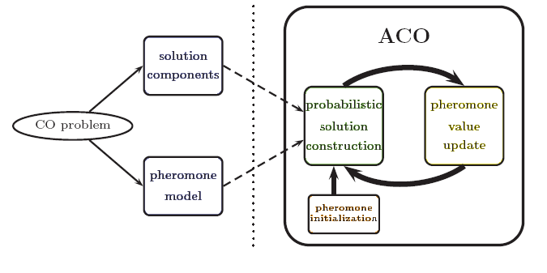
Figure 4: ACO Framework

Given a CO (combinatorial) problem to be solved, one first has to derive a finite set C of solution components which are used to assemble solutions to the CO problem. Second, one has to define a set of pheromone values T. This set of values is commonly called the pheromone model, which is—seen from a technical point of view—a parameterized probabilistic model. The pheromone model is one of the central components of ACO. The pheromone values τi є T are usually associated with solution components. The pheromone model is used to probabilistically generate solutions to the problem under consideration by assembling them from the set of solution components. In general, the ACO approach attempts to solve an optimization problem by iterating the following two steps:
- candidate solutions are constructed using a pheromone model, that is, a parameterized probability distribution over the solution space;
- the candidate solutions are used to modify the pheromone values in a way that is deemed to bias future sampling towards high-quality solutions. The pheromone update aims to concentrate the search in regions of the search space containing high-quality solutions. It implicitly assumes that good solutions consist of good solution components.

3.1.2 Particle swarm optimization

Particle swarm optimization (PSO) is a global optimization algorithm for dealing with problems in which a best solution can be represented as a point or surface in an n-dimensional space. Hypotheses are plotted in this space and seeded with an initial velocity, as well as a communication channel between the particles [26, 27]. Particles then move through the solution space, and are evaluated according to some fitness criterion after each timestamp. Over time, particles are accelerated towards those particles within their communication grouping which have better fitness values. The main advantage of such an approach over other global minimization strategies such as simulated annealing is that the large numbers of members that make up the particle swarm make the technique impressively resilient to the problem of local minima.

Particle swarm optimization (PSO) is a population-based stochastic optimization technique modelled on the social behaviours observed in animals or insects, e.g., bird flocking, fish schooling, and animal herding [40]. It was originally proposed by James Kennedy and Russell Eberhart in 1995 [40]. Since its inception, PSO has gained increasing popularity among researchers and practitioners as a robust and efficient technique for solving difficult optimization problems. In PSO, individual particles of a swarm represent potential solutions, which move through the problem search space seeking an optimal, or good enough, solution. The particles broadcast their current positions to neighbouring particles. The position of each particle is adjusted according to its velocity (i.e., rate of change) and the difference between its current positions, respectively the best position found by its neighbours, and the best position it has found so far. As the model is iterated, the swarm focuses more and more on an area of the search space containing high-quality solutions. PSO has close ties to artificial life models. Early works by Reynolds on a flocking model Boids [40], and Heppner’s studies on rules governing large numbers of birds flocking synchronously [40], indicated that the emergent group dynamics such as the bird flocking behaviour are based on local interactions.
In PSO, the velocity of each particle is modified iteratively by its personal best position (i.e., the best position found by the particle so far), and the best position found by particles in its neighbourhood. As a result, each particle searches around a region defined by its personal best position and the best position from its neighbourhood. Henceforth we use vi to denote the velocity of the ith particle in the swarm, xi to denote its position, pi to denote the personal best position and pg the best position found by particles in its neighbourhood. In the original PSO algorithm, vi and xi, for i = 1, . . . , n, are updated according to the following two equations :
vi ← vi + ϕ1 ⊙(pi − xi) ⊙ ϕ2 (pg − xi), Eq.(I)
xi ← xi + vi, Eq (II)
where ϕ1 = c1R1 and ϕ2 = c2R2. R1 and R2 are two separate functions, each returning a vector comprising random values uniformly generated in the range [0,1]. c1 and c2 are acceleration coefficients. The symbol ⊙ denotes point wise vector multiplication. Equation (I) shows that the velocity term vi of a particle is determined by three parts, the “momentum”, the “cognitive”, and the “social” part. The “momentum” term vi represents the previous velocity term which is used to carry the particle in the direction it has travelled so far; the “cognitive” part, ϕ1⊙(pi−xi), represents the tendency of the particle to return to the best position it has visited so far; the “social” part, ϕ2⊙(pg−xi), represents the tendency of the particle to be attracted towards the position of the best position found by the entire swarm. Position pg in the “social” part is the best position found by particles in the neighbourhood of the ith particle. Different neighbourhood topologies can be used to control information propagation between particles. Examples of neighbourhood topologies include ring, star, and von Neumann. Constricted information propagation as a result of using small neighbourhood topologies such as von Neumann has been shown to perform better on complex problems, whereas larger neighbourhoods generally perform better on simpler problems. Generally speaking, a PSO implementation that chooses pg from within a restricted local neighbourhood is referred to as lbest PSO, whereas choosing pg without any restriction (hence from the entire swarm) results in a gbest PSO [2]. Following algorithm summarizes a basic PSO approach and figure 4.2 shows each component of the velocity term vi in vector form, and the resulting position, xi (updated), for the ith particle. Note that the inertia coefficient w is used to scale the previous velocity term, normally to reduce the “momentum” of the particle.

The PSO algorithm, assuming maximization is as follows--
• Randomly generate an initial swarm
• repeat
• for each particle i do
• if f(xi) > f(pi) then pi ← xi
• pg = max(pneighbours)
• Update velocity (see Eq. (I))
• Update position (see Eq. (II))
• end for
• Until termination criterion is met

Figure 5: Visualizing PSO components as vectors

3.1.3 Stochastic diffusion search

Stochastic diffusion search (SDS) is an agent-based probabilistic global search and optimization technique best suited to problems where the objective function can be decomposed into multiple independent partial-functions. Each agent maintains a hypothesis which is iteratively tested by evaluating a randomly selected partial objective function parameterised by the agent's current hypothesis. In the standard version of SDS such partial function evaluations are binary, resulting in each agent becoming active or inactive. Information on hypotheses is diffused across the population via inter-agent communication. Unlike the stigmergic communication used in ACO, in SDS agents communicate hypotheses via a one-to-one communication strategy analogous to the tandem running procedure observed in some species of ant. A positive feedback mechanism ensures that, over time, a population of agents stabilise around the global-best solution. SDS is both an efficient and robust search and optimisation algorithm, which has been extensively mathematically described.

3.1.4 Gravitational search algorithm

Gravitational search algorithm (GSA) is constructed based on the law of Gravity and the notion of mass interactions. The GSA algorithm uses the theory of Newtonian physics and its searcher agents are the collection of masses. In GSA, we have an isolated system of masses. Using the gravitational force, every mass in the system can see the situation of other masses. The gravitational force is therefore a way of transferring information between different masses.

3.1.5 Intelligent Water Drops

Intelligent Water Drops algorithm (IWD) is a swarm-based nature-inspired optimization algorithm, which has been inspired from natural rivers and how they find almost optimal path to their destination. A natural river often finds good paths among lots of possible paths in its ways from the source to destination. These near optimal or optimal paths follow from actions and reactions occurring among the water drops and the water drops with their riverbeds. In the IWD algorithm, several artificial water drops cooperate to change their environment in such a way that the optimal path is revealed as the one with the lowest soil on its links. The solutions are incrementally constructed by the IWD algorithm. Consequently, the IWD algorithm [28] is generally a constructive population-based optimization algorithm.

3.2 Bio – Geographic Based Optimization

The science of biogeography can be traced to the work of nineteenth century naturalists such as Alfred Wallace [29] and Charles Darwin [30]. Until the 1960s, biogeography was mainly descriptive and historical. In the early 1960s, Robert MacArthur and Edward Wilson began working together on mathematical models of biogeography, their work culminating with the classic 1967 publication The Theory of Island Biogeography [31]. Their interest was primarily focused on the distribution of species among neighbouring islands. They were interested in mathematical models for the extinction and migration of species. Since MacArthur and Wilson’s work, biogeography has become a major area of research [32]. A recent search of Biological Abstracts (a biology research index) reveals that 25,452 papers were written in the year 2005 that were related to the subject of biogeography. However, a search of INSPEC, an engineering research index, reveals that no biogeography papers have ever been written. The application of biogeography to engineering is similar to what has occurred in the past few decades with genetic algorithms (GAs), neural networks, fuzzy logic, particle swarm optimization (PSO), and other areas of computer intelligence.

Mathematical models of biogeography describe how species migrate from one island to another, how new species arise, and how species become extinct. The term “island” [32] here is used descriptively rather than literally. That is, an island is any habitat that is geographically isolated from other habitats. Geographical areas that are well suited as residences for biological species are said to have a high habitat suitability index (HSI) [33]. Features that correlate with HSI include such factors as rainfall, diversity of vegetation, diversity of topographic features, land area, and temperature. The variables that characterize habitability are called suitability index variables (SIVs). SIVs can be considered the independent variables of the habitat, and HSI can be considered the dependent variable.
Habitats with a high HSI tend to have a large number of species, while those with a low HSI have a small number of species. Habitats with a high HSI have many species that emigrate to nearby habitats, simply by virtue of the large number of species that they host. Habitats with a high HSI have a low species immigration rate because they are already nearly saturated with species. Therefore, high HSI habitats are more static in their species distribution than low HSI habitats. By the same token, high HSI habitats have a high emigration rate; the large numbers of species on high HSI islands have many opportunities to emigrate to neighbouring habitats. (This does not mean that an emigrating species completely disappears from its home habitat; only a few representatives emigrate, so an emigrating species remains extant in its home habitat, while at the same time migrating to a neighbouring habitat.) Habitats with a low HSI have a high species immigration rate because of their sparse populations. This immigration of new species to low HSI habitats may raise the HSI of the habitat, because the suitability of a habitat is proportional to its biological diversity. However; if a habitat’s HSI remains low, then the species that reside there will tend to go extinct, which will further open the way for additional immigration. Due to this, low HSI habitats are more dynamic in their species distribution than high HSI habitats.

Biogeography is nature’s way of distributing species, and is analogous to general problem solutions. Suppose that we are presented with a problem and some candidate solutions. The problem can be in any area of life (engineering, economics, medicine, business, urban planning, sports, etc.), as long as we have a quantifiable measure of the suitability of a given solution. A good solution is analogous to an island with a high HSI, and a poor solution represents an island with a low HSI. High HSI solutions resist change more than low HSI solutions. By the same token, high HSI solutions tend to share their features with low HSI solutions. (This does not mean that the features disappear from the high HSI solution; the shared features remain in the high HSI solutions, while at the same time appearing as new features in the low HSI solutions. This is similar to representatives of a species migrating to a habitat, while other representatives remain in their original habitat.) Poor solutions accept a lot of new features from good solutions. This addition of new features to low HSI solutions may raise the quality of those solutions. This new approach to solve the problem is biogeography-based optimization (BBO) [4].

BBO has certain features in common with other biology based algorithms. Like GAs and PSO, BBO has a way of sharing information between solutions. GA solutions “die” at the end of each generation, while PSO and BBO solutions survive forever (although their characteristics change as the optimization process progresses). PSO solutions are more likely to clump together in similar groups, while GA and BBO solutions do not necessarily have any built-in tendency to cluster.

The concept highlighted by Dan Simon [4] is to formulate the bio geography in a way that it could be used to solve problems in different sciences, be it economics, engineering, chemistry etc. He used following diagram [4, 31] the base to build his formulation:
Figure 6: Species Model of Single Habitat

In the above figure λ is the rate of immigration and μ is the rate emigration, which are functions of the number of species in the habitat.

Consider the immigration curve. The maximum possible immigration rate to the habitat is, which occurs when there are zero species in the habitat. As the number of species increases, the habitat becomes more crowded, fewer species are able to successfully survive immigration to the habitat, and the immigration rate decreases. The largest possible number of species that the habitat can support is, at which point the immigration rate becomes zero.
Now consider the emigration curve. If there are no species in the habitat then the emigration rate must be zero. As the number of species increases, the habitat becomes more crowded, more species are able to leave the habitat to explore other possible residences, and the emigration rate increases. The maximum emigration rate is, which occurs when the habitat contains the largest number of species that it can support.

The equilibrium number of species is, at which point the immigration and emigration rates are equal. However, there may be occasional excursions from due to temporal effects. Positive excursions could be due to a sudden spurt of immigration (caused, perhaps, by an unusually large piece of flotsam arriving from a neighbouring habitat), or a sudden burst of speciation (like a miniature Cambrian explosion). Negative excursions from could be due to disease, the introduction of an especially ravenous predator, or some other natural catastrophe.

It can take a long time in nature for species counts to reach equilibrium after a major perturbation [32], [36].

3.2.1 BBO Definitions
BBO Definitions [4] are as follows:
Definition 1: A habitat H Є SIV ^{m} is a vector of m integers that represents a feasible solution to some problem.

Definition 2: A suitability index variable SIV Є C is an integer that is allowed in a habitat. C с Z ^{q} is the set of all integers that are allowed in a habitat. The requirement that SIV Є C is called a constraint. At a higher level, the requirement that H Є SIV ^{m} is also called a constraint.
Definition 3: A habitat suitability index HSI: H → R is a measure of the goodness of the solution that is represented by the habitat.

Definition 4: An ecosystem H ^{n} is a group of n habitats. The size n of an ecosystem is constant. Future work could allow variable-sized ecosystems, just as some flavours of Gas allow for variable population sizes.

Definition 5: Immigration rate λ (HSI): R → R is a monotonically no increasing function of HSI. λi is proportional to the likelihood that SIVs from neighbouring habitats will migrate into habitat Hi.

Definition 6: Emigration rate μ (HSI): R → R is a monotonically no decreasing function of HSI. μi is proportional to the likelihood that SIVs from habitat Hi will migrate into neighbouring habitats.
In practice, we assume that and are linear with the same maximum values. However, these assumptions are made only for mathematical convenience, and better performance might be attainable if these assumptions are relaxed.

Definition 7: Habitat modification Ω (λ, μ): H ^{n} → H is a probabilistic operator that adjusts habitat H based on the ecosystem H ^{n}. The probability that H is modified is proportional to its immigration rate λ, and the probability that the source of the modification comes from Hj is proportional to the emigration rate μj.
Habitat modification can loosely be described as follows.
Select Hi with probability proportional to λi
If Hi is selected
For j=1 to n
Select Hj with probability proportional to μi
If Hj is selected
Randomly select an SIV σ from Hj
Replace a random SIV in Hi with σ
end
end
end
From this algorithm, we note that elitism can be implemented by setting λ = 0 for the p best habitats, where p is a user selected elitism parameter. Also note that the definition of Ω ensures that the modified habitat H satisfies the SIV constraints.

Definition 8: Mutation M (λ, μ): H → H is a probabilistic operator that randomly modifies habitat SIVs based on the habitat’s a priori probability of existence.
Mutation can be described as follows.
For j=1 to m
Use λi and μi to compute the probability Pi
Select SIV Hi(j) with probability proportional to Pi
If Hi(j) is selected
Replace Hi(j) with a randomly generated SIV
end
end
As with habitat modification, elitism can be implemented by setting the probability of mutation selection Pi to zero for the p best habitats. From the above definition, we see that mutation must be constrained to result in an HSI that satisfies the SIV constraints.

Definition 9: An ecosystem transition function Ψ = (m, n, λ, μ, Ω, M): H ^{n} → H ^{n} is a 6-tuple that modifies the ecosystem from one optimization iteration to the next.
An ecosystem transition function can be written as follows:
Ψ = λ ^{n} . μ ^{n} . Ω ^{n} . HSI ^{n} . M ^{n} . HSI ^{n}
In other words, the ecosystem transition function begins by computing the immigration and emigration rates of each habitat. Then, habitat modification is performed on each habitat, followed by an HSI recalculation. Finally, mutation is performed, followed again by an HSI recalculation for each habitat.

Definition 10: A BBO algorithm BBO = (I, Ψ, T) is a 3-tuple that proposes a solution to an optimization problem. I: Φ → {H ^{n}, HSI ^{n}} is a function that creates an initial ecosystem of habitats and computes each corresponding HSI. Ψ is the ecosystem transition function defined earlier, and H ^{n} → {true, false} is a termination criterion.
I could be implemented with random number generators, heuristic solutions to the optimization problem, or some other problem-dependent procedure. T could depend on the number Ψ of iterations, or the HSI of the best habitat, or some other problem-dependent criterion. A BBO algorithm can be described as follows.
I
While not T
Ψ
End

3.2.2 BBO Algorithm

The BBO algorithm can be informally described with the following algorithm.
1) Initialize the BBO parameters. This means deriving a method of mapping problem solutions to SIVs and habitats, which is problem dependent. We also initialize the maximum species count and the maximum migration rates and the maximum mutation rate, and an elitism parameter. Note that the maximum species count and the maximum migration rates are relative quantities. That is, if they all change by the same percentage, then the behaviour of BBO will not change. This is because if E, I, and Smax change, then the migration rates λ, μ, and the species count S will change by the same relative amount for each solution.

2) Initialize a random set of habitats, each habitat corresponding to a potential solution to the given problem. This is the implementation of the I operator described in Definition 10.

3) For each habitat, map the HSI to the number of species, the immigration rate, and the emigration rate.

4) Probabilistically use immigration and emigration to modify each non-elite habitat, then recomputed each HSI.

5) For each habitat, update the probability of its species count using the (2). Then, mutate each non-elite habitat based on its probability, and recomputed each HSI.

6) Go to step (3) for the next iteration. This loop can be terminated after a predefined number of generations or after an acceptable problem solution has been found. This is the implementation of the T operator described in Definition 10.
Note that after each habitat is modified (steps 2, 4, and 5), its feasibility as a problem solution should be verified. If it does not represent a feasible solution, then some method needs to be implemented in order to map it to the set of feasible solutions.

Conclusion of the chapter is that from all the swarm intelligence technique BBO allows to take many factors into consideration simultaneously as proved by Dan Simon [4]. Also from the past work done in D.R.D.O in the field of swarm intelligence gives a conjecture that BBO is able to classify certain features better, it is able to better map certain patterns when applied for image classification.

4. METHODOLOGY FOR ENEMY BASE STATION PREDICTION

The soft computing technique to tackle the problem of predicting the enemy base station; selected in this project is Bio-Geographic based optimization from the swarm intelligence techniques. So going by the technique we consider the probable base stations as ‘islands’ [4]. These islands have a Habitat Suitability Index (HSI) determined on the basis of certain factors, here referred as Suitable Index Variables [4].

As discussed in above chapter (chapter 3), the algorithm proposed by Dan Simon [4] is used in its variant form to suit it to the problem statement of this project. The following sub sections give a detailed overview of the architecture and its functioning.

4.1 Architectural Layout
To solve the problem of finding the highly probable enemy base station through Bio-geographic based optimization the following architecture was modelled and used. The explanation of the same follows the architecture diagram.

There are in total five layers. The layers at the extremities are Input and Output Layers. The in between layers are processing layers, each having a unique purpose.

INPUT LAYER
PROCESSING LAYER 3:
BIO GEOGRAPHIC BASED OPTIMIZATION CLASSIFIER
OUTPUT LAYER
PROCESSING LAYER 1:
GEOGRAPHIC FEATURE EXTRACTIONPHASE IPHASE II
PROCESSING LAYER 2:
ENEMY’S PROBABLE BASE STATION EXTRACTION
Figure 7: Architectural Layout

The detailed explanation of each layer is as follows:

4.1.1 INPUT LAYER
This layer interacts with the user. It takes satellite images as input and passes it on to the following layer. Types of satellite images to be feed as input to this layer are: Seven band stereo graphic satellite image, Red image, Green image, Medium Infrared (MIR) image, Near Infrared (NIR) image, Very Near Infrared (VNIR) image, Radarsat-1 image, Radarsat-2 image or Google Earth Image and the Very Near Infrared image.

4.1.2 PROSSESSING LAYER 1: Geographic Feature Extraction
This layer takes the input from the Input Layer. Purpose of this layer is to extract all the geographic features such as slope, aspect, contour, DEM and the type (urban, forest, barren land, rocky land and water). Geographic feature extraction is done in two phases namely Phase I and Phase II. Phase I bears the responsibility to extract the geographic features in latitude and longitude format, while the Phase II converts these geographic features in the pixel by pixel format. There is a need of two phased architecture for this layer because of the fact that the geographic data cannot be extracted in pixel by pixel format directly from satellite images.

4.1.3 PROCESSING LAYER 2: Enemy’s Probable Base Station Extraction
This layer takes input from processing layer 2. Purpose of this layer is to extract the location of enemy’s probable base stations based on the drainage patterns (one of the geographic feature extracted in processing layer 2) of the area. The denser the drainage is at a particular location, the more are the chances of finding an enemy base station there, as the probability of finding the ground water in that area is higher (which is one of the influencing factor for situating a base station).

4.1.4 PROCESSING LAYER 3: BBO Classifier
The purpose of this layer is to identify or classify the enemy’s probable base stations into the most probable enemy base stations, least likely enemy base stations and the more likely probable base stations. This it adjudges on the basis of geographic features extracted in the processing layer 2 and the enemy’s probable base stations located in the processing layer 3 using the bio geographic based optimization technique of swarm intelligence.

4.1.5 OUTPUT LAYER
This layer gives the output to the user. The output consists of a collection of highly probable enemy base stations; the most likely enemy base station and a collection of least likely enemy base stations.

4.2 Functional Architecture
To solve the problem of finding the highly probable enemy base station through Bio-geographic based optimization the following functional architecture was modelled and used. The explanation of the same follows the functional architecture diagram.
In the below architecture the double bordered parallelograms represent the external software used during the flow of data (here images and tables); the rounded quadrilateral at the end represent the final result depicting the end of processing; and rest of the rectangular quadrilaterals represent the different layers through which data traverses to yield the final result.
SATTELITE IMAGES
(Latitude and Longitude Format)

EARTH SCIENCE SOFTWARE

GeoMedia Professional
ERDAS
FINAL PROCESSED RESULT
Most Probable Enemy Base Station
Set of Highly Probable Enemy Base Stations
Set of Least Probable Enemy Base Stations
EXTRACTED PROCESSED IMAGE DATA (Pixel by Pixel Format)
Probable Base Stations coordinates (X, Y)
SIVs for each pixel
Every pixel has 9 values (one for every SIV) and 2 more value denoting its X, Y coordinates
PROCESSED IMAGES
(Latitude and Longitude Format)

BATTLE FIELD SITUATION AWARENESS FUNCTIONS

Written and Run in MATLAB
Figure 8: Functional Architecture
In the following subsections module by module and layer by layer description of the above architecture is given.

4.2.1 Layer: Satellite Image
This layer is the main interface to accept the input, which are the various types of satellite images of the same area. The input images have a Lat-Long format, that is, every point in the image is identified by a unique pair of latitude and longitude. This layer also interacts with the Earth Science software Module, for the extraction of various geographic features from the satellite image.

4.2.2 Layer: Processed Images
This layer receives its input from satellite image layer, in the form of separate images depicting a separate geographic feature each. The input it receives is also in the lat-long format. This layer then uses the earth science software module to convert the lat-long format to a pixel by pixel format. This processed pixel by pixel format of data is passed on to next layer in tabular form with the row representing the X coordinate and column representing the Y coordinate of the pixel in an image.

4.2.3 Layer: Extracted Processed Image Data
This layer receives its input in the form of multiple tables having numeric data. This numeric data from respective tables is used and processed with the help of Battle Field Situation Awareness Functionality module. This layer hence in the end generates nine tables corresponding to nine SIVs and one table corresponding to probable enemy base station coordinates. This layer feeds input to two layers, to one of it, it passes the table corresponding to probable enemy base station coordinates and to the other it passes nine tables corresponding to nine SIVs.

4.2.4 Layer: Probable Base Station
This layer receives the input in form of a table in the excel format, having the probable enemy base station coordinates. It gives input to the Battle Field Situation Awareness Functionality module, which requires it for further processing.

4.2.5 Layer: Suitable Index Variable
This layer receives the input in form of tables in the excel format, having the nine tables corresponding to nine Suitability Index variables. It interacts with Battle Field Situation Awareness Functionality module, to generate HSI, Effort and Selectivity Factor for each of the probable base station.

4.2.6 Layer: Final Processed Result
This layer depicts the end of Processing and generates the results in an excel sheet and in the command window. The result states the three categories namely Most Probable Enemy Base Station; Set of Highly Probable Enemy Base Stations; and Set of Least Probable Enemy Base Stations, thereby solving the problem.

4.2.7 Module: Earth Science Software
This module encapsulates two software ERDAS and GeoMedia Professional, which were extensively used in the processing of the inputs, which were satellite images. This module is used in the first two layers of the architecture. In the first layer it is used for calculating various geographic features of the area depicted in the satellite images. The geographic features are extracted by utilizing their (earth science software) standard algorithms to calculate slope, aspect, drainage and contour. In the second layer it is used for mapping latitude longitude of a point to spatial X, Y coordinate of a point (a pixel in an image).

4.2.8 Module: Battle Field Situation Awareness Functions
This module interacts with the third, fourth and fifth layer of the architecture. It encapsulates following functionality [Appendix A]:

Aspect SIV Generation
The algorithm followed to extract Aspect SIV from the Aspect Image table is:

For all i and j
Aspect table is scanned in k
‘Where i and j mean the corresponding x and y values of enemy’s probable base station
End for
For all values of k
k is scaled on a scale of one to five depending on the criteria into a
‘Where a is the generated Aspect SIV
End for

Explanation of Aspect SIV generation is given below:
- Input is taken in the form of Aspect table is taken. The Aspect table is a pixel by pixel table in which each value ranges from one to eight, representing one of the category to which a pixel belongs.
- Depending on the category and the criteria defined (1-Category 6, Category 7 and Category 8; 2-Category 5; 3-Category 4; 4-Category 1 and Category 3; 5-Category 2) each pixel is associated to a scale ranging from one to five.
- The resultant table (pixel by pixel) map is then stored in an excel file named Aspect in the output folder.

Evenness (Contour) SIV Generation
The algorithm followed to extract Evenness SIV from the Elevation Image table is:

For every i, j
‘Where i and j mean the corresponding x and y values of enemy’s probable base station

Put cell[i,j] and 8 neighbours of cell[i,j] → WM
‘where WM is working Memory and 8 neighbours are cell[i-1,j-1], cell[i,j-1],
cell[i+1,j-1], cell[i-1,j], cell[i+1,j], cell[i-1,j+1], cell[i,j+1] and cell[i+1,j+1] taken from
the elevation table

For every m
‘where m is one of the nine values in the working Memory

V m Є WM, n = { n | number_of_simillar(m, V k Є WM) }
‘that is m is mapped to the working Memory and number of similar members
extracted ton n
End for

t = { t | t Є n, largest(n) }
‘that is Largest of the value t is picked from the set of n

t is scaled from one to five depending on the criteria and output to c
‘Where c is the generated Contour SIV
End for

Explanation of Contour SIV generation is given below:
- Input is taken in the form of elevation value table. The elevation value table is a pixel by pixel table in which each value gives the height or elevation of the pixel.
- For each pixel, number of neighbouring pixels (also taking that pixel into consideration for which evenness is being determined) belonging to the elevation in the range elevation minus two to elevation plus two are calculated. Nine elevations are considered for each of the nine values belonging to the adjacent nine pixels.
- Of the nine values of number of neighbouring pixels obtained in step two, the maximum one is selected and assigned to the pixel
- Then each pixel is scaled on a scale of one to five on the basis of the number of pixels assigned in step three. Scale 5 is assigned if number of pixels lies between seven to nine; scale 4 if the value of number of pixels is five or six; scale 3 if the value of number of pixels is three or four; scale 2 if the value of number of pixels is two; and scale 1 if the value of number of pixels is one.
- The resultant table (pixel by pixel) map is then stored in an excel file named Contour in the output folder.

Generic Degree Calculation for a type
By type it means Urban, Forest, Barren land, Rocky land or water. It is prefixed with generic because of the fact that same algorithm is used to define the degree of any type. The algorithm followed to extract Degree of Urban, Forest, Barren land, Rocky land and water SIVs from the Classified Image table is:

For every i, j
‘Where i and j mean the corresponding x and y values of enemy’s probable base station

Put cell[i,j] and 8 neighbours of cell[i,j] → WM
‘where WM is working Memory and 8 neighbours are cell[i-1,j-1], cell[i,j-1],
cell[i+1,j-1], cell[i-1,j], cell[i+1,j], cell[i-1,j+1], cell[i,j+1] and cell[i+1,j+1] taken from
the classified table

V m Є WM, n = { n | number_of_match(m, V k Є WM) }
‘where m specifies one of the type from barren, rocky, forest, urban and water)
m is mapped to the working Memory and number of matching members extracted to n

n is then scaled from one to five depending on the criteria and output to t
‘Where t is the generated Degree of m SIV
Where n Є { Urban, Water, Rocky, Barren, Forest }
End for

Explanation of Degree SIV generation is given below:
- The input is taken in the form of Classified Table and the type whose degree needs to be calculated for each pixel. The classified table is a pixel by pixel map of the classified image, each pixel have one of the five values corresponding to each type namely Urban, Forest, Barren land, Rocky land and water.
- For each pixel number of neighbouring pixels (also taking that pixel into consideration for which degree is being determined) belonging to the type (passed on as input in step one) are calculated.
- Then each pixel is scaled on a scale of one to five on the basis of the number of pixels belonging to the type calculated in step two. Scale 5 is assigned if number of pixels lies between seven to nine; scale 4 if the value of number of pixels is five or six; scale 3 if the value of number of pixels is three or four; scale 2 if the value of number of pixels is two; and scale 1 if the value of number of pixels is one.
- The resultant table (pixel by pixel) map is then stored in an excel file named after the type (for which the degree is calculated) in the output folder.

Digital Elevation Model SIV Calculation
The algorithm followed to extract DEM SIV from the Elevation Image table is:

Compute s, l, a, m, b and n are calculated over the elevation table, where
  - s = { s | minimum( k, k Є ( cell[i,j], V i, j of elevation table ) ) }
  - l = { l | maximum( k, k Є ( cell[i,j], V i, j of elevation table ) ) }
  - a = { a | average( cell[i,j], V i, j of elevation table ) }
  - m = { m | median(cell[i,j], V i, j of elevation table ) }
  - b = { b | (s+l)/2 }
  - n = { n | mode( cell[i,j], V i, j of elevation table ) }

Then s, l, a, m, b and are sorted in ascending order. And the criteria ranges are generated.

For all i and j
‘Where i and j mean the corresponding x and y values of enemy’s probable base
station.

Elevation table is scanned in k

For all values of k
k is scaled on a scale of one to five depending on the generated criteria into d
‘Where d is the generated DEM SIV
End for

End for

Explanation of DEM SIV generation is given below:
- Input is taken in the form of elevation value table. The elevation value table is a pixel by pixel table in which each value gives the height or elevation of the pixel.
- Minimum, Mode, Median, Average, Mid and Maximum are calculated of the values in the elevation table.
- Scales of one to five are defined based on the ranges derived from the values calculated in step two. Scale 1 would refer to a elevation value lying in between minimum and mode; scale 2 for a value between mode and median; scale 3 for the range from median to average; scale 4 for range from average to mid; and scale 5 for elevation values lying between mid to maximum.
- Depending on the elevation and in which range that elevation lays each pixel is associated to a scale ranging from one to five.
- The resultant table (pixel by pixel) map is then stored in an excel file named DEM in the output folder.

4.3 Terminology Used
This section goes through the meaning of all the terms coined and used in solving the problem of finding the highly probable base enemy base station.

4.3.1 Suitable Index Variables
In accordance with the problem statement and expert knowledge of military domain, the following are the Suitable Index Variables (SIV) taken into consideration for deciding the Habitat Suitability Index (HSI) for the base stations are:
- Elevation of that area: The more the elevation of that area is, more are the base station on that area visible. Hence the enemy would like to have its base station located on such an area that is out of the line of sight of others.
- Evenness of the area: The evenness of the area is important as the base station would not be possible on uneven surface that is pits and peaks. There has to be certain evenness of surface in that area for the construction of the base station.
- Area covered under Slope: More is the vertical area covered; more is the probability of locating a base station there.
- Aspect (Direction/Angle) of area: More is the aspect vertically aligned towards enemy; more is the probability of having their base station there as it acts as a natural shield for them.
- Degree of urbanity: More the area under consideration is urban; less is the probability of having a base station there. As civilians are kept as away from military operations as possible.
- Degree of water: For a base station the degree of water of that area should be from low to medium, as a little water could be of their help for their daily household work. But if it is in excess the probability of hiding their base station decreases.
- Degree of forest: The more is degree of forest in that area the more is the ease for them to situate their base station as that is the best location to maintain the anonymity of base station.
- Degree of barren land: The more is the barren land in the area, less are the chances of constructing a base station there. As it would easily be detectable in satellite images.
- Degree of rocky land: Medium level of rocky land is the best for the construction of base station, but both the extremities are not suited for the construction of base station.

4.3.2 Scales for SIVs
These SIVs were then determined for each area on a scale of one to five.
- Elevation of that area: The ranges were determined after calculating minimum, maximum, average, mode, median and mid of all DEM (Digital elevation model) values for the stretch of area taken under consideration. For the experimented data it was
  - Scale 1 Very Low: 247 to 256
  - Scale 2 Low: 257 to 278
  - Scale 3 Medium: 279 to 325
  - Scale 4 High: 326 to 419
  - Scale 5 Very High: 420 to 593

- Evenness of the area: This was determined by considering the neighbouring area of the small area taken into consideration at a time. If the neighbouring area was of similar height than the area was considered even. The levels were decided by considering the percentage of area (around the area under consideration) that is even.
  - Scale 1 Very Low: Less than equal to 11%
  - Scale 2 Low: 12% to 23%
  - Scale 3 Medium: 24% to 44%
  - Scale 4 High: 45% to 67%
  - Scale 5 Very High: Greater than equal to 68%

- Area covered under Slope: This was determined by scaling the area on the scale of four, depending on the percentage of area coming under the slope.
  - Scale 1 Very Low: Less than equal to 5%
  - Scale 2 Low: 6% to 10%
  - Scale 3 Medium: 11% to 15%
  - Scale 4 High: Greater than equal to 16%

- Aspect (Direction/Angle) of area: This was determined by calculating the angle for each area and was then categorized into eight categories first that is zero to 45 degree first, 45 to 90 degrees second, 90 to 135 degrees third, 135 to 180 degrees fourth, 180 to 225 degrees fifth, 225 to 270 degrees sixth, 270 to 315 degrees seventh and 315 to 360 degrees eighth. Then using these categories we scale the aspect of an area on scale of five.
  - Scale 1 Least Favourable: Category 6, Category 7 and Category 8
  - Scale 2 Less Favourable: Category 5
  - Scale 3 Medium Favourable: Category 4
  - Scale 4 Favourable: Category 1 and Category 3
  - Scale 5 Very Favourable: Category 2

- Degree of urbanity: The area was scaled on a scale of one to five by determining if the area itself is urban or what percentage of the area around is urban.
  - Scale 1 Very Low: If less than equal to 11% of its neighbouring area is urban.
  - Scale 2 Low: If 12% to 23% of its neighbouring area is urban.
  - Scale 3 Medium: If 24% to 44% of its neighbouring area is urban.
  - Scale 4 High: If 45% to 67% of its neighbouring area is urban.
  - Scale 5 Very High: If the area itself is urban or greater than equal to 68% of its neighbouring area is urban.

- Degree of water: The area was scaled on a scale of one to five by determining if the area itself is water or what percentage of the area around is water.
  - Scale 1 Very Low: If less than equal to 11% of its neighbouring area is water.
  - Scale 2 Low: If 12% to 23% of its neighbouring area is water.
  - Scale 3 Medium: If 24% to 44% of its neighbouring area is water.
  - Scale 4 High: If 45% to 67% of its neighbouring area is water.
  - Scale 5 Very High: If the area itself is urban or greater than equal to 68% of its neighbouring area is water.

- Degree of forest: The area was scaled on a scale of one to five by determining if the area itself is water or what percentage of the area around is forest.
  - Scale 1 Very Low: If less than equal to 11% of its neighbouring area is forest.
  - Scale 2 Low: If 12% to 23% of its neighbouring area is forest.
  - Scale 3 Medium: If 24% to 44% of its neighbouring area is forest.
  - Scale 4 High: If 45% to 67% of its neighbouring area is forest.
  - Scale 5 Very High: If the area itself is urban or greater than equal to 68% of its neighbouring area is forest.

- Degree of barren land: The area was scaled on a scale of one to five by determining if the area itself is water or what percentage of the area around is barren land.
  - Scale 1 Very Low: If less than equal to 11% of its neighbouring area is barren land.
  - Scale 2 Low: If 12% to 23% of its neighbouring area is barren land.
  - Scale 3 Medium: If 24% to 44% of its neighbouring area is barren land.
  - Scale 4 High: If 45% to 67% of its neighbouring area is barren land.
  - Scale 5 Very High: If the area itself is urban or greater than equal to 68% of its neighbouring area is barren land.

- Degree of rocky land: The area was scaled on a scale of one to five by determining if the area itself is water or what percentage of the area around is rocky land.
  - Scale 1 Very Low: If less than equal to 11% of its neighbouring area is rocky land.
  - Scale 2 Low: If 12% to 23% of its neighbouring area is rocky land.
  - Scale 3 Medium: If 24% to 44% of its neighbouring area is rocky land.
  - Scale 4 High: If 45% to 67% of its neighbouring area is rocky land.
  - Scale 5 Very High: If the area itself is urban or greater than equal to 68% of its neighbouring area is rocky land.

4.3.3 Wieghtages assigned to SIV
These SIVs are given wieghtages from a scale of one to ten according to their importance in deciding the location of the base station. These weightages are then utilized in determining the effort for migration from this base station to the ideal base station. This effort further helps in determining the selectivity factor of the base station.
- Elevation of that area (D as based on DEM): 9
- Evenness of the area (C as based on Contour): 8
- Area covered under Slope (S for Slope): 7
- Aspect (Direction/Angle) of area (A for Aspect): 9
- Degree of urbanity (U for Urban):7
- Degree of water (W for Water): 2
- Degree of forest (F for Forest): 8
- Degree of barren land (B for Barren): 5
- Degree of rocky land (R for Rocky): 7

4.3.4 Ideal Enemy Base Station
For Ideal Base Station the value of each SIV was taken, as per Expert Knowledge in Military Domain, on a scale of one to five would be:
- IdealD = Very Low (1) Elevation of that area
- IdealC = Very High (5) Evenness of the area
- IdealS = High (4) Area covered under Slope
- IdealA = Very Favourable (5) Aspect (Direction/Angle) of area
- IdealU = Very Low (1) Degree of urbanity
- IdealW = Low (2) Degree of water
- IdealR =Medium (3) Degree of rocky land
- IdealB = Very Low (1) Degree of barren land
- IdealF = Very High (5) Degree of forest

4.3.5 High Suitability Index
First HSI of the Ideal base station is calculated and then the HSI of all the other base stations are calculated using the following formula (the formula was generated by the interpretation of military data and the meaning of the Ideal base station in terms of its SIVs):
if A>3
HSI = F + (C / D) + mod((6-R),4) + ((A * S) / 10) – U – B - (W-2)
else
HSI = F + (C / D) + mod((6-R),4) - ((A * S) / 10) – U – B - (W-2)
Formula 1: High Suitability Index
Where F, C, D, R, A, S, U, B and W are SIVs of the island whose HSI is being calculated.

4.3.6 Threshold HSI
The Threshold HSI is one third of the Ideal HSI (decided by generating various HSIs of different regions). If the HSI of a base station is less than the threshold HSI, the base station is rejected to be an enemy’s base station. Otherwise the calculations are further made to calculate the effort and selectivity factor of the base station.
ThresholdHSI = Floor ( IdealHSI / 3 )
Formula 2: Threshold High Suitability Index

4.3.7 Required Effort
To calculate the effort for a base station we take the difference between the ideal value of SIV and the SIV of that particular base station and then this difference is multiplied by the weightage given to the corresponding SIV.
Effort = ∑ ((IdealSIVi-SIVi) X Weightage of SIVi ) V i
Formula 3: Required Effort
Where i denote the number of SIVs taken into consideration, here it value ranges from one to nine.

4.3.8 Selectivity Factor
To calculate the selectivity factor we subtract the Threshold HSI from the base station HSI, and then divide it by the effort.
SelectivityFactor = (HSI- ThresholdHSI)/EFFORT
Formula 4: Selectivity Factor
This was calculated for each base station that had its HSI greater than threshold HSI.

4.3.9 Probable Enemy Base Station
The initial base station selection is based on the drainage pattern of the area under consideration. The drainage pattern helps in deciding the areas which would have higher denser canals (by canal it means a line in drainage map, by density of canal it means the number of the sub canals that join to form this canal), which actually implies the probability of finding the ground water at that place.

4.4 Step by Step Procedure
A step by step detailed approach to solve the problem of finding the enemy’s most probable base station is given below.

4.4.1 Inputs
Take the inputs in form of following satellite images: Seven band stereo graphic satellite image, Red image, Green image, Medium Infrared (MIR) image, Near Infrared (NIR) image, Very Near Infrared (VNIR) image, Radarsat-1 image, Radarsat-2 image or Google Earth Image and VNIR image.

4.4.2 Processing
Processing can be mainly divided into three steps, Step 1 is the one in which the data interacts with earth science software; Step 2 is the one in which data interacts with battle field situation awareness functionality (written and run in MATLAB); Step 3 is the one which actually classifies the enemy’s probable base stations into the most likely, highly likely and the least likely enemy’s base stations using bio geographic based optimization, this functionality is also written and run in MATLAB. The description of the three steps is given below.
Step 1
The processing of the satellite images involves:
- Digital Elevation Model (DEM) Values were determined using VNIR image
- Supervised satellite image classification was done to identify urban, barren, water, rocky and forest areas using the seven bands combined false colour composition image or Google Earth Image.
- Erdas software was used for determining (using the VNIR image):
  - Slope
  - Aspect
- GeoMedia Professional software was used for determining (using VNIR image):
  - Drainage
  - Contour
- The above results are then converted into pixel by pixel format from the lat-long format using ERDAS.

Step 2
Using the Step 1 processed output data:
- The minimum, maximum, average, mode, median and mid of all DEM (Digital elevation model) values was calculated to determine the ranges. After that the areas are scaled into five levels using these ranges.
- The degree of urbanity, water, barren land, rocky land and forest was calculated for each area and was scaled as per five levels.
- The evenness of each area was calculated and was scaled to five levels.
- Slope was classified into four classes.
- Aspect was classified into eight classes and then further scaled down to five levels.
- Initial (Random) base stations were chosen depending on the drainage pattern of that area, the denser water zones, having a high probability of having underground water.

Step 3
- HSI for each enemy’s probable base station is calculated.
- If the value of HSI is less than the threshold HSI it is put in the class of least likely enemy’s probable base stations and no further computations are done for it.
- If the value of HSI is greater than threshold HSI then
  - Required Effort is computed for that particular probable enemy’s base station.
  - Selectivity Factor is computed for that particular probable enemy’s base station.
  - This particular probable enemy’s base station is put in highly likely enemy’s base stations.
- From the set of highly likely enemy’s base stations, the one with the highest selectivity factor is identified and removed from this class and declared as the most probable enemy base station.

4.4.3 Outputs
- The collection of highly likely enemy base stations.
- The most likely enemy base station.
- The collection of least likely enemy base stations.

5. EXPERIMENTAL STUDY

For the purpose of experimental study the area of ‘Alwar’ was selected. This area was selected because of the fact that it has all the features such as Urban, Forest, Rocky land, Barren land and Water; also the degree of elevation (heights) at different places vary a lot; hence forming a perfect test case to check all the SIVs defined in my work.

5.1 Alwar Region
For this region the satellite images were collected from D.R.D.O.

5.1.1 Inputs
The input was taken as a seven band stereo graphic satellite images; Red image, Green image, Middle Infrared (MIR) image, Near Infrared (NIR) image, Very Near Infrared (VNIR) image, Radarsat-1 image, Radarsat-2 image. After combining the entire seven images we obtain a False Colour Composition (FCC) Image. These images were taken from DRDO, under the approval of Dr. V.K Panchal.

These images of Alwar area are shown below with the caption depicting the type of the image:

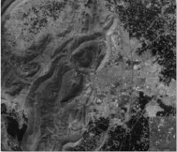  Figure 8: Red Image | 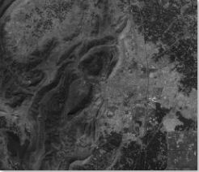  Figure 9: Green image
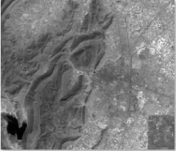  Figure 10: MIR Image | 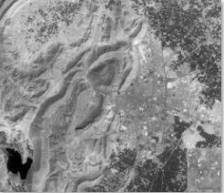  Figure 11: NIR Image
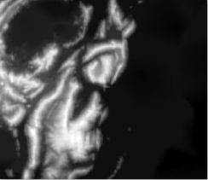  Figure 12: VNIR Image | 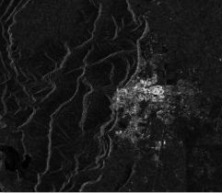  Figure 13: Radarsat-1 Image
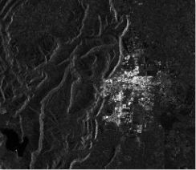  Figure 14: Radarsat-2 Image | 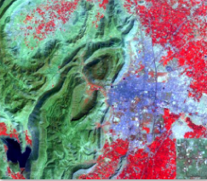  Figure 15: Seven Band FCC Image

5.1.2 Processed Data
After processing the input images in Erdas using the appropriate standard algorithms provided by it; aspect, slope, drainage and contours were calculated. The resultant images of the same are as follows:

Phase I Processed Data

In this phase the input satellite images are processed in earth science software for geographic feature extraction and the resultant processed images are shown below:
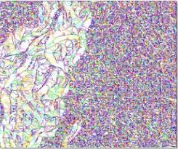  Figure 16: Aspect Vectors | 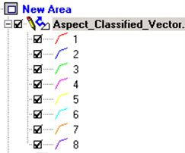  Figure 17: Aspect Legend
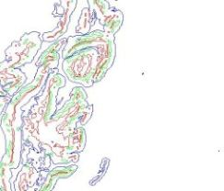  Figure 18: Slope Vectors | 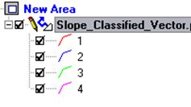  Figure 19: Slope Legend
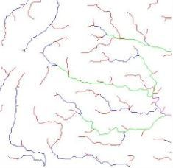  Figure 20: Drainage Vectors | 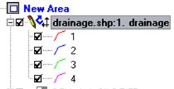  Figure 21: Drainage Legend
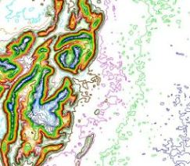  Figure 22: Contour Vectors | 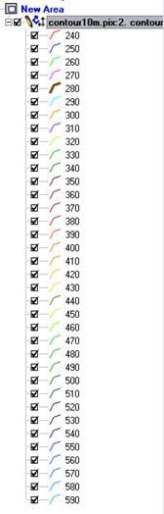  Figure 23: Contour Legend

Also in this phase to specify the type of region that is, Urban, Rocky, Barren, Forest or water, the supervised Classification of the Alwar satellite image is done the following is the resultant image:
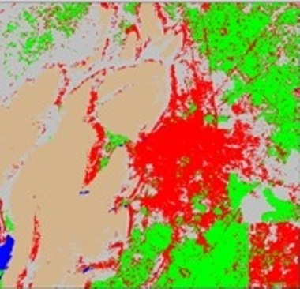
Figure 24: Classified Alwar Image
Here; Red is for Urban
Green is for Forest
Blue is for Water
Light Brown is for Rocky land
Grey is for Barren land

Phase II Processed Data
From all the processed images; aspect, slope, contour and classified alwar images; data was mapped in pixel by pixel format and the values of their corresponding feature read numerically. With the help of drainage image initial probable base stations were mapped by providing the values of X and Y coordinates, for .e.g.
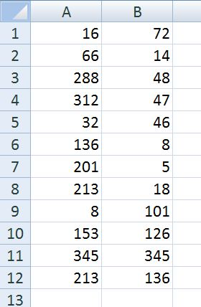
Here the Columns A and B correspond to axis X and Y. Each row corresponds to a new base station.

Table 1: Probable Enemy Base Station Coordinates

The example to interpret above table is stated below:
E.g. Cell B4 gives the y coordinate of 4th base station
Cell A7 gives the x coordinate of 7th base station.

Samples of the nine tables of scaled SIVs are given below.
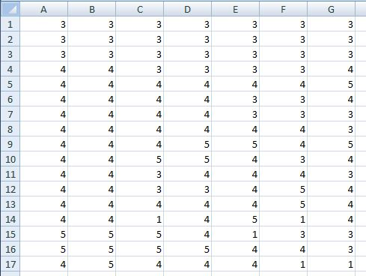
Table 2: Sample Aspect SIV
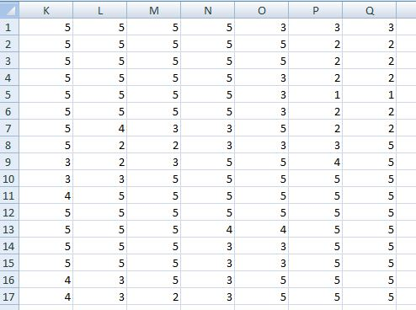
Table 3: Sample Barren SIV
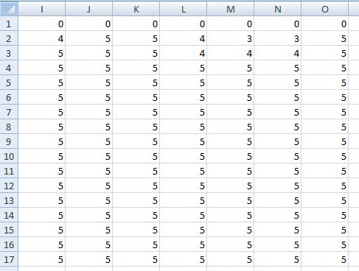
Table 4: Sample Contour SIV
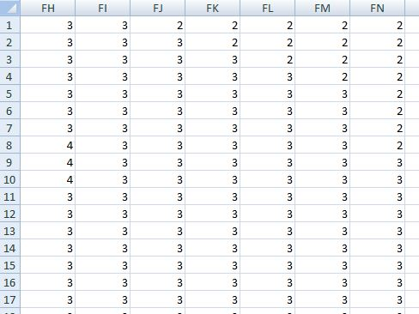
Table 5: Sample DEM SIV
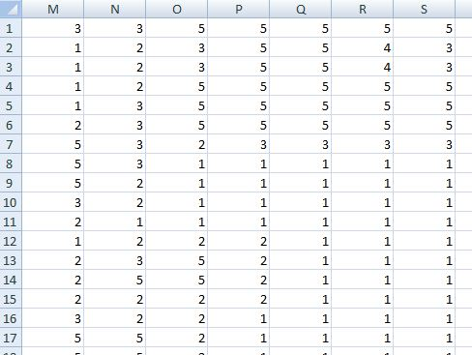
Table 6: Sample Forest SIV
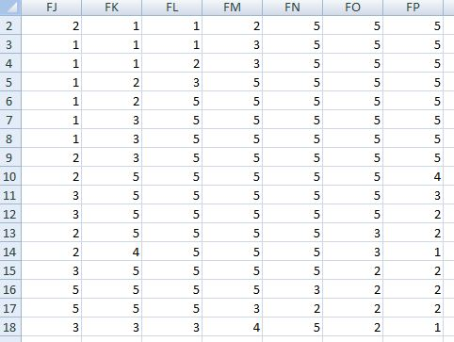
Table 7: Sample Rocky SIV
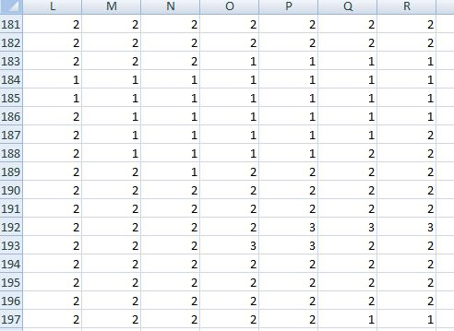
Table 8: Sample Slope SIV
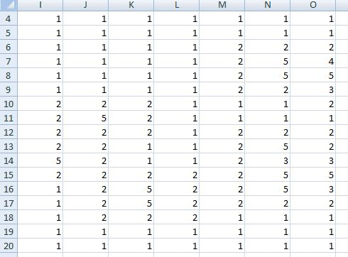
Table 9: Sample Urban SIV
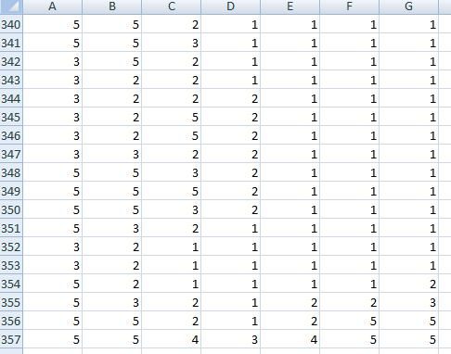
Table 10: Sample Water SIV

5.1.3 Outputs
The result is generated in the command window and in the excel sheet. Combining the two we get situation awareness of Alwar region. The command window result is as follows:

Processing the Input...

Data prepration for Urban parameter.

Data prepration for Water parameter.

Data prepration for Rocky parameter.

Data prepration for Barron parameter.

Data prepration for Forest parameter.

Data prepration for Aspect parameter.

Data prepration for DEM parameter.

Data prepration for Contour parameter.

Data prepration for Slope parameter.

Processing of Input Complete.

Reading the Processed Input.
HSI for the Ideal base Station is 13
Enter the no. of base stations : 12

HSI value of the base Station 1 is 5.466667
Effort for the base Station 1 is 41.000000
Selectivity factor for the base Station 1 is 0.035772

HSI value of the base Station 2 is 3.066667
As HSI value of the base Station 2 is less than the Threshhold HSI that is 4.000000, hence this base station is rejected and no further calculations are made.

HSI value of the base Station 3 is 1.650000
As HSI value of the base Station 3 is less than the Threshhold HSI that is 4.000000, hence this base station is rejected and no further calculations are made.

HSI value of the base Station 4 is 2.550000
As HSI value of the base Station 4 is less than the Threshhold HSI that is 4.000000, hence this base station is rejected and no further calculations are made.

HSI value of the base Station 5 is 5.066667
Effort for the base Station 5 is 18.000000
Selectivity factor for the base Station 5 is 0.059259

HSI value of the base Station 6 is 2.650000
As HSI value of the base Station 6 is less than the Threshhold HSI that is 4.000000, hence this base station is rejected and no further calculations are made.

HSI value of the base Station 7 is 1.750000
As HSI value of the base Station 7 is less than the Threshhold HSI that is 4.000000, hence this base station is rejected and no further calculations are made.

HSI value of the base Station 8 is 3.250000
As HSI value of the base Station 8 is less than the Threshhold HSI that is 4.000000, hence this base station is rejected and no further calculations are made.

HSI value of the base Station 9 is 4.066667
Effort for the base Station 9 is 13.000000
Selectivity factor for the base Station 9 is 0.005128

HSI value of the base Station 10 is 2.550000
As HSI value of the base Station 10 is less than the Threshhold HSI that is 4.000000, hence this base station is rejected and no further calculations are made.

HSI value of the base Station 11 is 7.900000
Effort for the base Station 11 is 37.000000
Selectivity factor for the base Station 11 is 0.105405

HSI value of the base Station 12 is 3.066667
As HSI value of the base Station 12 is less than the Threshhold HSI that is 4.000000, hence this base station is rejected and no further calculations are made.

Best suitaible base station for the enemy is 11 with Selectivity factor as 0.105405
>>

The excel sheet result is as follows:

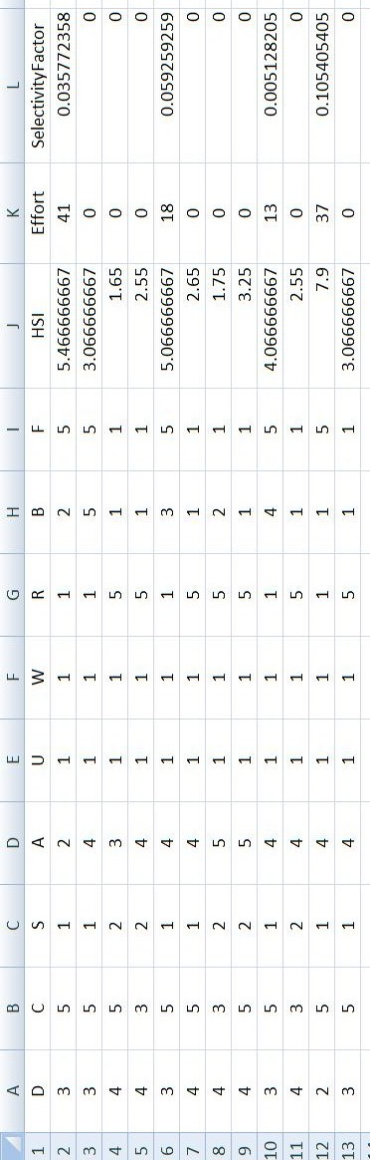
Table 11: Result

5.2 Mussoorie Region
For this region the satellite images were collected from Google Earth.

5.2.1 Inputs
The input was taken as a Google Earth Image, Very Near Infrared (VNIR) image. These images were taken from the Google Earth.

These images of Mussoorie area are shown below with the caption depicting the type of the image [43]:
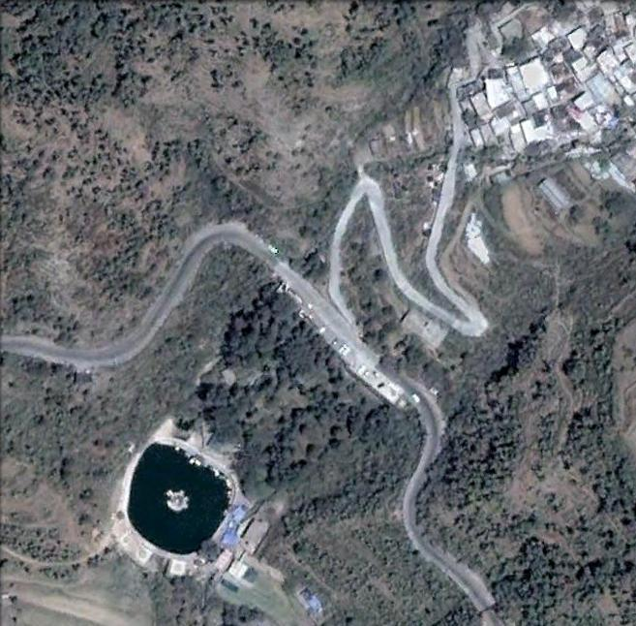
Figure 25: Google Earth Mussoorie Image

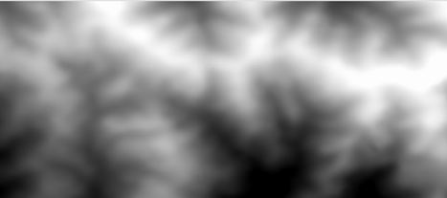
Figure 26: VNIR Mussoorie Image

5.1.2 Processed Data
After processing the input images in Erdas and GeoMedia Professional using the appropriate standard algorithms provided by it; aspect, slope, drainage and contours were calculated. The resultant images of the same are as follows:

Phase I Processed Data

In this phase the input satellite images are processed in earth science software for geographic feature extraction and the resultant processed images are shown below:
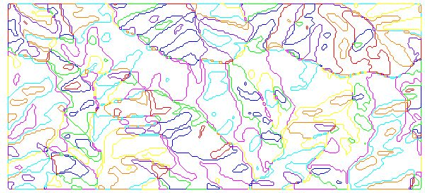  Figure 27: Aspect Vectors | 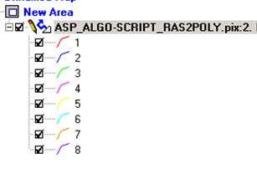  Figure 28: Aspect Legend
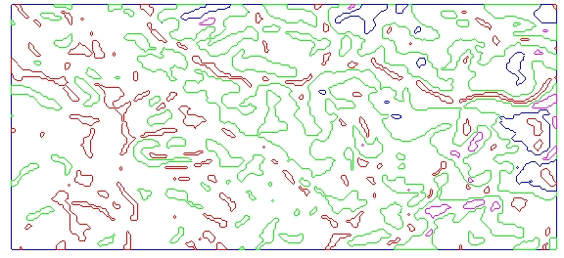  Figure 29: Slope Vectors | 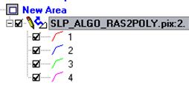  Figure 30: Slope Legend
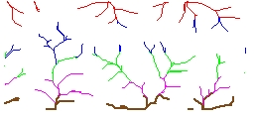  Figure 31: Drainage | 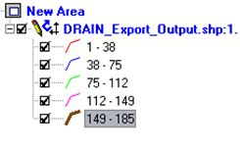  Figure 32: Drainage Legend
  Figure 33: Contour Vector | 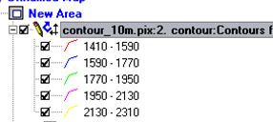  Figure 34: Contour Legend

Also in this phase to specify the type of region that is, Urban, Rocky, Barren, Forest or water, the supervised Classification of the Mussoorie google earth satellite image is done the following is the resultant image:

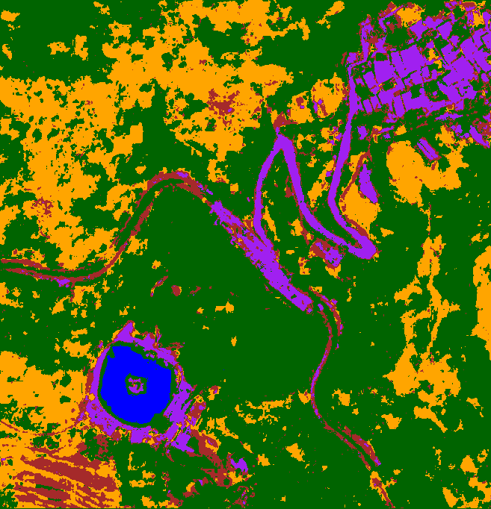
Figure 35: Classified Mussoorie Region

Here; Purple is for Urban, Green is for Forest, Blue is for Water, Brown is for Rocky land and Mustard is for Barren land.
Phase II Processed Data
From all the processed images; aspect, slope, contour and classified mussoorie images; data was mapped in pixel by pixel format and the values of their corresponding feature read numerically. With the help of drainage image initial probable base stations were mapped by providing the values of X and Y coordinates, for .e.g.
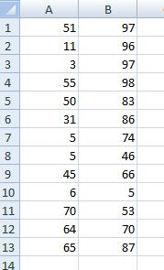
Table 12: Base Station Coordinates Mussoorie

Samples of the nine tables of scaled SIVs are given below.
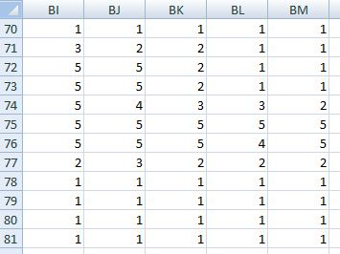
Table 13: Urban SIV

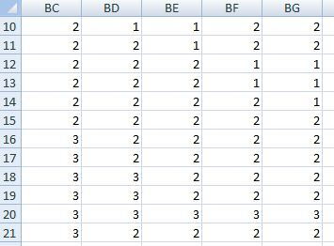
Table 14: Slope SIV
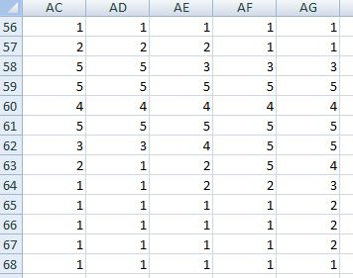
Table 15: Rocky SIV
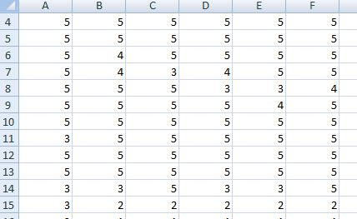
Table 16: Forest SIV
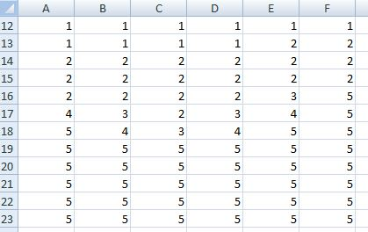
Table 17: DEM SIV
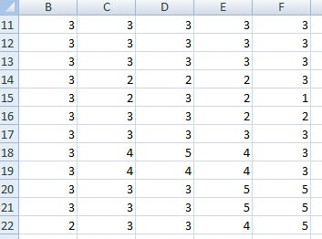
Table 18: Contour SIV
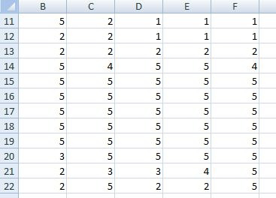
Table 19: Barren SIV
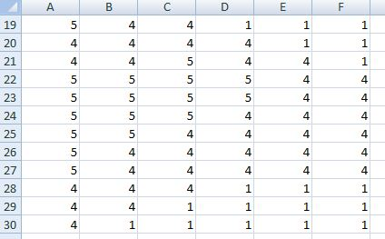
Table 20: Aspect SIV
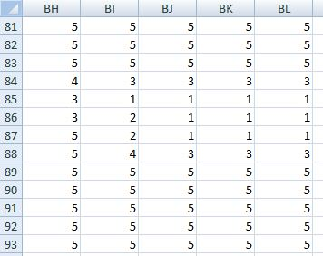
Table 21: Water SIV

5.1.3 Outputs
The result is generated in the command window and in the excel sheet. Combining the two we get situation awareness of Mussoorie region. The command window result is as follows:
Processing the Input...

Data prepration for Urban parameter.

Data prepration for Water parameter.

Data prepration for Rocky parameter.

Data prepration for Barron parameter.

Data prepration for Forest parameter.

Data prepration for Aspect parameter.

Data prepration for DEM parameter.

Data prepration for Contour parameter.

Data prepration for Slope parameter.

Processing of Input Complete.

Reading the Processed Input.
HSI for the Ideal base Station is 13
Enter the no. of base stations : 13

HSI value of the base Station 1 is 4.800000
Effort for the base Station 1 is 38.000000
Selectivity factor for the base Station 1 is 0.021053

HSI value of the base Station 2 is 1.550000
As HSI value of the base Station 2 is less than the Threshhold HSI that is 4.000000, hence this base station is rejected and no further calculations are made.

HSI value of the base Station 3 is 7.200000
Effort for the base Station 3 is 64.000000
Selectivity factor for the base Station 3 is 0.050000

HSI value of the base Station 4 is 7.400000
Effort for the base Station 4 is 66.000000
Selectivity factor for the base Station 4 is 0.051515

HSI value of the base Station 5 is 5.900000
Effort for the base Station 5 is 55.000000
Selectivity factor for the base Station 5 is 0.034545

HSI value of the base Station 6 is 5.800000
Effort for the base Station 6 is 28.000000
Selectivity factor for the base Station 6 is 0.064286

HSI value of the base Station 7 is -0.600000
As HSI value of the base Station 7 is less than the Threshhold HSI that is 4.000000, hence this base station is rejected and no further calculations are made.

HSI value of the base Station 8 is 5.400000
Effort for the base Station 8 is 46.000000
Selectivity factor for the base Station 8 is 0.030435

HSI value of the base Station 9 is 5.200000
Effort for the base Station 9 is 20.000000
Selectivity factor for the base Station 9 is 0.060000

HSI value of the base Station 10 is 6.800000
Effort for the base Station 10 is 77.000000
Selectivity factor for the base Station 10 is 0.036364

HSI value of the base Station 11 is 5.700000
Effort for the base Station 11 is 91.000000
Selectivity factor for the base Station 11 is 0.018681

HSI value of the base Station 12 is 5.000000
Effort for the base Station 12 is 62.000000
Selectivity factor for the base Station 12 is 0.016129

HSI value of the base Station 13 is 6.600000
Effort for the base Station 13 is 20.000000
Selectivity factor for the base Station 13 is 0.130000

Best suitaible base station for the enemy is 13 with Selectivity factor as 0.130000
>>
The excel sheet result is as follows:
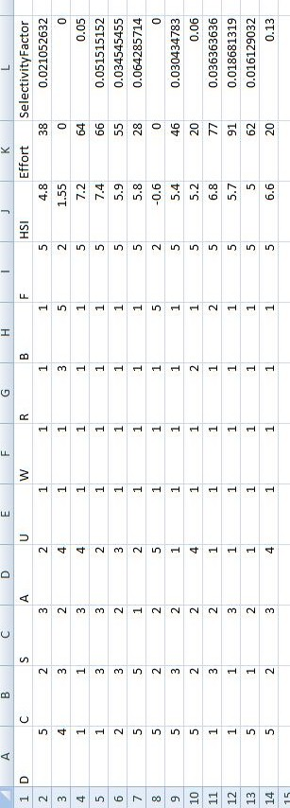
Table 22: Result Mussoorie region

5.4 Result Assessment
The results obtained in the experimental study were demonstrated to the military personnel and Dr. V.K Panchal (Scientist ‘G’) at Defence Research and Development Organization. They expressed satisfaction and verified the correctness of the results based on the manual analysis of the geography of the areas; which is the current methodology employed by them for prediction of enemy’s probable base stations.

Also as in the two experiments the images were taken from different data sources, .i.e., D.R.D.O and Google Earth Image; and the results were equally good for both. This proves that the project has the ability to process versatile set of satellite images and yield results.

6. CONCLUSION AND FUTURE WORK

Currently the project detects the probable base stations of the enemy as well as the most likely base stations and the least likely base stations. Though there is not a clear distinction between these three categories. But there is a fuzzy line which divides these categories. This fuzzy line specifies that a base station belonging to one category could be changed into the base station of other category with certain synthetic improvements and the degree of improvement is represented through the effort calculated in my work. Hence it is important to state base stations belonging to all the categories to give a clear picture of the situation, which is the aim of the project.

There is a lot of scope of improvement in the current work, by refining of the existing SIVs and the addition of some more SIVs.
Addition of new SIVs such as
- Climate / Weather conditions
- State
  - Liquid
    - Water
    - Petrol
  - Solid
    - Land
    - Mountain
  - Vapour
    - Gaseous Extracts
    - Fog / Smog
- Distance from transportation networks as it is of great importance in placement of men, resources and armour to the base station. Transport networks can be identified as:
  - Roads (highways)
  - Water transportation modes (boats, ships)
  - Air transportation modes (air strips supporting landing and flying of aircrafts (various sizes))
  - Railway networks
- Land Mine prone areas

Refinement of present SIVs such as
- Dimension
  - Height
  - Length
  - Breadth
- Habitat
  - Animals
    - Friendly
    - Dangerous
  - Vegetation
    - Edible
    - Poisonous
    - Allergic
- Positional Advantage (Ease of attack).
- Surprise Factor
- Weapon Capability
- Strength or Major Skills
Couple of factors from above such as weapon capability and skills of the enemy are certain things which require human interpretation as it cannot be judged by the satellite images. Also the surprise factor contributes negatively to the comfort factor (HSI) in other words we can say these are inversely proportional to each other.

This would further help in determining additional information aiding in better situation awareness hence that could be of great help in designing of the war / battlefield strategies. This information could be:
- Enemy’s camping areas.
- Our desirable targets, for e.g. enemy’s resource areas, enemy’s connectivity areas etc.
- Desirable routes for the enemy.
- Methodology or way to breach the enemy’s region.

Also we can sample the above SIVs round the year to generate very precise and accurate results. This would also enable us to detect any changes if there are, hence giving us the capability of any kind of movement detection. Thereby enhancing the situation awareness of a place.

7. REFRENCES

- Forest Fire Risk Zone Mapping from Satellite Imagery and GIS a Case Study by Esra Ertena , Vedat Kurgunb , Nebiye Musaoglu.
- Detection of Hidden Hostile/Terrorist Groups in Harsh Territories by Using Animals as Mobile Biological Sensors by Yasar Guneri Sahin and Tuncay Ercan , Sensors 2008, 8, 4365-4383; DOI: 10.3390/s8074365.
- The Generation of Situational Awareness within Autonomous Systems – A Near to Mid Term Study –Issues by Patrick Chisan Hew, Defence Systems Analysis Division Information Sciences Laboratory DSTO-GD-0467, Edinburgh South Australia 5111 Australia.
- Biogeography-Based Optimization by Dan Simon, Senior Member, IEEE, IEEE TRANSACTIONS ON EVOLUTIONARY COMPUTATION, VOL. 12, NO. 6, DECEMBER 2008.
- Psychology Wiki, the text from Wikipedia available under the GNU Free Documentation License.
- Adam, E.C. (1993). Fighter cockpits of the future. Proceedings of 12th DASC, the 1993 IEEE/AIAA Digital Avionics Systems Conference, 318-323.
- Jeannot, E., Kelly, C. and Thompson, D.; (2003). The Development of Situation Awareness Measures in ATM Systems. Brussels: Eurocontrol.
- Endsley, M. R. (1988). Situation awareness global assessment technique (SAGAT). Proceedings of the National Aerospace and Electronics Conference (NAECON). (New York: IEEE), 789-795.
- Endsley, M. R. (1995a) Toward a theory of situation awareness in dynamic systems. Human Factors, 37(1), 32–64.
- Endsley, M. R. (2000). Theoretical underpinnings of situation awareness: A critical review. In M. R. Endsley & D. J. Garland (Eds.), Situation Awareness Analysis And Measurement. Mahwah, NJ: LEA
- Sarter, N. B. & Woods, D. D. (1991). How in the world did I ever get into that mode: Mode error and awareness in supervisory control. Human Factors, 37(1), 5-19.
- Fracker, M. (1991). Measures of Situation Awareness: Review and Future Directions (Rep. No.AL-TR-1991-0128). Wright Patterson Air Force Base, Ohio: Armstrong Laboratories.
- Dominguez, C., Vidulich, M., Vogel, E. & McMillan, G. (1994). Situation Awareness: Papers and Annotated Bibliography. Armstrong Laboratory, Human System Center, ref. AL/CF-TR-1994-0085.
- Smith, K., & Hancock, P. A., (1995). Situation awareness is adaptive, externally directed consciousness. Human Factors, 37, (1), 137-148.
- Watts, B.D. (2004). "Situation awareness" in air-to-air combat and friction. Chapter 9 in Clausewitzian Friction and Future War, McNair Paper no. 68 (revised edition; originally published in 1996 as McNair Paper no. 52). Institute of National Strategic Studies, National Defence University.
- Taylor, R.M. (1989). Situational awareness rating technique (SART): The development of a tool for aircrew systems design. In Proceedings of the AGARD AMP Symposium on Situational Awareness in Aerospace Operations, CP478. Seuilly-sur Seine: NATO AGARD.
- Wikipedia, the free encyclopaedia. In it topic Remote Sensing.
- Canada Center for Remote Sensing, “Fundamentals of Remote sensing”, page numbers 1-164.
- T.M. Lillesand and R.W. kiefer “Remote Sensing & Image Interpretation ”, 3rd edition, 1994.
- Zadeh,L.A.,"Fuzzy sets," Information and Control, vol. 8, no. 3, pp.338- 353, June 1965.
- Long, W., III; Srihann, S, Geoscience and Remote Sensing Symposium, Unsupervised and supervised classifications: Land cover classification of SSC image: unsupervised and supervised classification using ERDAS Imagine, IGARSS '04. Proceedings, Volume 4, 20-24, Sept 2004.
- Beni, G., Wang, J. Swarm Intelligence in Cellular Robotic Systems, Proceed. NATO Advanced Workshop on Robots and Biological Systems, Tuscany, Italy, June 26–30 (1989).
- Wikipedia, the free encyclopaedia. In it topic Swarm Intelligence.
- Marco Dorigo and Mauro Birattari (2007), Scholarpedia, 2(9):1462. doi:10.4249/scholarpedia.1462.
- Ant Colony Optimization by Marco Dorigo and Thomas Stützle, MIT Press, 2004.
- Recent Approaches to Global Optimization Problems Through Particle Swarm Optimization, by Parsopoulos, K.E., Vrahatis, M.N., Natural Computing, 1 (2-3), pp. 235-306, 2002.
- Particle Swarm Optimization by Maurice Clerc, ISTE, ISBN 1-905209-04-5, 2006.
- Hamed Shah-Hosseini, The intelligent water drops algorithm: a nature-inspired swarm-based optimization algorithm, International Journal of Bio-Inspired Computation, Vol. 1, Nos. 1/2, pp. 71-79, 2009.
- A. Wallace, The Geographical Distribution of Animals (Two Volumes). Boston, MA: Adamant Media Corporation, 2005.
- C. Darwin, The Origin of Species. New York: Gramercy, 1995.
- R. MacArthur and E. Wilson, The Theory of Biogeography. Princeton, NJ: Princeton Univ. Press, 1967.
- I. Hanski and M. Gilpin, Metapopulation Biology. New York: Academic, 1997.
- T. Wesche, G. Goertler, and W. Hubert, “Modified habitat suitability index model for brown trout in southeastern Wyoming,” North Amer. J. Fisheries Manage., vol. 7, pp. 232–237, 1987.
- The Art of War, a Chinese military treatise that was written by Sun Tzu in the 6th century BC, during the Spring and Autumn period. Chapter 3.
- The Art of War, a Chinese military treatise that was written by Sun Tzu in the 6th century BC, during the Spring and Autumn period. Chapter 10 and 11.
- A. Hastings and K. Higgins, “Persistence of transients in spatially structured models,” Science, vol. 263, pp. 1133–1136, 1994.
- Pawlak, Z., “Rough Set Theory and its Applications to Data Analysis”,Cybernetics and Systems 29(7): 661-688 (1998).
- Pawlak,Z, Skowron,A.,”Rudiments of rough sets.Inf. Sci.177(1): 3-27(2007).
- A.Colorni, M. Dorigo, and V. Maniezzo, Distributed Optimization by Ant Colonies, In Proceedings of the First European Conference on Artificial Life (ECAL 91), pp. 134-142, 1991.
- D. Bratton and J. Kennedy. Defining a Standard for Particle Swarm Optimization. Proceedings of the 2007 IEEE Swarm Intelligence Symposium.
- Military Psychology, Situation Awareness by Dr. Steve Kass University of West Florida.
- A Cognitive Approach to Situation Awareness: Theory and Application by Simon Banbury and Sebastien Tremblay.
- Google Earth , Mussoorie Image.

Appendix A
CODE for SIV Generation

AspectCalculation.m
orignal=xlsread(xlfile);
final=zeros(size(orignal));
[x,y]=size(orignal);
for i=1:x
for j=1:y
if orignal(i,j)==2
final(i,j)=5;
elseif orignal(i,j)==1 || orignal(i,j)==3
final(i,j)=4;
elseif orignal(i,j)==4
final(i,j)=3;
elseif orignal(i,j)==5
final(i,j)=2;
else
final(i,j)=1;
end
end
end

ContourCalculation.m

orignal=xlsread(xlfile);
[x,y]=size(orignal);
final=zeros(x,y);
cnt=zeros(9);
tmp=zeros(9,9);
for i=2:(x-1)
for j=2:(y-1)
cnt(1)=orignal(i-1,j-1);
cnt(2)=orignal(i-1,j);
cnt(3)=orignal(i-1,j+1);
cnt(4)=orignal(i,j-1);
cnt(5)=orignal(i,j);
cnt(6)=orignal(i,j+1);
cnt(7)=orignal(i+1,j-1);
cnt(8)=orignal(i+1,j);
cnt(9)=orignal(i+1,j+1);
for k=1:9
for l=1:9
if (cnt(l)>=(cnt(k) -2) && cnt(l)<= (cnt(k)+2))
tmp(k,l)=1;
else
tmp(k,l)=0;
end
end
end
max=0;
for k=1:9
cnt(k)=TraverseTell(tmp);
if max<cnt(k)
max=cnt(k);
end
end
if max>=7
final(i,j)=5;
elseif max>=5
final(i,j)=4;
elseif max>=3
final(i,j)=3;
elseif max>1
final(i,j)=2;
else
final(i,j)=1;
end
end
end

TraverseTell.m
nodes=zeros(9);
n1=zeros(9);
n=0;
for i=1:9
n1(i)=0;
for j=1:9
if tmp(i,j)~=0
n1(i)=n1(i)+1;
nodes(j)=1;
end
end
change=1;
while change==1
change=0;
for j=1:9
if nodes(j)==1
for k=1:9
if tmp(j,k)~=0 && nodes(k)~=1
change=1;
nodes(k)=1;
n1(i)=n1(i)+1;
end
end
end
end
end
end

for i=1:9
if n1(i)>n
n=n1(i);
end
end

Generic DegreeCalculation.m

orignal=xlsread(xlfile);
[x,y]=size(orignal);
final=zeros(x,y);
for i=2:(x-1)
for j=2:(y-1)
cnt=0;
if orignal(i,j)==type
final(i,j)=5;
else
if orignal(i-1,j)==type
cnt=cnt+1;
end
if orignal(i+1,j)==type
cnt=cnt+1;
end
if orignal(i-1,j-1)==type
cnt=cnt+1;
end
if orignal(i,j-1)==type
cnt=cnt+1;
end
if orignal(i+1,j-1)==type
cnt=cnt+1;
end
if orignal(i-1,j+1)==type
cnt=cnt+1;
end
if orignal(i,j+1)==type
cnt=cnt+1;
end
if orignal(i+1,j+1)==type
cnt=cnt+1;
end
if cnt>=7
final(i,j)=5;
elseif cnt>=5
final(i,j)=4;
elseif cnt>=3
final(i,j)=3;
elseif cnt>=1
final(i,j)=2;
else
final(i,j)=1;
end
end
end
end

DEMCalculation.m

orignal=xlsread(xlfile);
final=zeros(size(orignal));
[x,y]=size(orignal);
for i=1:x
for j=1:y
if orignal(i,j)<257
final(i,j)=1;
elseif orignal(i,j)<279
final(i,j)=2;
elseif orignal(i,j)<326
final(i,j)=3;
elseif orignal(i,j)<420
final(i,j)=4;
else
final(i,j)=5;
end
end
end

Appendix B
An Introduction to MATLAB
URL: http://mathworks.com/

MATLAB is a high performance language for technical computing. It integrates computation, visualization and programming in an easy-to-use environment where problems and solutions are expresses in familiar mathematical notation. Typical uses include:
1. Math and computation
2. Algorithm, simulation and prototyping
3. Modelling, simulation and prototyping
4. Data analysis, exploration and visualization
5. Scientific and engineering and visualization
6. Application development, including graphical user interface building

MATLAB is an interactive system whose basic data element is an array that does not require dimensioning. This allows you to solve many technical computing problems, especially those with matrix and vector formulations in a fraction of the time it would take to write a program in a scalar non interactive language such as C or FORTRAN.
The name MATLAB stands for Matrix Laboratory. MATLAB was originally written to provide easy access to matrix software developed by the LINPACK and EISPACK projects. Today MATLAB uses software developed by the LAPACK and ARPACK projects, which together represent the state-of-the-art in software for matrix computation.
MATLAB has evolved over a period of years with input from many users. In university environments, it is the standard instructional tool for introductory and advanced courses in mathematics, engineering and science. In industry, MATLAB is the tool of choice for high-productivity research, development and analysis.
MATLAB features a family of application-specific solutions called toolboxes. Very important to most users of MATLAB toolboxes allow you to learn and apply specialized technology. Toolboxes are comprehensive collections of MATLAB functions (M-files) that extend the MATLAB environment to solve particular classes of problems. Areas in which toolboxes are available include signal processing, control system neural networks, fuzzy logic, wavelets, simulation and many others.

FILE TYPES
MATLAB can read and write several types of files. There are mainly five different types of files used in MATLAB which is used for storing data or programs.
• M-FILES- They are the standard ASCII files, with a .m extension to the file name. There are basically two types of files and they are SCRIPT and FUNCTION file. In general, mostly MATLAB files are saved as M-FILES.
• MAT-FILES- They are the binary data-files, with a .mat extension to the filename. These files are created when you save the MATLAB data with the save command. The data which you save in MATLAB can only be read by mat lab as it save in a special format.
• FIG-FILES- They are the binary figure-file, with a .fig extension to the filename. Such files are created by saving a figure in this format by using the save and save as option in it. These files basically create all kind of information which is used for again recreating a figure and can be opened by filename.fig.
• P-FILES- These are the compiled M-File, with a .p extension to the filename. These file can be executed directly without using any compiler and parsed in it. These files are created with the P-CODE command.
• MEX-FILES- These are MATLAB-callable Fortran and C programme, with the .mex extension to the filename. Use of these file require some experience in MATLAB and lot of patience in it.

Appendix C
An Introduction to ERDAS
URL: http://www.ERDAS.com/

ERDAS is one of the vastly used software in earth sciences it key features include IMAGINE Expert Classifier; Direct read and edit of ESRI’s Shapefiles ; Direct read of ESRI’s SDE data; Enhanced and expanded native raster file handling; Re-projection of raster data on-the-fly; Batch processing wizard; Enhanced Viewer functionality; Improved print versatility on Windows NT; International 2-byte font support in Annotation layers; Support for ERDAS IMAGINE .img files larger than 2 GB. Its Viewer has
- Dramatic Vector Performance Boost: A performance boost in creation, load, zoom and pan speed, and smoothness when viewing or editing of vector datasets, in some cases a 10x performance boost, makes ERDAS IMAGINE 9.3 the fastest vector display engine in any IMAGINE product to date.
- New Vector Roam capability: Along with the performance boost in the vector, the ability to roam at high speeds through a vector or vector over raster dataset without flickering or blurring is now possible.
- Dramatic Annotation Performance Boost: A performance boost in creation, load, zoom and pan speed, and smoothness when viewing or editing of annotation datasets, makes ERDAS IMAGINE 9.3 the fastest annotation display engine in any IMAGINE product to date.
- New Annotation Roam capability: Along with the performance boost in the annotation, the ability to roam at high speeds through an annotation or annotated dataset without flickering or blurring is now possible.
- Raster Zoom, Pan and Roam speed and smoothness have been improved, especially when displaying data with transparency.
- Improved raster performance for all systems by optimizing data handling, blocking, and pyramiding.
- Improved image display quality for images without a LUT: Adopted a Percentage LUT of 96.5% as the default display for all imagery without a LUT.
- Improved Relief Display appearance and performance: The display quality of raster elevation data displayed as relief has a much higher display quality (smoother transition between elevation values and using new Percentage LUT default), and responds much faster using the Relief Tool’s Sun-shading with Auto-Apply.
- Improved Relief Display appearance and performance: The display quality of raster elevation data displayed as relief has a much higher display quality (smoother transition between elevation values and using new Percentage LUT default), and responds much faster using the Relief Tool’s Sun-shading with Auto-Apply. Further, the user can now smoothly roam through raster elevation data displayed as relief.
- Much improved performance of Geospatial Services Explorer, in some places up to 10x: Speed and scalability of opening, browsing, and exploiting shared data from WMS, WCS, ERDAS Image Web Server, ERDAS Apollo suite, and ERDAS TITAN improved.
- Improved Dynamic Range Adjustment performance with the introduction of a New Dynamic Range Adjustment Slider on GLT. This is especially useful when using 16-bit data, bringing out the details on shadows and bright areas.
- New Color Temperature and Photo Enhancement tools allow the user to enhance imagery using color temperature, fill light (ambient light), highlights, and shadows, allowing the user to independent adjustment of bright and dark areas.
- New Image Contrast Adjustment tools allow the user to interactively compare various histograms modifications of the image with adjacent views, then apply the desired modification to a LUT or change the image by stretching through the pixels. New Image Convolution tools allow the user to interactively compare various convolution filter modifications of the image with adjacent views, then apply the desired modification to a LUT or change the image by stretching through the pixels. Improved ECW(P) read capability to support faster streaming of ECW data from ERDAS Image Web Server (IWS) into ERDAS IMAGINE 9.3.
- Improved handling of MrSID MG2 and MG3 formats, allowing simultaneous display and exploitation of a large amount of MrSID data.

Appendix D
An Introduction to GeoMedia Professional
URL: http://www.intergraph.com/gis

The first thing you do in GeoMedia Professional is create a GeoWorkspace or open an existing one. After you open a GeoWorkspace, you configure it to suit your needs. You can, for example, change the coordinate-system properties or insert a map or raster image to use as a backdrop for geographic data. Your configuration is saved when you save the GeoWorkspace and restored when you reopen it.

The data you view is stored in warehouses, and you access data by creating connections from the GeoWorkspace to one or more warehouses. The Warehouse Connection Wizard presents a series of dialog boxes that prompt you for the information necessary to create the connection. Because data is not stored in the GeoWorkspace, all workflows require at least one warehouse connection. A warehouse stores both geometric (graphic) and attributes (non graphic) information. For example, a parcel might be represented by area geometry and defined by attribute information such as the owner’s name and the date it was purchased. Once you connect to at least one warehouse, you can display and analyze data from it. The software allows you to view multiple data sets from different warehouses in various formats in a single GeoWorkspace. This means you can perform spatial analyses on data from different sources in different formats using buffer zones, spatial queries, and thematic displays.

In this product, features are contained in feature classes, and the word feature refers to each instance of a feature within a feature class. Feature classes, images, query results, and thematic displays in the map window are collectively referred to as either features or map objects.

Features are represented in the map window by geometry and in the data window by attributes. You can display any number of map and data windows simultaneously or separately. They are linked so that changes made in one window are automatically reflected in the other. You display features in a map window by adding entries to the legend.
The legend is the control centre for the map window. Through the legend, you populate the contents of the map window and control the display characteristics of the features, including their style and display priority.

You can also perform tasks, such as capturing new data, performing maintenance on existing data, and inserting images or buffer zones. Furthermore, you can view data written to a read/write warehouse along with other data sets in a single GeoWorkspace. Results of your analyses can be customized in the map window, printed, and saved for future use, all without altering the original data.

