AUTOMATIC GENERATION CONTROL OF
INTER-CONNECTED POWER SYSTEM

A dissertation submitted
in partial fulfillment
for the award of the degree of

MASTER OF ENGINEERING

in

POWER APPARATUS & SYSTEM

Submitted By

Ms. NIDHI JAIN

(University Roll No: 9092)

Under the guidance of

Dr. NARENDRA KUMAR
(Professor, Electrical Department)



DELHI COLLEGE OF ENGG. AND TECHNOLOGY
BAWANA ROAD, NEW DELHI
JUNE’06
CERTIFICATE

It is certified that the project entitled “Automatic Generation Control of Inter-connected Power System” being submitted by Ms. Nidhi Jain, M.E. in Power Apparatus System, Delhi College of Engg, is a record of original bonafide work carried out by her under my guidance and supervision. The results in this project have not been submitted in part or full to any other university or institute for award of any degree or diploma.

Dr. Narendra Kumar
Professor,
Electrical Department,
Delhi College of Engineering Bawana Road, New Delhi
ACKNOWLEDGEMENT

It gives me immense pleasure in expressing my deep sense of gratitude, indebtness and thankfulness to Dr. Narnedra Kumar for his invaluable guidance, continual encouragement and support at every stage of this work. I am also thankful to Dr.Pramod Kumar, Head of Electrical Department for the encouragement given through out the execution of this project.
It is acknowledge here that the present work has been carried under A.I.C.T.E, R & D project on FACTS (PI.Dr.Narendra Kumar).
I would also like to express my sincere thanks to Mr.Bhaumik (Lecturer, Electrical Deptt.)

Finally I acknowledge my deep gratitude to my loving family, who always gave moral support and continuously encourage my academic endeavor, who always comfort and console, never complain or interfere, ask nothing and endure all.

Ms. Nidhi Jain
(Lecturer)
Guru PremSukh Memorial College of Engg and Technology,
Under I.P. university, Delhi

ABSTRACT

Load frequency Control (LFC) is used for many years as part of Automatic Generation Control (AGC) in power system around the world. In a mixed power system, it is usual to find an area regulated by thermal generation or gas generation or in combination of both .A detailed literature search shows that there is a great need to improve the control strategy to achieve good performance of the mixed system in the transient mode.

This Project report highlights the Control performance analysis of three area-interconnected system. It has been done by the use of integral controller and optimal control design. The three area-interconnected systems is simulated and studied through Matlab’s Simulink software. In the following study, performance of AGC for Thermal, hydro and gas turbine based power system is examined on the application of Integral Controller & Optimal Controller.

CONTENTS

LITERATURE REVIEW 6
1. INTRODUCTION 11
Automatic Generation Control 11
2. LOAD FREQUENCY CONTROL (SINGLE AREA CASE) 14
Governor – Turbine Control 15
Thermal Turbine Model 19
Hydraulic Turbine 21
Gas Turbine 26
3. Three Area Inter Connected Power System 31
Interconnected Power System: 31
Three Area System 32
Integral Controlled LFC 38
Analysis of Integral Controller 40
Linear Optimal Control 42
Analysis of Optimal Control 45
4. SIMULATION AND STUDIES OF THREE AREA INTERCONNECTED MODELS 50
Thermal – Thermal – Thermal three-area power system. 50
Thermal – Hydro – Thermal three-area power system. 58
Thermal – Hydro – Gas three area power system. 66
5. OPTIMAL CONTROL DESIGN 75
Optimal design of thermal-thermal-thermal power system 75
Optimal design of thermal-hydro-thermal power system 77
6. CONCLUSION 81
REFERENCES 83
APPENDIX A 86
LIST OF SYMBOLS 86

LITERATURE REVIEW

The analysis and design of Automatic Generation Control (AGC) system of individual generator eventually controlling large interconnections between different control areas plays a vital role in automation of power system. The purposes of AGC are to maintain system frequency very close to a specified nominal value, to maintain generation of individual units at the most economic value, to keep the correct value of tie-line power between different control areas. If the load is increased, AGC system increases the mechanical torque by increasing the system flow rate to turbine to compensate the load by increasing the generators output in an area. This process must be repeated constantly on a power system because the loads change constantly.

By changing the generation level, AGC system maintains the frequency constant in power system. Today’s power system consists of control areas with many generating units with outputs that must be set according to economics.

The sensitivity of any power plant depends upon the response time taken by the automatic generation controller to control the frequency change due to load variation of governor control.

In the present work, three control areas are considered having one turbine generator model. Each area is connected by two tie lines with other two areas. The power flow over the transmission line will appear as summation of tie-line powers of two connected areas. The direction of flow will be dictated by the relative phase angle between the areas, which is determined by the relative speed deviations in the areas.
It is quite important to analyze the steady state frequency deviation, tie flow deviation and generator outputs for an interconnected area after a load change occurs. Such a control scheme would, of necessity, have to be recognized, if frequency decreases and net interchange power leaving the system increases or a load increase occurs outside the system.
For so many years, the problem of automatic generation control has been one of the most accentuated topics in the operation of autonomous and interconnected systems.
C.D. Vournas, E.N. Dialynas [4] in 1989 developed and AGC algorithm developed for the supervisory control and data acquisition (SCADA) of the Hellenic interconnected system.
M Cohn [5] in 1996 has got the solution of AGC problem and its first practical application is to decentralized control of large-scale dynamic systems.
Works reported in literature on AGC pertains to two-areas thermal-thermal or hydro-hydro or combination of these two but there is no or very little work on AGC for multi-generation thermal –hydro-gas system. In a mixed power system, it is usual to find an area regulated by hydro generation interconnected to another area regulated by hydro generation interconnected to another area regulated by thermal generation or in gas generation or in combination of both. The hydro power system differ from electric power system, in that the relatively large inertia of water used as a source of energy causes a considerably greater time lag in response to changes of the prime mover torque, due to changes in gate position. In addition the response may contain oscillating components caused by compressibility of the water or by surge tanks while gas turbine have relatively low inertia compared to hydraulic units. They generally spin at higher speed and generator is of round rotor type. Following a sudden load rejection event, a low inertia machine can experience excessive over-speed, which can be harmful if over speed protection fails to operate. For such systems of widely different characteristics no work has been done to study automatic generation controllers.
In the present work
1 Integral controller is used to restore the frequency to its nominal value and their dynamic responses are compared for various rating of thermal based generation. Controller minimizes the change in frequency in all the three area and the tie-line power change. Change in tie line power should also be minimized because if there is any load change in any area, then the extra power required can be get from other area but for this tie line should be capable of transmitting this extra power but as the agreement done by the systems tie-line has a pre specified capacity, so the control action should take place in area where the change has occurred to keep the change in tie-line power minimum.
2 Designing an optimal controller for an interconnected system through optimal control strategy using the Forsha-Elgerd approach and hence to study the dynamic responses for small perturbation in any one of the area.
Chapter 1 gives an introduction of automatic generation control

In chapter 2 mathematical models of turbine governor of thermal, hydro and gas based system is given which are further used in Power System modeling.
In chapter 3 the interconnected power system models are developed. Review of continuous controller is given in this chapter.
In chapter 4 the simulation is done for various combination of three-area power system and their dynamic response are studied. Various combinations of thermal, hydro, and gas based control area with different combinations of ratings have been considered. Each combination is analyzed in terms of their transient response as uncontrolled and controlled continuous model.
In chapter 5 optimal control design of the three inter connected system has done. Also there dynamic responses has been then studied
In chapter 6 final conclusions are derived from this work and a direction is given to further proceed in this work.

INTRODUCTION

1. INTRODUCTION

Automatic Generation Control

Automatic Generation Control (AGC) is defined by IEEE [9] as the regulation of the power output of electric generators within a prescribed are in response to changes in system frequency, tie-line loading or the regulation of these to each other, so as to maintain the scheduled system frequency or the established interchange with other areas within predetermined limits. AGC has evolved rapidly from the time when the function was performed manually, through the days of analog systems to the present application of sophisticated direct digital control systems. The AGC problem has been extensively studied during the last four decades. Most of the work concentrates on the net interchange tie-line bias control strategy making use of the area control error (ACE). The existence of ACE means that there is excess or deficient of spinning stored energy in an area and a correction to stored energy is required to restore the system frequency to scheduled value.
Many authors have reported the early work on AGC. Cohn [5] has extensively studied the static aspect of the net interchange tie line bias control strategy. On the static analysis basis Cohn has inferred that, for the minimum interaction between control areas, the frequency bias setting of a control area should be matched to the combined generation and load frequency response of the areas. However, no analysis has been made regarding deciding the magnitude of gain settings for the supplementary controllers.
Work reported in literature on AGC pertains to either two-area thermal-thermal or hydro-hydro or combination of these two but there is no or very little work on AGC for multi generation thermal system ,hydro system and gas system. In a mixed power system, it is usual to find an area regulated by hydro generation or gas generation or in combination of both.
In the present work ,Integral controller and Optimal control design are used to restore the frequency to its nominal value and their dynamic responses are compared for system consisting of thermal, hydro and gas based generation.

LOAD FREQUENCY CONTROL (SINGLE AREA CASE)

2. LOAD FREQUENCY CONTROL (SINGLE AREA CASE)

The most common power system control objectives are regulation, optimization and stabilization. The power system control analysis depends on simulation of system dynamic behavior. Simulation implies the existence of mathematical models for specific power systems. The mathematical model generally includes the components of the power system that influence the electrical and mathematical powers of the machines. Automatic Generation Control (AGC) was developed to both maintain a (nearly) constant frequency and to regulate tie line flows. This is done through the Load-Frequency Control (LFC). Load Frequency Control in electric power system represents the first realization of a higher-level control system. It has made the operation of interconnected systems possible and today it is still the basis of any advanced concept for guidance of large systems. A peculiarity of LFC lies in the fact that each partner in the interconnection has equal rights and possibilities being limited only by the installed power in the area and the capability of the tie-lines: thus it is not a centralized control system when total interconnection is considered.
Before moving into the interconnection system let’s first consider the single area network. To understand the model we should know the turbine speed governing system as frequency changes depend on speed.

Governor – Turbine Control

The prime sources of electrical energy supplied by utilities are the kinetic energy of water and thermal energy derived from fossil fuels. The prime movers convert these sources of energy into mechanical energy that is, in turn, converted to electrical energy by synchronous generators. The prime mover governing systems provide a means of controlling power and frequency, a function commonly referred to as load frequency control.
In a steam turbine the stored energy of high temperature and high-pressure stearn is converted into mechanical (rotating) energy, which then is converted into electrical energy in the generator. The original source of heat can be a furnace fired by fossil fuel (coal gas, or oil) or biomass, or it can be a nuclear reactor. It is the task of the turbine governor to control the control valve such that the generator in question produces the desired power. The turbine governor and the dynamic properties of the turbine determine the power produced by a generator.
To make more realistic studies, appropriate mathematical models of steam turbines [6,10,11] e.g. reheat, non-reheat steam turbines, hydro turbines [11,20,21,26] and gas turbine [15,16] are to be considered for the dynamic simulation of the system behavior. The important component for controlling the speed of the turbine is the governor. Governor for each system differs from other. Transfer function models for these turbine governors of references are used for the studies undertaken in this report.
This section gives an overview of the modeling of turbines based. Figure2.1 below shows a block diagram how these turbine models that are used in study in the system models.

Tie line power
Electrical system
- Loads
- Transmission lines
- Other generators
AGC
Generators
Turbine
Valves or gates
Speed governor
Speed changer
Energy supply system
Steam or water
Turbine controls

Frequency

Speed

Other signals

Fig. 2.1 Functional block diagram of power generation and control system

Speed Governing System:

As shown in Figure2.2 below, the steady state condition is considered assuming the linkage mechanism (ABC& CDE) to be stationary, pilot valve closed. Stearn valve open by a definite magnitude, the turbine output balances the generator output and the turbine of generator running at a particular speed when the frequency of the system is f°, the generator output P_{G0} and let stearn valve setting is X_{E}°
At the operating point, let the point A of the speed changer lower down by an amount ΔX_{A} as a result the commanded increase in power is ΔP_{C}, then ΔX_{A} = K1ΔP_{C.}
The movement of linkage point A causes small position changes ΔX_{C} and ΔX_{D}. With the movement of D upwards by ΔX_{D} high pressure oil moves into the hydraulic amplifier from top of the main piston and the stearn valve will move downwards a small distance ΔX_{E}, which results in increased turbine torque and hence power increase ΔP_{G} and increased speed and hence the frequency of generation. The increase in frequency Δf causes the link point B to move downwards by ΔX_{B}.
The movements are assumed positive if the points move downwards. Two factors contribute to the movement of C:
- Increase in frequency cause B to move by ΔX_{B} when the frequency changes by Δf, then the flyball moves outward and point B is lowered by ΔX_{B,} so the contribution is positive.
- The lowering of the speed changer by an amount ΔX_{A} lifts the point C upwards by an amount proportional to ΔX_{A.}
∴ ΔX_{C} = K₁ Δf – K₂ ΔP_{C} ………………..(1)

K₁ and K₂ are two positive constants, which depend upon the length of the linkage arms AB and BC. The movement of D is contributed by the movements of C and E. Since C and E moves downward when D moves upwards, therefore
∴ ΔX_{D} = K₃ X_{C} + K₄ X_{E} ………………..(2)
The positive constants K₃ and K₄ depend upon the length of linkage CD and DE. Assuming the oil flow into the hydraulic cylinder is proportional to position ΔX_{D} of the piston valve,
So, ΔX_{E} = K₅ ∫-ΔX_{D} ………………..(3)
K₃ depends upon the fluid pressure and the geometries of the orifice and the cylinder.
Taking laplace transform of equ. (1), (2) & (3), we get
ΔX_{C}(s) = K₁ ΔF(s) – K₂ ΔP_{C}(s) ………………..(4)
ΔX_{D}(s) = K₃ X_{C}(s) + K₄ X_{E}(s) ………………..(5)
ΔX_{E}(s) = -K₅ / s ΔX_{D}(s) ………………..(6)

So, ΔX_{E}(s) = (K_{G} / (1 + sT_{G})) (ΔP_{C}(s) - ΔF(s)/R) ………………..(7)

where,

R = K₂ / K₁ = speed regulation due to governing action.
K_{G} = K₂K₃ / K₄ = gain of speed governor
T_{G} = 1/ K₄K₅ = time constant of speed governor

The block diagram representation of the above transfer function is shown below.

ΔPc(s) ΔXe(s)
∑
K_{G}/(1+sT_{G})

+

-

1/R
ΔF(s)

Thermal Turbine Model

A non-reheat turbine with a single factor K_{T} and a single time constant T_{T} is considered; T_{T} = turbine time constant.
So, G_{T}(s) = K_{T} / (1+ sT_{T})……………………………………………………………8

This turbine transfer function is then incorporated with governor transfer function to form a closed loop system representation that is shown in figure below

ΔPc(s) ΔXe(s)
∑
K_{G}/(1+sT_{G})
K_{T}/(1+sT_{T})
ΔP_{G}(s)
+

-

1/R
ΔF(s)

Fig.2.3 Turbine Model Block Diagram

Generator load model

Let ΔP_{D} be the change in load, as a result the generation also swings by an amount ΔP_{G.} The net power surplus at the busbar is ΔP_{G} - ΔP_{D} and this power will be absorbed by the system in two ways.
- By increasing the kinetic energy (W) of the generator rotor at a rate dW / dt. w° be the kinetic energy initially and f° is the frequency. So, new KE
w = w° ((f° + Δf°) / f°)² = w° ( 1 + (2 * (Δf)/f°))………………………(9)
so, dw/dt = (2*w° / f° ) d(ΔF)/dt…………………………………(10)

- The load on the motors increase with increase in speed. The rate of change of load with respect to frequency can be regarded as nearly constant for small changes in frequency i.e. D = ∂P_{D} / ∂f. Net power surplus;
ΔF(s) = [ΔP_{G}(s) - ΔP_{Df}(s)] K_{p} / ( 1 + s T_{p})………………………………(11)
where,
T_{p} = (2*H / D* f°) = power system time constant …………………..(12)
K_{p} = 1/D = power system gain
The complete model consisting of governor turbine transfer function with speed droop representation and forming a closed loop system is as shown below

ΔP_{L}(s)

ΔPc(s) ΔXe(s)
∑
∑
K_{G}/(1+sT_{G})
K_{T}/(1+sT_{T})
ΔP_{G}(s)
+

-

K_{T}/(1+sT_{T})

1/R
ΔF(s)

Fig.2.4 Isolated Power System LFC Block Diagram

Hydraulic Turbine

The representation of hydraulic turbine and water column in load frequency control study is based on the following assumptions:

- The hydraulic resistance is negligible
- The penstock pipe is inelastic and water is incompressible.
- The velocity of water varies directly with the gate opening and with the square root of the net head.
- Turbine output power is proportional to the product of head and volume flow.

The essential elements of the hydraulic plant which are used in deriving turbine transfer function are depicted in Fig
The turbine and penstock characteristics are determined by three basic equations relating to the following:
- Velocity of water in penstock.
- Turbine mechanical power
- Acceleration of water column.

The velocity of the water in the penstock is given by
$U=K_{U}G\sqrt{H}$ (13)
where
U =water
G = Gate position
K_{U} = a constant of proportionality.

For small displacement about an operating point
$Δ\text{+=}\frac{∂U}{∂H}ΔH+\frac{∂U}{∂G}ΔG$ (14)

Substituting appropriate expressions and dividing through by U₀ yields.

$\frac{ΔU}{U_{o}}=\frac{ΔH}{2H_{o}}+\frac{ΔG}{G_{0}}$ (15)

Or $Δ\bar{U}=\frac{ΔH}{2_{o}}+Δ\bar{G}$ (16)

Where, subscript o donates initial steady state values, the prefix $Δ$denotes small deviations and the super bar--- indicates normalized values based on steady state operating values.

The turbine mechanical power is proportional to the production of pressure and flow; hence,
$P_{m}=K_{P}\text{HU}$ (17)
Linearizing by considering small displacements, and normalizing by dividing both sides by $P_{\text{mo}}$, we have

$\frac{{ΔP}_{m}}{P_{\text{mo}}}=\frac{ΔH}{H_{o}}+\frac{ΔU}{U_{0}}$ (18)

Or ${\bar{P}}_{m}=Δ\bar{H}+Δ\bar{U}$ (19)
Substituting for $Δ\bar{U}$yields

${\bar{P}}_{m}=1\text{.}5∗Δ\bar{H}+Δ\bar{G}$ (20)

or Substituting for $ΔH$yields

${\bar{P}}_{m}=3∗Δ\bar{U}−2∗Δ\bar{G}$ (21)
The acceleration of water column due to change in head at the turbine, characterized by Newton’s second law of motion, may be expressed as

$(\text{pLA}\frac{dΔU}{\text{dt}}=−A({\text{pa}}_{g})ΔH$

L =Length of conduit
A =Pipe area
P = Mass density
Ag=acceleration due to gravity
pLA = mass of water in conduit
${\text{pa}}_{g}ΔH$=Incremental change in pressure at turbine gate
t = time in seconds
by dividing both sides by ${\text{Apa}}_{g}H_{o}U_{o}$, acceleration equation in normalized form

$\frac{T_{W}dΔ\bar{U}}{\text{dt}}=−Δ\bar{H}$ (22)

Where, $T_{W}\frac{{\text{LU}}_{0}}{a_{g}H_{o}}$ water starting time (23)

from equation 16 and 23, we can express the relationship between change in velocity and change in gate position as

$T_{W}\frac{dΔ\bar{U}}{\text{dt}}=2∗(Δ\bar{G}−Δ\bar{U})$ (24)
Or $T_{W}\frac{sΔU}{\text{dt}}=2∗(Δ\bar{G}−Δ\bar{U})$ (25)

$Δ\bar{U}=\frac{Δ\bar{G}}{1+0\text{.}5T_{w}s}$ (26)

or ${ΔP}_{m}=\frac{1−T_{w}s}{1+0\text{.}5T_{w}s}$ (transfer function of hydraulic turbine) (27)

The approximate transfer function [20] for the mechanical –hydraulic governor is considered for the analysis and is given by:

$Δ\bar{U}=\frac{{ΔX}_{\text{EK}}(S)}{\frac{−1{ΔF}_{K}(S)}{R_{K}}}=\frac{(1+{\text{sT}}_{\text{RK}})}{(1+{\text{sT}}_{1K})(1+{\text{sT}}_{2K})}$ (28)

The time constants $T_{1K}$and $T_{2K}$occurring in the denominator are given by

$T_{1K}=\frac{T_{\text{gK}}+T_{\text{RK}}(σ_{K}+δ_{K})}{σ_{K}}$ (29)
$T_{2K}=\frac{T_{\text{RK}}∗T_{\text{RK}}}{T_{\text{RK}}+T_{\text{RK}}(σ_{K}+δ_{K})}$ (30)

Where $T_{\text{RK}}$= 5-25 sec, dashpot time constant
$σ_{K}$ = 0.03- 0.06 pu, permanent speed drop
$δ_{K}$ = 0.2 – 1 pu, temporary speed droop
$Talignl{\begin{aligned}\text{gK}\end{aligned}}_{}$= 0.2-0.4 sec, governor time constant

ΔP_{D}(s)
ΔPc(s) ΔXe(s)
∑
∑
(1+sT_{rk})
(1+St_{1k}) (1+sT_{2k})
(1-sT_{w})
(1+0.5sT_{w})
ΔP_{G}(s)
+

-

K_{T}/(1+sT_{T})

1/R
ΔF(s)

Fig.2.5 Isolated Hydro Power System LFC Block Diagram

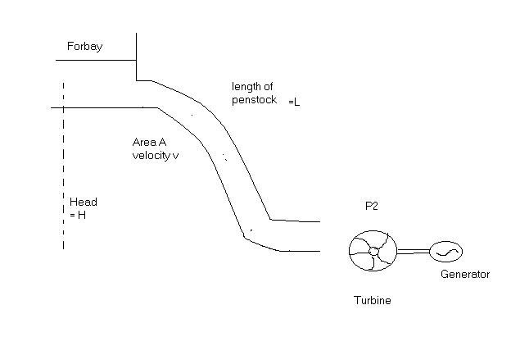
Fig.2.6 Schematic of hydro electric plant

Gas Turbine

A gas turbine cycle consists (1) compression of a gas (typically air), (2) addition of heat energy into the compressed gas by either directly firing or combusting the fuel in the compressed air or transferring the heat through a heat exchanger into the compressed gas followed by (3) expansion of the pressurized gases in a turbine to produce useful work. The turbine with the remaining being available for useful work supplies the work required by the compression. The useful work developed by the turbine may be used directly as mechanical energy or may be converted into electricity by turning a generator.

There exist several dynamic models of turbine – governors with varying degrees of complexity to represent different makes and models of gas turbine units.
There are essentially two types of gas turbine designs. One is a high-speed single shaft design with the compressor and turbine mounted on the same shaft as the alternator. Another is a split shaft design that uses a power turbine connected via a gearbox. In the split shaft design as shown in Fig., although there are two turbine, one is gasifier turbine driving a compressor and another is a free power turbine driving a generator, there is only are computer and one gasifier.

Considering our interest in slow dynamic performance of the system, we used following assumptions while selecting the desired model:
- System operation is under normal operating conditions. Start-up, shutdown, fast dynamics are not included. Since gas turbine units have relatively low inertia compared to hydraulic units. Following a sudden load rejection event, a low inertia machine can experience excessive over-speed, which can be harmful if over speed protections fails to operate and it introduces non-linearity in frequency versus time characteristics.
- The turbine’s electro-mechanical behavior is our main interest. The recuperator is not included in the model as it is only a heat exchanger to raise engine efficiency. Also, due to the recuperator’s very slow response, it has little influence on the time scale of our dynamic simulations.
- The gas turbine’s temperature control and acceleration control are of no significance under normal system conditions. The reason for this is that during start up, the unit is not online, and in temperature control mode, the governor will not respond to system frequency changes.
- The governor is a control system implementing three loops: startup and temperature. A low value select block is used to determine which control loop is asking for the minimum fuel. The control is then given priority and drives the fuel valve actuator to control the combustor output.

The GAST model (based on split shaft) as shown in Fig 2.8 has been selected for simulation studies for representing the dynamic behavior of gas powered turbine governor systems. This model was developed by GE company of USA. The model is simple and follows typical modeling guidelines.
The model structure has been selected from model of reference [15,16] for simulation studies. Parameters values are in accordance with WSCC testing programs for gas turbine unit [15]. Figure shows three-control loop involving fuel control, temperature control loop and speed feedback loop. A Low Value Select block is used to determine which control loop is asking for minimum fuel. This control is then given priority and drives the fuel value actuator to control the combustor output. Gas turbine units have relatively low inertia compared to hydraulic units. They generally spin at higher speeds and the generators are of round rotor type. Following a sudden load rejection event, a low inertia machine can experience excessive over-speed, which can be harmful if over speed protection fails to operator. If over speed, which can be harmful if over speed protection fails to operate. If over speed protection does operate to arrest the speed, if will introduce non-linearity in the frequency versus time characteristics. Therefore, the amount of load rejected should be low to limit over-speed and therefore the possible impact of non-linearity. The maximum opening by the governor must permit short time load of at least 104%. The load level 100% describes the situation that the unit is running on maximum load setting and 50 HZ. Model parameters as referred in figure: R= Governor Droop, T₁= Fuel system lag constant1, T₂= Fuel system lag constant2, T₃= Load limiter time constant, L_{max} = Load limit, K_{T}=Temperature control loop gain, V_{max} & V_{min}= Maximim and minimum value position.

1/R

vmax
ΔPc(s) low value gate ΔXe(s)
∑
ΔP_{G}(s)
∑
1
(1+St₁)
1
(1+St₁₂)
+
K_{T}/(1+sT_{T})

-

vmin ΔP_{L}(s

∑
∑
K_{T} 1/R
1
(1+St₃)
ΔF(s)

load limiter

Fig.2.7 Gas model to represent dynamic behavior of gas governor turbine in LFC Block Diagram

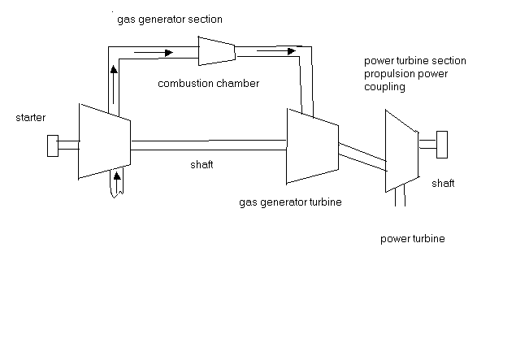
Fig2.8. Gas Turbine Model

THREE AREA INTERCONNECTED POWER SYSTEM

3. Three Area Inter Connected Power System

Interconnected Power System:

From a practical point of view, the problems of frequency control of interconnected areas, or power pools are more important than those of isolated areas. Practically, all power systems today are tied together with neighbor areas, and the problem of load frequency control becomes a joint undertaking.
Many advantages can be derived from pool operation, and they can all be summarized in two words, mutual assistance. Basic principal for pool operation are as follows:
- Under normal operating conditions each pool member or control area should strive to carry its own load, except such scheduled portions of the other member’s load as have been mutually agreed upon.
- Each control area must agree upon adopting regulating and control strategies and equipment that are mutually beneficial under both normal and abnormal situations.
A sudden load loss (around 30%) in a small system (e.g. 1000 MW), which is operating alone, will be lead to extensive frequency drop resulting in complete blackout. If the same system were part of pool (eg. 100,000 MW), the same 300MW load failure would represent only 0.3 percent loss. The frequency would be “saved”, and support power would instantaneously flow into crippled area via tie lines to carry its load until normal generation is restored.
System sizes reduce the need for reserve power among the pool members. “Spinning” reserves can be called upon for instantaneous assistance. They are made up of fully operating but only partially loaded units. Hydroelectric and gas turbine operated units can be called upon at a few minutes notice while steam reserve may take longer time.

Three Area System

ΔP_{tie23}
ΔP_{tie13}
ΔP_{tie12}
Area2
Area1
Area3

Ring Type connected three-area system

We have considered three areas interconnected in ring topology as shown in Fig. with tie-lines and the frequency deviations in these areas can be represented by variables Δf1, Δf2 and Δf3 respectively.
For normal operation the power on the tie-line is
P₁₂ = ((V₁V₂) / X) sin (δ₁ - δ₂) (31)
where
δ₁ and δ₂ are angles of end voltages V₁ and V₂ respectively.
For small deviations in the angles δ₁ and δ_{2,} the tie-line power changes with the amount
ΔP₁₂ = ((V₁V₂) / X ) cos(δ₁ - δ₂) (Δδ₁ - Δδ₂) MW (32)
The tie-line power deviation takes on the form
ΔP₁₂ = T(Δδ₁ - Δδ₂) MW
where
Δδ = 2 *Π ∫ΔFdt rad
By expressing tie-line power deviations in terms of Δf rather than Δδ, we get
ΔP₁₂ = 2 Π T(Δf₁(s) - Δf₂(s)) MW
Equation is represented as block diagram in given fig
ΔP_{tie}
+Δf₂
+Δf₁
∑
2 Π T
1/s

Linear representation of Tie-Line
Interconnected Three Area Model Equations

Fig 1 shows the block diagram representation of interconnected power system consisting of three-control area without any controller implementation. Each control area is represented as consisting of a governor, turbine and generator block. Each control area is being fed a feedback in the form of speed droop. Respective tie-line powers are denoted using synchronizing coefficients. Interconnected model is represented in standard state space form using state equations.
Frequency equation for power system 1

$\frac{K_{p}}{T_{P1}}\left[{ΔP}_{\text{GI}}−{ΔP}_{L!}−{ΔP}_{\text{tie}\text{13}}\right]\frac{{ΔF}_{1}}{T_{P1}}=\frac{{dΔF}_{1}}{\text{dt}}$ (33)

The Turbine-Generator equation for area 1

$\frac{{dΔP}_{G1}}{\text{dt}}=\frac{Δ{\text{XF}}_{E1}}{T_{1}}−\frac{{ΔP}_{G!}}{T1}$ (34)

Governor equation for area 1

$\frac{{dΔX}_{E1}}{\text{dt}}=\frac{{ΔP}_{C1}}{T_{G1}}−\frac{{ΔF}_{1}}{R_{1}T_{G1}}−\frac{{ΔX}_{E1}}{T_{G1}}$ (35)

Frequency equation for power system 2

$\frac{K_{p}}{T_{P2}}\left[{ΔP}_{G2}−{ΔP}_{L2}−α_{\text{12}}{ΔP}_{\text{tie}\text{12}}−{ΔP}_{\text{tie}\text{23}}\right]\frac{{ΔF}_{2}}{T_{P2}}=\frac{{dΔF}_{2}}{\text{dt}}$ (36)

The turbine-Generator equation for area 2

$\frac{{dΔP}_{G2}}{\text{dt}}=\frac{{ΔX}_{E2}}{T_{2}}−\frac{{ΔP}_{G2}}{T_{2}}$ (37)

Governor equation for area 2

$\frac{{dΔX}_{E2}}{\text{dt}}=\frac{{ΔP}_{C2}}{T_{G2}}−\frac{{ΔF}_{2}}{R_{2}T_{G2}}−\frac{{ΔX}_{E2}}{T_{G2}}$ (38)
Frequency equation for power system 3

$\frac{K_{p}}{T_{P3}}\left[{ΔP}_{G3}−{ΔP}_{L3}−α_{\text{23}}{ΔP}_{\text{tie}\text{23}}−α_{\text{13}}{ΔP}_{\text{tie}\text{13}}\right]\frac{{ΔF}_{3}}{T_{P3}}=\frac{{dΔF}_{3}}{\text{dt}}$ (39)

The Turbine – Generator equation for area 3

$\frac{{dΔP}_{G3}}{\text{dt}}=\frac{{ΔX}_{E3}}{T_{3}}−\frac{{ΔP}_{G3}}{T_{3}}$ (40)

Governor equation area 3

$\frac{{dΔX}_{E3}}{\text{dt}}=\frac{{ΔP}_{C3}}{T_{G3}}−\frac{{ΔF}_{3}}{R_{3}T_{G3}}−\frac{{ΔX}_{E3}}{T_{G3}}$ (41)

Tieline power equation

$\frac{{\text{dP}}_{\text{tie}\text{12}}}{\text{dt}}=\left[2{πT}_{\text{12}}F_{1}−2{πT}_{\text{12}}F_{2}\right]$ (42)

Tieline power equation

$\frac{{\text{dP}}_{\text{tie}\text{23}}}{\text{dt}}=\left[2{πT}_{\text{23}}F_{2}−2{πT}_{\text{23}}F_{3}\right]$ (43)

Tieline power equation

$\frac{{\text{dP}}_{\text{tie}3}}{\text{dt}}=\left[2{πT}_{\text{13}}F_{1}−2{πT}_{\text{13}}F_{3}\right]$ (44)

State Space Representation

Area State Vector

$$X_{i}(t)=[f_{1}(t)P_{\text{Gi}}(t)X_{i}(t)P_{\text{tiei}(t)}]$$

where
I = 1, 2, 3…N
Combining above given equations, we get following equation [2].

${\text{dX}}_{i}(t)/{\text{dt}}=A_{\text{ii}}X_{i}(t)+\sum{A_{\text{ij}}X_{j}(t)+B_{i}}U_{i}(t)+L_{i}W_{i}(t)$ (45)
$\begin{aligned}j=1 \\ j≠i\end{aligned}$

where x(t) is area state vector, u(t) is input vector w(t) is disturbance vector. Here A is referred as state matrix. B as input distribution matrix and L as the disturbance matrix.

$$\begin{aligned}\text{Aii}\begin{aligned}\left|{−1}/{T_{\text{pi}}}{K_{\text{Pi}}}/{T_{\text{Pi}}}0−{K_{\text{Pi}}}/{T_{\text{Pi}}} | \right|\left| 0−1/{T_{\text{Pi}}}1/{T_{\text{Pi}}} 0 | \right|\left|{−1}/{R_{i}}T_{\text{Gi}}00 0 | \right| \\ \end{aligned} \\ \end{aligned}$$

$$\begin{aligned}\text{Aii}\begin{aligned}\left|0000 | \right|\left|0000 | \right|\left|0000 | \right| \\ \end{aligned} \\ \end{aligned}$$

$$\begin{aligned}B_{i}=[{001}/{T_{\text{gi}}}0]^{T} \\ L_{i}=[−{K_{\text{Pi}}}/{T_{\text{Pi}}}000]^{T} \\ \end{aligned}$$
ACE as output $Y_{i}(t)+\text{Bu}(t)+\text{Lw}(t)$

Finally we get state equation for three area system by putting N=3 as

$\text{DX}(t)/{\text{dt}}=\text{AX}(t)+\text{Bu}(t)+\text{Lw}(t)$ (46)

And output equation is:

$Y_{i}(t)=C_{i}X_{i}(t)$ (47)

Steady State Performance Study for three area System

Under steady state conditions:

- d / dt = 0
- Tie –line have same frequency i.e.; ${Δf}_{1\text{stat}\text{.}}={Δf}_{2\text{stat}\text{.}}={Δf}_{3\text{stat}\text{.}}={Δf}_{\text{stat}\text{.}}$
- $${ΔP}_{G1\text{state}}=\frac{−{ΔF}_{1}}{R_{1}}{ΔP}_{G2\text{stat}}=\frac{−{ΔF}_{2}}{R_{2}}{ΔP}_{G3\text{state}}=\frac{−{ΔF}_{3}}{R_{3}}$$

Using equ. No. 33, 36, 39 and putting above assumptions in them and further solving the equations, we get:
$−β_{1}{ΔF}_{\text{stat}}={ΔP}_{L1}+{ΔP}_{\text{tie}\text{12}}+{ΔP}_{\text{tie}\text{13}}$ (48)

$−β_{2}{ΔF}_{\text{stat}}={ΔP}_{L2}+{ΔP}_{\text{tie}\text{23}}−{ΔP}_{\text{tie}\text{12}}$ (49)

$−β_{3}{ΔF}_{\text{stat}}={ΔP}_{L3}−{ΔP}_{\text{tie}\text{23}}−{ΔP}_{\text{tie}\text{13}}$ (50)

where $β_{1}=D+1/R\text{.}$ Solving this, we get:

${ΔF}_{\text{sstat}}=\frac{{ΔP}_{L1}+{ΔP}_{L2}+{ΔP}_{L3}}{−β_{3}−β_{\text{21}−}β_{1}}$ (51)
where ${ΔP}_{L}$is incremental step change in load.

If identical parameters are assumed: R1=R2=R3=R and $β_{1}=β_{2}=β_{3}=β$

${ΔF}_{o}=\frac{{ΔP}_{L1}+{ΔP}_{L2}+{ΔP}_{L3}}{3β}$ (52)

Thus freq. Drop will be 1/3rd of that which would be experience if the control areas were operating alone.

Integral Controlled LFC

The free governor operation gives a reasonable performance with a frequency drop of 4-5 % between no load and full load. But for better frequency control, some other means should be there, as so much change in frequency cannot be tolerated. So, the steady change in frequency should be zero. While steady state frequency can be brought back to the scheduled way by adjusting speed changer setting, the system could undergo intolerable dynamic frequency changes with changes in load. The speed changer setting be adjusted automatically by monitoring the frequency. So a signal from Δf is fed through an integrator to the speed changer. This signal is known as Area Control Error (ACE), which is the change (error) in frequency.
From the figure 2 which shows - integral controlled three area interconnected model, we get,
ΔP_{C} = - K₁ ∫ Δf₁dt

ΔP_{C} (s) = - (K_{i} / s) Δf (s)

i.e. if the frequency drops by 1 HZ (Δf = -1) then the integrator calls for an increase in power, with the call increasing at the rate of K_{i} pu MW/sec. Negative polarity must be chosen so as to cause a positive frequency error to give rise to a negative or “decrease” command. Here K_{i} is the gain constant that controls the rate of integration and the speed of response.
The guiding principle in pool operation is that each area in normal steady-state should supply its own load and such portions of others load as had been agreed upon. It is required that the steady state tie-line power deviation following load changes must be brought to zero. This is accomplished by a single integrating block, but finding ACE as a
linear combination of incremental frequency and incremental tie-line power accomplish this.
ACEi = ΔP_{tiei}(t) + biΔfi , i= 1,2,3.
where
ΔP_{tiei}(t) = Tij [Δf_{i}(t) - Δfj(t)], i,j = 1,2,3. i != j
The motor signal will be of the form
ΔPc_{i} (t) = - K_{1i} ∫ (ACE_{i}) dt
b_{i} is the frequency bias-settings. These are positive quantities. In order to get the perfect adjustment of P_{ci} we note that the frequency bias setting should be
b_{i} = (D_{i} + 1/R_{i})
Above control is known as the tie-line bias control and with this type of control, the steady state frequency error and tie-line power deviation can be eliminated.
From the above it is clear that to get a better performance the value of integral gain should be optimized. Our main concern is to keep the frequency and the interchanged power at the desired level. So frequency deviation and the error of the tie-line should be minimum.
So, for a good AGC design,
- The ACE signal should ideally be kept from becoming too large.
- ACE should not be allowed to drift i.e. the integral of ACE over an appropriate time should be small.
- The amount of control action called for by the AGC should be kept to a minimum.

Analysis of Integral Controller

Before we proceed to the design of integral controller we should know that why it is necessary to optimize the gain of the integral controller. The K_{i} are positive constants; associated negative sign is needed since we want negative ACE _{i} to increase Pc_{i.} As long as an error remains, the integrator output will increase, causing the speed changer to move. The integrator output and thus the speed changer position, attains a constant value only when the frequency error has been reduced to zero. From hardware point of view we can understand the presence of the integrator by considering the ACE voltages distributed to the dc motors of the individual generator units that participate in supplementary control within a given area. These moors run at a rate proportional to the ACE voltage and continue to run until they are driven to zero. This hardware implies an integrator in the block diagram.
From a control system point of view the integrator has the merit that it drives the ACE to zero in steady state. Of course, we are implicitly assuming the system is stable, so the steady state is achievable. Thus, in the steady state ACE ₁ = ACE ₂ = ACE ₃ = 0, and also Δf_{i} = 0.
In this case we find ΔP_{tiei.j} = 0. Thus, there is return to nominal frequency and the schedule interchanges. So the gain of the controller should be optimized to meet high accuracy requirements as the output response depends in some manner upon the integral of actuating signal. A significant contribution of this controller to the steady-state performance is, however obvious as the additional integration in the forward loop changes the system order and that the error of the input is eliminated or considerably reduced, as the practical integration may not be perfect.
For integral type control:

- If we use sub critical gain settings we obtain sluggish non-oscillatory response of the control loop. This means that the integral of Δf(t), and thus the time error, will be relatively large. In practical situation this setting is most often used. The advantage is that the generator now will not necessarily “chase” rapid load fluctuations, causing equipment wear.
- As the sudden load increase sets in, the frequency starts failing off at some exponential rate. During the first instants the integral controller has not yet had time to go into action, and the system response is determined by the primary ALFC loop. After a certain time (the shorter the time, the higher integral gain K_{i}), the integral controller comes into action and eventually lifts the frequency back to its original value.

Linear Optimal Control

Optimal control is a branch of modern control theory that deals with designing for dynamic systems by minimizing a performance index that depends on the system variables. It is one particular branch of modern control that sets out to provide analytical designs of a specific appealing type. The system that is the end result of an optimal design is not supposed merely to be stable, have a certain bandwidth, or satisfy any one of desirable constraints associated with classical control, but it is supposed to be the best possible system of a particular type – hence, the word optimal. If it is both optimal and possesses a number of the properties that classical control suggests are desirable, so much the better.
The design of optimal controllers for linear systems with quadratic performance index, are so-called linear quadratic regulator (LQR) problem. Linear Optimal control is a special sort of optimal control. The plant that is controlled is assumed linear, and the controller, the device that generates the optimal control is, constrained to be linear. Linear controllers are achieved by working with quadratic performance indices. Such methods that achieve linear optimal controls are termed Linear-Quadratic (LQ) methods.
The object of the optimal regulator design is to determine the optimal control law u* (x,t) which can transfer the system from its initial state to the final state such that a given performance index is minimized. The performance index is selected to give the best trade-off between performance and cost of control. The performance index that is widely used in optimal control design is known as the quadratic performance index and is based on minimum-error and minimum-energy criteria.
Consider the plant described by:
.
x(t) = A x(t) + B u(t) (1)
The problem is to find the vector k(t) of the control law
u(t) = -K(t) * x(t) (2)
Which minimizes the value of a quadratic performance index J of the form

J = $\int_{t0}^{\text{tf}}{(x^{'}\text{Qx}+u^{'}\text{Ru})}$ (3)
Subject to the dynamic plant equation 1. Q is a positive semi definite matrix, and R is real symmetric matrix. Q is positive semi definite, if all its principal minors are nonnegative. The choice of the elements of Q and R allows the relative weighting of individual state variables and individual control inputs.
To obtain a formal solution , we can use the method of Lagrange Multipliers .The constraint problem is solved by augmenting equation 1 into 3 using n vector of Lagrange multipliers, λ
Optimal values are found by equating the partial derivative equal to zero , which gives
λ = 2p(t)x where p(t) is a symmetric , time varying positive definite matrix .
this gives optimal solution to
u(t)= - R${}^{−1}$B${}^{T}$p(t)x
Finally the equations are reduces to the following algebraic Riccati equation.
p(t)${}^{\text{.}}$ = - p(t)A - A${}^{T}$ p(t)-Q + p(t)BR${}^{−1}$B${}^{T}$ p(t)
The optimal controller gain is a time varying state variable feedback. Such feedback are inconvenient to implement , because they require the storage in computer memory of time varying gains . An alternating control scheme is to replace the time varying optimal gain K(t) by its constant steady state value . in most practical application, the use of steady state feedback gain is adequate . For linear time variant system , since p(t)=0 , when the process is of infinite duration ,that is t=infinite which reduces to the algebraic Ricatti equation
- p A + A${}^{T}$ p + Q + p B R${}^{−1}$B${}^{T}$ p = 0
The MATLAB Control System Toolbox function [k,p] = lqr2(A, B, Q, R) ,that can be used for the solution of the algebraic Riccaccti equation.
The LQR design procedure is in stark contrast to classical control design, where the gain matrix K is selected directly. To design the optimal LQR, the design engineer first selects the design parameter weight matrices Q and R. Then, the feedback gain K is automatically given by matrix design equation and the closed loop time responses are found by simulation. If these responses are unsuitable, new values of Q and R are selected and the design is repeated. This has the significant advantage of allowing all the control loops in a multiloop system to be closed simultaneously, while guaranteeing closed loop stability.

Analysis of Optimal Control

During the last two decades, considerable interest has been shown towards the application of optimal control theory for arriving at more efficient automatic generation controllers for interconnected power systems. Foscha and Elgred were the first one to apply modern optimal control theory to the automatic generation control (AGC) problem.

However, for the realization of such a modern controller, it is necessary to have the knowledge of the new steady state which, in turn, is a function of the load demand. There is, thus, a problem of estimating the load demand through a load-demand estimator., which is complicated and expensive proposition. Some researchers designed optimal controllers with state and load-demand estimators. So far, no attempt has been made to design optimal controllers circumventing the load-demand estimator.

It is known that, although the loads are time-variant, the variations are relatively slow. From minute to minute we have an almost constant load. A minute is a long time period as compared with the electrical time constants of the system, and thus permits us to consider the system operating in a steady state: a steady state that slowly shifts throughout the 24 hours a day. Thus, the rate of change of load demand for a small duration considered in AGC problems can, for all practical purposes, be neglected, and hence a constant but unknown load demand may be assumed.

Moreover, the works reported in the literature on AGC using optimal control strategy pertain to either thermal systems or hydro systems. There is no work on AGC for a mixed system using optimal control strategy. In a mixed power system, it is unusual to find an area regulated by thermal generation. The hydropower systems also differ from steam electric power systems, in that the relatively large inertia of water used s the source of energy causes a considerable greater time lag in the response of changes of the prime-mover torque, due to a change in the gate position. With the hydro turbines there is again an initial tendency for the torque to change in a direction opposite to that finally produced. In addition, the response may contain oscillating components caused by the compressibility of the water (and expansion of piping) or by surge tanks. In securing stable operation, these response characteristics, in conjunction with limitations on permissible surge pressures, make it necessary to use speed governors having very different characteristics. Usually, the speed governor has a relatively large temporary droop and long washout time.

The main objective of this piece of work is to design an optimal controller for an interconnected hydrothermal system through optimal control strategy using Fosha-Elgerd approach, and, hence, to study the dynamic responses for small perturbation in either the thermal or the hydro area.

Transfer Function Model

Figure 4.1, 4.3,4.5 shows the transfer-function block diagram of a interconnected three-area small perturbation model of a thermal system and hydro system The detailed transfer-function models of speed governors and turbines are discussed in Chapter 2

Specification for control

Minimum control requirements stated by Fosha and Elgerd , and as discussed therein by Cohn, are either incomplete or incorrect. In view of Cohn’s discussion, the following
qualitative specifications may be considered for design purposes:
(i) The steady-state frequency error following a step load change should vanish, provided the area in which the load change occurred can adjust its generation fully to accommodate this change. If it cannot, the system-operating objective is to permit frequency deviation to persist to a degree sufficient to permit or cause other areas to provide an assistance to the area in need for the full duration of the need.
(ii) The static change in tie-power flow, following a step-load change in an area, must be zero, provided the area in which step-load change occurred can adjust its generation, in the steady-state sense, to accommodate the change. If this is not the case, the operating objective is to permit such flow to persist, so that other areas will provide sustained assistance to the area in need, for the full duration of the need.
(iii) The transient frequency and tie-power errors should be small. Time error and inadvertent interchange should also be small.
(iv) An automatic generation controller providing a slow monotonic type of response is preferred in order to reduce wear and tear of the equipment.

Dynamic Model in state variable form

The general linearized state-space model for the AGC system in controlled mode is written in the form
X = AX + BU + Γp (1)
X, U and p are the state, control and disturbance vectors respectively. A, B and Γ are real constant matrices of compatible dimensions and depend on system parameters and the operating point.

Synthesis of optimal controller

First, an optimal controller is derived following the approach of Fosha and Elgerd. The linear state-space model of the system (eqn. 1) is obtained by defining the vectors X, U and p as follows:
X${}^{T}$ = [$\int{{ΔF}_{1}}\text{dt}$ $Δ$F${\begin{aligned}1\end{aligned}}_{}$ $Δ$P${}_{G1}$ $Δ$X${}_{E1}$ $\int{}{ΔF}_{2}\text{dt}$ $Δ$ F${}_{{}_{2}}$$Δ$P${}_{{G1}_{2}}$ $Δ$X${}_{E_{2}}$ $\int{{ΔF}_{3}}\text{dt}$ $Δ$F${}_{3}$ $Δ$P${}_{{G1}_{3}}$ $Δ$X${}_{E3}$]
U${}^{T}$=[ $Δ$P${}_{C1}$ $Δ$P${}_{{}_{C2}}$$Δ$P${}_{C3}$]
p${}^{T}$=[ $Δ$P${}_{D1}$ $Δ$P${}_{{}_{D2}}$$Δ$P${}_{{}_{D}3}$]
The control vector u which minimizes the quadratic cost function
J = $\int_{t0}^{\text{tf}}{(x^{'}\text{Qx}+u^{'}\text{Ru})}$dt which is given by
u = - K * x
K = - R${}^{−1}$B${}^{T}$p
Where p is the symmetric positive definite solution of algebraic Riccati equation.
p A + A${}^{T}$ p + Q - p B R${}^{−1}$B${}^{T}$ p = 0
as u is a control vector which is linear function of the state x which is again dependant on the load demand, thereby requiring a load demand estimator.
The weighting matrix Q and R are chosen in a manner similar to the fosha and elgerd .
T${}_{\text{12}}$ = P${}_{t\text{max}}$ cos($δ1^{∘}−δ2^{∘}$)
Where P${}_{t\text{max}}$ is the maximum power handling capacity.

SIMULATION AND STUDIES

OF

THREE AREA INTERCONNECTED MODELS

4. SIMULATION AND STUDIES OF THREE AREA INTERCONNECTED MODELS

In this section, various three-area models with different generating stations are considered and simulated using Matlab’s simulink software. Mathematical models used for individual components of systems as earlier defined.

Thermal – Thermal – Thermal three-area power system.

Uncontrolled System

The given figure 4.1 shows the Simulink model of thermal –3 uncontrolled system. 1000 Mw is selected as base quantity and various parameters used in models are calculated on 1000 Mw basis. Model is studied in terms of size variation besides transient performance of the system. Frequency deviation and tie-line analysis as shown in figure shows that rating change has far less effect on system performance if control areas consist of same rating generators. Oscillation in terms of overshoot and undershoot produced on step unit change in load are low and settling time is also low. Settling time for frequency deviation and tie – line deviation stabilization is around 6-7 seconds.

Fig.4.1 Three area uncontrolled thermal-thermal-thermal power system model

Uncontrolled thermal-thermal-thermal power system model
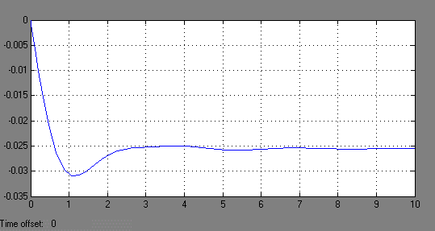

∆F1
(Hz)

fig.1 time (sec)

Fig.4.1.1 Change in frequency of thermal 1 w.r.t. time

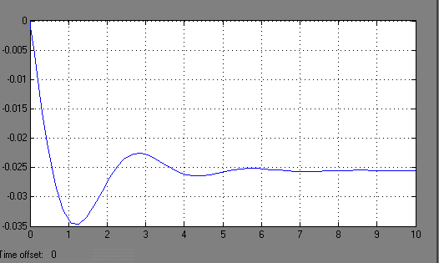

∆F2
(Hz)
time (sec)

Fig.4.1.2 Change in frequency of thermal 2 w.r.t. time
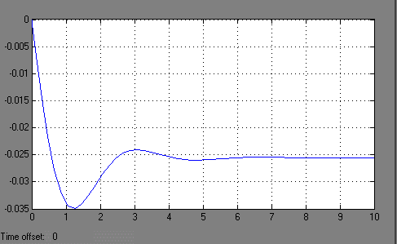

∆F3
(Hz)

time (sec)

Fig.4.1.3 Change in frequency of thermal 3 w.r.t. time

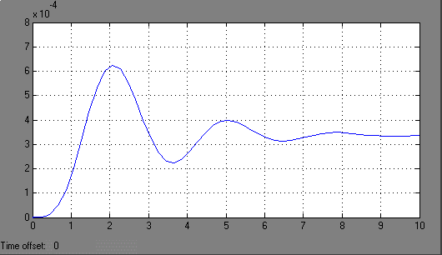

∆P12
(Hz)

time (sec)

Fig.4.1.4 Change in tie-line power of area12 w.r.t. time

Controlled System

In the figure 4.2, the simulink model of thermal-3 integral controlled optimum system 1000 Mw is selected as base quantity and various parameters used in models are calculated on 1000 Mw basis. Model is studied in terms of size variation besides transient performance of the system. Frequency deviation and tie line analysis shows the controller gain and its output changes with different areas of different rating. Oscillation in terms of overshoot and undershoot produced during initial period is comparatively more than uncontrolled area systems. Settling time for frequency deviation and tie-line deviation stabilization also varies for controlled system. Settling time is around 10-15 seconds.

Fig.4.2 Three area controlled thermal-thermal-thermal power system model

Controlled thermal-thermal-thermal power system model

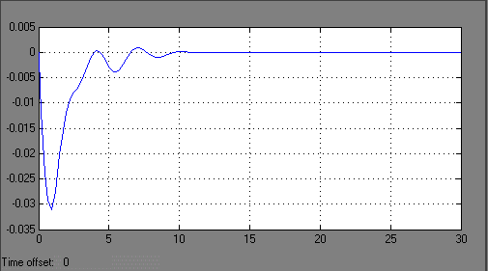

∆F1
(Hz)

time (sec)

Fig.4.2.1 Change in frequency of thermal 1 w.r.t. time

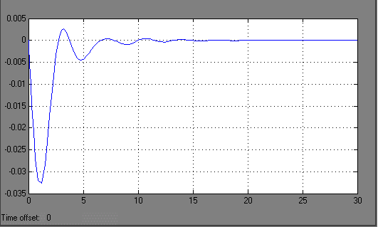

∆F2
(Hz)

time (sec)

Fig.4.2.2 Change in frequency of thermal 2 w.r.t. time

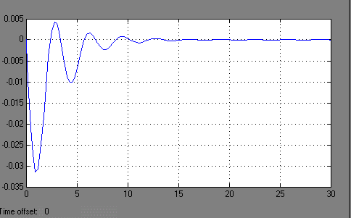

∆F3
(Hz)
time (sec)

Fig.4.2.3 Change in frequency of thermal 3 w.r.t. time

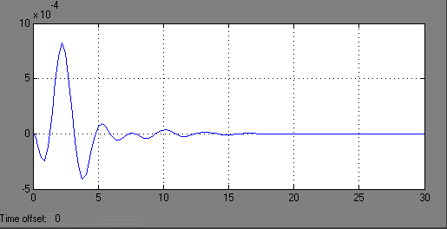

∆P12
(Hz)

time (sec)

Fig.4.2.4 Change in tie-line power of area12 w.r.t. time

Thermal – Hydro – Thermal three-area power system.

Uncontrolled System

The given figure 4.3, shows the Simulink model of thermal-hydro-thermal uncontrolled system. 1000 Mw is selected as base quantity and various parameters used in models are calculated on 1000 Mw basis. Model is studied in terms of size variation besides transient performance of the system. Frequency deviation and tie-line analysis as shown in figure shows that rating change has far less effect on system performance if control areas consist of same rating generators. Oscillation in terms of overshoot and undershoot produced on step unit change in load are much than thermal-thermal-thermal system and settling time has also increased. Settling time for frequency deviation and tie – line deviation stabilization is around 15-20 seconds.

Fig.4.3 Three area uncontrolled thermal-hydro-thermal power system model

Uncontrolled Thermal-Hydro-Thermal Power System Model

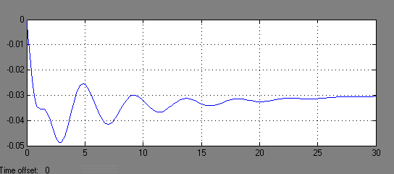

∆F1
(Hz)
time (sec)

Fig.4.3.1 Change in frequency of thermal 1 w.r.t. time

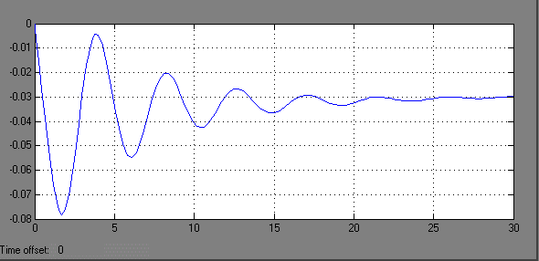

∆F2
(Hz)

time (sec)

Fig.4.3.2 Change in frequency of hydro 2 w.r.t. time

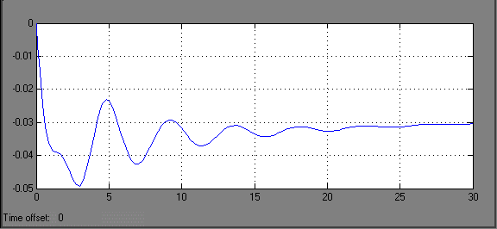

∆F3
(Hz)

time (sec)

Fig.4.3.3 Change in frequency of thermal 3 w.r.t. time

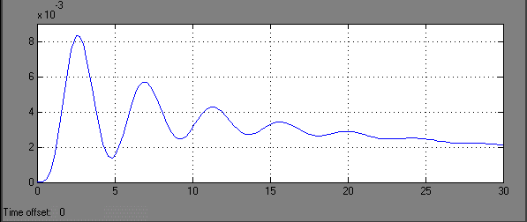

∆P12
(Hz)

time (sec)

Fig.4.3.4 Change in tie-line power of area12 w.r.t. time

Controlled System

In the figure 4.4, the simulink model of thermal-hydro-thermal integral controlled optimum system. 1000 Mw is selected as base quantity and various parameters used in models are calculated on 1000 Mw basis. Model is studied in terms of size variation besides transient performance of the system. Frequency deviation and tie line analysis shows the controller gain and its output changes with different areas of different rating. Oscillation in terms of overshoot and undershoot produced during initial period is comparatively more than uncontrolled area systems. Settling time for frequency deviation and tie-line deviation stabilization also varies for controlled system. Settling time is around 20-30 seconds.

Fig.4.4 Three area controlled thermal-hydro-thermal power system model

Controlled Thermal-Hydro-Thermal Power System Model
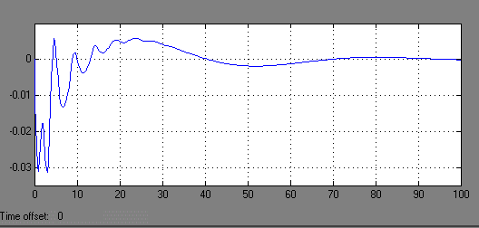

∆F1
(Hz)

time (sec)

Fig.4.4.1 Change in frequency of thermal 1 w.r.t. time

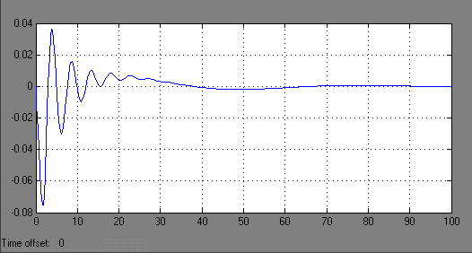

∆F2
(Hz)

time (sec)

Fig.4.4.2 Change in frequency of hydro 2 w.r.t. time

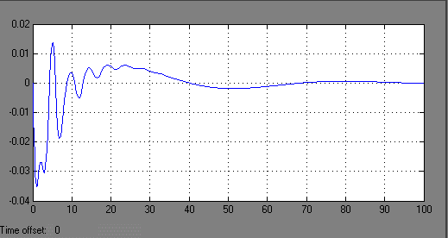

∆F3
(Hz)

time (sec)

Fig.4.4.3 Change in frequency of thermal 3 w.r.t. time

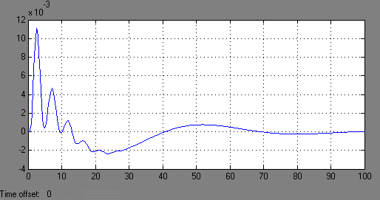

∆P12
(Hz)

time (sec)

Fig.4.4.4 Change in tie-line power of area12 w.r.t. time

Thermal – Hydro – Gas three area power system.

Uncontrolled System

The given figure 4.5, shows the Simulink model of thermal-hydro-thermal uncontrolled system. 1000 Mw is selected as base quantity and various parameters used in models are calculated on 1000 Mw basis. Model is studied in terms of size variation besides transient performance of the system. Frequency deviation and tie-line analysis as shown in figure shows that rating change has far less effect on system performance if control areas consist of same rating generators. Oscillation in terms of overshoot and undershoot produced on step unit change in load are much than thermal-thermal-thermal system and settling time has also increased. Settling time for frequency deviation and tie – line deviation stabilization is around 30-40 seconds.

Fig.4.5 Three area uncontrolled thermal-hydro-gas power system model

Uncontrolled Thermal-Hydro-Gas Power System Model

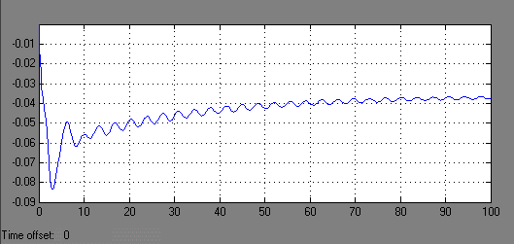

∆F1
(Hz)
time (sec)

Fig.4.5.1 Change in frequency of thermal 1 w.r.t. time

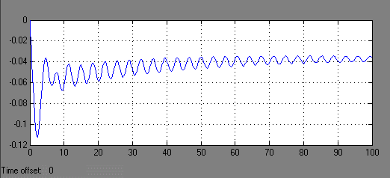

∆F3
(Hz)

time (sec)

Fig.4.5.2 Change in frequency of hydro 2 w.r.t. time

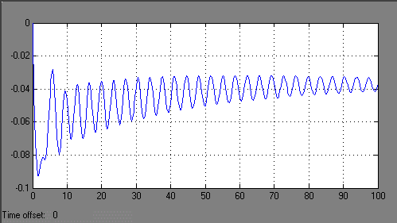

∆F3
(Hz)

time (sec)

Fig.4.5.3 Change in frequency of gas 3 w.r.t. time

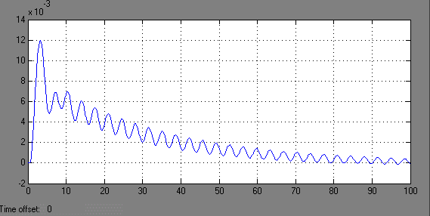

∆P12
(Hz)

time (sec)

Fig.4.5.4 Change in tie-line power of area12 w.r.t. time

Controlled System

In the figure 4.6, the simulink model of thermal-hydro-thermal integral controlled optimum system. 1000 Mw is selected as base quantity and various parameters used in models are calculated on 1000 Mw basis. Model is studied in terms of size variation besides transient performance of the system. Frequency deviation and tie line analysis shows the controller gain and its output changes with different areas of different rating. Oscillation in terms of overshoot and undershoot produced during initial period is comparatively more than uncontrolled area systems. Settling time for frequency deviation and tie-line deviation stabilization also varies for controlled system. Settling time is around 50-60 seconds.

Fig.4.6 Three area controlled thermal-hydro-gas power system model

Controlled Thermal-Hydro-Gas Power System Model

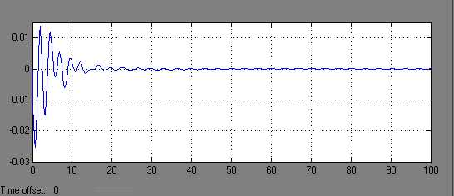

∆F1
(Hz)
time (sec)

Fig.4.6.1 Change in frequency of thermal 1 w.r.t. time

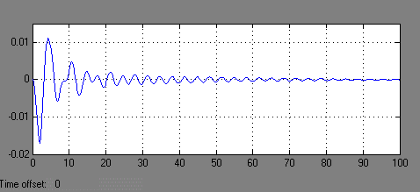

∆F2
(Hz)
time (sec)

Fig.4.6.2 Change in frequency of hydro 2 w.r.t. time

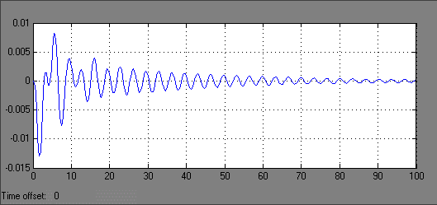

∆F3
(Hz)
time (sec)

Fig.4.6.3 Change in frequency of gas 3 w.r.t. time

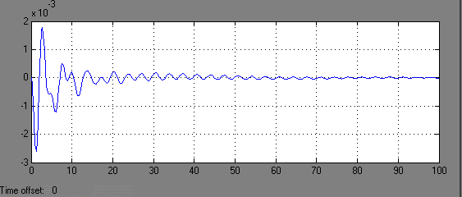

∆P12
(Hz)
time (sec)

Fig.4.6.4 Change in tie-line power of area12 w.r.t. time

OPTIMAL CONTROL DESIGN

5. OPTIMAL CONTROL DESIGN

Optimal design of thermal-thermal-thermal power system

Modern control theory is applied to design an optimal frequency controller for a three area thermal- thermal-thermal system as given in AppendixA. In accordance with modern technology PC1, PC2 and PC3 will be referred as control inputs u1, u2 and u3. In the conventional approach u1,u2 and u3 were provided by the integral of ACE’s. In modern control theory approach input will be created by linear combination of all the system states (full state feedback). For formulating the state variable model for this purpose the conventional feedback loops are opened and a separate block represents each time the constant. State variable are defined as the outputs of all the blocks having either the integrator or a time constant. By noticing the figure 4.1 we realize that there are 15 state variables.
State variables assumed are described below: -

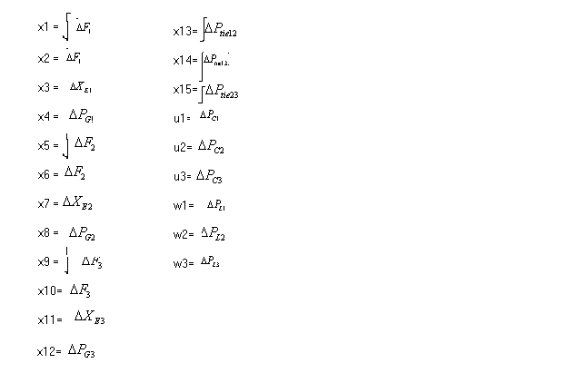

.
x = Ax + Bu + Fw

Where,
T
x = [x1 x2 x3 x4 x5 x6 x7 x8 x9 x10 x11 x12 x13 x14 x15 ] = state vector
T
u = [u1 u2 u3] = control vector
T
W= [w1 w2 w3]= disturbance vector

Fig.5.2 Optimal design of thermal-thermal-thermal power system

Optimal design of thermal-hydro-thermal power system

Modern control theory is applied to design an optimal frequency controller for a three area thermal- hydro-thermal system as given in Appendix B. In accordance with modern technology PC1, PC2 and PC3 will be referred as control inputs u1, u2 and u3. In the conventional approach u1, u2 and u3 were provided by the integral of ACE’s. In modern control theory approach input will be created by linear combination of all the system states (full state feedback). For formulating the state variable model for this purpose the conventional feedback loops are opened and a separate block represents each time the constant. State variable are defined as the outputs of all the blocks having either the integrator or a time constant. By noticing the figure 4.2 we realize that there are 16 state variables.
State variables assumed are described below: -

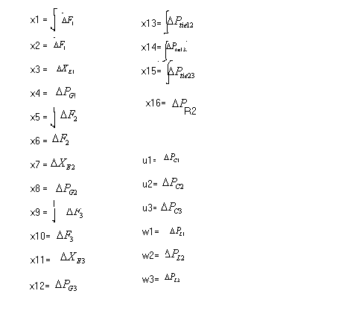

.
x = Ax + Bu + Fw

where,
T
x = [x1 x2 x3 x4 x5 x6 x7 x8 x9 x10 x11 x12 x13 x14 x15 x16 ] = state vector
T
u = [u1 u2 u3] = control vector
T
W= [w1 w2 w3]= disturbance vector

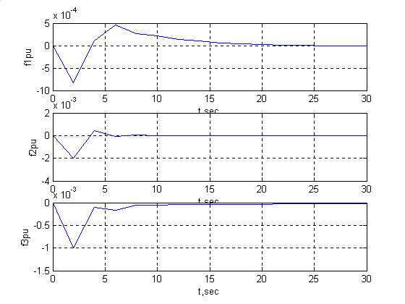

Fig.5.2 Optimal design of thermal-hydro-thermal power system
Controlled thermal-thermal-thermal power system model
By Optimal Control Design

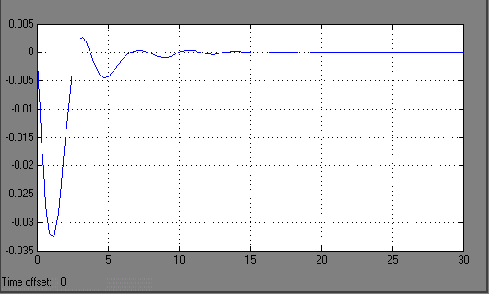By Integral Controller

F1 vs time F2 vs time

F3 vs time

Controlled thermal-hydro-thermal power system model
By Optimal Control Design

By Integral Controller

F1 vs time F2 vs time

F3 vs time

6. CONCLUSION

In the project, Integral controller gain and optical control methods are used for Automatic Generation Control of three-area interconnected power system. When there is sudden load change in any area, the frequency and tie line power are affected. For economic and reliable operation of power system, it is essential to minimize the errors. So the integral controller and optimal control are designed to meet the stated demand.
It has been found that reduction of R (speed droop) reduces frequency error. With high R, low damping of oscillations and with low R, high damping of oscillation is produced. Use of sub critical gain setting gives sluggish non oscillatory response of control loop and which means integral of Δf(t) and time error is relatively large . Further it has been found that if all the parameters are considered same, then frequency drop will be 1/3rd of that which would be experienced if the control areas were operating alone.
It has been found that a per unit disturbance in thermal area produces more oscillations in hydro and gas based system in comparison to thermal based system. While a per unit disturbance in hydro or gas based system produces large disturbance in hydro and gas based system rather than in thermal based system. There is overall increase in oscillations and settling time for frequency and tie line deviations for all three different interconnected systems.
with the use of integral control and optimal control , it is clear that optimal solution give better response than integral control.

SCOPE FOR FUTURE WORK

- New Optimal controller based on different performance index can applicable on interconnected system.
- Optimal control of thermal-hydro-gas can be done .
- Integral controller can be optimized
- Integral controller can be compared with fuzzy logic and neural network .
- Non-linearity can be added in the models and there effects can be studied.

REFERENCES

- J. Nanda & A. Mangla, “Automatic Generation Control of an Interconnected Hydro-Thermal System using Conventional Integral & Fuzzy Logic Controller.” IEEE International Conference on Electric Utility Deregulation Restructuring & Power Technology, April 2004.
- M. L. Kothari, J. Nanda, “Application of optimal Control Strategy to Automatic Generation Control of a Hydro-Thermal System.” Proc. IEE, Vol.135, Pt. D, No. 4, July 1998.
- D. P. Kothari, A. K. Mahalanabis & S. I. Ahson, “Computer Aided Power System Analysis & Control.” TMH 1981.
- C.D.Vournas, E.N.Dialynas and N.Hatziargyrion ; "A flexible AGC algorithm for interconnected system ", IEEE Transactions on power system , vol. 4 , feb 1989
- N.Cohn, “Some aspects of Tie-line Bias Control on Interconnected Power Systems”, AIEE Transactions, vol. 75, Feb. 1957, pp. 1415-1436
- G.Concordia and L.K.Kirchmayer, “Tie-line Power and Frequency Control of PowerSystem”, AIEE Trans., Vol 2, Part III, June 1953, pp. 562-572.
- D.P.Kothari and I.J.Nagrath , "Modern power system analysis "'TMH
- Hadi Sadat, "Power system analysis",TMH, 2002
- IEEE Committee Report, “IEEE Standard Definitions of Terms for Automatic Generation Control of Electric Power System”, IEEE Trans. on Power Apparatus and Systems, Vol. PAS-89, July/Aug 1970, pp. 1358-1364.
- Elgred, O.I; “Electric Energy System Theory: An introduction”, Mcgraw hill, 1971, pp. 315-389.
- J.Nanda and B.L.Kaul, “Automatic Generation Control of an Interconnected Power System”, Proc. IEE, Vol. 125, May 1978, pp. 385-390.
- M. Gopal, “Digital Control and State Variable Methods”, TMH, 2003.
- Kirchmayer, L.K., “Economc Control of Interconnected Systems”, Wiley, 1959, pp. 35-47.
- D.O.Anderson & b.Moore, “Optimal Control, Linear Quadratic Methods”, PHI, 1990
- L.M.Hajagos, G.R.Berube, “Utility Experienec with gas turbine testing and modeling”, IEEE Symposium on frequency control requirements, New York, Feb. 1999.
- M.Nagpal, A.Moshref, G.K.Morison and P.Kundur, “Experience with Testing and Modelling of Gas turbines”, IEEE Power Engineering Society Entity Annual Report No. 7802-6672-7/01, 2001.
- M.Ogata, “Modern Control Engineering”, PHI Third Edition.
- J.Dazzao & H.Houpis, “Linear Control System Analysis and Design”, TMH, International Student Edition.
- E.Djaferis, “Automatic Control, Power of feedback using MATLAB”, 2000 Edition by Brooks/Cole Thompson Learning.
- P.Kundur, “Power System Stability and Control”, TMH, 1994.
- Ramey, D.G. and Skooglund, J.W., “Detailed Hydro Governor Representation for System Stability”, IEEE Trans. on Power Apparatus and Systems, vol. PAS-81, Jan. 1970, pp. 106-112.
- R.C.Dorf and R.H.Bishop, “Modern Control Systems”, Pearson Education, Inc., 8th Edition, 1998.
- IEEE Committee Report, “Dynamic models for steam and hydro turbines in power system studies”, IEEE Trans. on Power apparatus and Systems, Vol. PAS-92, Nov/Dec. 1978, pp. 1904-1915.
- Woodward, J.L., “Hydraulic Turbine Transfer Function for use in Governing Studies”, proc. IEE (London), vol. 115, March 1968.
- George Gross; "Analysis of load frequency control performance assessment criteria, IEEE Transactions vol16, no.3, aug2001
- Multhana T. Alrifai and Mohamed Zribi; "Decentralized controllers for power system load frequency control",ACSE
- Allen J wood, Bruce F.Wollenberg; "Power generation operation and control", Wiley
- Jan Machowski;"power system dynamics and stability ", wiley

APPENDIX A

LIST OF SYMBOLS

ΔF_{s} System frequency deviation. Hz
R Speed regulation of generator
K_{G} Gain of speed governor
T_{G} Time constant of speed governor
T_{T} Time constant of thermal turbine
T_{P} Power system Time constant
T_{W} Water starting turbine for hydraulic turbine
K_{T} Gain of non-reheat turbine
K_{P} Power system gain
ΔP_{G} Change in generated power
ΔP_{D} Change in load demand
ΔP_{C} Change in speed governor
ΔP_{M} Hydraulic turbine mechanical power
ΔG Change in gate position
T₁ Fuel system lag constant1 for gas turbine
T₂ Fuel system lag constant2 for gas turbine
T₃ Load limiter constant for gas turbine
L_{max} Load Limit
V_{max} Maximum value position for gas turbine
V_{min} Minimum value position for gas turbine
ΔP_{tie} Tie-line power deviation
T_{ij} Synchronizing coefficient for tie-line
X Area state vector
u Control vector
p Disturbance vector
[A] System matrix
[B] Control matrix
[r] Disturbance matrix
K_{i} Integral controller gain
K_{Di} Discrete Integral controller gain
ACE Area Controller Error
B Bais constant
T_{s} Sampling period
i Area index
j Area index
s Laplace operator

