ANALYSIS OF SURFACE ROUGHNESS FOR TURNING OF ALUMINIUM (6061) AND BRASS (IS 319, GRADE I) USING REGRESSION ANALYSIS AND NEURAL NETWORK

A Major Project thesis Submitted in partial fulfillment for the requirement for the award of the degree of

Masters of Engineering

In

Production and Industrial Engineering

Submitted By:
RAJ KUMAR MEENA
(13/PRO/2005)
Under the guidance of
Sh. VIPIN
ASST. PROF.



DEPARTMENT OF MECHANICAL ENGINEERING
DELHI COLLEGE OF ENGINEERING
DELHI UNIVERSITY, DELHI-110042
July, 2007

Candidate’s declaration

I, RAJ KUMAR MEENA, hereby certify that the work which is being presented in this thesis entitled “ANALYSIS OF SURFACE ROUGHNESS FOR TURNING OF ALUMINIUM(6061) AND BRASS(IS 319, GRADE 1) USING REGRESSION ANALYSIS AND NEURAL NETWORK” in the partial fulfillment of requirement for the award of degree of Masters of Engineering submitted in the Department of Mechanical Engineering at DELHI COLLEGE OF ENGINEERING, is an authentic record of my own work carried out during a period from July 2006 to July 2007, under the supervision of Sh. VIPIN, Asst. PROF, Department of Mechanical Engineering, Delhi College of Engineering, Delhi.

The matter presented in this thesis has not been submitted in any other University/ Institute for the award of M.E. Degree.

Signature of the Student
(RAJ KUMAR MEENA)

CERTIFICATE
This is to certify that the above statement made by the candidate is correct to best of my knowledge.

Signature of the Guide
(ASST. PROF. Sh. VIPIN)

ACKNOWLEDGEMENT

It is a matter of great pleasure for me to present my dissertation report on “ANALYSIS OF SURFACE ROUGHNESS FOR TURNING OF ALUMINIUM(6061) AND BRASS(IS 319, GRADE 1) USING REGRESSION ANALYSIS AND NEURAL NETWORK”. First and foremost, I am profoundly grateful to my guide Sh. VIPIN, Asst. PROF, Department of Mechanical Engineering for his expert guidance and continuous encouragement during all stages of thesis. Their help in form of valuable information and research papers at proper time brought life in this thesis. I feel lucky to get an opportunity to work with him. Not only understanding the subject, but also interpreting the results drawn thereon from the graphs was very thought provoking. I am thankful to the kindness and generosity shown by him towards me, as it helped me morally complete the project before actually starting it.
I would like to thank Sh. I Fransis (CNC In charge), Sh. Rahul Mool (Metrology Lab In charge) without their support it would be almost impossible to complete my thesis work in time.
Last, but not the least, I would like to thank my family members for their help, encouragement and prayers through all these months. I dedicate my work to them.
Date: 31.07.07
Place: DELHI RAJ KUMAR MEENA

CONTENTS

CANDIDATE’S DECLARATION
ACKNOWLEDGEMENT
ABSTRACT

Chapter 1: INTRODUCTION 7-19

1.1 Ideal roughness

1.2 Machining variables and surface roughness
1.2.1 Types of chips
Cutting Parameters
1.2.2.1 Cutting speed
1.2.2.2 Feed
1.2.2.3 Depth of cut
1.2.2.4 Effects of cutting parameters
1.2.3 Cutting fluids effect on surface roughness
1.2.4 Tool geometry

Chapter 2: LITERATURE REVIEW 20-24

Chapter 3: THEORY 25-53

  - Neural Network
    - Historical Background
    - Advantages of Neural Network
    - Human and Artificial Neurons
      - Firing Rules
    - Architecture of Neural Networks
      - Feed Forward Networks
      - Feedback Networks
      - Network Layers
      - Perceptrons
      - Learning Process
      - Transfer Function
    - Mathematics of ANN
    - Application of Neural Networks

  - Regression Analysis 43-52
    - Linear Regression
    - Non-Linear Regression
    - Analysis Technique
      - Least Square analysis
      - Model Assumptions
      - Model Validity

Chapter 4: EXPERIMENTAL SET UP 54-65

  - CNC Trainer Lathe
  - Surface Roughness Measuring Instrument
  - Workpiece material
  - Cutting tool material

Chapter 5: ANALYSIS OF MACHINING DATA 66-108

5.1 Regression Analysis
    - Linear Model
    - Non-linear model
  - Neural network Modelling
    - Introduction
    - Scope
    - System overview
    - CODE file
    - Network for Linear Model for Al
    - Network for Non-Linear Model for Al
    - Network for Linear Model for Brass
    - Network for Non-Linear Model for Brass

Chapter 6: RESULTS AND DISCUSSIONS 109-110

REFERENCES 111-113

APPENDIX

BIBLOGRAPHY

ABSTRACT

Surface roughness and tolerances are among the most critical quality measures in many mechanical products. As competition grows closer, customers now have increasingly high demands of quality, making surface roughness become one of the most competitive dimensions in today's manufacturing industry. Surfaces of a mechanical product can be created with a number of manufacturing processes. This work applies the fractional factorial experimentation approach to studying the impact of turning parameters on the roughness of turned surfaces. Analysis of variances is used to examine the impact of tu models to predict the surface roughness of a machined work piece. Other objectives of this study are:

1. To develop prediction models.
2. Comparing the surface roughness values obtained by regression analysis and neural network analysis.
rning factors and factor interactions on surface roughness. A considerable number of studies have studied the effects of the speed, feed and depth of cut on the surface roughness. The aim of this study was to set up a multiple regression models and neural network models to predict the surface roughness of a machined work piece. Other objectives of this study are:

1. To develop prediction models.
2. Comparing the surface roughness values obtained by regression analysis and neural network analysis.

Chapter 1
INTRODUCTION

In machining of parts, surface quality is one of the most specified customer requirements where major indication of surface quality on machined parts is surface roughness. Surface roughness is mainly a result of process parameters such as tool geometry (i.e. nose radius, edge geometry, rake angle, etc.) and cutting conditions (feed rate, cutting speed, depth of cut, etc.).
Surface roughness is harder to attain and track than physical dimensions are, because relatively many factors affect surface roughness. Some of these factors can be controlled and some cannot. Controllable process parameters include feed, cutting speed, tool geometry, and tool setup. Other factors, such as tool, work piece and machine vibration, tool wear and degradation, and work piece and tool material variability can not be controlled as easily.
The resultant roughness produced by a machining process can be thought of as the combination of two independent quantities: Ideal roughness and Natural roughness.

1.1 Ideal Roughness
Ideal surface roughness is a function of only feed and geometry. It represents the best possible finish which can be obtained for a given tool shape and feed. It can be achieved only if the built-up-edge, chatter and inaccuracies in the machine tool movements are eliminated completely. For a sharp tool without nose radius, the maximum height of unevenness is given by:

R _{max} = f / (cot φ + cot β)

The surface roughness value is given by:

Ra = R_{max} / 4

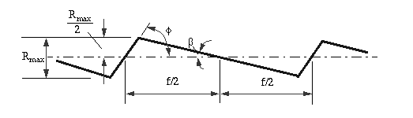
f feed
Ф Major cutting edge angle
β Working minor cutting edge angle

Natural Roughness
In practice, it is not usually possible to achieve conditions such as those described above, and normally the natural surface roughness forms a large proportion of the actual roughness. One of the main factors contributing to natural roughness is the occurrence of a built-up edge. Thus, larger the built up edge, the rougher would be the surface produced, and factors tending to reduce chip-tool friction and to eliminate or reduce the built-up edge would give improved surface finish.

Surface roughness of machined surfaces

Surface roughness is caused by (i) the feed marked or ridges left by the cutting tool and (ii) the fragments of built-up edge shed on the work surface in the process of chip formation. Surface finish can be improved by reducing the height of the feed ridges and the size of the built up edge.

1.2 MACHINING VARIABLES AND SURFACE ROUGHNESS

The most important machining variables influencing surface roughness are as follows:
- Geometry of chip formation.
- Cutting parameters
- Cutting fluids.
- Tool geometry.

1.2.1 Types of chips
Chip formation during machining operation may be classified under 3 categories:

- Continuous chips without built up edge
- Continuous chips with built up edge
- Discontinuous chips

In the case of chips of group (a) the material passing through the plane of shear during cutting flows in a continuous chip which has a smooth burnished layer of highly compressed materials, that slides in contact with the tool face. This type of chip formation is generally found to occur when machining ductile material with fine feed and comparatively high cutting speeds along with an efficient cutting fluid.

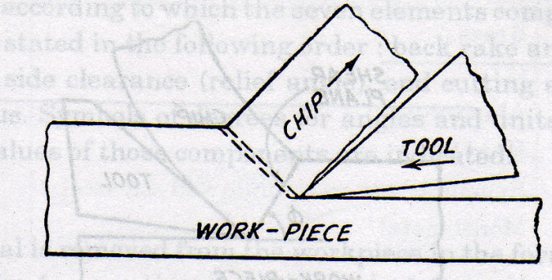
Figure: 1.1 Continuous Chips (Referred R.K JAIN, Production Technology)

The groups (b) of chips are generally found to occur when machining ductile materials of high hardening type at comparatively low cutting speeds without the use of a cutting fluid. During the operation, a built up edge is formed, some fragments of which are carried away on the chip while others became a part of the surface of work piece rendering the machined surface considerable rough in the direction of cutting.
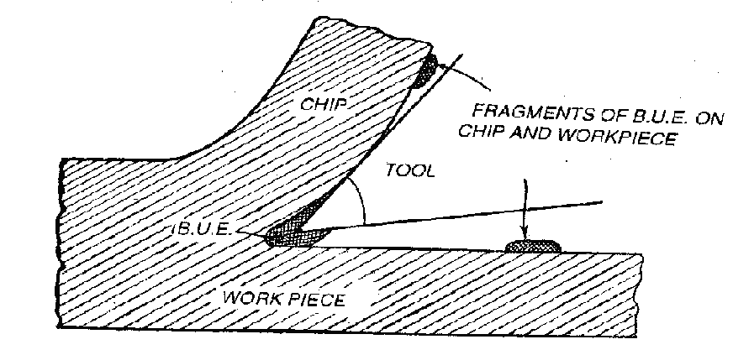
Figure: 1.2 Continuous chips with built up edge formation
(Referred R.K. JAIN, Production Technology)

The discontinuous chips of group (c) are found to occur while machining brittle materials. In this case, the roughness of machined surface is believed to depend on the size of chips.

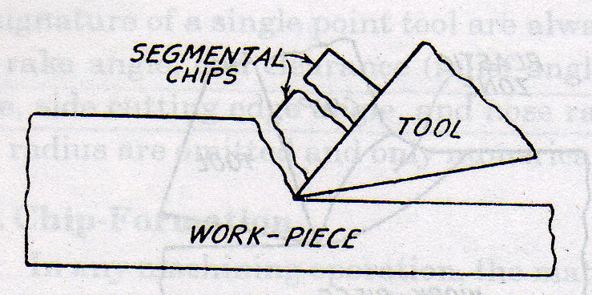
Figure: 1.3 Discontinuous Chips without built-up edge formation
(Referred R.K. JAIN, Production Technology)

Thus with the three above cases, we could say that surface roughness for a built up edge is more than that for continuous chips. Surface finish will be poor if friction between chips and the tool is high. Finish is also poor if the metal has high strain hardenability.
1.2.2 Cutting Parameters
The important cutting parameters discussed here are cutting speed, feed and depth of cut.1.2.2.1Cutting Speed
All materials have an optimum Cutting Speed and it is defined as the speed at which a point on the surface of the work passes the cutting edge or point of the tool and is normally given in meters/min. To calculate the spindle Speed required,
N= 1000 V_{C} /Dπ
Where:
N = Spindle Speed (RPM)
V_{C} = Cutting Speed of Metal (m/min)
D = Diameter of Work piece
1.2.2.2 Feed
The term `feed' is used to describe the distance the tool moves per revolution of the work piece and depends largely on the surface finish required. For roughing out a soft material a feed of up to 0.25 mm per revolution may be used. With tougher materials this should be reduced to a maximum of 0.10 mm/rev. Finishing requires a finer feed then what is recommended.
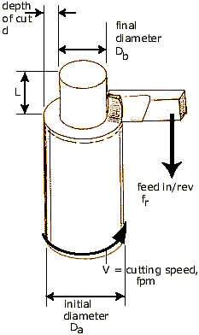
Figure: 1.4 Metal Cutting Process
(Referred Manufacturing Process by DeGarmo)

1.2.2.3 Depth of cut
It is the advancement of tool in the job in a direction perpendicular to the surface being machined. Depth of cut depends upon cutting speed, rigidity of machine tool and tool material etc. Depth of cut normally varies between 1 to 5mm for roughing operation and 0.2 to 1 mm for finishing operation.
1.2.2.4 Effect of cutting parameters
It is found in most of the cases surface roughness decreases with increase in cutting speed and decrease in feed and depth of cut.
Since these cutting parameters will decide about the type of chips which we expect at the time of machining of a single constant material thus we have to analyze them for no such built-up edge chips formation. At the optimum cutting speed at which the effect of built up edge is negligible, (high speed, ductile material) the profile of the cutting edge of the tool is reproduced on the work surface and this ideal surface roughness is mainly dependent on cutting feed. That means for a greater feed the average roughness value is more as compared to the lesser feed. Fig 1.5 shows the relation of feed and roughness while finishing turning aluminum alloys with a diamond tool.

Figure 1.5 Finish turning aluminum alloy with diamond tool
(Referred R.K. JAIN, Production Technology)
It would be noted that the size of chips cross-sectional area has a large effect on surface finish. Surface finish is poor for large cuts which is desirable from considerable of high tool life and power consumption. Large feed is more detrimental to surface finish than a large depth of cut.
The characteristics in fig.1.6 for finish turning of non-ferrous alloys between depth of cut 0.025 mm and 0.25 mm shows that the roughness is not very much affected at low depth of cut.

Figure 1.6 Finish turning non-ferrous alloys with feed of 0.01 mm/rev
(Referred R.K. JAIN, Production Technology)

For very high cutting speeds the chances of built up edge reduces thus surface roughness also expected to reduce, while when cutting speed is low built-up formation of chips would increase the surface roughness.

1.2.3 Cutting fluid’s effect on surface roughness
The use of cutting fluid during machining operation in many instances results in an improvement in surface finish. This is because of the reduction in the coefficient of friction and a lessening in the size of built up edge.

1.2.4 Tool geometry
The important tool characteristics considered here are the nose radius, rake angle and tool plan contour. In general, an increase in tool rake angle improves the surface finish as it reduced the size of built-up edge. An increase in the side cutting edge angle ordinarily improves the surface finish. Since increase in end cutting edge angle increases the heightthe feed ridges on the work pieces on the work piece surface, it makes the surface finish worse, as roughness increases.
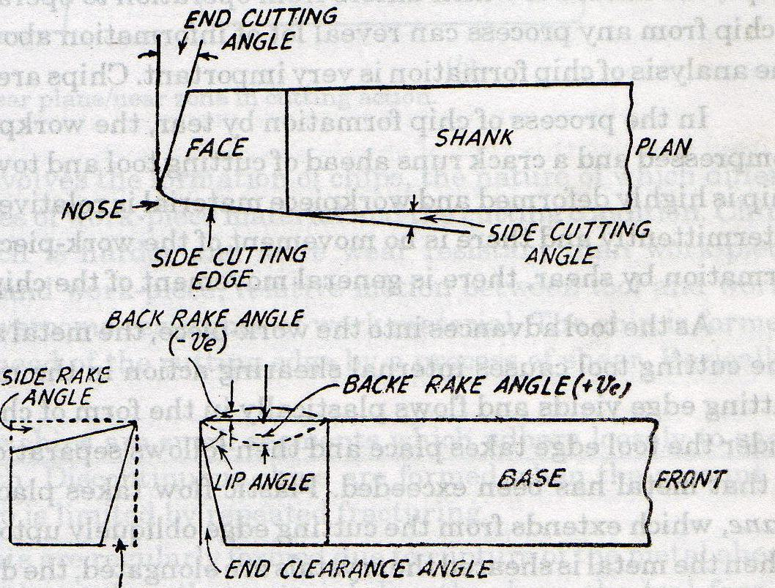
Figure: 1.7 Cutting Tool Angles (Referred Metal Cutting by M.C.SHAW)

Fig 1.8 for finish turning aluminum alloys with carbide tools indicate that roughness decreases as the nose radius is increased. Tools, with a very small nose radius produce surfaces with much sharper irregularities than tools with larger ones. Moreover, sharper pointed tools are subjected to rapid deformation. Generally a radius of not less than 1.00 mm is recommended if the feed is greater than 0.50 mm. Thus we could conclude that with greater nose radius surface roughness values decreases.

Figure 1.8 Finish turning aluminum alloy with carbide tools
(Referred R.K. JAIN, Production Technology)

1.3 MACHINING ALUMINUM AND ALUMINUM ALLOYS
Traditional machining operations such as turning, milling, boring, tapping, sawing etc. are easily performed on aluminum and its alloys. The machines that are used can be the same as for use with steel, however optimum machining conditions such as rotational speeds and feed rates can only be achieved on machines designed for machining aluminum alloys.

1.3.1 The specific properties of aluminum alloys which are considered:
- Their density allows high speeds of rotation and translation as the inertia of aluminum alloy swarf is less than that of steel.
- Their modulus of elasticity, one third that of steel requires appropriate chucking and clamping arrangements that avoid deformation and distortion. The alloy’s thermal conductivity assists with heat dissipation.
- Given the high rate of chip removal, the heat generated by the machining process is taken away with the swarf without having the time to diffuse into the metal, a coefficient of linear expansion that is twice that of steel makes heating undesirable if criteria of dimensional stability are to be satisfied. Unlike steel, there is no need to provide heat treatment of the “stress-free annealing” type during machining.

1.3.2 Cutting Force required for machining Aluminum:
The specific cutting force needed to machine aluminum alloys is far less than is required for steel. For the same section of swarf, the force is one third of that required for aluminum than for low-carbon steel, so it follows for the same cutting force, chip removal is three times higher with aluminum alloys whose level of mechanical properties is on a par with that for low carbon steel.
Machining aluminum generate moderate cutting pressure and low machining temperatures. Milling aluminum requires less horsepower than steel, however, the horsepower needed for high speed machining of soft metals is much greater than currently available in conventional machines. Until now, the factors that limit cutting soft metals at high speeds, assuming a machine has adequate horsepower, were the risks of built-up edges, flank wear, poor surface finish, and loss of chip control. Fortunately, insert grades that are specially made to machine aluminum minimize those risks.
Built-up edges can be seen with some aluminum alloys even at relatively high cutting speeds, while flank wear is more prevalent with some silicon-content alloys. Both of these conditions result in poor surface texture and shorter tool life.
1.3.3 Tooling required for machining Aluminum:
The geometry of tools must be specially designed for use with aluminum alloys. Edges must be very keen and cutting tool faces must be highly polished so as to remove swarf efficiently and prevent it from bonding to the tool. Cutting angles will depend on the alloys. The rake angle of the cutting edge must be greater than 6 and can attain 12 (Angle of 15 for diamond coated carbide (CVD Diamond) tools and polycrystalline diamond (PCD) tools). Provided tooling is designed for aluminum alloys, tool life is much longer than for machining steels, all other factors being equal.
Tools for aluminum and aluminum alloys should have larger relief and rake angles than tools for cutting steel. For high-speed steel turning tools the following angles are recommended: relief angles, 14 to 16 degrees; back rake angle 5 to 20 degrees; side rake angle 15 to 35 degrees. For very soft alloys even larger side rake angles are sometimes used.
High silicon aluminum alloys and some others have a very abrasive effect on the cutting tool. While these alloys can be cut successfully with high-speed steel tools, cemented carbides are recommended because of their superior abrasion resistance. The tool angles recommended for cemented carbide turning tools are: relief angles, 12 to 14 degrees; back rake angle, 0 to 15 degrees; side rake angle, 8 to 30 degrees. Cut-off tools and necking tools for machining aluminum and its alloys should have from 12 to 20 degrees back rake angle and the end relief angle should be from 8 to 12 degrees. Excellent threads can be cut with single-point tools in even the softest aluminum.
Fine surface finishes are often difficult to obtain on aluminum and aluminum alloys, particularly the softer metals. When a fine finish is required, the cutting tool should be honed to a keen edge and the surfaces of the face and the flank will also benefit by being honed smooth. Tool wear is inevitable; however, it should not be allowed to progress too far before the tool is changed or sharpened.
A sulphurized mineral oil or heavy-duty soluble oil will sometimes be helpful in obtaining a satisfactory surface finish. For best results, however, a diamond cutting tool is recommended. Excellent surface finishes can be obtained on even the softest aluminum and aluminum alloys with these tools.

Chapter 2

LITERATURE REVIEW

A considerable number of studies have investigated the general effects of the speed, feed, and depth of cut, nose radius and others on the surface roughness. These studies have been briefly discussed for the variations observed experimentally.

Rasch and Rolstadas [1971] worked on the series of finish turning tests, the surface roughness value has been observed under variation of parameters: material quality, tool quality, tool nose radius, feed, speed and cutting time. For one material and one tool quality the test results have been treated by a combined method for regression and multiple correlation analysis in order to establish that describes the surface roughness by the significant parameters.
With this equation as a basis, an automatic system for calculation of optimal cutting data has been developed. A mathematical model has been built enabling the use of mathematical programming techniques in solving the problem of optimal cutting data. Thus, the system gives as output optimal feed, speed and tool nose radius for given surface roughness, diameter and cutting length.

Hassan and Suliman [1990] studied a two-stage method for obtaining machinability data for the steel turning process. In the first-stage, different mathematical model types are developed and compared for the turning process of medium carbon steel. The parameters of the models are established by curve fitting of experimental data which are collected from experiments conducted especially for this work. In the second stage, the model type(s) producing the best estimates of performance is/are used as aid in process optimization. Consequently, optimal machinability data is obtained for maximum removal of metal. This paper aims at developing modeling tools for turning medium carbon steels (225-275 BHN) with tungsten carbide tip (Sandvik Coromant SNMG 12 04 04-15).
Mathematical programming was applied to determine optimum cutting conditions by both deterministic and probabilistic models. Also, the optimal cutting conditions were approached by a manufacturing economics-based model consisting of cost elements required for a machining operation.

Feng et al [1990] conducted a series of factorial experiments to examining the impact of working parameters on the surface roughness, and the following conclusions were reached.
- The tool point angle also had a significant impact on the surface roughness
- The smallest values of surface roughness were produced when the softer material was used with a smaller feed.
- All cases showed that a higher speed would smooth the surface within the range of experiments according to the main effect plots and the interaction plots.

Kirby et al [1981] study in-process surface roughness prediction system, however, is an approach that can be used to indirectly determine the surface roughness of a work piece without the concern of components being negatively affected by the cutting process itself.
The surface roughness of the finish-turned work pieces was measured using a Federal Pocket Surf stylus profilometer, set up to measure Ra in μ-inch, with a travel length of 0.1 inch. The vibration data collection system was comprised of an accelerometer from which signals are amplified, converted to digital data, and processed using Windows-based software. The accelerometer sensor used was a PCB Piezotronics #356B08 triaxial accelerometer, which was mounted on the shank of the tool holder, directly below the cutting tool. The axes of the accelerometer were aligned with the axes of the lathe (X, Y, and Z), using the applicable surfaces on the tool turret as references.

Taraman et al [1974] developed a mathematical model for the surface roughness in a turning operation in terms of cutting speed, feed and depth of cut. Utilizing PL1 language and an IBM 360/50 computer, the model was used to generate contours of surface roughness in planes containing the cutting speed and feed at different levels of depth of cut. The surface roughness contours were to select the machining conditions at which an increase in the rate of metal removal was achieved without sacrifices in surface finish.
The surface roughness model was developed by utilizing Response Surface Methodology.

Sundaram et al [1981] developed mathematical models to predict surface finish in fine turning of steels Part I. This paper outlines the experimental development of mathematical models for predicting the surface finish of AISI 4140 steel in fine turning operation using TiC coated tungsten carbide throw-away tools. A novel experimental design called the rotatable design was used for the experimental procedures. Variables included in the model are: cutting speed, feed, depth of cut, and time of cut of the tool. Statistical coding was used for the experimental variables. First order (log transformed) models were developed. For tools that exhibited lack of fit for the first-order models, a second-order model was developed. Multiple regression analysis was used in developing these prediction models.

Malakutti and Raman [1998], developed an artificial neural network model to optimize machine setup. Here artificial neural network model was used by varying process parameters i.e. speed, feed and depth of cut to optimize cutting force, tool life, cutting temperature and surface finish.

Feng [2001] studied the impact of turning parameters on surface roughness. He studied the impact of Feed, Speed, and Depth of Cut, Nose radius of tool and work material on the surface roughness of work material. He found that the feed have most significant impact on the observed surface roughness and also observed that there were strong interactions among different turning parameters.

Feng and Wang [2002], developed a model considering the following working parameters: work-piece hardness (material), feed, cutter nose radius, spindle speed and depth of cut. Two competing data mining techniques, nonlinear regression analysis and computational neural networks, are applied in developing the empirical models. The values of surface roughness predicted by these models are then compared with those from some of the representative models in the literature. Metal cutting experiments and tests of hypothesis demonstrate that the models developed in this research have a satisfactory goodness of fit. It has also presented a rigorous procedure for model validation and model comparison.

Sahin and Motorcu in [2004], found that feed rats, nose radius, work material and speed has significant impact on observed surface roughness but depth of cut has a little effect on the results. They also found that interactions play a significant role in the process.

Jiao et al [2004], fuzzy adaptive networks in machining process modeling to predict surface roughness in turning operation and found that feed is most significant and also came to a conclusion that this approach is more powerful than the classical regression approach.

Cus and Zuperl [2005], proposed a neural network-based approach to complex optimization of cutting parameters. It describes the multi-objective technique of optimization of cutting conditions by means of the neural networks taking into consideration the technological, economic and organizational limitations. To reach higher precision of the predicted results, a neural optimization algorithm is developed and presented to ensure simple, fast and efficient optimization of all important turning parameters.
Chandiramani and Cook [1964], investigated the effect of cutting speed on the surface finish of the machined product. They have also shown that the formation of the built-up edge deteriorates the surface finish.

Dimla et al [1997], gave a critical review of neural network method used in TCM problem in metal cutting. By literature survey they conclude that neural network with multi layer perceptrons can predict the wear very accurately.
Lee and Chen [2003] have developed an online surface roughness recognition system using artificial neural network in turning operation. In their model, vibration signatures in the three directions have been used. The cutting tool with constant nose radius has been considered in their analysis.
Yang and Tarng [1998] made a model to optimize the cutting parameters in turning operation. In this study it has been shown that tool life and surface roughness can be improved significantly for turning operation. The confirmation experiments were conducted to verify the optimal cutting parameters and there was an improvement of 250% by conducting the experiments according to optimal parameters.

Chapter 3

NEURAL NETWORK
An Artificial Neural Network (ANN) is an information processing paradigm that is inspired by the way biological nervous systems, such as the brain, process information. The key element of this paradigm is the novel structure of the information processing system. It is composed of a large number of highly interconnected processing elements (neurons) working in unison to solve specific problems. ANNs, like people, learn by example. An ANN is configured for a specific application, such as identity selection, pattern recognition or data classification, through a learning process. Learning in biological systems involves adjustments to the synaptic connections that exist between the neurons. This is true of ANNs as well.

3.1.1 Historical background
Neural network simulations appear to be a recent development. However, this field was established before the advent of computers, and has survived at least one major setback and several eras. Many important advances have been boosted by the use of inexpensive computer emulations. Following an initial period of enthusiasm, the field survived a period of frustration and disrepute. These pioneers were able to develop convincing technology which surpassed the limitations identified by Minsky and Papert (1969). Minsky and Papert, published a book in which they summed up a general feeling of frustration (against neural networks) among researchers, and was thus accepted by most without further analysis. Currently, the neural network field enjoys a resurgence of interest and a corresponding increase in funding.
The first artificial neuron was produced in 1943 by the neurophysiologist Warren McCulloch and the logician Walter Pits. Then they were followed by Donald Hebb. The first practical application of artificial neural networks came in the late 1950s, with the invention of the perceptron network and associated learning rule by Frank Rosenblatt. Rosenblatt and his colleagues built a perceptron network and demonstrated its ability to perform pattern recognition. At about the same time, Bernard Widrow and Ted Hoff introduced a new learning algorithm and used it to train adaptive linear neural networks, which were similar in structure and capability to Rosenblatt perceptron. Then Teuvo Kohonen and James Anderson independently and separately developed new neural networks that could act as memories. Stephen Grossberg [was also very active during this period in the investigation of self-organizing networks.
Interest in neural networks had faltered during the late 1960s because of the lack of new ideas and powerful computers with which to experiment. During the 1980s both of these impediments were overcome, and research in neural networks increased dramatically. New personal computers and workstations, which rapidly grew in capability, became widely available.

Two new concepts were most responsible for the rebirth of neural networks. The first was the use of statistical mechanics to explain the operation of a certain class of recurrent network, which could be used as an associative memory. This was described in a seminal paper by physicist John Hopfield. The second key development of the 1980s was the back propagation algorithm for training multilayer perceptron networks, which was discovered independently by several different researchers. The most influential publication of the back propagation algorithm was by David Rumelhart and James McClelland.

3.1.2 Advantage of neural networks
Neural networks, with their remarkable ability to derive meaning from complicated or imprecise data, can be used to extract patterns and detect trends that are too complex to be noticed by either humans or other computer techniques. A trained neural network can be thought of as an "expert" in the category of information it has been given to analyze. This expert can then be used to provide projections given new situations of interest and answer "what if” questions.
Other advantages include:
- Adaptive learning: An ability to learn how to do tasks based on the data given for training or initial experience.
- Self-Organization: An ANN can create its own organization or representation of the information it receives during learning time.
- Real Time Operation: ANN computations may be carried out in parallel, and special hardware devices are being designed and manufactured which take advantage of this capability.
- Fault Tolerance via Redundant Information Coding: Partial destruction of a network leads to the corresponding degradation of performance. However, some network capabilities may be retained even with major network damage.

3.1.3 Human and Artificial Neurons
Much is still unknown about how the brain trains itself to process information, so theories abound. In the human brain, a typical neuron collects signals from others through a host of fine structures called dendrites. The neuron sends out spikes of electrical activity through a long, thin stand known as an axon, which splits into thousands of branches. At the end of each branch, a structure called a synapse converts the activity from the axon into electrical effects that inhibit or excite activity from the axon into electrical effects that inhibit or excite activity in the connected neurons. When a neuron receives excitatory input that is sufficiently large compared with its inhibitory input, it sends a spike of electrical activity down its axon. Learning occurs by changing the effectiveness of the synapses so that the influence of one neuron on another changes.

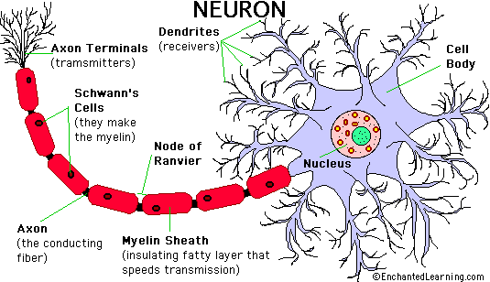
Fig 3.1 Human neuron
Artificial Neurons: - Neural networks are conducted by first trying to deduce the essential features of neurons and their interconnections. Then typically program a computer to simulate these features. However because our knowledge of neurons is incomplete and our computing power is limited, our models are necessarily gross idealizations of real networks of neurons. An artificial neuron is a device with many inputs and one output. The neuron has two modes of operation; the training mode and the using mode. In the training mode, the neuron can be trained to fire (or not), for particular input patterns.
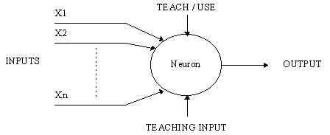
Fig 3.2 Simple neuron

In the using mode, when a taught input pattern is detected at the input, its associated output becomes the current output. If the input pattern does not belong in the taught list of input patterns, the firing rule is used to determine whether to fire or not.

3.1.3.1 Firing rules
The firing rule is an important concept in neural networks and accounts for their high flexibility. A firing rule determines how one calculates whether a neuron should fire for any input pattern. It relates to all the input patterns, not only the ones on which the node was trained.
A simple firing rule can be implemented by using Hamming distance technique. The rule goes as follows:
Take a collection of training patterns for a node, some of which cause it to fire (the 1-taught set of patterns) and others which prevent it from doing so (the 0-taught set). Then the patterns not in the collection cause the node to fire if, on comparison, they have more input elements in common with the 'nearest' pattern in the 1-taught set than with the 'nearest' pattern in the 0-taught set. If there is a tie, then the pattern remains in the undefined state.
For example, a 3-input neuron is taught to output 1 when the input (X1, X2 and X3) is 111 or 101 and to output 0 when the input is 000 or 001. Then, before applying the firing rule, the truth table is;

X1: |  | 0 | 0 | 0 | 0 | 1 | 1 | 1 | 1
X2: |  | 0 | 0 | 1 | 1 | 0 | 0 | 1 | 1
X3: |  | 0 | 1 | 0 | 1 | 0 | 1 | 0 | 1
OUT: |  | 0 | 0 | 0/1 | 0/1 | 0/1 | 1 | 0/1 | 1
As an example of the way the firing rule is applied, take the pattern 010. It differs from 000 in 1 element, from 001 in 2 elements, from 101 in 3 elements and from 111 in 2 elements. Therefore, the 'nearest' pattern is 000 which belongs in the 0-taught set. Thus the firing rule requires that the neuron should not fire when the input is 001. On the other hand, 011 is equally distant from two taught patterns that have different outputs and thus the output stays undefined (0/1). By applying the firing in every column the following truth table is obtained;
X1: |  | 0 | 0 | 0 | 0 | 1 | 1 | 1 | 1
X2: |  | 0 | 0 | 1 | 1 | 0 | 0 | 1 | 1
X3: |  | 0 | 1 | 0 | 1 | 0 | 1 | 0 | 1
OUT: |  | 0 | 0 | 0 | 0/1 | 0/1 | 1 | 1 | 1

The difference between the two truth tables is called the generalization of the neuron. Therefore the firing rule gives the neuron a sense of similarity and enables it to respond 'sensibly' to patterns not seen during training.

3.1.3.2 A more complicated neuron
The previous neuron doesn't do anything that conventional computers don't do already. A more sophisticated neuron is the McCulloch and Pitts model (MCP). The difference from the previous model is that the inputs are ‘weighted’ the effect that each input has at decision making is dependent on the weight of the particular input. The weight of an input is a number which when multiplied with the input gives the weighted input. These weighted inputs are then added together and if they exceed a pre-set threshold value, the neuron fires. In any other case the neuron does not fire.
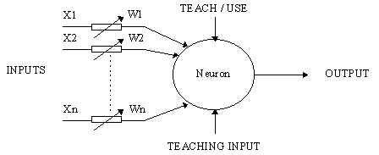
Fig 3.3 Complicated neuron
In mathematical terms, the neuron fires if and only if;
X1W1 + X2W2 + X3W3 + ... > T
The addition of input weights and of the threshold makes this neuron a very flexible and powerful one. The MCP neuron has the ability to adapt to a particular situation by changing its weights and/or threshold. Various algorithms exist that cause the neuron to 'adapt'; the most used ones are the Delta rule and the back error propagation. The former is used in feed-forward networks and the latter in feedback networks.

3.1.4 Architecture of neural networks

3.1.4.1 Feed-forward networks
Feed-forward Artificial Neural Networks (ANNs) allow signals to travel one way only; from input to output. There is no feedback (loops) i.e. the output of any layer does not affect that same layer. Feed-forward ANNs tend to be straight forward networks that associate inputs with outputs. They are extensively used in pattern recognition. This type of organization is also referred to as bottom-up or top-down.

3.1.4.2 Feedback networks
Feedback networks can have signals traveling in both directions by introducing loops in the network. Feedback networks are very powerful and can get extremely complicated. Feedback networks are dynamic; their 'state' is changing continuously until they reach an equilibrium point. They remain at the equilibrium point until the input changes and a new equilibrium needs to be found. Feedback architectures are also referred to as interactive or recurrent, although the latter term is often used to denote feedback connections in single-layer organizations.
Fig 3.4 Simple feed forward network

Fig 3.5 Complicated network

3.1.4.3 Network layers
The commonest type of artificial neural network consists of three groups, or layers, of units: a layer of "input" units is connected to a layer of "hidden" units, which is connected to a layer of "output" units.
- The activity of the input units represents the raw information that is fed into the network.
- The activity of each hidden unit is determined by the activities of the input units and the weights on the connections between the input and the hidden units.
- The behavior of the output units depends on the activity of the hidden units and the weights between the hidden and output units.

3.1.4.4 Perceptrons
The most influential work on neural nets in the 60's went under the heading of 'perceptrons' a term coined by Frank Rosenblatt. The perceptron turns out to be an MCP model (neuron with weighted inputs) with some additional, fixed, pre--processing. Perceptrons mimic the basic idea behind the mammalian visual system. They were mainly used in pattern recognition even though their capabilities extended a lot more.
Fig 3.6 Perceptron

3.1.4.5 Learning Process
The memorization of patterns and the subsequent response of the network can be categorized into two general paradigms:
- Associative mapping in which the network learns to produce a particular pattern on the set of input units whenever another particular pattern is applied on the set of input units. The associative mapping can generally be broken down into two mechanisms:
- Auto-association: an input pattern is associated with itself and the states of input and output units coincide. This is used to provide pattern completion, i.e. to produce a pattern whenever a portion of it or a distorted pattern is presented. In the second case, the network actually stores pairs of patterns building an association between two sets of patterns.
- Hetero-association: is related to two recall mechanisms:
  - Nearest-neighbor recall, where the output pattern produced corresponds to the input pattern stored, which is closest to the pattern presented, and Interpolative recall, where the output pattern is a similarity dependent interpolation of the patterns stored corresponding to the pattern presented. Yet another paradigm, which is a variant associative mapping, is classification, i.e. when there is a fixed set of categories into which the input patterns are to be classified.
- Regularity detection in which units learn to respond to particular properties of the input patterns. Whereas in associative mapping the network stores the relationships among patterns, in regularity detection the response of each unit has a particular 'meaning'. This type of learning mechanism is essential for feature discovery and knowledge representation.
Every neural network possesses knowledge which is contained in the values of the connections weights. Modifying the knowledge stored in the network as a function of experience implies a learning rule for changing the values of the weights.
Fig 3.7 Learning of network
Information is stored in the weight matrix W of a neural network. Learning is the determination of the weights. Following the way learning is performed, we can distinguish two major categories of neural networks:
- Fixed networks in which the weights cannot be changed, i.e. dW/dt=0. In such networks, the weights are fixed a priori according to the problem to solve.
  - Adaptive networks which are able to change their weights, i.e. dW/dt not= 0.
All learning methods used for adaptive neural networks can be classified into two major categories:
- Supervised learning which incorporates an external teacher, so that each output unit is told what its desired response to input signals ought to be. During the learning process global information may be required. Paradigms of supervised learning include error-correction learning, reinforcement learning and stochastic learning. An important issue concerning supervised learning is the problem of error convergence, i.e. the minimization of error between the desired and computed unit values. The aim is to determine a set of weights which minimizes the error. One well-known method, which is common to many learning paradigms, is the least mean square (LMS) convergence.
- Unsupervised learning uses no external teacher and is based upon only local information. It is also referred to as self-organization, in the sense that it self-organizes data presented to the network and detects their emergent collective properties. Paradigms of unsupervised learning are Hebbian learning and competitive learning. Human Neurons to Artificial Neuronesther aspect of learning concerns the distinction or not of a separate phase, during which the network is trained, and a subsequent operation phase. We say that a neural network learns off-line if the learning phase and the operation phase are distinct. A neural network learns on-line if it learns and operates at the same time. Usually, supervised learning is performed off-line, whereas unsupervised learning is performed on-line.

3.1.4.6 Transfer Function
The behavior of an ANN (Artificial Neural Network) depends on both the weights and the input-output function (transfer function) that is specified for the units. This function typically falls into one of three categories:
  - Linear (or ramp)
  - Threshold
  - Sigmoid
For linear units, the output activity is proportional to the total weighted output. For threshold units, the output are set at one of two levels, depending on whether the total input is greater than or less than some threshold value.
For sigmoid units, the output varies continuously but not linearly as the input changes. Sigmoid units bear a greater resemblance to real neurons than do linear or threshold units, but all three must be considered rough approximations.
To make a neural network that performs some specific task, we must choose how the units are connected to one another, and we must set the weights on the connections appropriately. The connections determine whether it is possible for one unit to influence another. The weights specify the strength of the influence.
We can teach a three-layer network to perform a particular task by using the following procedure:
- We present the network with training examples, which consist of a pattern of activities for the input units together with the desired pattern of activities for the output units.
- We determine how closely the actual output of the network matches the desired output.
- We change the weight of each connection so that the network produces a better approximation of the desired output.
3.1.5 Mathematics of ANN:
We want to train a multi-layer feed forward network by gradient descent to approximate an unknown function, based on some training data consisting of pairs (x,t). The vector x represents a pattern of input to the network, and the vector t the corresponding target (desired output).
Definitions:
- The error signal for unit j: |  | 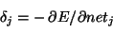
- The (negative) gradient for weight w_{ij}: |  | 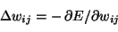
- The set of nodes anterior to unit i: |  | 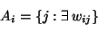
  - The set of nodes posterior to unit j:
Two factors by use of the chain rule:
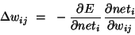
The first factor is the error of unit i. The second is
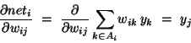
Putting the two together, we get
.
To compute this gradient, we thus need to know the activity and the error for all relevant nodes in the network.
Forward activation: The activity of the input units is determined by the network's external input x. For all other units, the activity is propagated forward:
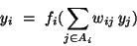
Note that before the activity of unit i can be calculated, the activity of all its anterior nodes (forming the set A_{i}) must be known. Since feed forward networks do not contain cycles, there is an ordering of nodes from input to output that respects this condition.
Calculating output error Assuming that we are using the sum-squared loss
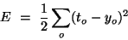
the error for output unit is simply.
Error back propagation For hidden units, we must propagate the error back from the output nodes (hence the name of the algorithm). Again using the chain rule, we can expand the error of a hidden unit in terms of its posterior nodes:
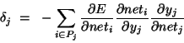
Of the three factors inside the sum, the first is just the error of node i. The second is
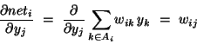
While the third is the derivative of node j's activation function:
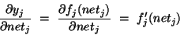
For hidden units h that use the tanh activation function, we can make use of the special identity
tanh(u)' = 1 - tanh(u)², giving us
Putting all the pieces together we get
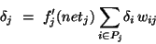
Note that in order to calculate the error for unit j, we must first know the error of all its posterior nodes (forming the set P_{j}). Again, as long as there are no cycles in the network, there is an ordering of nodes from the output back to the input that respects this condition. For example, we can simply use the reverse of the order in which activity was propagated forward.

3.1.6 Applications of neural networks
Neural networks have broad applicability to real world problems. In fact, they have already been successfully applied in many industries. Since neural networks are best at identifying patterns or trends in data, they are well suited for almost all problems including:
Aerospace In Aero space it is used in high performance aircraft autopilots, flight path simulations, aircraft control systems, autopilot enhancements, aircraft component simulations, aircraft component fault detectors, Automobile automatic guidance systems, warranty activity analyzers. In Banking neural network is used to Checks and other document readers, credit application evaluators. In Defense it is can be used as Weapon steering, target tracking, object discrimination, facial recognition, new kinds of sensors, sonar, radar and image signal processing including data compression, feature extraction and noise suppression, signal/image identification. Neural networking can be extensively used in Electronics for Code sequence prediction, integrated circuit chip layout, process control, chip failure analysis, machine vision, voice synthesis, nonlinear modeling. In Entertainment world it can be used as a tool for Animation, special effects, market forecasting etc. Its application are also in Financial for Real estate appraisal, loan advisor, mortgage screening, corporate bond rating, credit line use analysis, portfolio trading program, corporate financial analysis, currency price prediction. It can be used for Insurance Policy application evaluation, product optimization. In Manufacturing it is used for Manufacturing process control, product design and analysis, process and machine diagnosis, real-time particle identification, visual quality inspection systems, beer testing, welding quality analysis, paper quality prediction, computer chip quality analysis, analysis of grinding operations, chemical product design analysis, machine maintenance analysis, project bidding, planning and management, dynamic modeling of chemical process systems. Medical science can also take the benefit of neural networking in Breast cancer cell analysis, EEG and ECG analysis, prosthesis design, optimization of transplant times, hospital expense reduction, hospital quality improvement, and emergency room test advisement. It has a wide application in Robotics like Trajectory control, forklift robot, manipulator controllers, and vision systems etc. it is also used for Speech recognition, speech compression, vowel classification, text to speech synthesis, Market analysis, automatic bond rating, stock trading advisory systems. In Telecommunications it is applied in Image and data compression, automated information services, real-time translation of spoken language, customer payment processing systems. In Transportation neural networking can be used as Truck brake diagnosis systems, vehicle scheduling, routing systems.

Table 3.1: Application of Neural Networks

S.No. | AREA OF APPLICATION | REMARKS
1 | Production(cutting parameter opimization), Cus and Zuperl (2005) | In this paper, a neural network-based approach to complex optimization of cutting parameters is proposed. It describes the multi-objective technique of optimization of cutting conditions by means of the neural networks taking into consideration the technological, economic and organizational limitations. To reach higher precision of the predicted results, a neural optimization algorithm is developed and presented to ensure simple, fast and efficient optimization of all important turning parameters.
2 | Production(tool condition monitoring in metal cutting), Dimla,Lister and Leighton(1996) | In this paper a review of tool condition monitoring (TCM) systems, developed or implemented through application of neural networks, is provided. The review seeks to illustrate the extent of application of neural networks and the need for multiple source sensor signals in TCM systems.
3 | Production(cutting parameter optimization), Zuperl,Cus,Mursec and Ploj(2004) | In the contribution, a new hybrid optimization technique for complex optimization of cutting parameters is proposed. The developed approach is based on the maximum production rate criterion and incorporates 10 technological constraints. It describes the multi-objective technique of optimization of cutting conditions by means of the artificial neural network (ANN) and OPTIS routine by taking into consideration the technological, economic and organizational limitations.
4 | Production(tool condition monitoring in metal cutting), Dimla and Lister(1999) | This paper outlines a neural networks based modular tool condition monitoring system for cutting tool state classification. Test cuts were conducted on EN24 alloy steel using P15 and P25 coated cemented carbide inserts and on-line cutting forces and vibration data acquired. Simultaneously the wear lengths on the cutting edges were measured, and these together with the processed data were fed to a neural network trained to distinguish tool-state.
5. | Production( surface roughness prediction), Feng and Wang(2002) | The model considers the following working parameters: work-piece hardness (material), feed, cutter nose radius, spindle speed and depth of cut. Two competing data mining techniques, nonlinear regression analysis and computational neural networks, are applied in developing the empirical models. The values of surface roughness predicted by these models are then compared with those from some of the representative models in the literature. Metal cutting experiments and tests of hypothesis demonstrate that the models developed in this research have a satisfactory goodness of fit. It has also presented a rigorous procedure for model validation and model comparison.
6 | Production(surface quality of molded parts), Erzurumlu and Oktem(2005) | In this study, response surface (RS) model and an artificial neural network (ANN) are developed to predict surface roughness values error on mold surfaces. In the development of predictive models, cutting parameters of feed, cutting speed, axial–radial depth of cut, and machining tolerance are considered as model variables. For this purpose, a number of machining experiments based on statistical threelevel full factorial design of experiments method are carried out in order to collect surface roughness values. An effective fourth order RS model is developed utilizing experimental measurements in the mold cavity. A feed forward neural network based on back-propagation is a multilayered architecture made up of one or more hidden layers (2 layers–42 neurons) placed between the input (1 layer–5 neurons) and output (1 layer-1 neuron) layers. The response surface model and an artificial neural network are compared with manufacturing problems such as computational cost, cutting forces, tool life, dimensional accuracy, etc.
7 | Procedure presentation and operation validation in nuclear power plant, Mo,Lee and Seong(2007) | An operation guidance system (OGS) was developed to regulate and supervise operators’ actions during abnormal environments in nuclear power plants (NPPs). The system integrated a primitive computerized procedures system (CPS) and an operation validation system (OVS) imbedded in a virtual simulated operational environment. As the key component of the OGS, OVS provided two important functions for the operators: validated check of operations, and qualitative and quantitative effects analysis of operations. Each of operators’ action was evaluated by the system and possible results were simulated by using artificial neural networks (ANN). Finally, corresponding suggestion or warning was provided to operators.
8 | Inspection(LED inspection system), Chen and Hsu(2007) | This paper presents neural-network-based recognition system for automatic light emitting diode (LED) inspection. Two types of neural- networks, back-propagation neural-network (BPNN) and radial basis function network (RBFN), are proposed and tested. The current– voltage (I–V) data from the LED inspection process is used for the network training and testing. This study adopts 300 random picking as network training and employs 100 samples as network testing. The experimental results show that if the classification work is done well, the accuracy of recognition is 100% for BPNN and 96% for RBFN, and the testing speed of the proposed approach is almost one half faster than the traditional inspection system does.
9 | Medical(Image compression and segmentation), Dokur(2006) | This paper presents a novel unified framework for compression and decision making by using artificial neural networks. The proposed framework is applied to medical images like magnetic resonance (MR), computer tomography (CT) head images and ultrasound image. Two artificial neural networks, Kohonen map and incremental self-organizing map (ISOM), are comparatively examined.Compression and decision making processes are simultaneously realized by using artificial neural networks.
10 | Civil(General application), Jeng,Cha and Blumenstein | In this paper, an artificial neural network (ANN) is applied to several civil engineering problems, which have difficulty to solve or interrupt through conventional approaches of engineering mechanics. These include tide forecasting, earthquake-induced liquefaction and wave-induced seabed instability. As shown in the examples, ANN model can provide reasonable accuracy for civil engineering problems, and a more effective tool for engineering applications.
11 | Civil(water resource management), Iliadis and Marsi(2007) | This is a preliminary attempt towards a wider use of Artificial Neural Networks in the management of mountainous water supplies. It proposes a model to be used effectively in the estimation of the average annual water supply, in each mountainous watershed of Cyprus. This is really a crucial task, especially during the long dry summer months of the island. On the other hand the evaluation of the potential torrential risk due to high volume of water flow in the winter season is also very important. Data (from 1965e1993) from 78 measuring stations located in the 70 distinct watersheds of Cyprus were used. This data volume was divided in the training subset comprising of 60 cases and in the testing subset containing 18 cases. The input parameters are the area of the watershed, the average annual and the average monthly rain-height, the altitude and the slope in the location of the measuring station. Consequently three structural and two dynamic factors are considered. After several and extended training-testing efforts a Modular Artificial Neural Network was determined to be the optimal one.
12 | Forecasting, Hui(2007) | This study proposes a new method for predicting the reliability for repairable systems. The novel method constructs a predictive model by employing evolutionary neural network modeling approach. Genetic algorithms are used to globally optimize the number of neurons in the hidden layer and learning parameters of the neural network architecture.
13 | Machining(stellite 6), Aykut,Golcu,Semiz and Ergur(2007) | In this study, artificial neural networks (ANNs) was used for modeling the effects of machinability on chip removal cutting parameters for face milling of stellite 6 in asymmetric milling processes. Cutting forces with three axes (Fx, Fy and Fz) were predicted by changing cutting speed (Vc), feed rate (f) and depth of cut (ap) under dry conditions. Experimental studies were carried out to obtain training and test data and scaled conjugate gradient (SCG) feed-forward back-propagation algorithm was used in the networks.
14 | Thermal (Predictive temperature control), Aggelogiannaki,Sarimveis and Koubogiannis(2007) | In this paper, a nonlinear model predictive control (MPC) configuration for hyperbolic distributed thermal systems is presented and applied in the flow-based temperature control in a long duct. At first, a radial basis function neural network is developed to estimate the temperature distribution along the duct with respect to flow velocity, assuming constant ambient temperature. The nonlinear model is then incorporated in the context of an MPC procedure. The use of the neural network model avoids the spatial discretization and decreases significantly the computational effort required to solve the optimization problem that is formulated in real time, compared to conventional modeling approaches. The proposed MPC scheme is able to overcome delay effects and accelerates the outlet temperature response. Reduced tuning effort is another advantage of the proposed control scheme.
15 | Thermal (Free Laminar convection heat transfer), Mahmoud and Nakhi(2005) | The feasibility of using neural networks (NNs) to predict the complete thermal and flow variables throughout a complicated domain, due to free convection, is demonstrated. Attention is focused on steady, laminar, two-dimensional, natural convective flow within a partitioned cavity. The objective is to use NN (trained on a database generated by a CFD analysis of the problem of a partitioned enclosure) to predict new cases; thus saving effort and computation time. Three types of NN are evaluated, namely General Regression NNs, Polynomial NNs, and a versatile design of Backpropagation neural networks. An important aspect of the study was optimizing network architecture in order to achieve best performance. For each of the three different NN architectures evaluated, parametric studies were performed to determine network parameters that best predict the flow variables.
16 | Forging, Serajzadeh(2006) | In this work, a neural network model is used to calculate flow stress of deforming metal as a function of temperature, strain and strain rate. Then, with the aid of this model and employing a finite element analysis, flow behavior of material and the temperature variations in hot upsetting process are predicted. To examine the model, hot nonisothermal forging of low carbon steel is performed while force–displacement behavior during hot deformation is recorded. A good agreement is observed between the predicted data and the measured results.

REGRESSION ANALYSIS

Regression Analysis is a statistical forecasting model, that is concerned with describing and evaluating the relationship between a given variable (usually called the dependent variable) and one or more other variables (usually called the independent variables).
3.2.1 Linear Regression
In statistics, linear regression is a regression method that allows the relationship between the dependent variable Y and the p independent variables X and a random term ε. The model can be written as
Y = β₁ + β₂ X₂ +………. + β_{p}X_{p} + ε
where β₁ is the intercept ("constant" term), the β_{I} are the respective parameters of independent variables, and p is the number of parameters to be estimated in the linear regression.
This method is called "linear" because the relation of the response to the explanatory variables is assumed to be a linear function of the parameters. It is often erroneously thought that the reason the technique is called "linear regression" is that the graph of Y = β₀ + βX is a straight line or that Y is a linear function of the X variables. But if the model is (for example)
Y = α + βX + γX ²
The problem is still one of linear regression, that is, linear in x and x² respectively, even though the graph on x by itself is not a straight line.
There are many different approaches to solving the regression problem that is, determining suitable estimates for the parameters.
3.2.2 Nonlinear Regression
In statistics, nonlinear regression is the problem of inference for a model
y = f (x, θ) + ε
Based on multidimensional x,y data, where f is some nonlinear function with respect to unknown parameters θ. At a minimum, we may like to obtain the parameter values associated with the best fitting curve (usually, least squares).Also, statistical inference may be needed, such as confidence intervals for parameters, or a test of whether of not the fitted model agrees well with the data.
The scope of nonlinear regression is clarified by considering the case of polynomial regression, which actually is best not treated as a case of nonlinear regression. When f takes a form such as
f(x) = ax² + bx + c
Our function f is nonlinear as a function of x but it is linear as a function of unknown parameters a, b, and c. The latter is the sense of "linear" in the context of statistical regression modeling. The appropriate computational procedures for polynomial regression are procedures of (multiple) linear regression with two predictor variables x and x² say. However, on occasion it is suggested that nonlinear regression is needed for fitting polynomials. Practical consequences of the misunderstanding include that a nonlinear optimization procedure may be used when the solution is actually available in closed form. Also, capabilities for linear regression are likely to be more comprehensive in some software than capabilities related to nonlinear regression.
3.2.3 Analysis Technique
3.2.3.1 Least-squares analysis
Least-squares analysis was developed by Carl Friedrich Gauss in the 1820s. This method uses the following Gauss-Markov assumptions:
- The random errors ε_{i} have expected value 0.
- The random errors ε_{i} are uncorrelated (this is weaker than an assumption of probabilistic independence).
- The random errors ε_{i} are homoscedastic, i.e., they all have the same variance.
These assumptions imply that least-squares estimates of the parameters are optimal in a certain sense.
A linear regression with p parameters (including the regression intercept β₁) and n data points (sample size), with n >= (p + 1) allows construction of the following vectors and matrix with associated standard errors:
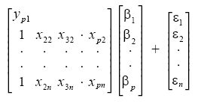
or, from vector-matrix notation above,
Y = Xβ + ε
Each data point can be given as , i = 1,2,3………..n. For n = p, standard errors of the parameter estimates could not be calculated. For n less than p, parameters could not be calculated.
The estimated values of the parameters can be given as
= (X^{T}X)⁻¹ X^{T}

Using the assumptions provided by the Gauss-Markov Theorem, it is possible to analyze the results and determine whether or not the model determined using least-squares is valid. The number of degrees of freedom is given by m − n.
The residuals, representing 'observed' minus 'calculated' quantities, are useful to analyze the regression. They are determined from
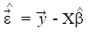
The standard deviation, for the model is determined from
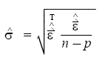
The variance in the errors can be described using the Chi-square distribution:
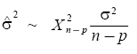
The 100(1 − α) % confidence interval for the parameter, β_{i}, is computed as follows:
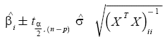
where t follows the Student's t-distribution with m − n degrees of freedom and (X^{T}X)_{ii} ⁻¹ denotes the value located in the i^{th} row and column of the matrix.
The 100(1 − α) % mean response confidence interval for a prediction (interpolation or extrapolation) for a value is given by:
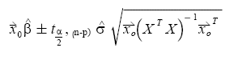
Where, 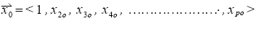
The 100(1 − α) % predicted response confidence intervals for the data are given by:
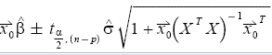
The regression sum of squares SSR is given by:
SSR = ∑ (_{i} - ) ²
where is an n by 1 unit vector.
The error sum of squares ESS is given by:
ESS = ∑ (y_{i} - _{i} ) ²
The total sum of squares TSS' is given by
TSS = ESS + SSR
Pearson's co-efficient of regression, R² is then given as:
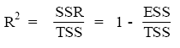
Assessing the least-squares model
Once the above values have been corrected, the model should be checked for 2 different things:
- Whether the assumptions of least-squares are fulfilled and
- Whether the model is valid
3.2.3.2 Model assumptions
The model assumptions are checked by calculating the residuals and plotting them. The residuals are calculated as follows:
The following plots can be constructed to test the validity of the assumptions:
- Plotting a normal probability plot of the residuals to test normality. The points should lie along a straight line.
- Plotting a time series plot of the residuals, that is, plotting the residuals as a function of time.
- Plotting the residuals as a function of the explanatory variables, X.
- Plotting the residuals against the fitted values, .
- Plotting the residuals against the previous residual.
In all, but the first case, there should not be any noticeable pattern to the data.
3.2.3.3 Model validity
The validity of the model can be checked using any of the following methods:
- Using the confidence interval for each of the parameters, β_{i}. If the confidence interval includes 0, then the parameter can be removed from the model. Ideally, a new regression analysis excluding that parameter would need to be performed and continued until there are no more parameters to remove.
- Calculate Pearson’s co-efficient of regression. The closer the value is to 1; the better the regression is. This co-efficient gives what fraction of the observed behavior can be explained by the given variables.
- Examining the observational and prediction confidence intervals. The smaller they are the better.
- Computing the F-statistic.
Confidence or prediction interval of a regression line
If you check the option box, Prism will calculate and graph either the 95% confidence interval or 95% prediction interval of the regression line. Two curves surrounding the best-fit line define the confidence interval.
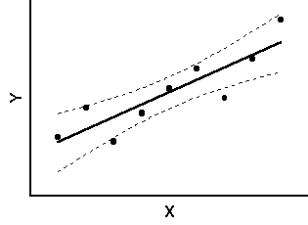
The dashed lines that demarcate the confidence interval are curved. This does not mean that the confidence interval includes the possibility of curves as well as straight lines. Rather, the curved lines are the boundaries of all possible straight lines. The figure below shows four possible linear regression lines (solid) that lie within the confidence interval (dashed).
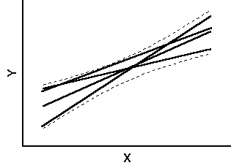
Given the assumptions of linear regression, you can be 95% confident that the two curved confidence bands enclose the true best-fit linear regression line, leaving a 5% chance that the true line is outside those boundaries.
Many data points will be outside the 95% confidence interval boundary. The confidence interval is 95% sure to contain the best-fit regression line. This is not the same as saying it will contain 95% of the data points.
The 95% prediction interval is the area in which you expect 95% of all data points to fall. In contrast, the 95% confidence interval is the area that has a 95% chance of containing the true regression line. This graph shows both prediction and confidence intervals (the curves defining the prediction intervals are further from the regression line).
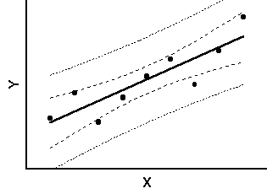
The analysis of Experimental results obtained of surface roughness was analyzed. The data for speed, feed, depth of cut and surface roughness was recorded and analyzed in terms of obtaining best fit curve equations.
Chapter 4
EXPERIMENT SET UP

In this chapter, we would discuss the experimental set up, machine used its limitations, advantages, measuring instrument, tooling used on the machine.

4.1 CNC trainer lathe
The CNC Trainer Lathe consists of the machine unit with a three jaw independent chuck,
a computer numerically controlled tool slide, which cud move accordingly to two axis horizontal and vertical- X and Z axis. X axis represents the vertical movement which gives the depth of cut where as Z axis represents the location of the cutting tool. Thus after deciding the machining zero at a certain point the command is given in the form of a part program. The machine is also provided with a automatic lubrication motor for its slides.
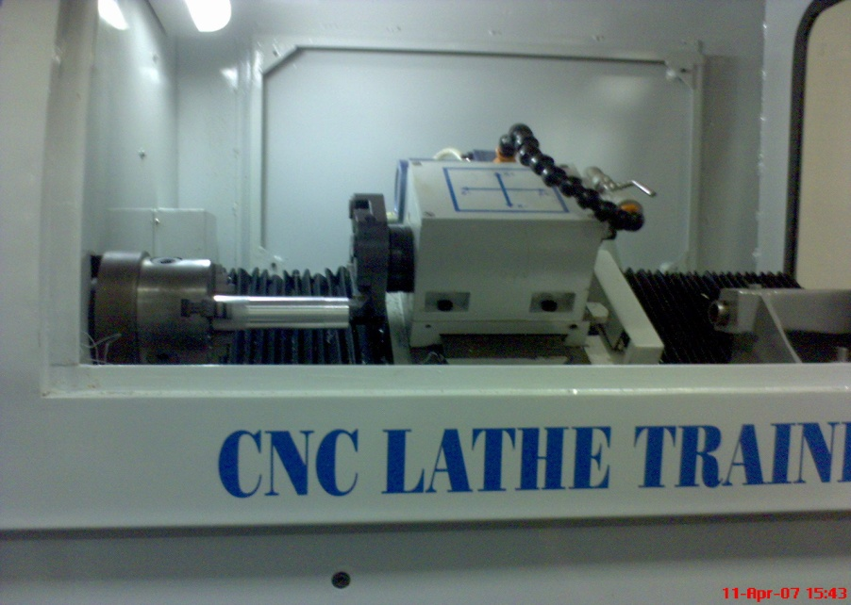

Figure: 4.1 CNC TRAINER LATHE
System configuration
ENKAY make CNC lathe is the Computer Numerically Controlled Lathe Trainer. This machine has following configurations.
- Machine Controller consists of :
  - Pentium IV (866 MHz) with preinstalled Windows-98
  - 128 MB RAM
  - 40 GB HDD
  - SVGA Color Monitor
  - I/O interface card. (Inside PC)
- Electronic Stabilizer :
  - Capacity – 3KVA
  - Regulation 1%
  - Voltage 230V
  - Current – 10 Amp.
  - Frequency – 50 Hz.
- Lubrication motor :
  - Voltage – 230V
  - Current – 1 Amp.
  - Operating Pressure : 6 – 15 Kg/Cm²
- X & Z Axes Stepper motor :
  - Capacity – 13 Kg-Cm for X Axis & 20 Kg-Cm for Z Axis.
  - Operating Voltage 36V DC
  - O/P Current– 4 Amp.
- Power supply :
  - Input 230V, 5 Amps.
  - Output 24V, 2 Amps.
  - 5V, 2 Amp, 15/0/ - 15V 500 mA
- SPECIFICATIONS OF I/0 CARD: (PCI 1751) :
  - I/O Controller – 8255-2
  - Slot for connection – PCI slot on the motherboard of the PC.
  - I/O Lines – 32 output & 16 inputs.
Table 4.1 CNC lathe trainer specifications
Model | SS-PT-100
Swing over bed | 250mm
Swing over cross slide | 100mm
Distance between centers | 400mm
Max. Longitudinal Travel | 350mm
Spindle inside diameter | MT3
Type of bearing for spindle | Angular contact bearings
Spindle Speed | 50 to 3500 rpm
Thrust (max.) | 120 kg
Cross Slide inclination | 0 deg.
Standard cutting tool size | 16*16mm
Spindle Motor | 2hp, PDNC
Threading | Straight
Automatic Lubrication points | Provided
Input System | Metric/inch
Control Axes | Simultaneous
Interpolation | Linear and circular
Minimum movement command X | 0.005
Minimum movement command Z | 0.005
Rapid Feed Rate X | 200 mm/min
Rapid Feed Rate X | 400 mm/min
X axis ballscrew | 16mm* 5mm PITCH
Z axis ballscrew | 25mm* 5mm PITCH
Feed override | 100%
Dwell (sec) | Programmable
Backlash compensation | Provided
Constant surface speed control | G96, G97
Canned Cycles | Available
In Built interface | Serial, Parallel
Manual reference point return | Provided
Emergency Stop | Provided
S function | Provided
Floor Space required | 1100* 700mm
Overall height of machine | 1450 mm
Net weight | 210 kg
4.2 Surface Roughness Measuring Instrument
The Surtronic 3+ is a portable, self-contained instrument for the measurement of surface texture and is suitable for use in both the workshop and laboratory. Parameters available for surface texture evaluation are: Ra, Rq, Rz (DIN), Ry and Sm.
The parameters evaluations and other functions of the instrument are microprocessor based. The measurement results are displaced on an LCD screen and can be output to an optional printer or another computer for further results.
The instrument is normally powered by an alkaline non-rechargeable battery. If preferred, a Ni-Cad rechargeable battery can be used.

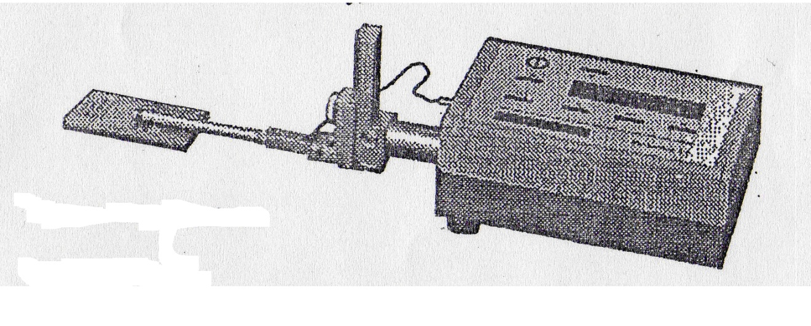
Figure: 4.2 Surface roughness measurement apparatus
(Referred from Instrument Manual)

Display-Transverse Unit
The top panel of the display-traverse unit carries a membrane type control panel and a liquid crystal display. The unit houses the electronics for controlling the measurement sequence, computing the measurement data and outputting the results to the display, or to the RS232 port for use with a printer( when included) or to a computer for further analysis.

The unit also contains a drive motor which traverses the pickup across the surface to be measured. The measuring stroke always starts from the extreme outward positions. At the end of the measurement the pick up returns to this position ready for the next measurement. The traverse length is determined from selections of cut-off (Lc) or length (Ln).

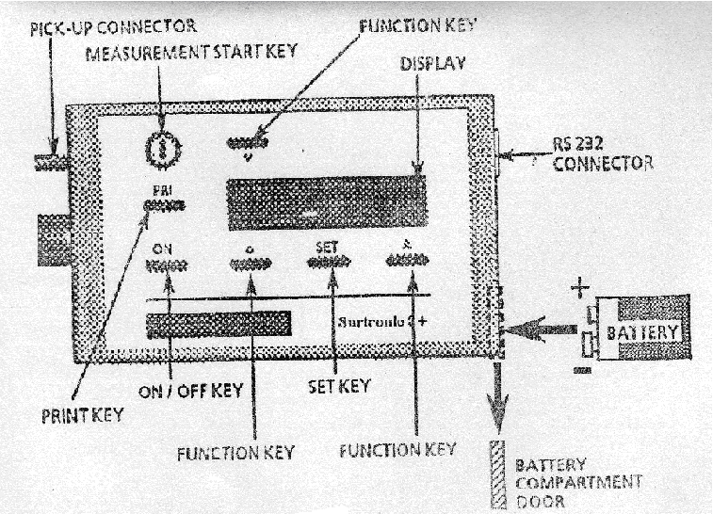

Figure: 4.3 Display Transverse Unit (Referred from Instrument Manual)

Pick-Up Mounting Components
The pick-up is fastened to the drive shaft by the following means:

Mounting Bracket: This is clamped to the drive shaft by means of a knurled knob. Although normally used upright, it can be turned to angle the pick-up or to take it off the centre line. It can also be mounted sideways on the drive shaft, when the right-angle pick-up is in use.
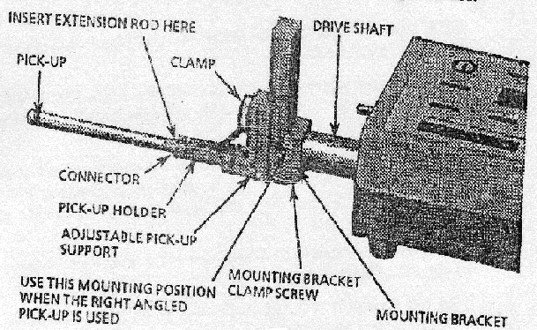

Figure: 4.4 Mounting Bracket (Referred from Instrument Manual)
Adjustable Support: this can be clamped at any positions on the slide of the mounting bracket to provide pick-up height adjustment.

Pick-up Holder: This fits into the crutch of the pick-up support and is held in place by a spring plunger.
Connector: the connector of the pick-up lead is screwed into the end of pick-up and is then inserted into the end of the pick-up holder, with the lead coming out through the slot in the holder. It is advisable to connect the lead to the display-traverse unit first and then to the pick-up. When the extension rod is used, the short pick-up is not required and the end of the rod itself is inserted into the holder.

DIP switch settings: The instrument default settings, when powering up with a new battery, are set via DIP switches housed inside the display-traverse unit. The selections can be changed by menu/pushbuttons operations. The DIP switches are accessed by unscrewing the three feet from the base of the display-traverse unit, then removing the screws which were partly covered by the feet.

Pick-up
The pickup is a variable reluctance type transducer which is supported on the surface to be measured by a skid, a curved support projecting from the underside of the pickup in the vicinity of the stylus. As the pickup traverses across the surface, movements of the stylus relative to the skid are detected and are converted into a proportional electrical signal. The radius of curvature of the skid is much greater than the roughness spacing. This enables it to ride across the surface almost unaffected by the roughness, and provides a datum representing the general form of the surface. Even so, where the waviness is widely spaced it will be necessary to use the pickup with shoe, in conjunction with the 2.5mm (0.1 in) cut-off.
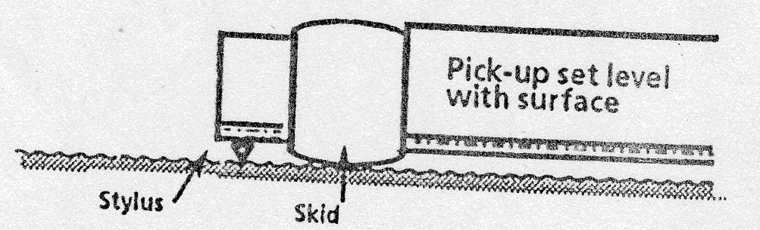

Figure: 4.5 Pick-up (Referred from Instrument Manual)

Specifications

Battery: Alkaline: Minimum 600 Measurements of 4mm Measurements Lengths.
Ni-Cad: Minimum 200 Measurement of 4mm Length
Size: 6 LR 61 (USA/Japan), Fixed Battery
External Charger (Ni-Cad Only)
110/240V, 50/60 Hz
Traverse Unit: Traverse Speed: 1mm/Sec
Measurement: Metric/Inch Preset by DIP-Switch
Cut-Off Values: 0.25mm, 0.8mm, and 2.50mm
Traverse Length: 1, 3, 5, 10, Or 25.4 + 0.2mm At 0.8mm Cut-Off.
Display: LCD-Matrix. 2lines * 16 Characters
Keyboard: Membrane Switch Panel Tactile.
Filters: Digital Gauss Filters or 2CR Filter (ISO) Selectable By DIP-Switch.
Parameters: Ra, Rq, Rz (DIN), Ry and Sm.
Calculations Time: Less Than Reversal Time Or 2 Sec Which Ever Is The Longer.
4.3 Workpiece material
CNC Lathe Trainer made ENKAY was available for turning only Non-ferrous materials. The chuck holding the work piece diameter was only limited to 35 mm and the maximum work piece length was limited to about 150 mm length. Even the work pieces required are soft but ductile nature as the machine was not preferred to work on much harder work pieces.

Standardized material were selected to ensure consistency of the alloy, which was a common wrought alloy used in industry 6061 Aluminum HINDALCO and Brass(IS 319 GRADE I) made in the form of bars with the size of diameter 28.5 mm 120mm length and 30.1 mm dia 120 mm length respectively,so as to fit under the chuck. I took three pieces of each material so as to conduct my turning process three times on a single work piece while calculating the average roughness value, simultaneously by the Stylus instrument. To more closely replicate typical finish turning processes and to avoid excessive vibrations due to work piece dimensional inaccuracies and defects, each work piece was rough-cut just prior to the measured finish cut.

After one rough cut on each work piece so as to smooth the surface, each work piece is divided into three zones with length starting from one face from where tool starts cutting. Thus simultaneously we could choose the machining zero required for generating cutting profile with reference to our work piece dimensions. These three zones of machining would represent three different values of feed at one depth of cut and at a single speed. These zones were from 0-25 mm, 25-50 mm and 50-75 mm from the machining zero side. Surtronic 3+ instrument available has a pickup with a skid which is used to travel automatically through a drive motor. Thus such travel would at least require a distance of at least 10 mm. Thus we require appropriate surface travel distance on turned aluminum work piece. These dimensions were taken so as to keep travel the stylus on the best surface as the cutting could improper at the starting or at the end. In this way the error in measurement cud also be reduced and there are less chance of measuring the wrong side values.

The aluminum we have chosen for turning is actually a Heat Treatable Alloy manufactured in the form of bars by HINDALCO. The inputs which were fed in the form of part program include dimensions of the work piece, cutting parameters depth of cut in mm, Speed available was 50-3500 rpm and feed in mm/min.
Cutting Parameters taken theoretically from the text were as follows: For Aluminum Alloys:
Table 4.2 Chemical Composition of Aluminium Alloy

Element | Weight %
Cu | 0.15-0.4
Mg | 0.7-1.2
Si | 0.4-0.8
Fe | 0.7 max
Mn | 0.2-0.8
Other | 0.4

Table 4.3 Mechanical properties (Referred from HINDALCO manual)

Alloy  Old(ISS)  New(ISS) | Ultimate Tensile Strength Kg/mm² |  | 0.2% Proof Stress,Kg/mm² | Elongation ON 50mm GL
Alloy  Old(ISS)  New(ISS) | Min. | Max. | 0.2% Proof Stress,Kg/mm² | Elongation ON 50mm GL
6061 | ----  19  28.5 | 15  ----  ---- | -----  11.5  24.0 | 16.0  14.0  7.0

This standard structural alloy, one of the most versatile of the heat- treatable alloys, is popular for medium to high strength requirements and has good toughness characteristics. Applications range from transportation components to machinery and equipment applications to recreation products and consumer durables.

Alloy 6061 has excellent corrosion resistance to atmospheric conditions and good corrosion resistance to sea water. This alloy also offers good finishing characteristics and responds well to anodizing. Alloy 6061 is easily welded and joined by various commercial methods. (Caution: direct contact by dissimilar metals can cause galvanic corrosion). For screw machine applications, alloy 6061 has adequate machinability characteristics in the heat-treated condition.

4.4 Cutting Tool Material
The cutting tool which is provided with the CNC lathe Trainer was a 30 mm square tool
with 60 mm length having the same tool angles as for a normal turning tool.
All the three elements-tungsten, molybdenum and cobalt help in achieving high hot hardness; the first two do so by forming complex carbides and the cobalt forms an alloy by going into solid solution in the ferrite matrix and thus raising the recrystallisation temperature. Vanadium in high speed steels increases the wear resistance of tool at all operating temperatures. Vanadium also helps to inhibit grain growth at the high temperatures required in heat treatment.

The tool used was cemented carbide insert type. The geometry of tool is: Rake angle 6⁰ (+ve), 5⁰ (+ve) clearance angle, 60⁰ (+ve) major cutting edge angle, 60⁰ (+ve) included angle and 0⁰ cutting edge inclination angle.
Chapter 5
ANALYSIS OF MACHINING DATA

Regression analysis is one of the most widely used techniques for analyzing multifactor data. Its broad appeal and usefulness result from the conceptually logical process of using an equation to express the relationship between a variable of interest (the response) and a set of related predictor variables. So regression analysis was used to develop the parametric equations. The following factors are used in the present analysis
Regression sum of squares:
${\text{SS}}_{R}=\sum_{i=1}^{n}{{\left({\hat{y}}_{i}−\bar{y}\right)}^{2}}$ (5.1)
Where $\bar{y}$= sum of dependent variable
${\hat{y}}_{i}$= fitted value of i^{th} dependent variable
Residual sum of squares:
${\text{SS}}_{\text{Res}}=\sum_{i=1}^{n}{{\left(y_{i}−{\hat{y}}_{i}\right)}^{2}}$ (5.2)
y_{i} = observed value of i^{th} dependent variable
Total sum of squares: It is the total variability in the observations of the data.
${\text{SS}}_{T}={\text{SS}}_{R}+{\text{SS}}_{\text{Res}}$ (5.3)
Predictor variables
$k={\text{SS}}_{R} / σ^{2}$ (5.4)
This has the same number of degree of freedom as number of regressor or predictor variables in the model.
σ² = variance
Regression mean squares
${\text{MS}}_{R}=\frac{{\text{SS}}_{R}}{k}$ (5.5)
Residual mean squares
${\text{MS}}_{\text{Res}}=\frac{{\text{SS}}_{\text{Res}}}{n−p}$ (5.6)
p = k +1 = parameter in the regression model
n = number of observations
Test of statistic
$F=\frac{{\text{MS}}_{R}}{{\text{MS}}_{\text{Res}}}$ (5.7)
Coefficient of determination
$R^{2}=\frac{{\text{SS}}_{R}}{{\text{SS}}_{T}}=1−\frac{{\text{SS}}_{\text{Res}}}{{\text{SS}}_{T}}$ (5.8)
Adjusted coefficient of determination
$\text{Adjusted} R^{2}=1−\frac{{{\text{SS}}_{\text{Res}}}/{\left(n−p\right)}}{{{\text{SS}}_{T}}/{\left(n−1\right)}}$ (5.9)
Standard error of regression: $\text{SE}=\sqrt{{\text{MS}}_{\text{Res}}}$ (5.10)

Mathematical Models Formulation of Machining Data
The purpose of developing the mathematical models relating the machining responses and their machining factors was to facilitate the optimization of the machining process. Using these mathematical models, the objective function and process constraints were formulated, and the optimization problem was then solved by using regression analysis.
The mathematical models commonly used are represented by:
$Y=φ\left(\text{V,f,d}\right)$ (5.11)
Where Y is the machining response,
$ϕ$ is the response function,
and V, f, d are machining variables.

5.1.1 Linear Regression
When expressed in the linear form, equation 5.11 becomes
Y = C + αV + βf + γd (5.12)
The surface roughness model was formulated as:
R_{a} = C + αV + βf + γd (5.13)
Using these mathematical models, the objective function and process constraints were formulated, and the optimization problem was then solved by using regression analysis as shown in Figure 5.1

Surface
Roughness

Cutting speed

Feed

Depth of cut

Raw machinability data
Data set

Procedure

Output

Figure: 5.1 Flow Chart for processing Linear Model in regression analysis

Table 5.1 Data Collection for Linear Model [For Aluminium]
S.No. | Diameter  (mm) | RPM | V | d | Feed |  | Ra | Predicted Ra
 | Diameter  (mm) | RPM | (m/min) | (mm) | (mm/min) | (mm/rev) | (µm) | Predicted Ra
1. | 28.5 | 1000 | 89.49 | 0.2 | 25 | 0.025 | 1.16 | 1.34
2. | 28.5 | 1000 | 89.49 | 0.2 | 50 | 0.05 | 2.6 | 2.23
3. | 28.5 | 1000 | 89.49 | 0.2 | 75 | 0.075 | 4.48 | 3.13
4. | 28.1 | 1000 | 88.23 | 0.3 | 25 | 0.025 | 0.96 | 1.04
5. | 28.1 | 1000 | 88.23 | 0.3 | 50 | 0.05 | 1.18 | 1.93
6. | 28.1 | 1000 | 88.23 | 0.3 | 75 | 0.075 | 2.3 | 2.83
7. | 27.5 | 1000 | 86.35 | 0.4 | 25 | 0.025 | 0.98 | 0.73
8. | 27.5 | 1000 | 86.35 | 0.4 | 50 | 0.05 | 1.58 | 1.63
9. | 27.5 | 1000 | 86.35 | 0.4 | 75 | 0.075 | 2.56 | 2.52
10. | 28.5 | 1200 | 107.39 | 0.2 | 25 | 0.0208 | 1.04 | 1.28
11. | 28.5 | 1200 | 107.39 | 0.2 | 50 | 0.0416 | 1.92 | 2.02
12. | 28.5 | 1200 | 107.39 | 0.2 | 75 | 0.0625 | 2.78 | 2.77
13. | 28.1 | 1200 | 105.88 | 0.3 | 25 | 0.0208 | 1.1 | 0.97
14. | 28.1 | 1200 | 105.88 | 0.3 | 50 | 0.0416 | 1.44 | 1.72
15. | 28.1 | 1200 | 105.88 | 0.3 | 75 | 0.0625 | 2.4 | 2.46
16. | 27.5 | 1200 | 103.62 | 0.4 | 25 | 0.0208 | 0.9 | 0.67
17. | 27.5 | 1200 | 103.62 | 0.4 | 50 | 0.0416 | 1.2 | 1.41
18. | 27.5 | 1200 | 103.62 | 0.4 | 75 | 0.0625 | 1.86 | 2.16
19. | 28.5 | 1400 | 125.30 | 0.2 | 25 | 0.0179 | 1.28 | 1.25
20. | 28.5 | 1400 | 125.30 | 0.2 | 50 | 0.0357 | 1.8 | 1.90
21. | 28.5 | 1400 | 125.30 | 0.2 | 75 | 0.0536 | 2.54 | 2.53
22. | 28.1 | 1400 | 123.53 | 0.3 | 25 | 0.0179 | 0.72 | 0.95
23. | 28.1 | 1400 | 123.53 | 0.3 | 50 | 0.0357 | 1.2 | 1.59
24. | 28.1 | 1400 | 123.53 | 0.3 | 75 | 0.0536 | 2.2 | 2.23
25. | 27.5 | 1400 | 120.89 | 0.4 | 25 | 0.0179 | 1.6 | 0.64
26. | 27.5 | 1400 | 120.89 | 0.4 | 50 | 0.0357 | 1.4 | 1.28
27. | 27.5 | 1400 | 120.89 | 0.4 | 75 | 0.0536 | 2.04 | 1.92
Table 5.2 Regression Analysis for Linear Model [For Aluminium]
n | 27
R² | 0.74
Adjusted R² | 0.71
SE | 0.4383
Term | Coefficient | SE | P | 95% CI of Coefficient
Intercept | 0.6131 | 0.8412 | 0.4734 | -1.1270 | to 2.3532
V - (m/min) | 0.0047 | 0.0062 | 0.4520 | -0.0081 | to 0.0175
d - (mm) | -2.9553 | 1.0397 | 0.0092 | -5.1060 | to -0.8046
f - (mm/rev) | 35.8601 | 4.8181 | <0.0001 | 25.8932 | to 45.8270
Source of variation | SSq | DF | MSq | F | p
Due to regression | 12.849 | 3 | 4.283 | 22.29 | <0.0001
About regression | 4.419 | 23 | 0.192
Total | 17.267 | 26

Figure: 5.2 Regression Analysis showing Variation of Surface roughness parameter in linear model for Aluminium

Surface roughness equation for linear model
The data of analysis of variance of the roughness model for finish turning operation for aluminum are shown in table 5.2. The surface roughness model developed as:
R_{a} = 0.6131 + 0.0047V -2.9553d + 35.8601f (5.14)
The R-square value of 0.74 indicated that 74% of the variability in the surface roughness was explained by the model with factors V, f and d. Based on the mathematical model, it can be concluded that the cutting speed is a dominant factor in the roughness model of finish turning in heavy machining operation.

5.1.2 Non-Linear Model
When expressed in the non- linear form, equation 5.11 becomes
$$Y=C V^{α} f^{β} d^{γ}$$
The surface roughness model was formulated as:
(5.15)
Logarithms taken on both sides of the equation 5.15
(5.16)

Equation 5.16 changed into the regression equation by changing the factors as:
Using these mathematical models, the objective function and process constraints were formulated, and the optimization problem was then solved by using regression analysis as shown in Figure 5.3

Surface
Roughness

Cutting speed

Feed

Depth of cut

Raw machinability data
Logarithmic transformation
Data set
Procedure
Output
Figure: 5.3 Flow Chart for processing Non-Linear Model in regression analysis

Table 5.3 Data Collection for Non-Linear Model [For Aluminium]
S.No. | Diameter  (mm) | RPM | V | d | Feed |  | Ra | Predicted Ra
 | Diameter  (mm) | RPM | (m/min) | (mm) | (mm/min) | (mm/rev) | (µm) | Predicted Ra
1. | 28.5 | 1000 | 89.49 | 0.2 | 25 | 0.025 | 1.16 | 1.266372
2. | 28.5 | 1000 | 89.49 | 0.2 | 50 | 0.05 | 2.6 | 2.135097
3. | 28.5 | 1000 | 89.49 | 0.2 | 75 | 0.075 | 4.48 | 2.898144
4. | 28.1 | 1000 | 88.23 | 0.3 | 25 | 0.025 | 0.96 | 1.066559
5. | 28.1 | 1000 | 88.23 | 0.3 | 50 | 0.05 | 1.18 | 1.798213
6. | 28.1 | 1000 | 88.23 | 0.3 | 75 | 0.075 | 2.3 | 2.440863
7. | 27.5 | 1000 | 86.35 | 0.4 | 25 | 0.025 | 0.98 | 0.939936
8. | 27.5 | 1000 | 86.35 | 0.4 | 50 | 0.05 | 1.58 | 1.584727
9. | 27.5 | 1000 | 86.35 | 0.4 | 75 | 0.075 | 2.56 | 2.151082
10. | 28.5 | 1200 | 107.39 | 0.2 | 25 | 0.0208 | 1.04 | 1.185857
11. | 28.5 | 1200 | 107.39 | 0.2 | 50 | 0.0416 | 1.92 | 1.999349
12. | 28.5 | 1200 | 107.39 | 0.2 | 75 | 0.0625 | 2.78 | 2.713882
13. | 28.1 | 1200 | 105.88 | 0.3 | 25 | 0.0208 | 1.1 | 0.998748
14. | 28.1 | 1200 | 105.88 | 0.3 | 50 | 0.0416 | 1.44 | 1.683884
15. | 28.1 | 1200 | 105.88 | 0.3 | 75 | 0.0625 | 2.4 | 2.285675
16. | 27.5 | 1200 | 103.62 | 0.4 | 25 | 0.0208 | 0.9 | 0.880176
17. | 27.5 | 1200 | 103.62 | 0.4 | 50 | 0.0416 | 1.2 | 1.483972
18. | 27.5 | 1200 | 103.62 | 0.4 | 75 | 0.0625 | 1.86 | 2.014318
19. | 28.5 | 1400 | 125.30 | 0.2 | 25 | 0.0179 | 1.28 | 1.12179
20. | 28.5 | 1400 | 125.30 | 0.2 | 50 | 0.0357 | 1.8 | 1.891332
21. | 28.5 | 1400 | 125.30 | 0.2 | 75 | 0.0536 | 2.54 | 2.567261
22. | 28.1 | 1400 | 123.53 | 0.3 | 25 | 0.0179 | 0.72 | 0.944789
23. | 28.1 | 1400 | 123.53 | 0.3 | 50 | 0.0357 | 1.2 | 1.59291
24. | 28.1 | 1400 | 123.53 | 0.3 | 75 | 0.0536 | 2.2 | 2.162189
25. | 27.5 | 1400 | 120.89 | 0.4 | 25 | 0.0179 | 1.6 | 0.832623
26. | 27.5 | 1400 | 120.89 | 0.4 | 50 | 0.0357 | 1.4 | 1.403798
27. | 27.5 | 1400 | 120.89 | 0.4 | 75 | 0.0536 | 2.04 | 1.905492
Table 5.4 Regression Analysis for Non-Linear Model
n | 27
R² | 0.76
Adjusted R² | 0.72
SE | 0.0981
Term | Coefficient | SE | P | 95% CI of Coefficient
Intercept | 0.2558 | 0.6377 | 0.6920 | -1.0634 | to 1.5749
LogV | 0.3933 | 0.3302 | 0.2458 | -0.2898 | to 1.0764
Logd | -0.4098 | 0.1538 | 0.0138 | -0.7279 | to -0.0916
Logf | 0.7536 | 0.0958 | <0.0001 | 0.5554 | to 0.9519
Source of variation | SSq | DF | MSq | F | p
Due to regression | 0.684 | 3 | 0.228 | 23.68 | <0.0001
About regression | 0.221 | 23 | 0.010
Total | 0.905 | 26

Figure: 5.4 Regression Analysis showing Variation of Surface roughness parameter in non-linear model for Aluminium
Surface roughness equation
The data of analysis of variance of the roughness model for finish turning operation are shown in table 5.4 The surface roughness model developed as:
log R_{a} = 0.2558– 0.3933log V -0.4098log d + 0.7536log f (5.17)
Equation formulated from the above model is:
R_{a} = 1.8022 d^{-0.4098} f^{0.7536} V^{0.3933} (5.18)
The R-square value of 0.76 indicated that 76% of the variability in the surface roughness was explained by the model with factors V, f and d. Based on the mathematical model, it can be concluded that the cutting speed is a dominant factor in the roughness model of finish turning in heavy machining operation.
Table 5.5 Data Collection for Linear Model [For Brass]
S.No. | Diameter  (mm) | RPM | V | d | Feed |  | Ra | Predicted Ra
 | Diameter  (mm) | RPM | (m/min) | (mm) | (mm/min) | (mm/rev) | (µm) | Predicted Ra
1. | 30.1 | 1000 | 94.514 | 0.2 | 25 | 0.025 | 3.34 | 3.11
2. | 30.1 | 1000 | 94.514 | 0.2 | 50 | 0.05 | 4.64 | 4.40
3. | 30.1 | 1000 | 94.514 | 0.2 | 75 | 0.075 | 5.66 | 5.70
4. | 29.7 | 1000 | 93.258 | 0.3 | 25 | 0.025 | 3.16 | 3.21
5. | 29.7 | 1000 | 93.258 | 0.3 | 50 | 0.05 | 5.08 | 4.50
6. | 29.7 | 1000 | 93.258 | 0.3 | 75 | 0.075 | 4.76 | 5.79
7. | 29.1 | 1000 | 91.374 | 0.4 | 25 | 0.025 | 3.06 | 3.32
8. | 29.1 | 1000 | 91.374 | 0.4 | 50 | 0.05 | 4.84 | 4.61
9. | 29.1 | 1000 | 91.374 | 0.4 | 75 | 0.075 | 5.82 | 5.89
10. | 30.1 | 1200 | 113.417 | 0.2 | 25 | 0.020833 | 2.82 | 2.91
11. | 30.1 | 1200 | 113.417 | 0.2 | 50 | 0.041667 | 4.08 | 3.98
12. | 30.1 | 1200 | 113.417 | 0.2 | 75 | 0.0625 | 5.2 | 5.05
13. | 29.7 | 1200 | 111.91 | 0.3 | 25 | 0.020833 | 3.04 | 3.02
14. | 29.7 | 1200 | 111.91 | 0.3 | 50 | 0.041667 | 4 | 4.09
15. | 29.7 | 1200 | 111.91 | 0.3 | 75 | 0.0625 | 5.06 | 5.16
16. | 29.1 | 1200 | 109.65 | 0.4 | 25 | 0.020833 | 3 | 3.12
17. | 29.1 | 1200 | 109.65 | 0.4 | 50 | 0.041667 | 4.18 | 4.19
18. | 29.1 | 1200 | 109.65 | 0.4 | 75 | 0.0625 | 5.86 | 5.26
19. | 30.1 | 1400 | 132.32 | 0.2 | 25 | 0.017857 | 2.46 | 2.77
20. | 30.1 | 1400 | 132.32 | 0.2 | 50 | 0.035714 | 4.42 | 3.69
21. | 30.1 | 1400 | 132.32 | 0.2 | 75 | 0.053571 | 4.18 | 4.61
22. | 29.7 | 1400 | 130.561 | 0.3 | 25 | 0.017857 | 2.4 | 2.88
23. | 29.7 | 1400 | 130.561 | 0.3 | 50 | 0.035714 | 4.14 | 3.80
24. | 29.7 | 1400 | 130.561 | 0.3 | 75 | 0.053571 | 4.56 | 4.72
25. | 29.1 | 1400 | 127.924 | 0.4 | 25 | 0.017857 | 2.84 | 2.98
26. | 29.1 | 1400 | 127.924 | 0.4 | 50 | 0.035714 | 4.12 | 3.90
27. | 29.1 | 1400 | 127.924 | 0.4 | 75 | 0.053571 | 4.98 | 4.82
Table 5.6 Regression Analysis for Linear Model [For Brass]
n | 27 | (cases excluded: 1 due to missing values)
R² | 0.88
Adjusted R² | 0.86
SE | 0.3809
Term | Coefficient | SE | P | 95% CI of Coefficient
Intercept | 1.5265 | 0.7295 | 0.0476 | 0.0173 | to 3.0356
V - R2 | 0.0009 | 0.0051 | 0.8542 | -0.0096 | to 0.0115
Depth | 1.0734 | 0.9029 | 0.2466 | -0.7944 | to 2.9411
f | 51.4141 | 4.1869 | <0.0001 | 42.7528 | to 60.0754
Source of variation | SSq | DF | MSq | F | p
Due to regression | 24.278 | 3 | 8.093 | 55.78 | <0.0001
About regression | 3.337 | 23 | 0.145
Total | 27.615 | 26

Figure: 5.5 Regression Analysis showing Variation of Surface roughness parameter in linear model for Brass

Surface roughness equation for linear model
The data of analysis of variance of the roughness model for finish turning operation for brass are shown in table 5.6. The surface roughness model developed as:
R_{a} =1.5265 + 0.0009V +1.0734d + 51.414f (5.19)
The R-square value of 0.88 indicated that 88% of the variability in the surface roughness was explained by the model with factors V, f and d. Based on the mathematical model, it can be concluded that the cutting speed is a dominant factor in the roughness model of finish turning in heavy machining operation.

Table 5.7 Data Collection for Non-Linear Model [For Brass]
S.No. | Diameter  (mm) | RPM | V | d | Feed |  | Ra | Predicted Ra
 | Diameter  (mm) | RPM | (m/min) | (mm) | (mm/min) | (mm/rev) | (µm) | Predicted Ra
1. | 30.1 | 1000 | 94.514 | 0.2 | 25 | 0.025 | 3.34 | 3.128656
2. | 30.1 | 1000 | 94.514 | 0.2 | 50 | 0.05 | 4.64 | 4.501928
3. | 30.1 | 1000 | 94.514 | 0.2 | 75 | 0.075 | 5.66 | 5.569887
4. | 29.7 | 1000 | 93.258 | 0.3 | 25 | 0.025 | 3.16 | 3.210188
5. | 29.7 | 1000 | 93.258 | 0.3 | 50 | 0.05 | 5.08 | 4.619247
6. | 29.7 | 1000 | 93.258 | 0.3 | 75 | 0.075 | 4.76 | 5.715038
7. | 29.1 | 1000 | 91.374 | 0.4 | 25 | 0.025 | 3.06 | 3.269157
8. | 29.1 | 1000 | 91.374 | 0.4 | 50 | 0.05 | 4.84 | 4.7041
9. | 29.1 | 1000 | 91.374 | 0.4 | 75 | 0.075 | 5.82 | 5.820019
10. | 30.1 | 1200 | 113.417 | 0.2 | 25 | 0.020833 | 2.82 | 2.845456
11. | 30.1 | 1200 | 113.417 | 0.2 | 50 | 0.041667 | 4.08 | 4.094422
12. | 30.1 | 1200 | 113.417 | 0.2 | 75 | 0.0625 | 5.2 | 5.065712
13. | 29.7 | 1200 | 111.91 | 0.3 | 25 | 0.020833 | 3.04 | 2.919608
14. | 29.7 | 1200 | 111.91 | 0.3 | 50 | 0.041667 | 4 | 4.201122
15. | 29.7 | 1200 | 111.91 | 0.3 | 75 | 0.0625 | 5.06 | 5.197723
16. | 29.1 | 1200 | 109.65 | 0.4 | 25 | 0.020833 | 3 | 2.973239
17. | 29.1 | 1200 | 109.65 | 0.4 | 50 | 0.041667 | 4.18 | 4.278294
18. | 29.1 | 1200 | 109.65 | 0.4 | 75 | 0.0625 | 5.86 | 5.293202
19. | 30.1 | 1400 | 132.32 | 0.2 | 25 | 0.017857 | 2.46 | 2.626109
20. | 30.1 | 1400 | 132.32 | 0.2 | 50 | 0.035714 | 4.42 | 3.778796
21. | 30.1 | 1400 | 132.32 | 0.2 | 75 | 0.053571 | 4.18 | 4.675213
22. | 29.7 | 1400 | 130.561 | 0.3 | 25 | 0.017857 | 2.4 | 2.694545
23. | 29.7 | 1400 | 130.561 | 0.3 | 50 | 0.035714 | 4.14 | 3.877271
24. | 29.7 | 1400 | 130.561 | 0.3 | 75 | 0.053571 | 4.56 | 4.797048
25. | 29.1 | 1400 | 127.924 | 0.4 | 25 | 0.017857 | 2.84 | 2.744042
26. | 29.1 | 1400 | 127.924 | 0.4 | 50 | 0.035714 | 4.12 | 3.948494
27. | 29.1 | 1400 | 127.924 | 0.4 | 75 | 0.053571 | 4.98 | 4.885167
Table 5.8 Regression Analysis for Non-Linear Model
n | 27
R² | 0.93
Adjusted R² | 0.92
SE | 0.0333
Term | Coefficient | SE | p | 95% CI of Coefficient
Intercept | 1.3719 | 0.2189 | <0.0001 | 0.9189 | to 1.8248
LogV | 0.0046 | 0.1119 | 0.9674 | -0.2269 | to 0.2362
Logd | 0.0636 | 0.0521 | 0.2347 | -0.0442 | to 0.1714
Logf | 0.5250 | 0.0325 | <0.0001 | 0.4578 | to 0.5922
Source of variation | SSq | DF | MSq | F | p
Due to regression | 0.316 | 3 | 0.105 | 95.40 | <0.0001
About regression | 0.025 | 23 | 0.001
Total | 0.342 | 26

Figure: 5.6 Regression Analysis showing Variation of Surface roughness parameter in non-linear model for Brass
Surface roughness equation
The data of analysis of variance of the roughness model for finish turning operation are shown in table 5.8 The surface roughness model developed as:
log R_{a} = 1.3719 + 0.0046log V + 0.0636log d + 0.5250log f (5.20)
Equation formulated from the above model is:
R_{a} = 23.545 d^{0.0636} f^{0.525} V^{0..0046} (5.21)
The R-square value of 0.93 indicated that 93% of the variability in the surface roughness was explained by the model with factors V, f and d. Based on the mathematical model, it can be concluded that the cutting speed is a dominant factor in the roughness model of finish turning in heavy machining operation.
2. Neural Network Modelling

5.2.1 Introduction: - Artificial neural networking (ANN) is a tool in MATLAB, which is used to get the output based upon the input. Using neural networking a code is developed, with the help of this code ANN develops a network and this network gets training from the data which a used provides. Then this trained network can be used to calculate the surface roughness values of aluminium and brass. The user is required to train the network as per the available data and based on that learning, the network will start producing results.

5.2.2 Scope: - The scope of the application is inside any manufacturing organization and in particular within production department. Although this code is custom build to find surface roughness values of aluminium and brass, but similar efforts can be extended to any other problem with multiple criterion decision making with some modification.

5.2.3 System overview: - The use of this software is very simple, user is required to write the input in excel file and call the input file in the network. It will produce the results in the terms of excel files and graphs. The hardware requirements of this application are:-

Processor- Intel P IV 2.2 GHz
Cache- 1MB
RAM – 256 MB
The software requirements are:-
Operating system- Windos98/ Me/ NT/ 2000/ XP
Communication interface- Excel
Development interface- MATLAB
Window of MATLAB is shown below.

5.2.4 CODE FILE:- The code is written in MATLAB and is as follows

function [net,ps,ts] = fitwithnet(p,t)
%FITWITHNET Creates and trains a neural network to fit input/target data.
%
% [NET,PS,TS] = FITWITHNET(P,T) takes:
% P - RxQ matrix of Q R-element input samples
% T - SxQ matrix of Q S-element associated target samples
% arranged as columns, and returns these results:
% NET - The trained neural network
% PS - Settings for preprocessing network inputs with MAPMINMAX.
% TS - Settings for postprocessing network outputs with MAPMINMAX.
%
% For example, to create an network with this function:
%
% load housing
% [net,ps,ts] = fitwithnet(p,t);
%
% To test the network on the original or new data:
%
% pn = mapminmax('apply',p,ps); % Preprocess inputs
% an = sim(net,pn); % Apply network
% a = mapminmax('reverse',an,ts); % Postprocess outputs
% e = t - a; % Compare targets and outputs
%
% To reproduce the results you obtained in NFTOOL:
%
% [net,ps,ts] = fitwithnet(unnamed',output');

% Random Seed for Reproducing NFTool results
rand('seed',9.31316785E8)
% Normalize Inputs and Targets
[normInput,ps] = mapminmax(p);
[normTarget,ts] = mapminmax(t);

% Create Network
numInputs = size(p,1);
numHiddenNeurons = 5; % Adjust as desired
numOutputs = size(t,1);
net = newff(minmax(normInput),[numHiddenNeurons,numOutputs]);

% Divide up Samples
testPercent = 0.20; % Adjust as desired
validatePercent = 0.20; % Adust as desired
[trainSamples,validateSamples,testSamples] = dividevec(normInput,normTarget,testPercent,validatePercent);

% Train Network
[net,tr] = train(net,trainSamples.P,trainSamples.T,[],[],validateSamples,testSamples);

% Simulate Network
[normTrainOutput,Pf,Af,E,trainPerf] = sim(net,trainSamples.P,[],[],trainSamples.T);
[normValidateOutput,Pf,Af,E,validatePerf] = sim(net,validateSamples.P,[],[],validateSamples.T);
[normTestOutput,Pf,Af,E,testPerf] = sim(net,testSamples.P,[],[],testSamples.T);

% Reverse Normalize Outputs
trainOutput = mapminmax('reverse',normTrainOutput,ts);
validateOutput = mapminmax('reverse',normValidateOutput,ts);
testOutput = mapminmax('reverse',normTestOutput,ts);

% Plot Regression
figure
postreg({trainOutput,validateOutput,testOutput}, ...
{t(:,trainSamples.indices),t(:,validateSamples.indices),t(:,testSamples.indices)});

5.2.5 Networking for Linear Model
TRAINING GRAPH:-Training graph of the data in table 5.9 is presented in figure 5.7. This is generated with the help of Neural Networking. When a network get trained, it is required to define the percentage of train data, validation data, test data so that the network can itself validate and test its own training. This graph shows that how the training is progressing in each Epoch (regression) and consequently validation and test of network is in progress after 9 epochs training is complete as the nature of test data and validation data has become same.
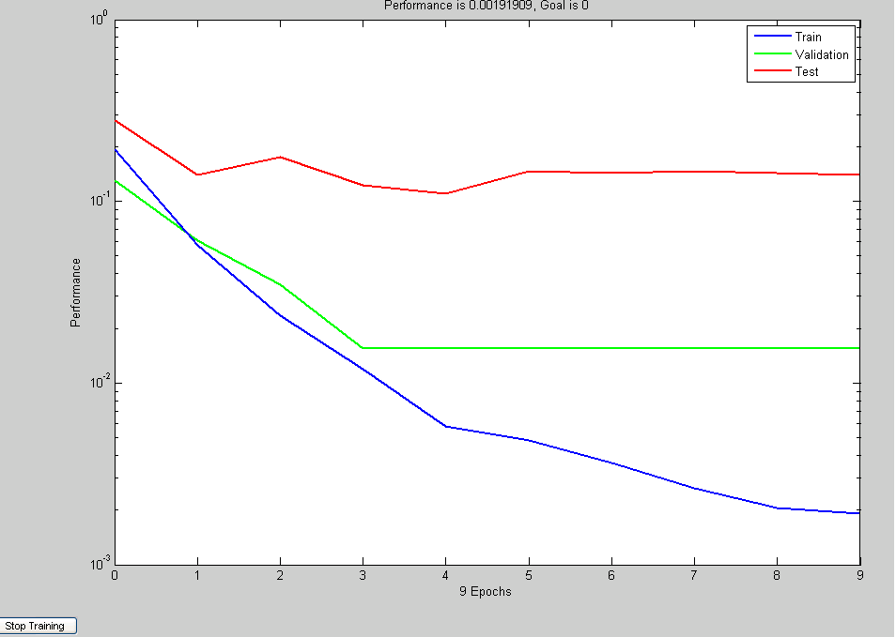
Fig 5.7 Training Graph
REGRESSION GRAPHS:- Figure 5.8 to figure 5.10 shows the regression graphs of learning data, validation data and test data. In these graphs the dotted line shows A(output) = T (target) i.e. the ideal condition. While the dots show the actual output for particular sample and based on that a best fit line is drawn the best fit line should be as close as the dotted line.

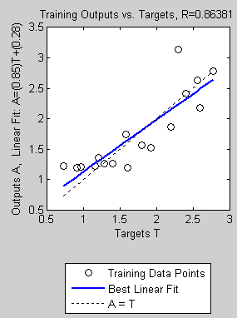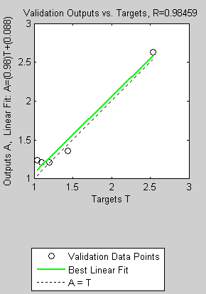

Fig 5.8 Regression Coefficient of Fig 5.9 Regression Coefficient of validation
of learning data data

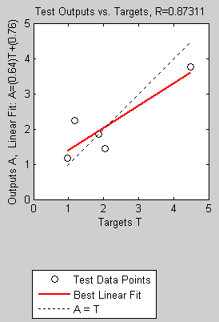

Fig 5.10 Regression coefficient of test data

Regression coefficients based on the data are 0.86381 for training set, 0.98459 for validation set and 0.87311 for test data set shows that the learning of the network is proper and now this application can be used
Table 5.9 Data Collection for Linear Model [AL]

S.No. | Diameter  (mm) | RPM | V | d | Feed |  | Ra | Predicted Ra
 | Diameter  (mm) | RPM | (m/min) | (mm) | (mm/min) | (mm/rev) | (µm) | Predicted Ra
1. | 28.5 | 1000 | 89.49 | 0.2 | 25 | 0.025 | 1.16 | 1.32
2. | 28.5 | 1000 | 89.49 | 0.2 | 50 | 0.05 | 2.6 | 2.23
3. | 28.5 | 1000 | 89.49 | 0.2 | 75 | 0.075 | 4.48 | 3.77
4. | 28.1 | 1000 | 88.23 | 0.3 | 25 | 0.025 | 0.96 | 0.98
5. | 28.1 | 1000 | 88.23 | 0.3 | 50 | 0.05 | 1.18 | 1.36
6. | 28.1 | 1000 | 88.23 | 0.3 | 75 | 0.075 | 2.3 | 2.51
7. | 27.5 | 1000 | 86.35 | 0.4 | 25 | 0.025 | 0.98 | 1.06
8. | 27.5 | 1000 | 86.35 | 0.4 | 50 | 0.05 | 1.58 | 1.4
9. | 27.5 | 1000 | 86.35 | 0.4 | 75 | 0.075 | 2.56 | 2.45
10. | 28.5 | 1200 | 107.39 | 0.2 | 25 | 0.0208 | 1.04 | 1.47
11. | 28.5 | 1200 | 107.39 | 0.2 | 50 | 0.0416 | 1.92 | 1.52
12. | 28.5 | 1200 | 107.39 | 0.2 | 75 | 0.0625 | 2.78 | 1.82
13. | 28.1 | 1200 | 105.88 | 0.3 | 25 | 0.0208 | 1.1 | 1.34
14. | 28.1 | 1200 | 105.88 | 0.3 | 50 | 0.0416 | 1.44 | 1.44
15. | 28.1 | 1200 | 105.88 | 0.3 | 75 | 0.0625 | 2.4 | 2.09
16. | 27.5 | 1200 | 103.62 | 0.4 | 25 | 0.0208 | 0.9 | 0.93
17. | 27.5 | 1200 | 103.62 | 0.4 | 50 | 0.0416 | 1.2 | 1.15
18. | 27.5 | 1200 | 103.62 | 0.4 | 75 | 0.0625 | 1.86 | 1.81
19. | 28.5 | 1400 | 125.30 | 0.2 | 25 | 0.0179 | 1.28 | 1.46
20. | 28.5 | 1400 | 125.30 | 0.2 | 50 | 0.0357 | 1.8 | 1.47
21. | 28.5 | 1400 | 125.30 | 0.2 | 75 | 0.0536 | 2.54 | 1.53
22. | 28.1 | 1400 | 123.53 | 0.3 | 25 | 0.0179 | 0.72 | 1.47
23. | 28.1 | 1400 | 123.53 | 0.3 | 50 | 0.0357 | 1.2 | 1.6
24. | 28.1 | 1400 | 123.53 | 0.3 | 75 | 0.0536 | 2.2 | 1.991
25. | 27.5 | 1400 | 120.89 | 0.4 | 25 | 0.0179 | 1.6 | 1.63
26. | 27.5 | 1400 | 120.89 | 0.4 | 50 | 0.0357 | 1.4 | 2.01
27. | 27.5 | 1400 | 120.89 | 0.4 | 75 | 0.0536 | 2.04 | 2.21

5.2.6 Non Linear Model for Aluminium

TRAINING GRAPH:-Training graph of the data in table 5.10 is presented in figure 5.11. This is generated with the help of Neural Networking. When a network get trained, it is required to define the percentage of train data, validation data, test data so that the network can itself validate and test its own training. This graph shows that how the training is progressing in each Epoch (regression) and consequently validation and test of network is in progress after 9 epochs training is complete as the nature of test data and validation data has become same.
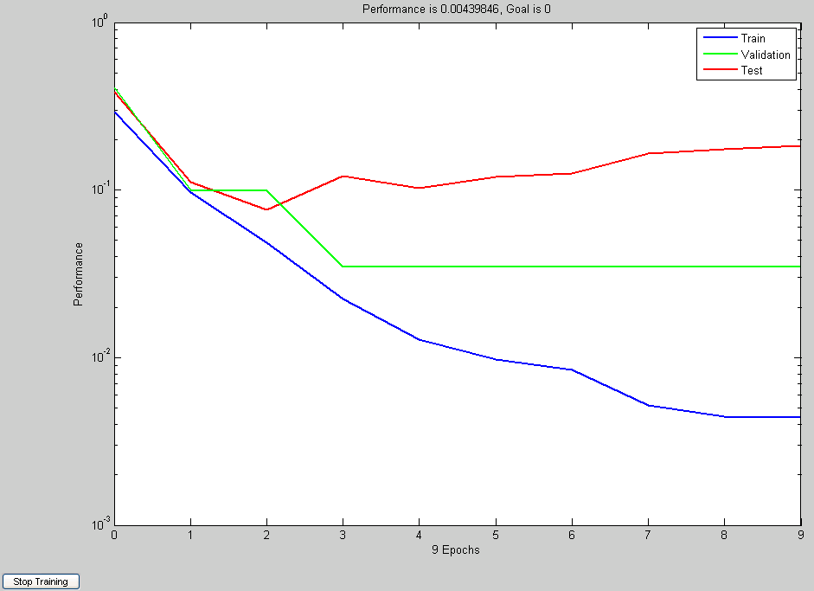
Fig 5.11 Training Graph
REGRESSION GRAPHS:- Figure 5.12 to figure 5.14 shows the regression graphs of learning data, validation data and test data. In these graphs the dotted line shows A(output) = T (target) i.e. the ideal condition. While the dots show the actual output for particular sample and based on that a best fit line is drawn the best fit line should be as close as the dotted line.

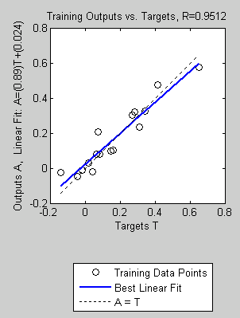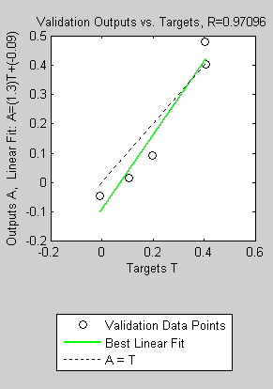

Fig 5.12 Regression Coefficient of Fig 5.13 Regression Coefficient of validation
of learning data data

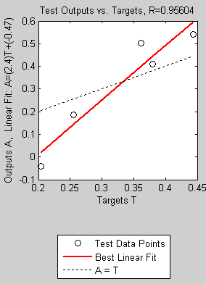

Fig 5.14 Regression coefficient of test data

Regression coefficients based on the data are 0.9512 for training set, 0.97096 for validation set and 0.95604 for test data set shows that the learning of the network is proper and now this application can be used
Table 5.10 Data Collection for Non-Linear Model

S.No. | Diameter  (mm) | RPM | V | d | Feed |  | Ra | Predicted Ra
 | Diameter  (mm) | RPM | (m/min) | (mm) | (mm/min) | (mm/rev) | (µm) | Predicted Ra
1. | 28.5 | 1000 | 89.49 | 0.2 | 25 | 0.025 | 1.16 | 1.2
2. | 28.5 | 1000 | 89.49 | 0.2 | 50 | 0.05 | 2.6 | 3
3. | 28.5 | 1000 | 89.49 | 0.2 | 75 | 0.075 | 4.48 | 3.78
4. | 28.1 | 1000 | 88.23 | 0.3 | 25 | 0.025 | 0.96 | 0.98
5. | 28.1 | 1000 | 88.23 | 0.3 | 50 | 0.05 | 1.18 | 1.61
6. | 28.1 | 1000 | 88.23 | 0.3 | 75 | 0.075 | 2.3 | 3.19
7. | 27.5 | 1000 | 86.35 | 0.4 | 25 | 0.025 | 0.98 | 0.9
8. | 27.5 | 1000 | 86.35 | 0.4 | 50 | 0.05 | 1.58 | 1.23
9. | 27.5 | 1000 | 86.35 | 0.4 | 75 | 0.075 | 2.56 | 2.54
10. | 28.5 | 1200 | 107.39 | 0.2 | 25 | 0.0208 | 1.04 | 1.07
11. | 28.5 | 1200 | 107.39 | 0.2 | 50 | 0.0416 | 1.92 | 2.1
12. | 28.5 | 1200 | 107.39 | 0.2 | 75 | 0.0625 | 2.78 | 3.48
13. | 28.1 | 1200 | 105.88 | 0.3 | 25 | 0.0208 | 1.1 | 0.95
14. | 28.1 | 1200 | 105.88 | 0.3 | 50 | 0.0416 | 1.44 | 1.27
15. | 28.1 | 1200 | 105.88 | 0.3 | 75 | 0.0625 | 2.4 | 2.57
16. | 27.5 | 1200 | 103.62 | 0.4 | 25 | 0.0208 | 0.9 | 0.89
17. | 27.5 | 1200 | 103.62 | 0.4 | 50 | 0.0416 | 1.2 | 1.19
18. | 27.5 | 1200 | 103.62 | 0.4 | 75 | 0.0625 | 1.86 | 2.01
19. | 28.5 | 1400 | 125.30 | 0.2 | 25 | 0.0179 | 1.28 | 1.03
20. | 28.5 | 1400 | 125.30 | 0.2 | 50 | 0.0357 | 1.8 | 1.53
21. | 28.5 | 1400 | 125.30 | 0.2 | 75 | 0.0536 | 2.54 | 3.02
22. | 28.1 | 1400 | 123.53 | 0.3 | 25 | 0.0179 | 0.72 | 0.94
23. | 28.1 | 1400 | 123.53 | 0.3 | 50 | 0.0357 | 1.2 | 1.2
24. | 28.1 | 1400 | 123.53 | 0.3 | 75 | 0.0536 | 2.2 | 2.11
25. | 27.5 | 1400 | 120.89 | 0.4 | 25 | 0.0179 | 1.6 | 0.91
26. | 27.5 | 1400 | 120.89 | 0.4 | 50 | 0.0357 | 1.4 | 1.25
27. | 27.5 | 1400 | 120.89 | 0.4 | 75 | 0.0536 | 2.04 | 1.72

5.2.7 Network Modelling for Brass [Linear Model]

TRAINING GRAPH:-Training graph of the data in table 5.11 is presented in figure 5.15. This is generated with the help of Neural Networking. When a network get trained, it is required to define the percentage of train data, validation data, test data so that the network can itself validate and test its own training. This graph shows that how the training is progressing in each Epoch (regression) and consequently validation and test of network is in progress after 9 epochs training is complete as the nature of test data and validation data has become same.
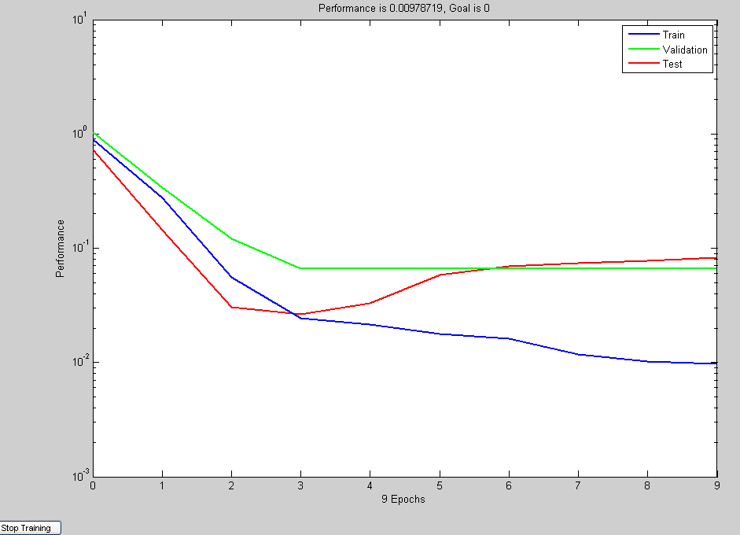
Fig 5.15 Training Graph
REGRESSION GRAPHS:- Figure 5.16 to figure 5.18 shows the regression graphs of learning data, validation data and test data. In these graphs the dotted line shows A(output) = T (target) i.e. the ideal condition. While the dots show the actual output for particular sample and based on that a best fit line is drawn the best fit line should be as close as the dotted line.

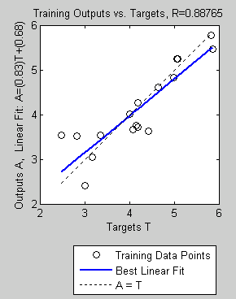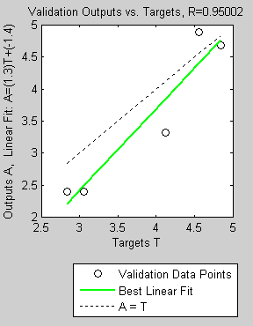

Fig 5.16 Regression Coefficient of Fig 5.17 Regression Coefficient of validation
of learning data data

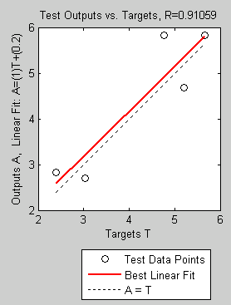

Fig 5.18 Regression coefficient of test data

Regression coefficients based on the data are 0.88765 for training set, 0.95002 for validation set and 0.91059 for test data set shows that the learning of the network is proper and now this application can be used
Table 5.11 Data Collection for Linear Model (Brass)

S.No. | Diameter  (mm) | RPM | V | d | Feed |  | Ra | Predicted Ra
 | Diameter  (mm) | RPM | (m/min) | (mm) | (mm/min) | (mm/rev) | (µm) | Predicted Ra
1. | 30.1 | 1000 | 94.514 | 0.2 | 25 | 0.025 | 3.34 | 3.339
2. | 30.1 | 1000 | 94.514 | 0.2 | 50 | 0.05 | 4.64 | 4.73
3. | 30.1 | 1000 | 94.514 | 0.2 | 75 | 0.075 | 5.66 | 5.37
4. | 29.7 | 1000 | 93.258 | 0.3 | 25 | 0.025 | 3.16 | 3.14
5. | 29.7 | 1000 | 93.258 | 0.3 | 50 | 0.05 | 5.08 | 4.94
6. | 29.7 | 1000 | 93.258 | 0.3 | 75 | 0.075 | 4.76 | 5.45
7. | 29.1 | 1000 | 91.374 | 0.4 | 25 | 0.025 | 3.06 | 3.25
8. | 29.1 | 1000 | 91.374 | 0.4 | 50 | 0.05 | 4.84 | 5.23
9. | 29.1 | 1000 | 91.374 | 0.4 | 75 | 0.075 | 5.82 | 5.61
10. | 30.1 | 1200 | 113.417 | 0.2 | 25 | 0.020833 | 2.82 | 2.75
11. | 30.1 | 1200 | 113.417 | 0.2 | 50 | 0.041667 | 4.08 | 4.2
12. | 30.1 | 1200 | 113.417 | 0.2 | 75 | 0.0625 | 5.2 | 5.05
13. | 29.7 | 1200 | 111.91 | 0.3 | 25 | 0.020833 | 3.04 | 3.1
14. | 29.7 | 1200 | 111.91 | 0.3 | 50 | 0.041667 | 4 | 4.47
15. | 29.7 | 1200 | 111.91 | 0.3 | 75 | 0.0625 | 5.06 | 5.13
16. | 29.1 | 1200 | 109.65 | 0.4 | 25 | 0.020833 | 3 | 3.33
17. | 29.1 | 1200 | 109.65 | 0.4 | 50 | 0.041667 | 4.18 | 4.53
18. | 29.1 | 1200 | 109.65 | 0.4 | 75 | 0.0625 | 5.86 | 5.26
19. | 30.1 | 1400 | 132.32 | 0.2 | 25 | 0.017857 | 2.46 | 2.72
20. | 30.1 | 1400 | 132.32 | 0.2 | 50 | 0.035714 | 4.42 | 3.89
21. | 30.1 | 1400 | 132.32 | 0.2 | 75 | 0.053571 | 4.18 | 4.48
22. | 29.7 | 1400 | 130.561 | 0.3 | 25 | 0.017857 | 2.4 | 2.76
23. | 29.7 | 1400 | 130.561 | 0.3 | 50 | 0.035714 | 4.14 | 3.98
24. | 29.7 | 1400 | 130.561 | 0.3 | 75 | 0.053571 | 4.56 | 4.61
25. | 29.1 | 1400 | 127.924 | 0.4 | 25 | 0.017857 | 2.84 | 2.8
26. | 29.1 | 1400 | 127.924 | 0.4 | 50 | 0.035714 | 4.12 | 4.05
27. | 29.1 | 1400 | 127.924 | 0.4 | 75 | 0.053571 | 4.98 | 4.73

5.2.8 Non Linear Model for Brass

TRAINING GRAPH:-Training graph of the data in table 5.12 is presented in figure 5.19. This is generated with the help of Neural Networking. When a network get trained, it is required to define the percentage of train data, validation data, test data so that the network can itself validate and test its own training. This graph shows that how the training is progressing in each Epoch (regression) and consequently validation and test of network is in progress after 20 epochs training is complete as the nature of test data and validation data has become same.
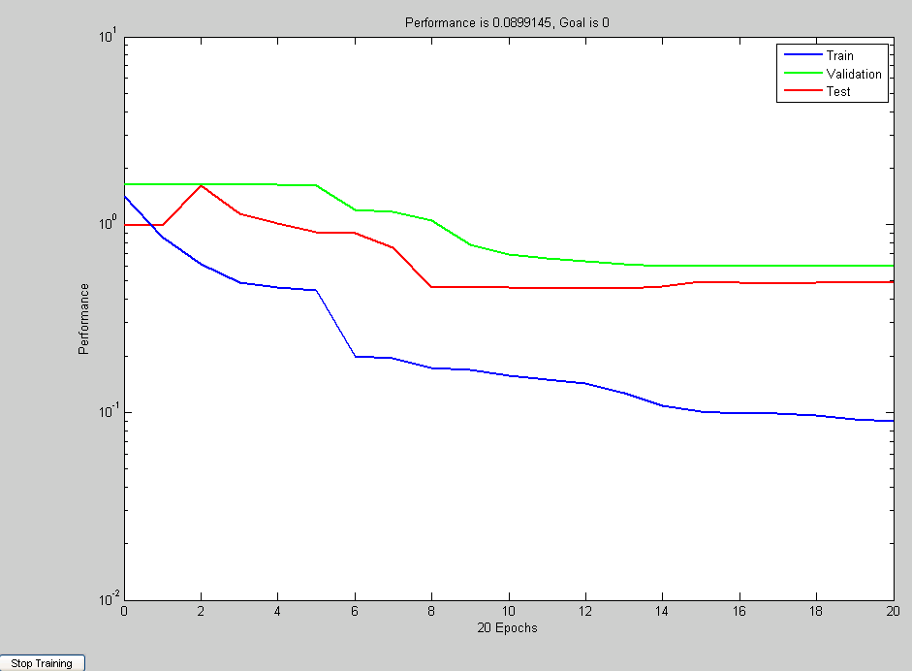
Fig 5.19 Training Graph
REGRESSION GRAPHS:- Figure 5.20 to figure 5.22 shows the regression graphs of learning data, validation data and test data. In these graphs the dotted line shows A(output) = T (target) i.e. the ideal condition. While the dots show the actual output for particular sample and based on that a best fit line is drawn the best fit line should be as close as the dotted line.
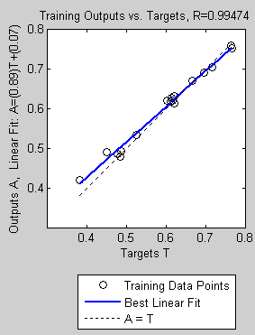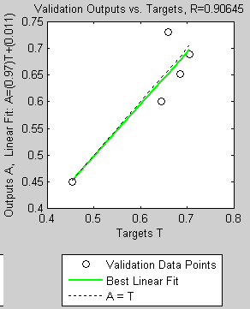

Fig 5.20 Regression Coefficient of Fig 5.21 Regression Coefficient of validation
of learning data data

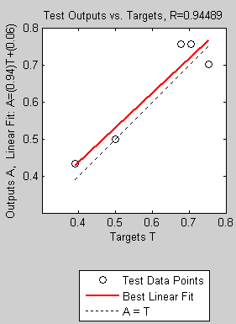

Fig 5.22 Regression coefficient of test data

Regression coefficients based on the data are 0.99474 for training set, 0.90645 for validation set and 0.94489 for test data set shows that the learning of the network is proper and now this application can be used
Table5.12 Data Collection for Non-Linear model (Brass)
S.No. | Diameter  (mm) | RPM | V | d | Feed |  | Ra | Predicted Ra
 | Diameter  (mm) | RPM | (m/min) | (mm) | (mm/min) | (mm/rev) | (µm) | Predicted Ra
1. | 30.1 | 1000 | 94.514 | 0.2 | 25 | 0.025 | 3.34 | 3.25
2. | 30.1 | 1000 | 94.514 | 0.2 | 50 | 0.05 | 4.64 | 4.61
3. | 30.1 | 1000 | 94.514 | 0.2 | 75 | 0.075 | 5.66 | 4.74
4. | 29.7 | 1000 | 93.258 | 0.3 | 25 | 0.025 | 3.16 | 3.18
5. | 29.7 | 1000 | 93.258 | 0.3 | 50 | 0.05 | 5.08 | 4.55
6. | 29.7 | 1000 | 93.258 | 0.3 | 75 | 0.075 | 4.76 | 4.71
7. | 29.1 | 1000 | 91.374 | 0.4 | 25 | 0.025 | 3.06 | 3.15
8. | 29.1 | 1000 | 91.374 | 0.4 | 50 | 0.05 | 4.84 | 4.43
9. | 29.1 | 1000 | 91.374 | 0.4 | 75 | 0.075 | 5.82 | 4.69
10. | 30.1 | 1200 | 113.417 | 0.2 | 25 | 0.020833 | 2.82 | 2.89
11. | 30.1 | 1200 | 113.417 | 0.2 | 50 | 0.041667 | 4.08 | 4.41
12. | 30.1 | 1200 | 113.417 | 0.2 | 75 | 0.0625 | 5.2 | 4.69
13. | 29.7 | 1200 | 111.91 | 0.3 | 25 | 0.020833 | 3.04 | 2.79
14. | 29.7 | 1200 | 111.91 | 0.3 | 50 | 0.041667 | 4 | 4.25
15. | 29.7 | 1200 | 111.91 | 0.3 | 75 | 0.0625 | 5.06 | 4.71
16. | 29.1 | 1200 | 109.65 | 0.4 | 25 | 0.020833 | 3 | 2.8
17. | 29.1 | 1200 | 109.65 | 0.4 | 50 | 0.041667 | 4.18 | 4.18
18. | 29.1 | 1200 | 109.65 | 0.4 | 75 | 0.0625 | 5.86 | 4.9
19. | 30.1 | 1400 | 132.32 | 0.2 | 25 | 0.017857 | 2.46 | 2.67
20. | 30.1 | 1400 | 132.32 | 0.2 | 50 | 0.035714 | 4.42 | 4.099
21. | 30.1 | 1400 | 132.32 | 0.2 | 75 | 0.053571 | 4.18 | 4.65
22. | 29.7 | 1400 | 130.561 | 0.3 | 25 | 0.017857 | 2.4 | 2.65
23. | 29.7 | 1400 | 130.561 | 0.3 | 50 | 0.035714 | 4.14 | 4.12
24. | 29.7 | 1400 | 130.561 | 0.3 | 75 | 0.053571 | 4.56 | 4.96
25. | 29.1 | 1400 | 127.924 | 0.4 | 25 | 0.017857 | 2.84 | 2.78
26. | 29.1 | 1400 | 127.924 | 0.4 | 50 | 0.035714 | 4.12 | 4.27
27. | 29.1 | 1400 | 127.924 | 0.4 | 75 | 0.053571 | 4.98 | 4.97

Discussions

Surface Texture of Aluminium

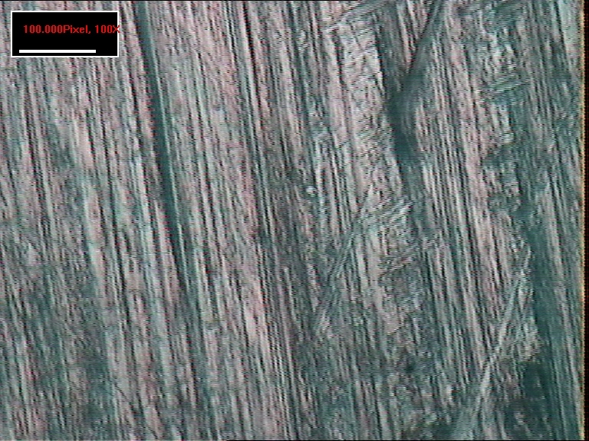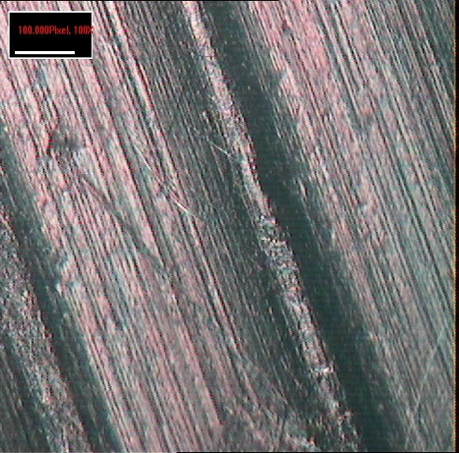
(1000 r.p.m, 25mm/min) (1000r.p.m,75mm/min)

Now by comparing the two structural surface finish for aluminium it can be said that when speed is been constant, finish gets poor as the feed increases, thus the average surface roughness value increases with increase in feed.

Surface Texture of Aluminium

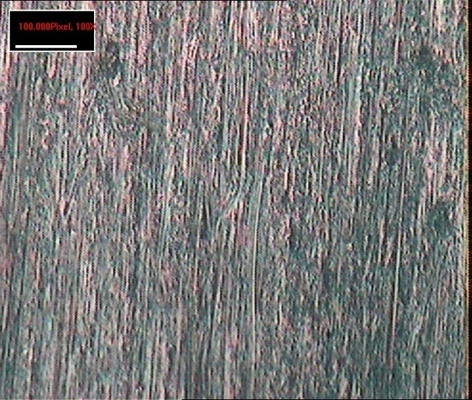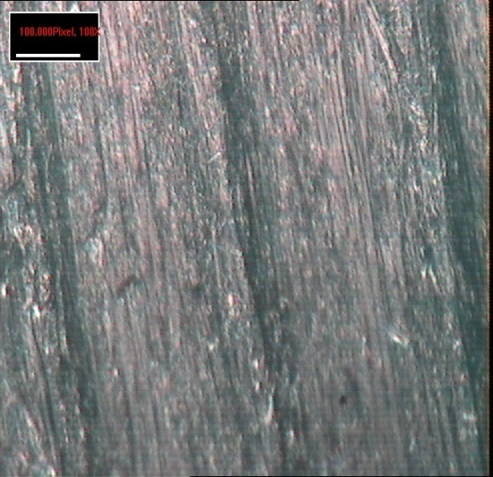
(1400 r.p.m,25mm/min) (1400r.p.m,75mm/min)

Comparing the two surface finish for Aluminium at (1400 r.p.m,25mm/min)and (1400 r.p.m,75mm/min) it can be said that. when speed is been constant, finish gets poor as the feed increases, thus the average surface roughness value increases with increase in feed.

Now by comparing all the four surface finish it can be concluded that the increase in cutting speed tends to improve the finish, thus the average surface roughness value decreases. And
when speed is been constant, finish gets poor as the feed increases, thus the average surface roughness value increases with increase in feed

BRASS:

Surface texture of Brass

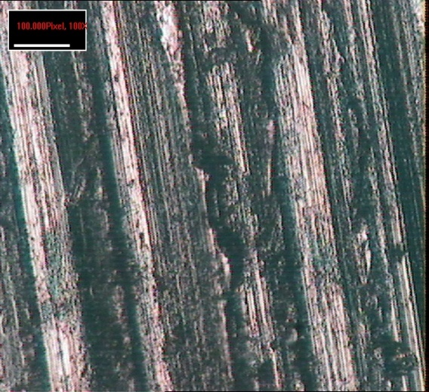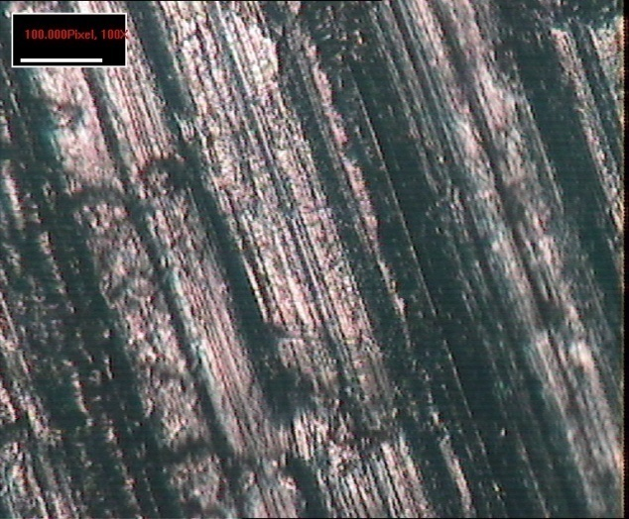
(1000 r.p.m,25mm/min) (1000r.p.m,75mm /min)

Now by comparing the two structural surface finish for Brass it can be said that when speed is been constant, finish gets poor as the feed increases, thus the average surface roughness value increases with increase in feed.

Surface Texture of Brass
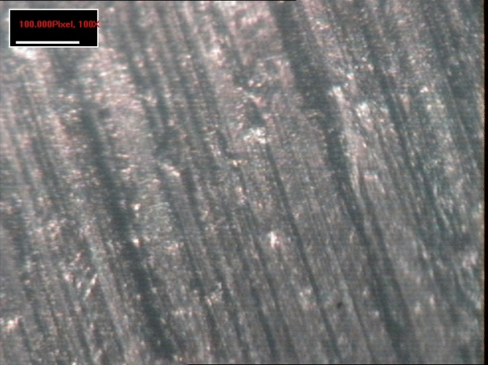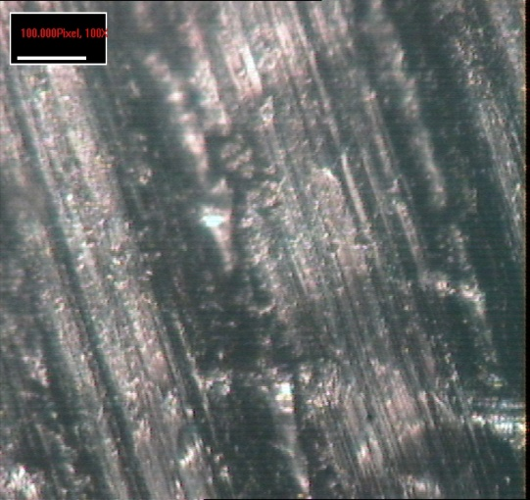
(1400 r.p.m,25mm/min) (1400r.p.m,75mm/min)

Comparing the two surface finish for Aluminium at (1400 r.p.m,25mm/min)and (1400 r.p.m, 75mm/min) it can be said that. when speed is been constant, finish gets poor as the feed increases, thus the average surface roughness value increases with increase in feed.

Now by comparing all the four surface finish it can be concluded that the increase in cutting speed tends to improve the finish, thus the average surface roughness value decreases. And
when speed is been constant, finish gets poor as the feed increases, thus the average surface roughness value increases with increase in feed
Chapter 6
RESULTS AND CONCLUSIONS

This work presented an experimentation approach to studying the impact of machining parameters on surface roughness. Strong interactions were observed among the machining turning parameters. Most significant interactions were found between work materials, feed and cutting speeds. A systematic approach was provided to design and analyze the experiments, which is able to reduce the cost and time of experiments and to utilize the data obtained to the maximum extend.

From the data collection i have observed that the increase in cutting speed tends to improve the finish, thus the average surface roughness value decreases. The increase in depth of cut influences the finish slightly, but greater depth of cut marks the finish poor. Feed rate is the most critical parameter when finish is the criterion. Finish gets poor as the feed increases, thus the average surface roughness value increases with increase in feed.

I have developed the regression models of aluminium and brass for both the linear as well as non-linear cases.
where the results are the relationship equations.

1. For linear regression equation of Aluminium relationship with the R-square value of 0.74 indicated that 74% of the variability in the surface roughness was explained by the model with factors V, f and d.

2. For non-linear regression equation of Aluminium relationship with the R-square value of 0.76 indicated that 76% of the variability in the surface roughness was explained by the model with factors V, f and d.
3. . For linear regression equation of Brass relationship with the R-square value of 0.88 indicated that 84% of the variability in the surface roughness was explained by the model with factors V, f and d.
4. . For non-linear regression equation of Brass relationship with the R-square value of 0.93 indicated that 93% of the variability in the surface roughness was explained by the model with factors V, f and d.

It is being observed that the non-linear model gives more accurate result than the linear model as when compared with the actual experimental results.
5.By using neural network analysis I have found that the predicted values of surface roughness for both Aluminium and Brass are very close to calculated value,in comparison to regression analysis although values obtain by regression analysis are also close.

REFERENCES

- Albrecht A.B., (1956) “How to secure desired surface finish in turning operations. American Machinist”,pp.113–136.
- C.G. Looney, Advances in feedforward neural networks: Demystifying knowledge acquiring black boxes. IEEE Trans. Knowledge Data Engng 6 2 (1996), pp. 211.
- Choon, S.-L. Dornfeld, D.A. and Dreyfus, S.L. (1995) A customized neural network for sensor fusion in on-line monitoring of cutting tool wear. J. Engng Ind. 117 , pp. 152.
- Feng, C.X..,( 2001)“An experimental study of the impact of turning parameters on surface roughness” Proceeding of the 2001 Industrial Engineering Research Conference. Paper no: 2036.
- Feng, C. X. and Wang, X,( 2002), “Development of empirical models for surface roughness prediction in finish turning”. International Journal of Advanced Manufacturing Technology, vol. 20, pp. 348-356.
- Hassan and Suliman, (1990), “Two-stage method for obtaining machinability data for the steel turning process”. International Journal of Production Research 26, pp.1861-1876.
- Ho S.Y., Lee K.C., Chen S.S, Ho SJ (2002) Accurate modeling and prediction of surface roughness by computer vision in turning operations using an adaptive neuro-fuzzy inference system. Int J Mach Tools Manuf 42:pp.1441–1446.
- Kirby, Zhang and Chen,( 2004), “Determining the surface roughness of a work piece using a Federal Pocket Surf stylus profilometer”. Journal of Industrial Technology, vol-20 number-4 date Sept,(2004).
- Lambert, B. K., and Taraman, K. (1974) A surface roughness model for a turning operation. International Journal of Production Research, 12: pp.691-703.
- Lambert, B. K. (1983) Determination of metal removal rate with surface finish restriction. Carbide and Tool Journal, May- June:pp. 16-19.
- L.I. Burke, An unsupervised neural network approach to tool wear identification. IEE Trans. 25 ,(1993), pp. 16.
- Malakooti B. and Raman V. (2000) “An interactive multi-objective artificial neural network approach for machine setup optimization”. Journal of Intelligent Manufacturing, vol11, , pp 41-50.
- Monostori L (1993) A step towards intelligent manufacturing: modelling and monitoring of manufacturing processes through artificial neural network. Ann CIRP 42(1):pp.485–493.
- Purushothaman, S. and Srinivasa, Y.G. (1994) A back propagation algorithm applied to tool wear monitoring. Int. J. Mach. Tools Manufact. 34,pp. 625.
- Rasch and Rolstadas, (1971), “Series of finish turning tests under variation of parameters: material quality, tool quality, tool nose radius, feed, speed and cutting time”. Journal of Materials Processing Technology vol-132,pp.203-214.
- Sundaram. R. M., (1976), A statistical analysis of surface finish in fine turning of steel, unpublished Doctoral Dissertation in Industrial Engineering, Texas Tech
University Lubbock, TN.
- Sundaram, R. M. and B. K. Lambert, (1981), Mathematical models to predict surface finish in fine turning of steel: Part I and Part II. International Journal of Production Research, 19(5):pp. 557-564.
- Sundaram, R. M. and B. K. Lambert,(1979), Surface roughness variability of ANSI 4140 steel in fine turning using carbide tools. International Journal of Production Research, 17(3): pp.249-258.
- Taraman, K. and B. K. Lambert, (1974), A surface roughness model for a turning operation. International Journal of Production Research, 12(6), pp. 691-703.
- Wu, S.M. (1964). ‘Tool life testing by Response Surface Methodology-Part1’.Journal of Engineering for Industry. Transactions of ASME, p111.

APPENDIX

Programming of CNC Trainer Lathe

List of G Codes

CODE | FUNCTION
G00 | RAPID POSITIONING
G01 | LINEAR INTERPOLATION
G02 | CLOCKWISE CIRCULAR INTERPOLATION
G03 | CONTER CLOCKWISE CIRCULAR INTERPOLATION
G04 | DWELL IN SECONDS
G20 | INCH PROGRAMMING
G21 | METRIC PROGRAMMING
G28 | AUTO. RETURN TO REF. POINT
G32 | THREAD CUTTING CYCLE
G70 | FINISHING CYCLE
G71 | STOCK REMOVAL IN TURNING
G72 | STOCK REMOVAL IN FACING
G73 | PATTERN REPEATING CYCLE
G74 | PECK DRILLING CANNED CYCLE
G90 | DAIMETER CUTTING CYCLE
G94 | FACING CANNED CYCLE
G96 | CONSTANT SURAFCE SPEED ON

List of M Codes

CODE | FUNCTION
M00 | PROGRAM STOP
M01 | OPTIONAL PROGRAM STOP
M02 | PROGRAM END
M03 | SPINDLE START CLOCKWISE
M04 | SPINDLE START ANTICLOCKWISE
M05 | SPINDLE STOP
M07 | COOLANT NO. 1 ON
M08 | COOLANT NO.2 ON
M09 | COOLANT OFF
M13 | SPINDLE CLOCKWISE & COOLANT ON
M14 | SPINDLE ANTI-CLOCKWISE &  COOLANT ON
M30 | PROGRAM END & REWIND
M98 | START OF SUBROUTINE
M99 | END OF SUBROUTINE

PART PROGRAM CARRIED OUT ON CNC LATHE:
G21 G97 G98
G28 V0 W0
M06 T1
M03 S1400
N10 M03 S1400
N15 G00 X31 Z2
N20 G01 X29.4 Z2 F100
N25 G01 X29.4 Z-20 F25
N30 G01 X29.4 Z-40 F50
N35 G01 X29.4 Z-60 F75
N40 G01 X32
N45 Z2 F100
N50 M05
N55 M30

Bibliography:
1. Surface Roughness Terminology:
The quality of machined surface is characterized by the accuracy of its manufacture with respect to the dimensions specified by the designer. Every machining operation leaves characteristic evidence on the machined surface. This evidence in the form of finely spaced micro irregularities left by the cutting tool. Each type of cutting tool leaves its own individual pattern which therefore can be identified. This pattern is known as surface finish or surface roughness.
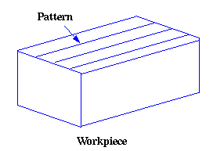

2. Roughness:
Roughness consists of surface irregularities which result from the various machining process. These irregularities combine to form surface texture.

3. Roughness Height:
It is the height of the irregularities with respect to a reference line. It is measured in millimeters or microns or micro inches. It is also known as the height of unevenness.

4. Roughness Width:
The roughness width is the distance parallel to the nominal surface between successive peaks or ridges which constitute the predominate pattern of the roughness. It is measured in millimeters.
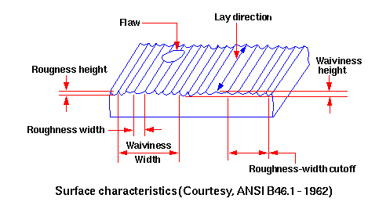

5. Roughness Width Cut Off:
Roughness width cut off is the greatest spacing of respective surface irregularities to be included in the measurement of the average roughness height. It should always be greater than the roughness width in order to obtain the total roughness height rating.
6. Lay:
Lay represents the direction of predominant surface pattern produced and it reflects the machining operation used to produce it.
7. Waviness:
This refers to the irregularities which are outside the roughness width cut off values. Waviness is the widely spaced component of the surface texture. This may be the result of work piece or tool deflection during machining, vibrations or tool run out.

8. Waviness Width:
Waviness height is the peak to valley distance of the surface profile, measured in millimeters.
9. Arithmetic Average (AA):
A close approximation of the arithmetic average roughness-height can be calculated from the profile chart of the surface. Averaging from a mean centerline may also be automatically performed by electronic instruments using appropriate circuitry through a meter or chart recorder. If X is the measured value from the profilometer, then the AA value can be calculated as shown below.

10. Root Mean Square (rms)
The rms value can be calculated as shown below. Its numerical value is about 11% higher than that of AA.
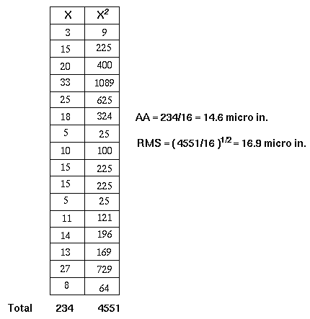

11. Cut-off value
The cut-off value controls the measurement length. For example, if an 0.8mm cut-off is selected and 7 sample lengths are measured, then the measurement length will be 7 x 0.8=5.6mm. In general for good statistical analysis, it is recommended that 5 sample lengths be used for assessment, although this is not always possible. If a 2CR filter is used, then 2 cut-offs will be discarded. This means the measurement length for a 2CR type filter will have to be 7 x 0.8 to allow for the 2 discarded cut-offs leaving a final 5 sample lengths for assessment. The Gaussian type filter is different and only discards one sample length.

12. Spacing Parameters
RSm is the mean spacing between profile peaks as they pass through the mean line (spacing is the distance between points that cross the mean line within a sample length in
an upward direction.
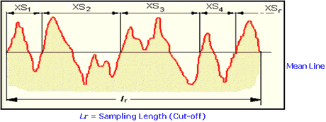
HSC - The high spot count is the number of complete profile peaks (within an assessment length) projecting above a horizontal reference line, in other words, parallel with the mean line. The reference line can be set at a selected distance above or below the mean line.
RPc - The peak count is the number of local peaks which project through a selectable band centered about the mean line. The count is determined only over the assessment length though the results are given in peaks per cm (or per inch). The peak count is obtained by using a multiplication factor. The parameter should, therefore, be measured over the greatest assessment length possible.
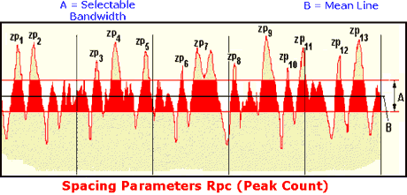

13. Stylus Tip Radius
The stylus tip radius is a key feature that is often overlooked. Assuming that a conisphere stylus is being used, the profile recorded by the instrument will in effect be the locus of the centre of a ball, whose radius is equal to that of the stylus tip, as it is rolled over the surface. This action broadens the peaks of the profile and narrows the valleys. For simplicity, if we consider the surface to be a sine wave, then this distortion is dependent both on the wavelength and the amplitude.

