CHAPTER 1
INTRODUCTION
  - General
As the use of piled raft foundations as an alternative to conventional piled foundation for tall buildings has been increasing, different techniques have been developed for performing analyses over the last decade. The piled rafts are composite structures comprised of the piles, raft and soil (Figure 1.1). In piled rafts, the raft directly interacts with soil and is supported by group of piles of various configurations. Such foundations will be subjected to the vertical loadings transferred directly from the structure and horizontal loadings mostly due to wind loads. These loads are transferred to the soil through the raft and the piles. Unlike the conventional piled foundation design in which the piles are designed to carry the majority of the load, the design of a piled-raft foundation allows the load to be shared between the raft and piles. For most piled raft foundations, the primary purpose of the piles is to act as settlement reducers. The proportion of load carried by the piles is considered as a secondary issue in the design. It is necessary to take the complexities while designing piled-raft foundation. The concept of pile-raft foundation is given in Figure 1.2
Piled raft foundations provide an economical foundation option for circumstances where the performance of the raft alone does not satisfy the design requirements. Under these situations, the addition of a limited number of piles may improve the ultimate load capacity, the settlement and differential settlement performance, and the required thickness of the raft. (Van Impe, et. al. 2001):
Raft foundations are generally provided where the soils stratum at shallow depth is weak and high stress is applied by superstructures to soil. Due to large dimension the rafts is able to withstand high pressure of superstructure. In areas, where the soil strata consists of soft compressible clay and the water table is near ground surface, the concern for safety of building arises due to excessive settlement both total and differential settlement. The settlement of raft can be brought within permissible limits if it is supported by group of piles of various configurations which includes (i) number of piles; (ii) diameter of piles; (iii) spacing of piles and; (iv) length of pile embedded in soil. Thus, a piled raft foundation provides an economical solution to the problem of designing the foundation of heavy structures on soft, compressible soil.

Figure 1.1- Concept of Pile Raft Foundation (a) Piles; (b) Raft and; (c) Piled Raft (Maharaj and Gandhi, 2004)

αL
Raft Foundation
Pile Foundation
Piled Raft
Foundation
1.0
0.0 | 0.2 | 0.4 | 0.6 | 0.8 | 1.0
S_{PR} / S_{PR}
α_{L} = Pile Load Share/ Total Load
S_{PR} = Settlement of Piled-Raft and S_{R} = Settlement of Raft

Figure 1.2: Concept of Piled Raft ( Katzenbach, et. al. 2000)

  - Design Concepts of Piled Raft
In the design of piled rafts, design engineers have to understand the mechanism of load transfer from the raft to the piles and to the soil to predict (i) the behavior of the raft which includes the settlements, bending moments and the proportion of load carried by the raft, and (ii) the behavior of the piles which includes the displacements and load distributions along the piles. Interactions between piles, raft and soil are of major concern in the analysis. The concept of interaction between piles introduced by Poulos (1968) was used in the analysis of pile groups and can be extended to the analysis of piled rafts.
Randolph (1994) has defined clearly three different design philosophies with respect to piled rafts:
- the “conventional approach”, in which the piles are designed as a group to carry the major part of the load with regular spacing of the piles over the complete foundation area, while making some allowance for the contribution of the raft, primarily to ultimate load capacity. The principal benefit is a reduction in the total number of piles due to perhaps only 60-75% of the total structural load carried by the piles.
- “creep piling”, in which the piles are designed to operate at a working load at which significant creep starts to occur, typically 70-80% of the ultimate load capacity; sufficient piles are included to reduce the net contact pressure between the raft and the soil to below the pre-consolidation pressure of the soil.In this the foundation is designed as raft foundation but the total settlement is reduced in the manner suggested by Burland et al (1977), by inclusion of piles, distributed uniformly beneath the raft, that are allowed to move plastically relative to the surrounding soil. The choice of the creep load as the working load of each pile prevents high loads developing in piles at the edges of the foundation, allowing more precise determination of bending moments in the raft.
- The “differential settlement control”, in which the piles are located strategically in order to reduce the differential settlements, rather than to reduce the overall average settlement substantially. Figure 1.3 shows schematically the principles behind the design of piles to reduce differential settlements. Assuming that
Contact Stress Distribution
Average Pressure
Rigid Raft
Contact Stress Distribution for Rigid Raft
Load carried for piled raft
Contact Stress Distribution
Average Pressure
Flexible Raft
Load Distribution for Piled Raft
Figure 1.3: Design Approach for piles to reduce Differential Settlements ( Randolph and Clancy,1996)
structural load is relatively uniformly distributed over the plan area of the building, then there will be a tendency for an un-piled raft to dish in the centre. Few piles which are added over the central region of the foundation will reduce the tendency to dish in the centre and minimize the differential settlements. The central pile is designed to absorb 50-70% of the average applied pressure, leading to a contact distribution for a flexible raft that matches for a rigid raft and will thus give minimal differential settlement.
De Sanctis et al (2001) and Viggiani (2001) have distinguished between two classes of piled raft foundations:
- “Small” piled rafts, where the primary reason for adding the piles is to increase the factor of safety ( typically involves rafts with widths between 5 and 15 m);
- “Large” piled rafts, whose bearing capacity is sufficient to carry the applied load with a reasonable safety margin, but piles are required to reduce settlement or differential settlement. In such cases, the width of the raft is large in comparison with the length of the piles (typically, the width of the piles exceeds the length of the piles).
Figure 1.4 illustrates the concept of the load-settlement behavior of piled rafts designed according to the first two strategies give by Randolph (1994). Curve O shows the behavior of the raft alone, which in this case settles excessively at the design load. Curve 1 represents the conventional design philosophy, for which the behavior of the pile-raft system is governed by the pile group behavior, and which may be largely linear at the design load. In this case, the piles take the great majority of the load. Curve 2 represents the case of creep piling where the piles operate at a lower factor of safety, but because there are fewer piles, the raft carries more load than for Curve 1. Curve 3 illustrates the strategy of using the piles as settlement reducers, and utilizing the full capacity of the piles at the design load. Consequently, the load-settlement may be nonlinear at the design load, but nevertheless, the overall foundation system has an adequate margin of safety, and the settlement criterion is satisfied. Therefore, the design depicted by Curve 3 is acceptable and is likely to be considerably more economical than the designs depicted by Curves 1 and 2.

  - Design Issues of Piled Raft
As with any foundation system, a design of a piled raft foundation requires the consideration of a number of issues which includes the following:
- Ultimate load capacity for vertical, lateral and moment loadings
- Maximum settlement
- Differential settlement
- Raft moments and shears for the structural design of the raft
- Pile loads and moments, for the structural design of the piles.

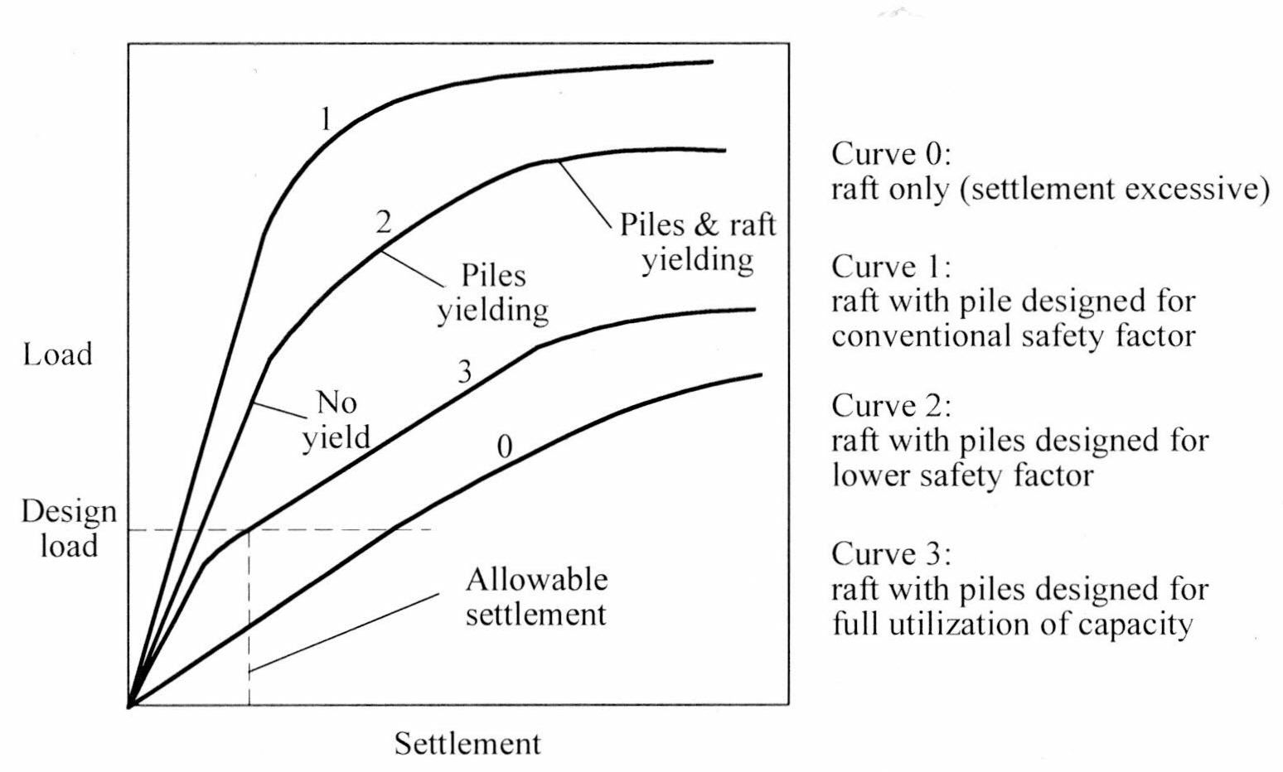

Figure 1.4: Load Settlement Curve for piled rafts as per various design philosophies
(Reference Van Impe, et. al. 2001)

In much of the available literature, emphasis has been placed on the bearing capacity and settlement under vertical loads. While this is a critical aspect, the other issues must also be addressed. In some cases, the pile requirements may be governed by the overturning moments applied by wind loading, rather than the vertical dead and live loads. (Poulos, 2001)

  - Factors Influencing the Behavior of Piled Raft
The various factors which influence the behavior and performance of piled raft needs to be identified for optimizing the design. Detailed examinations of these factors have shown that the displacement of the raft and the proportion of load carried by piles are significantly affected by them. The major factors influencing the design are as follows:
- soil conditions viz. (i) physical and elastic properties of soil; (ii) properties of various strata of soil; (iii) consolidation characteristics of various strata
- properties of raft viz. (i) physical properties of raft; (ii) elastic properties of raft
- properties of piles viz. (i) physical properties of raft; (ii) elastic properties of raft; (iii) diameter of pile; (iv) embedded length of piles
- pile arrangements viz. spacing
For piled rafts subjected to non-uniform vertical or horizontal loads, the use of non-identical piles can improve the performance of the piled rafts. For vertically loaded piled rafts, longer piles are preferred to be used underneath the heavily loaded region while for horizontally loaded piled rafts; larger diameter piles are more preferable.

  - Factors Influencing the Cost of Piled Raft
The cost of construction of a piled raft mainly consists of (i) the cost of installation of the pile group and (ii) the cost of construction of the raft. The overall cost piled raft can be effectively optimized by minimizing installations of piles and construction cost of raft. This can be achieved by optimizing the configuration of the pile group which would be effective in reducing:
- total settlements
- differential settlements and
- moments and shears induced in the raft slab.
The geometrical configurations of a pile group supporting the raft includes viz.: (i) Number of piles (n); (ii) Diameter of piles (d); (iii) Length of the piles (L) and; (iv) Spacing of the piles (S)
The design strategies that enable an optimized design have major importance for an economic construction to be achieved. An optimized design may be defined as a design achieved maximum economy of the solution that is minimum cost for the installation of the foundation, while maintaining satisfactory performance (Russo and Vaggiani, 1998). Serviceability is the decisive criterion for the design of vertically loaded piled-rafts of tall buildings under relevant loads. The magnitude of settlement and of differential settlement and resulting tilting of the building can lead to impairments of technical installation such as elevators, are therefore of special importance. Moreover, the objective of an economic optimized foundation design has to include the reduction of the bending moments acting on the rafts. An optimized design of a piled raft can therefore be defined as a design with minimum costs for the installation of the foundation and satisfactory bearing behavior for a given raft geometry and raft loading (Reul and Randolph, 2004). An For optimizing the cost of construction of a pile group in piled raft foundation as seen from the above mainly depends on n, d and L but the pile spacing has no influence on the construction cost. The pile spacing has great influence on the load-carrying capacity and settlement of the pile group. Also the spacing influences the total settlement as well as the differential settlements of the pile group which influences both the forces as well as moments in the raft. Thus the designer will need to find the optimum spacing for most economical design. The cost of will construction will vary with number, diameter and length of each pile in the pile group. But varying n, d, and L will also have impact on total settlement, differential settlement, and moment and shear force in the raft. Thus a particular each pile group may have a unique combination of the design parameter namely n, d, L and S which will result in most effective and economical design of the piled raft.
  - Classification of Analysis Methods of Piled Raft
Several methods of analyzing piled rafts have been developed which may be broadly classified in three classes namely (Van Impe, et. al. 2001):
- Simplified calculation methods
- Approximate computer-based methods
- More rigorous computer-based methods.
Simplified methods include those of Poulos and Davis (1980), Randolph (1983, 1994), van Impe and Clerq (1995), and Burland (1995). All involve a number of simplifications in relation to the modeling of the soil profile and the loading conditions on the raft.
The approximate computer-based methods include the following broad approaches:
- Methods employing a “strip on springs” approach, in which the raft is represented by a series of strip footings, and the piles are represented by springs of appropriate stiffness (e.g. Poulos, 1991)
- Methods employing a “plate on springs” approach, in which the raft is represented by a plate and the piles as springs (e.g. Clancy and Randolph, 1993; Poulos, 1994; Viggiani, 1998; Anagnastopoulos and Georgiadis, 1998).
The more rigorous methods include:

- Boundary element methods, in which both the raft and the piles within the system are discretized, and use is made of elastic theory (e.g. Butterfield and Banerjee, 1971; Brown and Wiesner, 1975; Kuwabara, 1989; Sinha, 1997)
- Methods combining boundary element for the piles and finite element analysis for the raft (e.g. Hain and Lee, 1978; Ta and Small, 1996; Franke et al, 1994; Russo and Viggiani, 1998)
- Simplified finite element analyses, usually involving the representation of the foundation system as a plane strain problem (Desai,1974) or an axi-symmetric problem (Hooper, 1974), and corresponding finite difference analyses via the commercial program FLAC (e.g. Hewitt and Gue, 1994)
- Three-dimensional finite element analyses (e.g. Zhuang et al, 1991; Lee, 1993; Wang, 1995; Katzenbach et al, 1998) and finite difference analyses via the commercial program FLAC 3D.
Table 1.1 lists the methods and summarizes their ability to predict the response of the foundation system.

Table1.1: Summary of Capabilities of Various Method
(Van Impe, et. al. 2001)

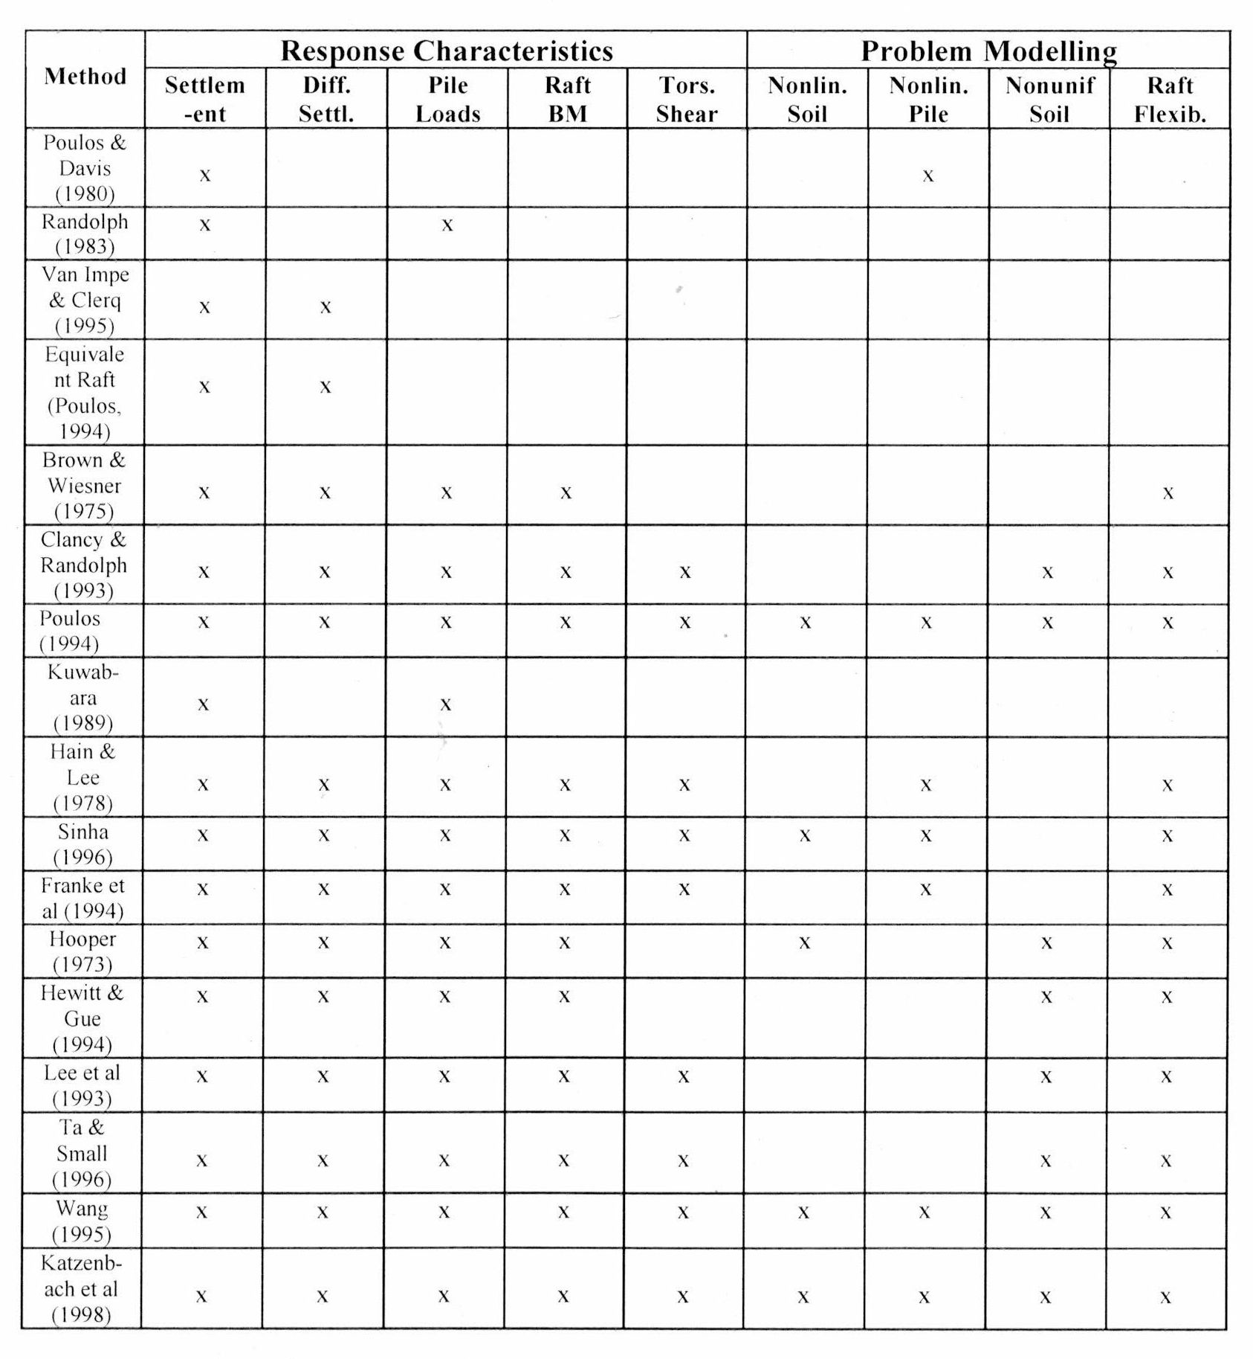

  - Finite Element Analysis for Piled Raft Foundation
A complete three-dimensional analysis of a piled raft foundation system can be carried out by finite element analysis (Katzenbach, et.al.1998) or by use of the commercially available computer program FLAC 3D, ABAQUS,etc are potentially appropriate numerical methods available for piled raft analysis. In principle, the use of such a program removes the need for the approximate assumptions inherent in all of the above analyses. The components of a structure supported by a piled raft include the superstructure, the raft that is supported by the piles, and the soil mass around the pile shaft and below the pile tip. The interactions between two or more of these elements increase the degree of difficulty in obtaining a solution. A closed form solution is often difficult to obtain and the designer may have to employ numerical techniques. In this regard, the finite element method has some distinct advantages over other methods, as it allows the designer to handle the complex foundation system consisting of the superstructure, the raft, the piles and the soil with relative ease, and can readily take into account the interaction effects among them. A complete three-dimensional analysis of a piled raft foundation system can be carried out by finite element analysis ( Katzenbach, et.al.1998) or by use of the commercially available computer program FLAC 3D, ABAQUS,etc . In principle, the use of such a program removes the need for the approximate assumptions inherent in all of the above analyses. Some problems still remain, however, in relation to the modeling of the pile-soil interfaces, and whether interface element should be used. If they are, then approximations are usually involved in the assignment of joint stiffness properties. Such analyses are therefore more suited to obtaining benchmark solutions against which to compare simpler analysis methods, rather than as routine design tools. It may also lead to unsatisfactory and un-conservative bending moments if solid elements are used for the raft and the output stresses are used directly to compute the moments. More satisfactory results are obtained by extrapolating the stresses at the Gauss points or by using the computed displacements to obtain the moments.

  - Advantages and Limitations for Piled Rafts
The most effective application of piled rafts occurs when the raft can provide adequate load capacity, but the settlement and or differential settlements of the raft alone exceed the allowable values. An innovative application of piled-raft is its special adjustment to cases of foundation with large eccentricities and non-uniformly loaded parts of building to avoid the needs of complex settlement joints especially below ground water table. The main advantages of piled raft foundation are:
- Reduction of settlements, differential settlements and tilts
- An increase of overall stability of foundation
- Reduces number of piles as compared to conventional piled foundation where bearing effect of raft is ignored which result in more number of piles
- A centralization of actions and resistances for the cases of large eccentricities
- A reduction of the bending stress for the foundation raft and
- A cost optimization of the whole foundation
- Provides economical foundation where structural loads are carried partly by piles and partly by raft contact stresses.
- Effective in stiff as well as soft clay
Poulos (1991) has examined a number of idealized soil profiles, and has found that the following situations may be favorable for piled raft are:
- soil profiles consisting of relatively stiff clays
- soil profiles consisting of relatively dense sands
In both circumstances, the raft can provide a significant proportion of the required load capacity and stiffness, with the piles acting to reduce the settlement of the foundation, rather than providing the major means of support.
The situations those are unfavorable for piled raft includes:
- soil profiles containing soft clays near the surface
- soil profiles containing loose sand near the surface
- soil profiles that containing soft compressible layers at relatively shallow depths
- soil profiles that are likely to undergo consolidation settlements
- soil profiles that are likely to undergo swelling movements due to external causes
In the first two cases, the raft may not be able to provide significant load capacity and stiffness, while in the third case, long-term settlement of the compressible underlying layers may reduce the contribution of the raft to the long-term stiffness of the foundation. The later two cases should be treated with considerable caution. Consolidation settlements (such as those due to dewatering or shrinking of an active clay soil) may result in a loss of contact between the raft and the soil, thus increasing the load on the piles, and leading to increased settlement of the foundation system. In the case of swelling soils, substantial additional tensile forces may be induced in the piles because of the action of the swelling soil on the raft. (Poulos ,1991)
  - Scope and Objectives of the Study
The present study consists of Numerical Analysis of the effects of various design parameters of piled-raft related to raft, soil, pile and pile group namely (i) Pile Length; (ii) Pile Diameter; (iii) Number of Piles; (iv) Thickness of Raft and (v) Elastic Modulus of soil (Es). For Elastic Analysis the soil considered to carry out the parametric study is a homogenous layer of (i) Soft Clay deposit and (ii) Loose Sand. For Elasto-Plastic Analysis the soil considered to carry out the parametric study is a homogenous layer of soft clay deposit using Mohr-Coulomb Model of Elasto-Plastic soil continuum. Only uniformly distributed Static Loads is being considered for the parametric study. The results obtained from the parametric study have been compared with the past study. The analysis of model has been carried out with the help of finite element method based software of ABAQUS.
The main objective of the study the effect on (i) Settlement and (ii) Differential Settlement by variation of various design parameters namely (i) Pile Length (L); (ii) Pile Diameter (d); (iii) Number of Piles (n); (iv) Thickness of Raft (tr) and (v) Elastic Modulus of Soil (Es) and comparing the results obtained with the past studies.

CHAPTER 2
LITERATURE REVIEW
2.1 Introduction
In foundation design, rafts, pile groups and piled rafts are commonly used to support structures. Extensive research work has been carried out and published in the past decades, and different analysis methods have been developed that can be classified into several categories namely (i) Empirical Method; (ii) Analytical Method and; (iii) Numerical Method. The lack of experimental evidence, disparity between theoretical evaluation and field measurements and the urge for developing more rational techniques have prompted many researchers to undertake investigation in the areas of the analysis of piled raft foundations. A wide variety of loading and site conditions have been considered and various approaches of analysis have been followed.
In this chapter, a brief review of the techniques developed for the analysis of viz. (i) Raft Foundation; (ii) Pile Group Foundation and; (iii) Piled-Raft Foundation are presented. These have been classified into the following two categories:
- Raft Behavior
- Pile Group Behavior
- Piled Raft Behavior

2.2 Raft Foundation
In the design of raft foundations, the soil can be treated as (i) Series of Individual Springs also known as a Winkler Model and (ii) Continuum. The Winkler Model treats the soil as a series of springs and assumes that the pressure at any point on the surface of the soil is related to the (a) modulus of sub-grade reaction (or Winkler Spring Stiffness) and (b) deflection of the soil. The spring stiffness depends on the settlement characteristic of the soil and the geometry of the foundation. This model can be easily handled by mathematical equations and can produce reasonably accurate results. However, it neglects the interaction between each individual spring and the supporting soil is therefore not modeled as a continuum. An alternative approach that treats the supporting soil as an elastic continuum can better represent the physical behavior of the supporting soil. The soil parameters used in this approach depend on the field stress state different methods ranging from one-dimensional to full three-dimensional models have been developed for the analysis of raft foundations.

2.2.1 Analytical Methods
The use of Analytical Methods for the analysis of rafts on elastic foundations has been investigated by numerous researchers. However, this approach is limited to simple geometrical shapes of the raft and homogeneous soils.
Brown (1969) divided the raft into a number of equal width annular elements and the contact stress was assumed to be uniformly distributed over the annular elements.
Kay and Cavagnaro (1983) presented a method for the prediction of settlement for raft foundations by the use of field parameters in which the soil can have numerous sub-layers having different properties. The raft was replaced by an equivalent uniformly loaded circular area such that the influence of the raft stiffness was considered in the assessment of differential settlement

2.2.2 Boundary Element Methods
The Boundary Element Method is a powerful tool that can be applied in Engineering Applications as only the boundary has to be discritized which reduces the amount of computer memory and the time to solve the problem.
Costa and Brebbia (1986) used the Boundary Integral Equation Method for the analysis of plates resting on a Winkler type elastic foundation. In this method the boundary of the plate was divided into a finite number of elements with a node defined at the midpoint of each element. Each boundary element was approximated by a curve so that the boundary of the plate can be approximated by straight line or curved line segments.
Sapountzakis and Katsikadelis (1992) presented a Boundary Element Solution for plates resting on a homogeneous or non-homogeneous elastic foundation. The soil was modeled by independent springs with the sub-grade reaction dependent linearly or non-linearly on the deflection. The contact between the plate and soil was unbonded and separation contact between the plate and soil had been considered. Discretization along the boundary and within the domain was required and the solution was obtained by an iterative process.
de Paiva and Butterfield (1997) presented a formulation for the analysis of plate-soil interaction where the interface was divided into triangular elements in which the displacements and the sub-grade reaction varied linearly. Linear functions were used for the approximation of the displacements and bending moment of the boundary elements. The shear force on the boundary was approximated by reaction forces applied to the nodes of the elements.

2.2.3 Finite Element Methods
The first solution which employed the finite element method for the analysis of foundation structures was obtained by Cheung and Zienkiewicz (1965). The behavior of the raft was obtained by the finite element technique in which the raft was divided into a number of rectangular elements joined at a discrete number of nodal points. The soil was modeled either by the Winkler model in which interactions between springs were not considered or by the elastic continuum model in which separation between the raft and the soil was not allowed when negative reactions existed. The stiffness matrix for the whole system was formed by combining the stiffness of the soil with the stiffness matrix of the plate bending elements. Contact stresses were represented by equivalent forces applied at nodal points of the finite element mesh.
Fraser and Wardle (1976) extended the approach of Cheung and Zienkiewicz (1965) to a multi-layered soil system with isotropic or cross-anisotropic properties. The layered soil system was divided into a number of horizontal layers of uniform thickness with infinite lateral extent. The loaded surface of the soil mass was discretized into surface elements corresponding to the raft elements, and the raft was modeled by finite elements. The contact between the raft and the soil was assumed to be smooth.
Hain and Lee (1974) suggested that in the analysis of raft foundations, the structure, foundation and supporting soil have to be analyzed as a system. The stiffness of the structure can have an influence on the distribution of loads and moments transferred to the raft.
Results have revealed that there were significant differences in the behavior of the raft predicted by the use of different soil models for the supporting soil. Flexibility of the raft has significant effects on the distribution of column loads and moments. Results have shown that the linear elastic continuum model provided a more realistic solution to the behavior of the raft and is more preferable to use in modeling the supporting soil.

2.3 Pile Group Foundation
2.3.1 Simplified Analytical Method
Randolph and Wroth (1978) developed an approximate closed form solution for the analysis of single vertically loaded piles. In this approach, the soil was divided into an upper and a lower layer in which the base of the upper layer corresponded to the level of the base of the pile. The deformation of the upper layer was due to the load acting along the pile shaft, whereas the deformation of the lower layer was due to the load acting on the pile base. For the upper layer, the deformation of the soil around the pile shaft was modeled as shearing of concentric cylinders. For the lower layer, the base of the pile was assumed to act as a rigid punch on the surface of the layer, and this layer was acting as a restraint on the deformation of the upper layer. This approach was then extended to the analysis of pile groups by incorporating the interaction between loaded piles. The overall displacement of a pile with the presence of adjacent loaded piles was obtained by the principle of superposition. This approach was limited to piles of the same embedded length.
Lee (1993) presented an approach for approximating the load-settlement behavior of a pile for a compressible pile embedded in a soil with the stiffness increasing linearly with depth. The settlement of pile groups could then be obtained by the principle of superposition.
Guo and Randolph (1999) developed a program GASGROUP for predicting the settlement of pile groups in non-homogeneous soil by using a load transfer approach. The stiffness of the soil was assumed to increase with depth. The pile-soil interaction was represented by a series of independent springs along the pile shaft and at the pile base. The load transfer factors take into account the pile slenderness ratio, the soil non-homogeneity factor and the Poisson’s ratio. The interaction factor between the two identical piles was computed by modifying the load transfer factor to account for the presence of a neighboring pile.

2.3.2 Finite Element Method
Ottaviani (1975) used the three-dimensional finite element method for the analysis of vertically loaded pile groups with or without pile caps. Due to the complexity of large number of elements, the piles and the soil were assumed as weightless linearly elastic homogeneous media for the examination of the load transfer mechanism. It was found that the presence of a cap would cause a non-uniform distribution of load among the piles of the group. If the cap is in contact with the soil surface, reduction of the shear stress in the soil around the upper portion of the pile was found.
Chow (1987) presented a method based on elasticity theory for the analysis of axially and laterally loaded pile groups embedded in isotropic non-homogeneous soils. The foundation system was decomposed into two systems – (i) a pile group subjected to external loads and pile-soil interaction forces, and (ii) a layered soil continuum subjected to pile-soil interaction forces. The piles were discretized into discrete elements and the soil was discretized into constant elements at the pile-soil interface with uniformly distributed vertical or lateral forces acting over each element. The pile group and the soil continuum were analyzed separately. The load deformation relationship of the soil was determined using the flexibility approach in which the soil flexibility coefficients were evaluated using the finite element method with a fourier series. By applying equilibrium of the pile-soil interaction forces and the compatibility of the pile and soil displacements, the load deformation relationship of the pile was determined and expressed as

([Kp] + [Ks]){wp} = {Q}
Where,
[Kp] = stiffness matrix of piles
[Ks] = stiffness matrix of the soil obtained by inverting the soil flexibility matrix,
[Fs], i.e [Ks] = [Fs]-1
{wp} = vector of deformations at the pile nodes
{Q} = vector of external applied loads
The reinforcing effect of all piles in the group was considered in the formulation. Non-homogeneity of the soil was taken into account by incorporating continuously varying soil stiffness into the numerical integration process during the formulation of the element stiffness matrices. The soil non-linearity was assumed to be elasto-plastic and was analyzed by limiting the shear forces or lateral soil pressures to some values and the excess soil forces at the nodes were then redistributed to other nodes.

2.3.3 Infinite Layer Method
Guo et al. (1987) presented an infinite layer method for the analysis of piles. This method was based on the finite layer concept. The layered soil mass was divided into a number of horizontal layers, each layer was represented by an infinite layer element. The pile was divided into a number of elements along its length and was treated as a solid bar. Interaction between the soil and pile was defined by the compatibility conditions along the pile-soil interface. Cheung et al. (1988) extended the method to the analysis of pile groups with caps by incorporating an iteration procedure to determine the interaction between two identical piles. The cap was discretized into a number of eight noded isoparametric bending elements and analyzed by thick plate bending theory. The connection between the cap and piles was assumed to be a sliding ball joint such that only the vertical forces were transmitted from the cap to the pile heads.

2.3.4 Finite Layer Method
In Finite Layer Method, a single pile embedded in a layered soil was treated as two components: (i) the single isolated pile, and (ii) the layered soil. The pile was divided into a series of one-dimensional two noded elastic solid elements. The layered soil component was subjected to the interaction forces along the pile-soil interface. The displacements at all soil nodes were determined by applying a unit load at each soil node in turn. Combining the pile and soil stiffness formed the stiffness matrix for the system and displacements of the pile group were then obtained by solving a set of stiffness equations.
The finite layer theory was employed for the layered soil and simple beam theory for the piles. The piles were divided into a series of finite elements and the soil was divided into corresponding layers. Interaction and stiffness methods were developed to generate the influence matrices for the soil and the pile group. In the interaction method, each pair of piles in the pile group was considered in turn to compute the soil influence and pile influence matrices. For the stiffness method, the soil stiffness matrix was formed by first generating the soil influence matrix. Comparison of results between the two methods has shown that the stiffness method is the most accurate method; however, it is not practicable for large pile groups as it requires a large amount of computer memory. The shortcoming of the interaction method is that the formation of the pile influence matrix only considers the interaction between a pair of piles and ignores the effects of other piles in the pile group.

2.4 Piled Raft Foundations
2.4.1 Simplified Analysis Methods

Poulos-Davis-Randolph (PDR) Method (1980)
For assessing vertical bearing capacity of a piled raft foundation using simple approaches, the ultimate load capacity can generally be taken as the lesser of the following two values:
- The sum of the ultimate capacities of the raft plus all the piles
- The ultimate capacity of a block containing the piles and the raft, plus that of the portion of the raft outside the periphery of the piles.
For estimating the load-settlement behavior, an approach similar to that described by Poulos and Davis (1980) can be adopted. However, a useful extension to this method can be made by using the simple method of estimating the load sharing between the raft and the piles, as outlined by Randolph (1994). The definition of the pile problem considered by Randolph is shown in Figure 2.1. Using his approach, the stiffness of the piled raft foundation can be estimated as follows:

Kpr = (Kp + Kr (1-αcp)) / (1- αcp ² Kr / Kp) …………………. (1)

where, Kpr = stiffness of piled raft
Kp = stiffness of the pile group
Kr = stiffness of the raft alone
αcp = raft – pile interaction factor.
The raft stiffness Kr and pile group stiffness can estimated from elastic theory. The single pile stiffness is computed from elastic theory, and then multiplied by a group stiffness efficiency factor which is estimated approximately from elastic solutions.
The proportion of the total applied load carried by the raft is:
Pr / Pt = Kr (1- αcp) / (Kp + Kr (1- αcp)) = X ……………………..……..(2)

where, Pr = load carried by the raft and Pt = total applied load.

The raft – pile interaction factor αcp can be estimated as follows:

αcp = 1 – ln (rc / ro) / ζ ………………………..…………………..…(3)

where, rc = average radius of pile cap and ro = radius of pile

The above equations are used to develop a tri-linear load-settlement curve as shown in Figure 2.2. First, the stiffness of the piled raft is computed from equation (1) for the number of piles being considered. This stiffness will remain operative until the pile capacity is fully mobilized. Making the simplifying assumption that the pile load mobilization occurs simultaneously, the total applied load, P1, at which the pile capacity is reached, is given by:

P1 = Pup / (1-X)…………………………………………………….(4)
where, Pup = ultimate load capacity of the piles in the group
X = proportion of load carried by the piles (Equation 2).

Beyond that point A in Figure 2.2, the stiffness of the foundation system is that of the raft alone (Kr), and this holds until the ultimate load capacity of the piled raft foundation system is reached point B in Figure 2.2. At that stage, the load-settlement relationship becomes horizontal. Thus load – settlement curves for a raft with various numbers of piles can be computed.

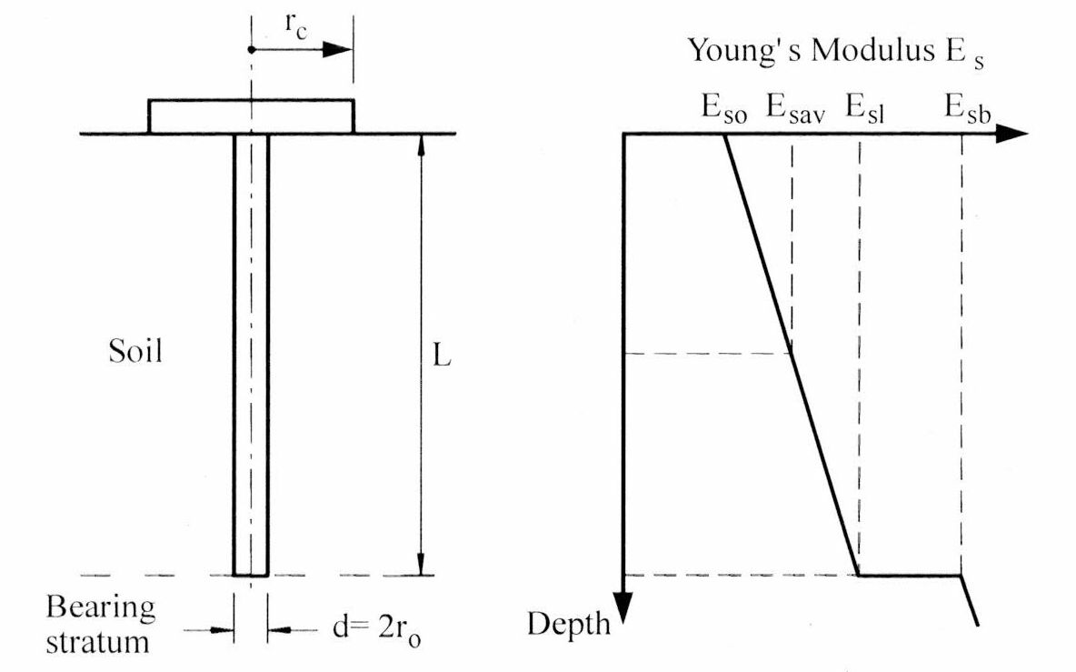

Figure 2.1: Simplified Representation of Piled-Raft Unit
(Randolph, 1994)

Burland’s Approach

Burland (1995) has developed the following simplified process of design:
- Estimate the total long-term load-settlement relationship for the raft without piles (Figure 2.3). The design load P₀ gives a total settlement S₀.
- Assess an acceptable design settlement Sa, which should include a margin of safety.
- P1 is the load carried by the raft corresponding to Sa.
- The load excess P₀ – P₁ is assumed to be carried by settlement-reducing piles.
- The shaft resistance of these piles will be fully mobilized and therefore no factor of safety is applied. However, Burland suggests that a ‘mobilization factor’ of about 0.9 be applied to the ‘conservative best estimate’ of ultimate shaft capacity, Psu.
- If the piles are located below columns which carry a load in excess of Psu, the piled raft may be analyzed as a raft on which reduced column loads act. At such columns, the reduced load Qr is:
Qr = Q – 0.9 Psu ……………..(5)
- The bending moments in the raft can then be obtained by analyzing the piled raft as a raft subjected to the reduced loads Qr.
- The process for estimating the settlement of the piled raft is not explicitly set out by Burland, but it would appear reasonable to adopt the approximate approach of Randolph (1994) in which:
Spr = Sr *Kr / Kpr………… (6)
Where,
Spr = settlement of piled raft
Sr = settlement of raft without piles subjected to the total applied loading
Kr = stiffness of raft
Kpr = stiffness of piled raft.

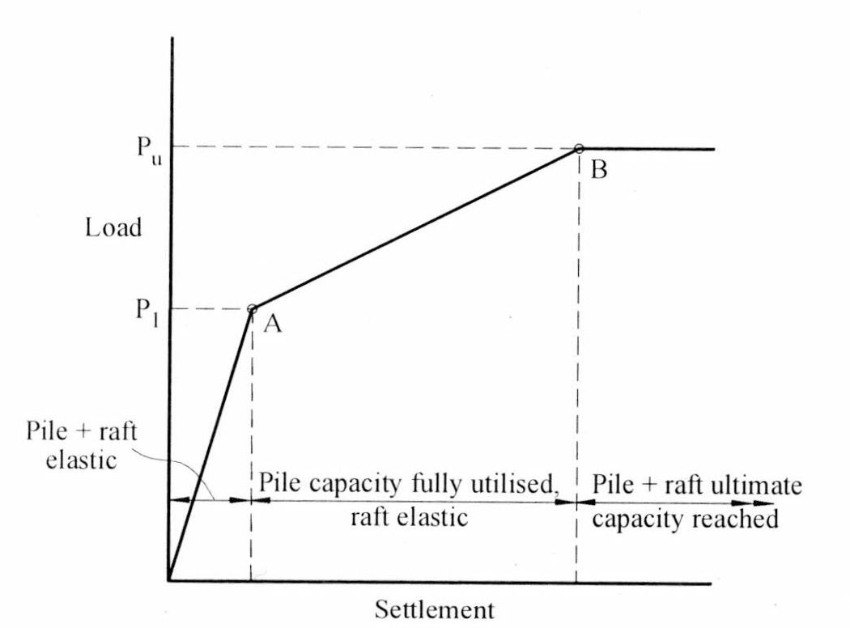
Figure 2.2: Simplified Load-Settlement Curve for Preliminary Analysis
(Randolph, 1994)

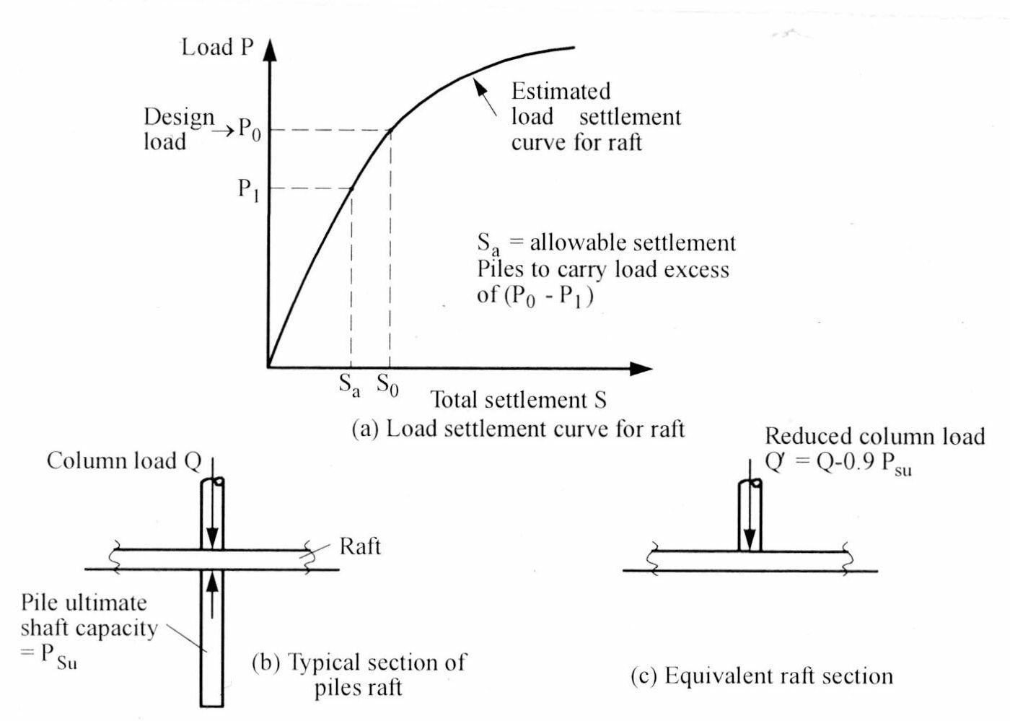
Figure 2.3: Burland’s Simplified Design Concepts
(Van Impe, 2001)

2.4.2 Approximation Method
Strip on Springs Approach (GASP) was presented by Poulos (1991) as illustrated in Figure 2.4. A section of the raft is represented by a strip and the supporting piles by springs. Approximate allowance is made for all four components of interaction viz. (i) Raft-Raft Elements; (ii) Pile-Pile Elements; (iii) Raft-Pile Elements and; (iv) Pile-Raft Elements. The effects of the parts of the raft outside the strip section being analyzed are taken into account by computing the free-field soil settlements due to these parts. These settlements are then incorporated into the analysis and the strip section is analyzed to obtain the settlements and moments due to the applied loading on that strip section and the soil settlements due to the sections outside the Raft. The method has been implemented via a computer program GASP (Geotechnical Analysis of Strip with Piles) and has given settlement which is in reasonable agreement with more complete methods of analysis. However, it does have some significant limitations, especially as it cannot consider torsional moments within the raft.
Poulos (1994) developed a program GARP (Geotechnical Analysis of Raft with Piles) which employed a Finite Difference Method for the raft with the consideration of the interaction effects between the piles and raft. Allowances were made for the piles to reach their ultimate capacities and local bearing failure of the raft. In Plate on Springs Approach (GARP) of analysis, the raft is represented by an elastic plate, the soil is represented by an elastic continuum and the piles are modeled as interacting springs. Some of the early approaches in this category neglected some of the components of interaction and gave pile-raft stiffness which was too large. Poulos (1994) has employed a Finite Difference Method for the plate and has allowed for the various interactions via approximate elastic solutions. This analysis has been implemented via a program GARP (Geotechnical Analysis of Raft with Piles). Allowance has been made for layering of the soil profile, the effects of piles reaching their ultimate capacity (both in compression and tension), the development of bearing capacity failure below the raft, and the presence of free-field soil settlements acting on the foundation system. The approximations involved are similar to those employed in the program GASP for piled strips.

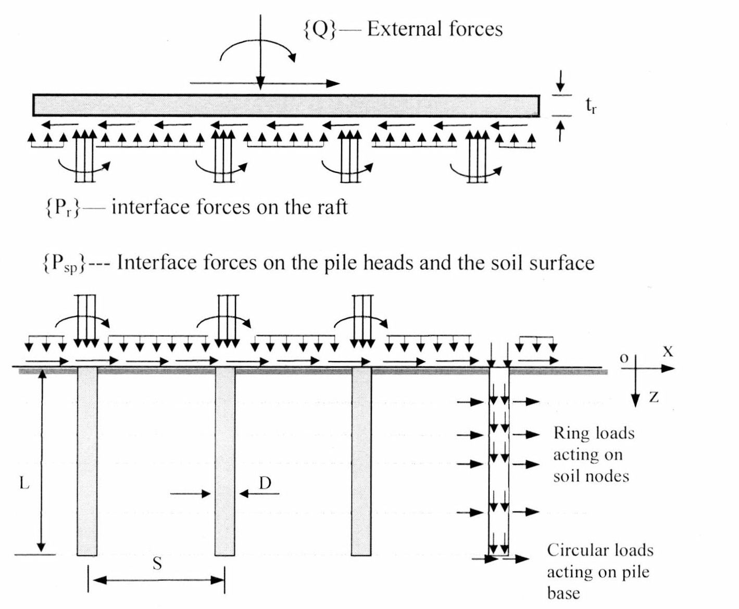

Figure 2.4: Representation of piled strip problem via GASP Analysis
(Poulos, 1991)

A later version of GARP has replaced the finite difference analysis for the raft with a finite element analysis, and has employed a modified approach to considering the development of the ultimate load capacity in the piles.
Most analyses of piled rafts are based on the raft being treated as a thin plate. Poulos et. al. (2001) have examined the effect of the method of modeling the raft as a thin plate who analyzed a typical problem using firstly, a three dimensional finite element program and then secondly, by making the raft 0.3m thick, and assigning the raft modulus to that part of the finite element mesh representing the raft. It was assumed in the analysis that there was no slip between the raft and the soil or between the piles and the soil. It was found that there was not a great deal of difference in the computed deflections for the raft, for both a stiff raft and a flexible raft.

2.4.3 Finite Element Method
The finite element method is one of the most powerful tools for the analysis of piled rafts. It requires the discretation of both the structural foundation system and the soil. In order to reduce the computational effort, problems are sometimes simplified to an axisymmetric problem or a plane-strain problem.
An early example of the analysis of a piled raft was given by Hooper (1973), in which a model with eight noded isoparametric elements was used. In the analysis, approximation of the equivalent stiffness of the pile group was made such that each concentric row of piles was modeled by a continuous annulus with an overall stiffness that was equivalent to the sum of the stiffness of the individual piles. The soil was assumed to be a linear elastic isotropic material with the modulus increasing linearly with depth. In order to incorporate the additional stiffening effect of the superstructure into the analysis, an equivalent raft thickness which had the same bending stiffness as the combined raft and the superstructure was introduced. However, Hooper’s results have shown that the contribution of the stiffening effect of the superstructure on the behavior of the piled raft was relatively small.
Ottaviani (1975) applied this method to the analysis of a rigid raft resting on a pile group embedded in a homogeneous medium. The piles and the soil were assumed to be a weightless linearly elastic homogeneous media.
Chow and Teh (1991) presented a numerical method to examine the behavior of a rigid piled raft embedded in a non-homogeneous soil. The raft was discretized into square sub-elements. The base of the raft was assumed to be perfectly smooth. The soil was assumed to be a linearly elastic, isotropic material and the Young’s Modulus assumed to increase linearly with depth. The piles were assumed to have a circular cross-section and were discretized into two noded elements at the pile-soil interface. Interactions between the piles, the raft and the soil were taken into account and the vertical deformation of the soil was determined by the principle of superposition.
Liu and Novak (1991) employed the finite element method to examine the behavior of a raft supported by a single pile at the centre. In the analysis, the cap was assumed to be circular and to contact the soil perfectly.. The cap, the pile and the surrounding soil medium were modeled by finite elements. The pile was assumed to be linearly elastic and the soil was assumed to be either elastic or elastic perfectly plastic. A weak zone around the pile with lower strength and modulus was introduced to account for the slip at the pile-soil interface.
Katzenbach and Reul (1997) described a structural model which employed the finite element method for the geometrical modeling of the continuum, an elasto-plastic constitutive model to describe the soil behavior and a step-by-step analysis for numerical simulation. The piles were modeled by 3-dimensional isoparametric finite elements and the raft was modeled by shell elements. A realistic stress-strain behavior of the soil was simulated by a constitutive model for the soil which consisted of two main yield-surface segments: a pressure dependent perfectly plastic shear failure surface and a compression cap yield surface. Katzenbach et al. (2000) used the same structural model to carry out parametric studies on the behavior of piled rafts in Frankfurt Clay.
Smith and Wang (1998) proposed the use of iterative techniques with the finite element method to examine the behavior of a non-uniformly loaded piled raft. Unlike the traditional techniques, this approach can reduce the size of the stiffness matrices, thus reducing the number of equations to be solved in the system
Reul and Randolph (2003) presented a three-dimensional elasto-plastic finite element method for the analyses of piled raft foundations in overconsolidated clay – Frankfurt clay. The analysis was implemented by the program ABAQUS. In the finite element method, the soil was modeled by hexahedron elements and the piles were modeled by triangular prism elements. The circular piles were modeled by square piles with the same shaft circumference. The interfaces between the raft and soil and between the pile and soil were modeled by thin solid continuum elements and were assumed to be perfectly rough. The soil was modeled by a cap model to simulate the non-linear behavior. The cap model consisted of three yield surface segments: the pressure-dependent, perfectly plastic shear failure surface, the compression cap yield surface, and the transition yield surface. The same model was used by these authors to perform a parametric study of a piled raft with different pile configurations and subjected to non-uniform vertical loading (Reul and Randolph, 2004).
Maharaj (2003) presented the results of three-dimensional nonlinear finite element analysis of piled raft foundation under uniformly distributed load. The raft, pile and soil had been idealized as a Drucker-Prager elasto-plastic continuum. The load settlement curves for raft and piled raft had been presented. The effect of soil modulus and pile length on load settlement behavior of raft and piled raft had also been presented. Based on analysis it had been found that the ultimate load carrying capacity of the flexible raft increased with increase in soil modulus and length of pile. Piles length even less than the width of flexible raft had been found effective in reducing differential settlement. The increase in soil modulus had been found to reduce the overall settlement and differential settlement. It had been found that although the increase in soil modulus reduced the overall settlement, differential settlement increased with increase in soil modulus for the same overall settlement.
Maharaj and Gandhi (2004) proposed a non-linear finite element method for the analysis of a piled raft subjected to a uniformly distributed load. This method combined an incremental iterative procedure with a Newton-Raphson method to solve the non-linear equations involved in a plasticity analysis. The raft, pile and soil were discretized into eight noded brick elements. The raft and piles were assumed to be linearly elastic and the non-linear behavior of the soil was modeled by the Drucker-Prager yield criterion.

CHAPTER 3
SOIL-STRUCTURE INTERACTION

  - Introduction
Soil-structure interaction refers to the interaction between a structure, its foundation and the subsoil. As the term soil-structure interaction covers a broad field, the work presented in this chapter will be restricted to the analysis of raft or piled raft foundations under static load.
Traditionally, the design work for structures has been separated from that of the foundations by the structural and geotechnical engineers, thus the stiffness of the superstructure is neglected. However, the structural stiffness can have effects on the distribution of column loads and bending moments transmitted from the structure to the foundation, therefore interaction analysis which accounts for the structural stiffness has to be considered.
Davis and Poulos (1972) developed an approach to analyze the piled raft system by considering interaction between pile-cap units. Hain and Lee (1978) presented a method which considered the foundation system as a flexible elastic plate supported by a group of compressible friction piles. This method took into account the interactions between the piles, raft and soil. However, the connection between the raft and the pile was assumed to be a sliding ball joint which implied that no moments or lateral forces were transferred between the raft and pile heads. Poulos (1994) developed an approximate method where the raft was modeled as a thin elastic plate and the piles were modeled as a series of springs.
Piled rafts are composite structures which are comprised of three elements: the piles, raft and the supporting soil. Loads applied to the raft are transferred to the soil through the piles; therefore, it is necessary to take into account the interaction among the three elements. In this chapter, the interaction mechanism for piled raft foundations is discussed.

  - Effect of Superstructure on Foundations
Methods for the analysis of soil-structure interaction have been developed over many years. Lee and Brown (1972) developed an analysis by treating the structure, foundation and soil system as an integral unit. The soil was treated as a Winkler or linear elastic model. The method was applied to the analysis of a multi-bay frame. Results have shown that the maximum moment in the foundation decreases with increasing flexibility of the foundation.
The variation in the stiffness of the structure, raft or soil causes a redistribution of the force in the system. As the superstructure contributes additional stiffness to the raft, bending moment in the raft reduces which leads to forces being transferred to the superstructure and resulted in increasing the bending moment in the structure. Brown (1986) showed that the stiffness of the structure increases progressively during construction which could have significant effect on the differential settlements in the raft. Zhang and Small (1994) demonstrated that an increase in the relative stiffness of the frame will result in a decrease in the differential settlements in the raft.
By taking into account the stiffness of the superstructure in analyzing rafts or piled rafts, the differential deflections of the raft can be reduced. However, for very flexible structures, the raft can be analyzed alone without great error. Therefore, neglecting the superstructure in the analysis can be conservative.

  - Interaction Mechanism of Piled Raft
The concept of interaction factors has been introduction by Poulos (1968). Since then it has been widely adopted for the analysis of pile groups and piled rafts. Davis and Poulos (1972) suggested that the analysis of a piled raft involves the interaction between the piles and the cap. In this section, four different interactions (i) pile-pile, (ii) pile-soil, (iii) soil-pile and (iv) soil-soil as shown in Figure 3.1 is presented.
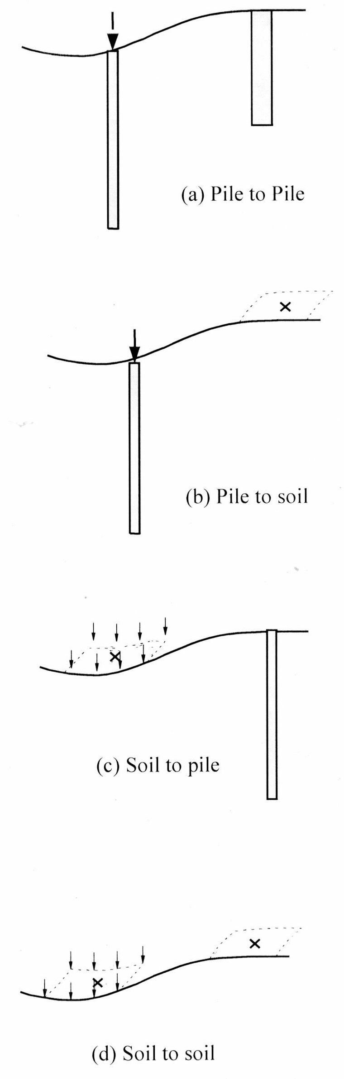
Figure 3.1: Type of interactions in a piled raft foundation (Small, et. al 2004)

  - Pile-Pile Interaction
Interaction between piles is an important consideration in the analysis of pile groups and piled rafts as shown in Figure 3.2. This interaction is defined as the additional deflection of an unloaded pile caused by an adjacent loaded pile.
The interaction factor, αpp, may be expressed as

αpp = additional deflection of an unloaded pile ………………………… …(eq 3.1)
deflection of a loaded pile in isolation

This interaction can be calculated by considering a pair of piles with a distance s between them and piles are divided into a number of beam elements. The soil is divided into several layers corresponding to the pile elements.

Deflections of the soil at the locations of the ring or uniform loads can be expressed as
δs = Is Ps……………………………………………………………………(eq 3.2)

where,
δs = vector of soil displacement at the nodes
Is = soil influence matrix
Ps = vector of forces acting at the soil interfaces

  - Pile-Soil Interaction
This is the interaction between a loaded pile and the soil surface at a distance s from the loaded pile as shown in Figure 3.3. The pile-soil interaction, αps, may be expressed as

αps = additional deflection of an unloaded soil surface
deflection of a loaded pile in isolation ……………………..( eq 3.3)

  - Soil-Pile Interaction
This is the interaction between a uniform rectangular load applied to the soil surface and an unloaded pile at a distance s from the centre of the loaded soil surface as shown in Figure 3.4.
The soil-pile interaction, αps, may be expressed as

αps = additional deflection of an unloaded pile
deflection of a loaded soil surface ……………………………..( eq 3.4)

This interaction is computed by considering the soil first. The deflection of the soil consists of two components – (i) due to the ring loads along the pile shaft and (ii) the surface load applied to the soil. The deflection due to the ring load can be computed by using equation (3.2). The load-deflection relationship can be written as

{δs}= [Is]{Ps} + { δt} …………………………………………………. (eq 3.5)

Where,
δs = vector of deflections of the soil along the pile shaft and at the pile base computed at the nodes of each pile
Ps = vector of loads acting on the soil along the pile shaft and at the base
δt = vector of deflections of the soil due to a unit surface load at a distance s from the pile computed at the nodes of the pile

  - Soil-Soil Interaction
This is the interaction between a uniformly loaded surface and the unloaded soil surface at a distance s from the centre of the loaded surface as shown in Figure 3.5. The soil-soil interaction, δss, may be expressed as
δss = additional deflection of an unloaded soil surface ……………………(eq 3.6)
deflection of a loaded soil surface

A uniform rectangular load in the horizontal or vertical direction is applied on the soil surface to each area in turn to calculate the deflection of the soil at the desired positions.
Many analysts of piled raft foundations employ structural analysis programs in which the raft is represented by a plate and the piles as springs. It is common for the spring stiffness of the piles to be computed for a single isolated pile, ignoring the effects of pile-soil-pile interaction. It is also common for such analyses to ignore the effects of raft-pile and pile-raft interaction. Such analyses will therefore tend to give a foundation stiffness which is too large, and settlements which are too low.

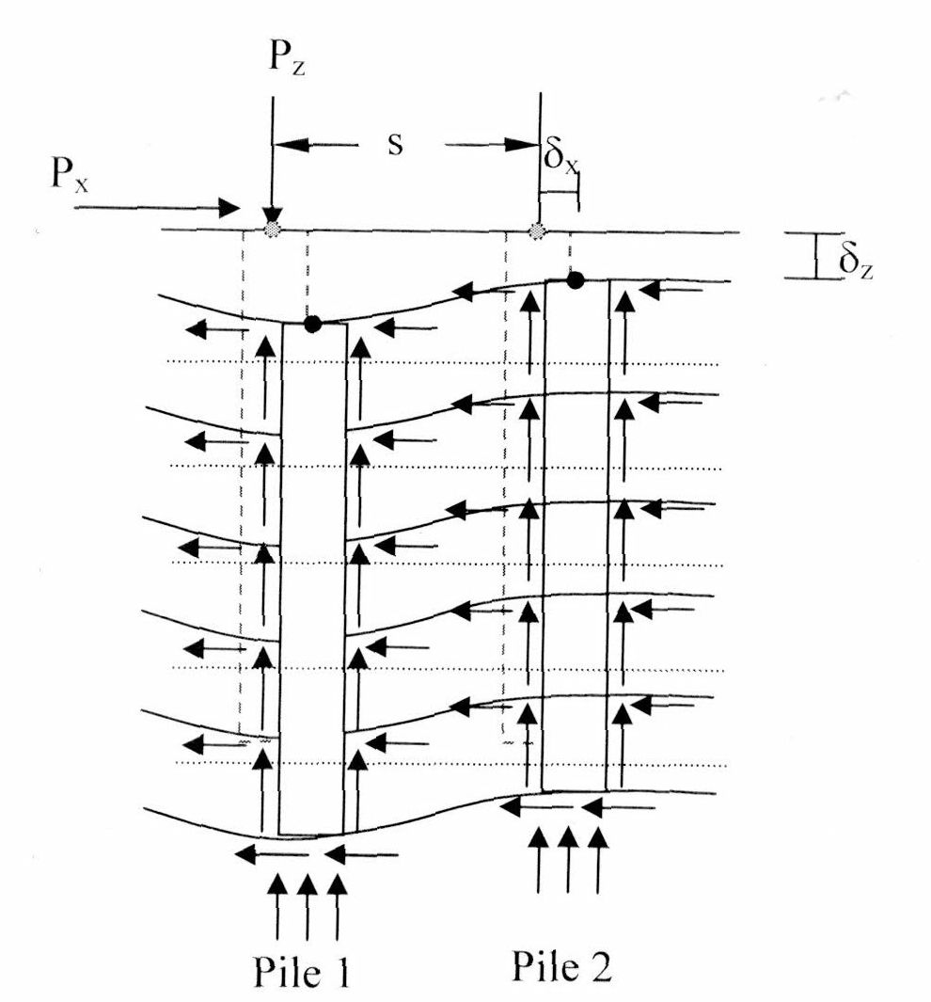

Figure 3.2: Interactions between a loaded pile and unloaded pile
Pile-Pile Interaction (Small, et. al 2004)

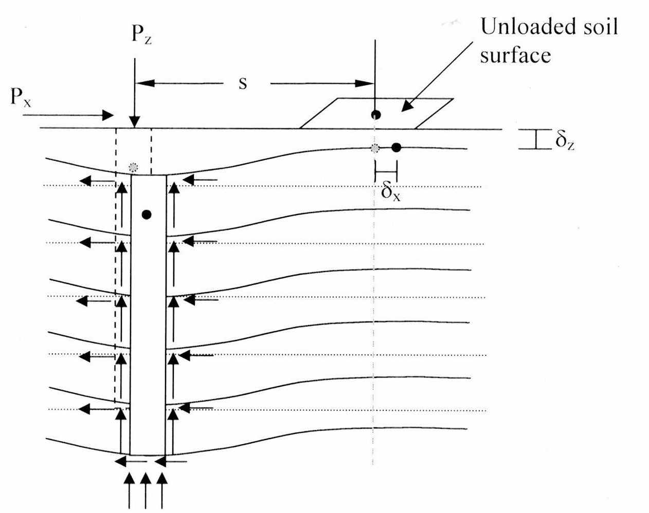

Figure 3.3: Interactions between a loaded pile and soil surface
Pile-Soil Interaction (Small, et. al 2004)
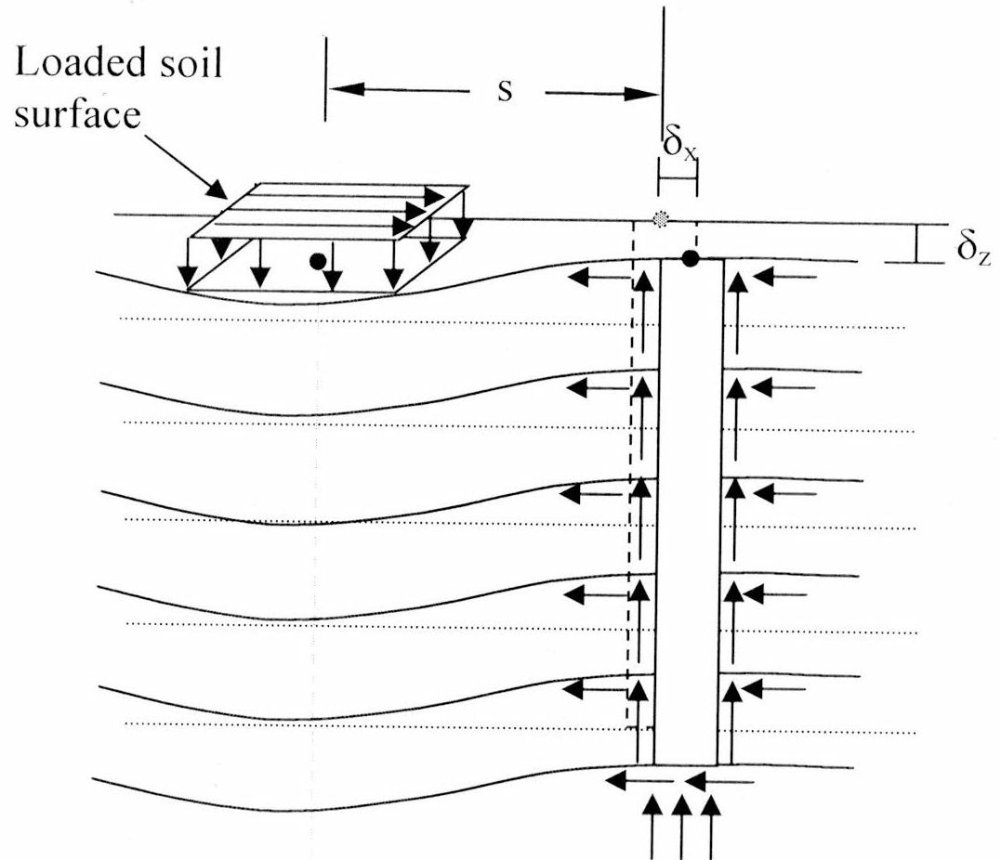

Figure 3.4: Interactions between a loaded surface and an unloaded pile
Soil- Pile Interaction (Small, et. al 2004)

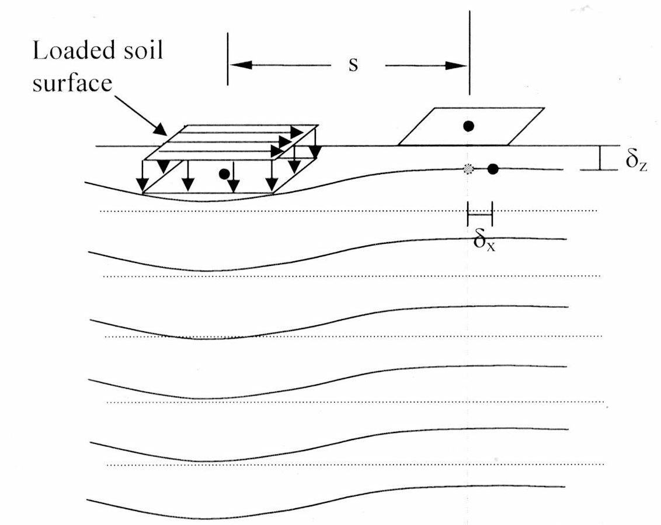

Figure 3.5: Interactions between a loaded surface and an unloaded surface
Sile-Soil Interaction (Small, et. al 2004)

CHAPTER 4
WORK PROGRAM FOR THE PARAMETRIC STUDY
4.1 Introduction
The present study involves a static analysis of a piled raft supporting relatively small buildings and embedded in (i) Soft, Compressible Clay deposits and (ii) Loose Sand for the Elastic Analysis and Soft Clay for Elasto-Plastic Analysis. The objective is to study the effects of pile group configuration on the settlement characteristics of a piled raft. The pile group configuration includes number of factors like the diameter of piles, their embedded lengths, the number and arrangement of piles, and their center-to-center spacing. For a structure having a given architectural plan and subjected to a definite loading, a change in any one or more of the above factors will result in a corresponding change in the total and differential settlements, which, for the type of structure considered here, are often the governing factors.

4.2 Methodology for Numerical Modeling
The procedure followed in the present investigation can be divided into the following steps:
- Physical Model of Structural System: Creation of three-dimensional physical models of the structural system consisting of (i) Raft; (ii) Piles and; (iii) Soil. The Super-Structure is removed and replaced by the corresponding uniformly load. Each part of the structural system has been modeled separately, and then discretized into a large number of finite elements. A sufficiently large zone of the infinite soil mass of length equal to twice breadth of raft from the edge of raft and depth equal two times breadth of raft plus length of pile has been selected as the zone of influence.
- Load: The total load applied on the structural system is assumed to be uniformly distributed over the entire surface area of the raft. This type of transmission of load is expected in a relatively flexible raft. On application of load the flexible raft is likely to undergo differential settlements. Due to this, the stress distribution due to uniform load will be non-uniform. Thus assumption that loads being uniformly distributed may not give accurate behavior as per actual condition but it can be acceptable for all practical purposes.
- Output: The model created by using the above condition is analyzed by using the finite element software ABAQUS to find out the settlement of structural system viz. piles on application of load for both (i) Elastic Soil and (ii) Elasto-plastic Soil Continuum. In both the cases the Raft and Piles are assumed to be Elastic throughout

4.3 ABAQUS 6.5-1
The static analysis of piled raft is carried out using the Finite Element based software package ABAQUS 6.5-1. This software is being widely used in different branches of engineering. ABAQUS is a suite of powerful engineering simulations programs, based on finite element method, that can solve problems ranging from simple linear analysis to most challenging nonlinear simulations. It has an extensive list of material models that can simulate the behavior of most typical engineering materials including metals, rubbers, polymers, composites, reinforced concrete, geotechnical materials such as rock and soils. ABAQUS can be used to study more than just structural problems. It can simulate problems in such diverse areas heat transfer, mass diffusion, thermal management of electronic components, acoustics, soil mechanics, and piezoelectric analysis. (ABAQUS Manual)
A complete ABAQUS analysis usually consists of three distinct stages
- Pre-processing,
- Simulation and
- Post-processing.

4.3.1 Preprocessing (ABAQUS/CAE)
In this stage we must define the model of the physical problem and create an ABAQUS input file. The model is usually created graphically using ABAQUS/CAE or another preprocessor, although the ABAQUS input file can also be created directly using a text editor. (ABAQUS Manual)

4.3.2 Simulation (ABAQUS/Standard or ABAQUS/Explicit)
The simulation, which normally runs as background process, is the stage in which ABAQUS/Standard or ABAQUS/Explicit solves the numerical problem defined in the model. Examples of output from stress analysis include displacements and stresses are stored in binary files ready for post processing. Depending on the complexity of the problem being analyzed and the power of computer being used, it may take anywhere from seconds to days to complete an analysis run. (ABAQUS Manual)
4.3.3 Post processing (ABAQUS/CAE)
We can evaluate the results once the simulation has been completed and displacements, stresses or other fundamental variables have been calculated. The evaluation is generally done interactively using visualization module of ABAQUS/CAE or other postprocessor. The visualization mode, which reads the neutral binary output database file, has a variety of options for displaying the results, including color, contour plots, animations, deformed shape plots, and X-Y plots. (ABAQUS Manual)

4.4 Analytical Method
4.4.1 The Soil Mass
It is difficult to ascertain the vertical and lateral extents of the zone of influence under the raft. However, the effects of soil-structure interaction can be adequately taken care of, if a sufficiently large zone of soil mass is taken into account. Accordingly, a large soil mass of rectangular cross-section, having a depth equal to twice that of the raft and a width equal to five times the raft width, is considered in each case. The elastic properties of the soil, Young’s modulus and Poisson’s ratio are given as input. Afterwards, this soil mass is discretized with the help of 8 noded brick elements.
The piled raft is assumed to be placed just below the ground surface on a deep, homogeneous, soft clay deposit. The average properties of this clay considered for the analysis are presented in Table 4.1

Table 4.1 Properties of Soil (Bowles, 1997)
Type of  Soil | Modulus of  Elasticity  (kN/m²)  E_{s} | Poisson’s  Ratio  μ_{s} | Density of Soil  (kN/m³)  γs | Unit  Cohesion  (kN/m²)  c | Adhesion  Factor  α
Soft Clay | 25000 | 0.45 | 18 | 25 | 1
Loose Sand | 25000 | 0.30 | 18 | 0 | 0

4.4.2 Raft
The raft considered is a flat slab having uniform thickness of 0.5 m resting on the ground surface. After modeling the raft, it is discretized with 8-noded brick elements. However, the volume occupied by the raft is much smaller as compared to that of the soil mass. Hence elements of smaller size are used for meshing the raft. The material properties of the elements used for modeling the RCC raft and soil mass are same.

4.4.3 Piles
Piles are modeled similar to that of raft, having higher Young’s modulus compared to the soil. The raft under each building frame is assumed to be supported by a group of RCC piles (Table 4.2) of circular cross-section. A total number of nine piles have been considered for the Elastic Analysis. In all the analyses, these piles are assumed to be elastic, identical, equally spaced and arranged in a square formation. Three different diameters of piles viz. (i) 0.30m; (ii) 0.40 m and; (iii) 0.50 m; pile of three different length namely (i) 8 m; (ii) 10 m and; (iii) 12 m have been considered for creating different models for carrying out the parametric study. The above two sets of design parameters of namely (i) Pile Diameter (d); (ii) Pile Length (L) and; (iii) Spacing Ratio (S/d) have been considered to create various models by combining these parameters for parametric study.

Table 4.2 Properties of Concrete in Pile and Raft (Bowles, 1997)

Elements of Structure | Poisson’s ratio  μc | Modulus of Elasticity (kN/m²)  Ec | Unit weight  (kN/m³)  γc
Raft | 0.25 | 25x10⁶ | 25
Pile | 0.25 | 25x10⁶ | 25

4.5 Results and Analysis of Results
A typical three-dimensional model of the piled raft generated using ABAQUS is shown in Figure 4.1 to Figure: 4.6. A Model of Raft, Pile and Soil defining their properties was created and assembled to create Raft-Pile-Soil System as per process given in ABAQUS. The Model which was created was meshed using partition procedure given in ABAQUS as the assembled model of Raft-Pile-Soil System was too big to mesh automatically. After successfully meshing the Model the input parameters were given to the input file. Boundary condition was applied by giving required degree of freedom of translation movements. The uniformly distributed load was applied to the model. The created model was submitted for the analysis in ABAQUS to carryout the analysis. The ABAQUS creates output of unknown forces, moments, and deflections at various nodes, which are then stored and can be retrieved whenever required. The variation of any of the above results along the nodes can be plotted. ABAQUS also allows visualizing the deformed shape of the structure. In the present analysis, the relevant output parameters that deserve attention are the differential settlements at different points of the raft.
The vertical displacement at any node obtained from the results of the analysis in any direction at any of the nodes gives the corresponding elastic (i.e., immediate settlement) settlement at that point. Thus the differential settlements below the tip of any pile or at any point below the raft can be easily computed. These results are then compared with a view to draw definite conclusions regarding the influence of the pile group configuration on the behavior of the piled rafts.

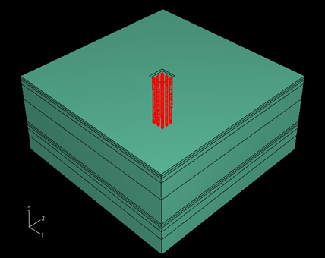
Figure: 4.1- Definition of the Problem.

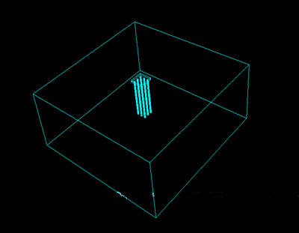

Figure: 4.2- Model of Soil-Raft-Pile System after Assembly of Various Elements.

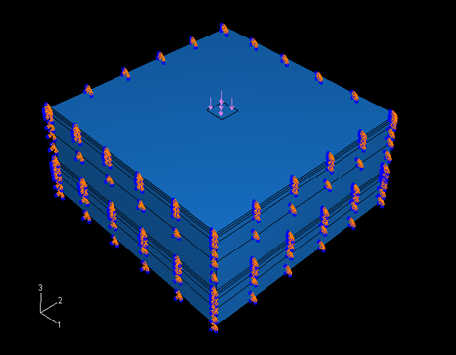

Figure: 4.3-Model after Applying Load and Boundary Conditions.

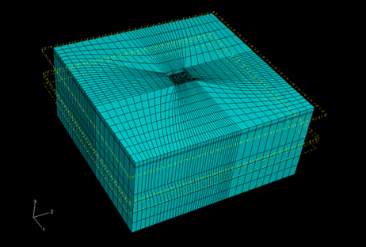
Figure: 4.4- Model of Meshed Soil-Raft-Pile System.

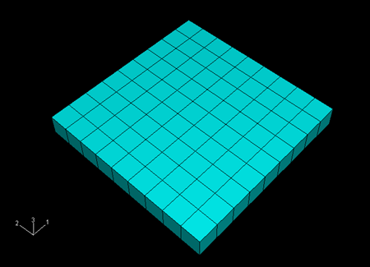
Figure: 4.5- Model of Meshed Raft.

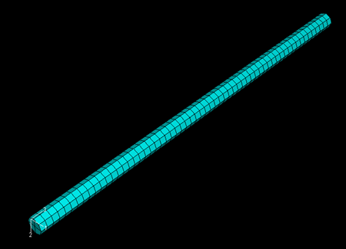

Figure: 4.6- Model of Meshed Pile.

CHAPTER 5
THE PARAMETRIC STUDY
5.1 Introduction
Installation of a pile group below a raft footing founded in a compressible soil deposit is often beneficial as it reduces the settlement of the structure to a great extent. Once the modeling and meshing of the system are done properly and the loads are applied, the settlements at different nodes are computed from the ABAQUS analysis. The effects of length, diameter and spacing of piles on the differential settlement of the piled raft have been studied.
The differential settlement of the piles can be defined in a number of ways. In the present analysis, it has been defined as the difference between the settlements below the tip of the center pile and those of outer piles.
First, parametric study of piled raft using elastic analysis is described. Later elasto-plastic analysis of piled raft foundation is given.

5.2 Results of Elastic Analysis
For the present study only the short-term settlement immediate settlement of the piles has been considered. Due to long-term consolidation of the soil mass, it is also assumed that the piles will settle uniformly. The uniformly distributed load of 100 kN/m² was applied load on the top of raft which is generally the magnitude of load for small residential building. The Finite Element Analysis using ABAQUS is based on the elastic deformation of the soil and concrete. Thus, the immediate settlements of the piles have been taken into consideration, while the consolidation settlements have been neglected for the present study. The consolidation settlements below various piles will not undergo significant variation due to the small zones of influence below the piles because of small diameters of piles. In general, the entire pile group and the soil mass between the piles is likely to consolidate as a composite material, which will restrict the differential consolidation settlement to minimum. Thus, the immediate elastic settlement can be considered for the present study.

The results obtained by the Finite Element Analysis using ABAQUS have been tabulated in Tables 5.1.to 5.3. Typical Contours of Displacements and Stresses are given in Figure- 5.1 and Figure- 5.2. Results of the Parametric Study are plotted in graphs i.e. Figure-5.3 to Figure-5.9.

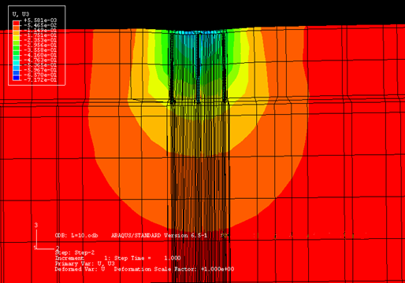
Figure: 5.1- Typical Displacement Contours

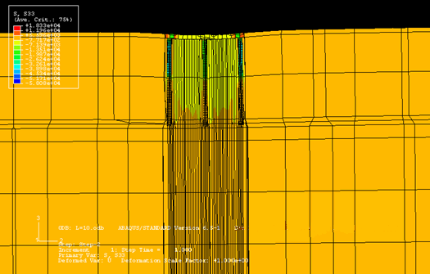
Figure: 5.2- Typical Stress Contours

Table 5.1: Settlement of Piles for Different Spacing Ratio
With Pile Diameter of 0.3m

Spacing Ratio | Pile Length  (m) | Settlement of Piles in Soft Clay  (mm) |  |  | Settlement of Piles in Loose Sand  (mm)
Spacing Ratio | Pile Length  (m) | Center | Side | Corner | Center | Side | Corner
S/d=3 | 8 | 26.47 | 25.20 | 25.22 | 20.07 | 19.10 | 19.12
S/d=3 | 10 | 25.53 | 24.57 | 24.82 | 19.13 | 18.37 | 18.72
S/d=3 | 12 | 24.72 | 23.93 | 23.82 | 18.32 | 17.83 | 17.62
S/d=5 | 8 | 27.15 | 25.04 | 24.38 | 20.85 | 19.09 | 18.43
S/d=5 | 10 | 26.52 | 24.74 | 23.84 | 20.22 | 18.64 | 18.34
S/d=5 | 12 | 26 | 24.46 | 23.43 | 19.7 | 18.46 | 17.93
S/d=8 | 8 | 28.15 | 24.09 | 21.46 | 22.05 | 18.29 | 15.66
S/d=8 | 10 | 27.19 | 23.54 | 21.14 | 21.09 | 17.74 | 15.34
S/d=8 | 12 | 26.4 | 22.91 | 20.84 | 20.3 | 17.11 | 14.94

Figure: 5.3- Differential Settlement v/s Pile Length with Pile Diameter of 0.3m.

Table 5.2: Settlement of Piles for Different Spacing Ratio
With Pile Diameter of 0.4m

Spacing Ratio | Pile Length  (m) | Settlement of Piles in Soft Clay  (mm) |  |  | Settlement of Piles in Loose Sand  (mm)
Spacing Ratio | Pile Length  (m) | Center | Side | Corner | Center | Side | Corner
S/d=3 | 8 | 25.75 | 24.9 | 24.83 | 17.75 | 17.10 | 16.93
S/d=3 | 10 | 24.80 | 24.1 | 24.13 | 16.80 | 16.30 | 16.13
S/d=3 | 12 | 24.37 | 23.72 | 23.72 | 16.37 | 15.92 | 15.82
S/d=5 | 8 | 26.54 | 24.61 | 23.64 | 18.54 | 16.91 | 15.94
S/d=5 | 10 | 25.67 | 23.98 | 23.42 | 17.67 | 16.28 | 15.72
S/d=5 | 12 | 24.53 | 23.22 | 22.71 | 16.53 | 15.52 | 15.01
S/d=8 | 8 | 27.05 | 23.48 | 20.85 | 19.05 | 15.78 | 13.15
S/d=8 | 10 | 26.09 | 23.04 | 20.20 | 18.09 | 15.34 | 12.50
S/d=8 | 12 | 25.12 | 22.55 | 19.89 | 17.12 | 14.75 | 12.19

Figure: 5.4- Differential Settlement v/s Pile Length with Pile Diameter of 0.4m.

Table 5.3: Settlement of Piles for Different Spacing Ratio
With Pile Diameter of 0.5m

Spacing Ratio | Pile Length  (m) | Settlement of Piles in Soft Clay  (mm) |  |  | Settlement of Piles in Loose Sand  (mm)
Spacing Ratio | Pile Length  (m) | Center | Side | Corner | Center | Side | Corner
S/d=3 | 8 | 24.95 | 24.37 | 24.2 | 16.85 | 16.47 | 16.3
S/d=3 | 10 | 24.15 | 23.58 | 23.48 | 16.05 | 15.78 | 15.58
S/d=3 | 12 | 23.75 | 23.34 | 23.2 | 15.65 | 15.54 | 15.3
S/d=5 | 8 | 25.42 | 23.92 | 23.37 | 17.52 | 16.22 | 15.67
S/d=5 | 10 | 24.88 | 23.68 | 22.88 | 16.98 | 15.98 | 15.18
S/d=5 | 12 | 23.62 | 22.78 | 21.8 | 15.72 | 15.08 | 14.1
S/d=8 | 8 | 26.19 | 23.17 | 20.77 | 18.29 | 15.47 | 13.37
S/d=8 | 10 | 25.18 | 22.8 | 19.96 | 17.28 | 15.1 | 12.76
S/d=8 | 12 | 24.2 | 21.98 | 19.25 | 16.3 | 14.38 | 12.05

Figure: 5.5- Differential Settlement v/s Pile Length with Pile Diameter of 0.5m.

Figure: 5.6- Differential Settlement v/s Pile Diameter with Spacing Ratio (S/d) of 8.

Figure: 5.7- Differential Settlement v/s Spacing Ratio (S/d) with Length of Pile of 8m

Figure: 5.8- Differential Settlement v/s Spacing Ratio (S/d) with Length of Pile of 10m

Figure: 5.9- Differential Settlement v/s Spacing Ratio (S/d) with Length of Pile of 12m

5.3 ELASTO-PLASTIC ANALYSIS
5.3.1 The Mohr-Coulomb Model for the Parametric Study
The Mohr-Coulomb failure or strength criterion has been widely used for Geotechnical application. It assumes that failure is controlled by maximum shear stress and that this failure shear stress depends on the normal stress. The Mohr-Coulomb failure line is the best straight line that touches Mohr’s circles as shown in Figure 5.10.The Mohr-Coulomb criterion can be written as
τ = c – σ tan Φ
where, τ is shear stress; c is cohesion; σ is the normal stress; Φ is angle of friction
Figure: 5.10- Mohr-Coulomb Failure Criterion (ABAQUS Version 6.5.1 Manual)
From Mohr’s circle,
τ = s cos Φ; σ = σ _{m} + s sin Φ substituting these values in Mohr-Coulomb equation we get, s + σ _{m} sin Φ- c cos Φ ; where, s= 0.5*(σ₁- σ₂) and σ _{m} = 0.5*(σ₁ + σ₂)
Thus, Mohr-Coulomb Model assumes that failure is independent of the value of intermediate principal stress. The failure of typical geotechnical materials generally includes some small dependence on the intermediate principal stress but the Mohr-Coulomb Model is generally considered to be sufficiently accurate for most applications. The failure model has vertices in the deviatoric stress plane as shown in Figure 5.11. (ABAQUS Version 6.5.1 Manual)
Figure: 5.11- Mohr-Coulomb Model in Deviatoric Plane (ABAQUS Version 6.5.1 Manual)
This Mohr-Coulomb Elasto-plastic Model uses a yield function which includes isotropic cohesion hardening/softening. It uses a flow potential that has a hyperbolic shape in the meridional stress plane and has no corners in the deviatoric stress plane. The flow potential is then completely smooth and therefore a unique definition of the direction of plastic flow. The ABAQUS/ Standard Mohr-Coulomb model uses a completely smooth flow potential. The flow potential ia a hyperbola in the meridional plane and it uses deviatoric section proposed by Menetrey and William.The friction angle Φ controls the shape of the yield surface in the deviatoric plane as shown in the Figure 5.12. For Φ =0⁰, the Mohr- Coulomb Model reduces to the pressure independent Tresca Model and for Φ =90⁰, the Mohr- Coulomb Model reduces to the “tension cut-off” Rankine Model. (ABAQUS Version 6.5.1 Manual)

Figure: 5.12- Mohr-Coulomb Yield Surface in Meridional and Deviatoric Plane (ABAQUS Version 6.5.1 Manual)
The Mohr-Coulomb Elatso-Plastic Model has the following properties (ABAQUS Manual):
- Its parameters are related to the physical soil properties of cohesion and friction angle in a straight forward way
- is used to model materials with the classical Mohr-Coulomb yield criterion
- allows the material to harden and/or soften isotropically
- uses a smooth flow potential that has a hyperbolic shape in the meridional stress plane and a piecewise elliptic shape in the deviatoric stress plane
- is used with the linear elastic material model and
- can be used for design applications in the geotechnical engineering area to simulate material response under essentially monotonic loading.
5.3.2 Arrangement of Piles and Raft
A Pile Group consisting of 9 piles have been considered for the modeling of piled-raft foundation. These piles are assumed to be identical, equally spaced and arranged in square formation. Diameter of pile is 500 mm, and the length is 10m &15m. Spacing is 5d. Overhang on all sides of raft is 0.75 m. Length of pile varied= 6 m, 8 m, 10 m, 15m, 18 m & 22 m.

5.3.3 The Properties Soil for Parametric Study
The Soil considered for the study is homogenous, fully saturated soft clay. Safe bearing capacity of the soil =100 kN/m² (as per IS 1904:1978). Properties of the soil taken are from literature is given in Table: 5.4. To idealize material non-linearity of soil has been modeled as Mohr-Coulomb Elasto-plastic medium.

Table: 5.4- Properties of Soil (Bowles, 1997)

Soil Type | Modulus of  Elasticity  (kN/m²)  E_{s} | Poisson’s  Ratio  μ_{s} | Density of Soil  (kN/m³)  γs | Compression Index  Cc | Adhesion  Factor α | Angle of Internal Friction
Fully Saturated Soft Clay | 12500, 25000, 50000 and 100000 | 0.45 | 18 | 0.25 | 1 | 0

5.3.4 The Properties Concrete for Parametric Study
The properties of concrete for Pile and Raft in carrying out the study are given in Table: 5.5. The Raft and Pile is assumed to remain Elastic at all times.

Table 5.5 Properties of Concrete in Pile and Raft (Bowles, 1997)

Elements of Structure | Poisson’s ratio  μc | Modulus of Elasticity (kN/m²)  Ec | Unit weight  (kN/m³)  γc
Raft | 0.25 | 25x10⁶ | 25
Pile | 0.25 | 25x10⁶ | 25

5.3.4 The Properties Interface Elements for the for Parametric Study
The interface elements are Two-dimensional quadratic elements comprising two 8-noded surfaces compatible with adjacent solid elements. The interface elements can transfer only shear forces across those surfaces when a compressive normal pressure acts on them. When contact exist the relationship between shear force and normal pressure is governed by a modified Coulombs Friction Theory. Thus elements are completely defined by their geometry, a friction coefficient and elastic stiffness used to provide convergence (reference ABAQUS Version 6.5.1).

5.3.5 Results of Elasto-plastic analysis
A parametric study has been done by varying the Modulus of Elasticity of soil (E_{s}), Pile Length (L). The variation of Settlement with various Load and E_{s} is plotted from Figs.5.16 to 5.20. To study response of piled-raft in terms of total and differential settlement for different pile length and raft thickness, a uniform load of 100 kN/m² was applied to piled raft which is approximately equal to load transferred by a small residential building to the raft. This load was applied to piled raft consisting of (i) Pile Group: 3x3 and (ii) Pile Group:4x4 and the variation of settlement for different Pile Length and Raft Thickness was studied by generating Models in ABAQUS. The result obtained for various combinations are tabulated in Table 5.4 to 5.14 and on the basis of this graphs are plotted in Figure 5.14 to Figure 5.30.

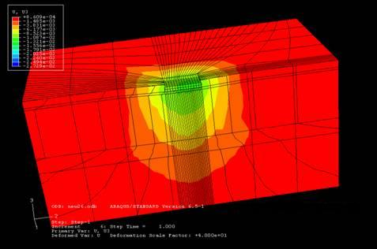

Fig 5.13 Typical Displacement Contours for Elasto-plastic Analysis

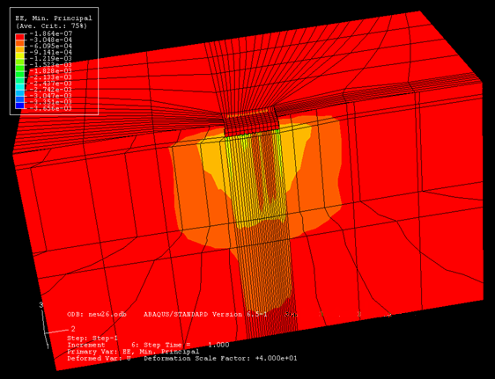

Fig 5.14 Typical Elastio-Plastic Strain Contours

RESULTS OF ELASTO-PLASTIC ANALYSIS
Table: 5.6 - Settlement of Piled- Raft for Different Modulus of Elasticity of Soil for Pile Length of 10m
 | Stress (kN/m²)
 | 50 | 75 | 100 | 150
Settlement (mm) for Es=12500 (kN/m²) | 15.4 | 27.3 | 43.6 | 54.2
Settlement (mm) for Es=25000 (kN/m²) | 8.2 | 12.2 | 16.1 | 20.3
Settlement (mm) for Es=50000 (kN/m²) | 4.1 | 6.2 | 8.1 | 10.4
Settlement (mm) for Es=100000 (kN/m²) | 2 | 3.1 | 4.1 | 5.1
Figure: 5.15- Settlement v/s Stress with different Modulus of Elasticity (Es) for Pile Length of 10m
Table: 5.7 - Settlement of Piled- Raft for Different Modulus of Elasticity of Soil for Pile Length of 15m
 | Stress (kN/m²)
 | 50 | 75 | 100 | 125
Settlement (mm) for Es=12500 (kN/m²) | 17.4 | 24.3 | 37.4 | 44.2
Settlement (mm) for Es=25000 (kN/m²) | 7.2 | 11.2 | 17.1 | 22.3
Settlement (mm) for Es=50000 (kN/m²) | 3.8 | 4.2 | 5.9 | 9.4
Settlement (mm) for Es=100000 (kN/m²) | 2.1 | 3.3 | 4.2 | 4.7

Figure: 5.16- Settlement v/s Stress with different Modulus of Elasticity (Es) for Pile Length of 15m
Table: 5.8 - Settlement of Piled- Raft for Different Pile Length with Modulus of Elasticity of Soil (Es) of 12500 kN/m2
 | Stress (kN/m²)
 | 50 | 75 | 100 | 125
Settlement (mm) for Pile Length of 6m | 26.2 | 41.1 | 58.7 | 96.6
Settlement (mm) for Pile Length of 10m | 13.2 | 29.4 | 45.8 | 56.3
Settlement (mm) for Pile Length of 18m | 9.3 | 16.6 | 18.7 | 19.4
Settlement (mm) for Pile Length of 22m | 8.6 | 11.4 | 14.2 | 16.7
Figure: 5.17- Settlement v/s Stress for Piles of Different Length and Modulus of Elasticity for Soil (Es) = 12500 kN/m²

Table: 5.9 - Settlement of Piled- Raft for Different Pile Length with Modulus of Elasticity of Soil (Es) of 25000 kN/m2
 | Stress (kN/m²)
 | 50 | 75 | 100 | 125
Settlement (mm) for Pile Length of 6m | 23.2 | 35.1 | 48.7 | 85.6
Settlement (mm) for Pile Length of 10m | 9.2 | 19.4 | 25.8 | 30.3
Settlement (mm) for Pile Length of 18m | 7.3 | 12.6 | 16.7 | 15.4
Settlement (mm) for Pile Length of 22m | 5.6 | 7.4 | 10.2 | 12.6

Figure: 5.18- Settlement v/s Stress for Piles of Different Length and Modulus of Elasticity for Soil (Es) = 25000 kN/m²
Table: 5.10 - Settlement of Piled- Raft for Different Pile Length with Modulus of Elasticity of Soil (Es) of 50000 kN/m2
 | Stress (kN/m²)
 | 50 | 75 | 100 | 125
Settlement (mm) for Pile Length of 6m | 7.3 | 9.1 | 11.2 | 12.3
Settlement (mm) for Pile Length of 10m | 3.6 | 4.7 | 5.8 | 9.6
Settlement (mm) for Pile Length of 18m | 2.3 | 3.8 | 4.2 | 7.4
Settlement (mm) for Pile Length of 22m | 1.8 | 2.4 | 3.8 | 4.8

Figure: 5.19- Settlement v/s Load for Piles of Different Length and Modulus of Elasticity for Soil (Es) = 50000 kN/m²
Table: 5.11 - Settlement of Piled- Raft with Pile Length of 10 m
Raft Thickness (m) | Settlement of Piled Raft (mm)
Raft Thickness (m) | Pile Group: 3x3 | Pile Group: 4x4
0.5 | 34.8 | 21.3
1 | 30.7 | 19.1
1.5 | 26.7 | 16.3
2 | 24.7 | 15.8

Figure: 5.20- Settlement v/s Raft Thickness with Different Pile Group for Pile Length of 10 m

Table: 5.12 - Settlement of Piled- Raft with Pile Length of 15 m

Raft Thickness (m) | Settlement of Piled Raft (mm)
Raft Thickness (m) | Pile Group: 3x3 | Pile Group: 4x4
0.5 | 29.6 | 17.2
1 | 26.6 | 14.2
1.5 | 20.6 | 13.7
2 | 18.6 | 12.2

Figure: 5.21- Settlement v/s Raft Thickness with Different Pile Group for Pile Length of 15 m

Table: 5.13 - Settlement of Piled- Raft with Raft Thickness of 0.5 m

Pile Length (m) | Settlement of Piled Raft (mm)
Pile Length (m) | Pile Group: 3x3 | Pile Group: 4x4
0 | 44.5 | 44.5
10 | 34.8 | 21.3
15 | 29.6 | 17.2

Figure: 5.22- Settlement v/s Pile Length with Different Pile Group
For Raft Thickness of 0.5 m

Table: 5.14 - Settlement of Piled- Raft with Raft Thickness of 1.0 m

Pile Length (m) | Settlement of Piled Raft (mm)
Pile Length (m) | Pile Group: 3x3 | Pile Group: 4x4
0 | 40.2 | 40.2
10 | 30.7 | 19.1
15 | 26.6 | 14.2

Figure: 5.23- Settlement v/s Pile Length with Different Pile Group
For Raft Thickness of 1.0 m

Table: 5.15 - Settlement of Piled- Raft with Raft Thickness of 1.5 m

Pile Length (m) | Settlement of Piled Raft (mm)
Pile Length (m) | Pile Group: 3x3 | Pile Group: 4x4
0 | 37.1 | 37.1
10 | 26.7 | 16.3
15 | 20.6 | 13.7

Figure: 5.24- Settlement v/s Pile Length with Different Pile Group
For Raft Thickness of 1.5 m

Table: 5.16 – Differential Settlement of Piled- Raft with Pile Length of 10 m

Raft Thickness (m) | Differential Settlement of Piled Raft (mm)
Raft Thickness (m) | Pile Group: 3x3 | Pile Group: 4x4
0.5 | 12.1 | 9.9
1 | 7.2 | 5.1
1.5 | 4.1 | 3.3
2 | 2.3 | 1.2

Figure: 5.25- Differential Settlement v/s Raft Thickness with Different Pile Group
For Pile Length of 10 m

Table: 5.17 – Differential Settlement of Piled- Raft with Pile Length of 15 m

Raft Thickness (m) | Differential Settlement of Piled Raft (mm)
Raft Thickness (m) | Pile Group: 3x3 | Pile Group: 4x4
0.5 | 9.5 | 7.8
1 | 5.5 | 3.3
1.5 | 2.6 | 1.5
2 | 1.2 | 0.8

Figure: 5.26- Differential Settlement v/s Raft Thickness with Different Pile Group
For Pile Length of 15 m

Table: 5.18 – Differential Settlement of Piled- Raft with Raft Thickness of 0.5 m

Pile Length (m) | Differential Settlement of Piled Raft (mm)
Pile Length (m) | Pile Group: 3x3 | Pile Group: 4x4
0 | 13.1 | 13.1
10 | 12.1 | 9.9
15 | 9.5 | 7.8

Figure: 5.27- Differential Settlement v/s Pile Length with Different Pile Group
For Raft Thickness of 0.5 m

Table: 5.19 – Differential Settlement of Piled- Raft with Raft Thickness of 1.0 m

Pile Length (m) | Differential Settlement of Piled Raft (mm)
Pile Length (m) | Pile Group: 3x3 | Pile Group: 4x4
0 | 9.93 | 9.93
10 | 7.2 | 5.1
15 | 5.5 | 3.3

Figure: 5.28- Differential Settlement v/s Pile Length with Different Pile Group
For Raft Thickness of 1.0 m

Table: 5.20 – Differential Settlement of Piled- Raft with Raft Thickness of 1.5 m

Pile Length (m) | Differential Settlement of Piled Raft (mm)
Pile Length (m) | Pile Group: 3x3 | Pile Group: 4x4
0 | 7.9 | 7.9
10 | 4.1 | 3.3
15 | 2.6 | 1.5

Figure: 5.29- Differential Settlement v/s Pile Length with Different Pile Group
For Raft Thickness of 1.5 m

Table: 5.21 – Differential Settlement of Piled- Raft with Raft Thickness of 2.0 m

Pile Length (m) | Differential Settlement of Piled Raft (mm)
Pile Length (m) | Pile Group: 3x3 | Pile Group: 4x4
0 | 6.5 | 6.5
10 | 2.3 | 1.2
15 | 1.2 | 0.8

Figure: 5.30- Differential Settlement v/s Pile Length with Different Pile Group
For Raft Thickness of 2.0 m

Table: 5.22 – Settlement of Piled- Raft with Raft Thickness

Raft Thickness (m) | Settlement of Piled Raft (mm)
Raft Thickness (m) | Pile Group: 3x3 | Pile Group: 4x4
0.5 | 44.5 | 44.5
1.0 | 40.2 | 40.2
1.5 | 37.1 | 37.1

Figure: 5.31- Settlement v/s Raft Thickness without Pile Group

Table: 5.23 – Differential Settlement of Piled- Raft with Raft Thickness

Raft Thickness (m) | Settlement of Piled Raft (mm)
Raft Thickness (m) | Pile Group: 3x3 | Pile Group: 4x4
0.5 | 13.1 | 13.1
1 | 9.93 | 9.93
1.5 | 7.9 | 7.9
2.0 | 6.5 | 6.5

Figure: 5.32- Differential Settlement v/s Raft Thickness without Pile Group

CHAPTER 6
DISCUSSION OF THE RESULTS

6.1 Discussions of Results for Elastic analysis
The results obtained from the parametric study for the piled raft in (i) Soft Clay and (ii) Loose Sand has been tabulated in Table 5.1, Table 5.2 and Table 5.3. On this basis of result graphs have been plotted from Figure: 5.3 to Figure:5.9 to interpret the result due variation of design parameters namely (i) Pile Length (L); (ii) Pile Diameter (d); (iii) Spacing (S) and ; (iv) Number of Piles. The values of the settlements as observed from Tables 5.1. to 5.3., shows that settlement of Center Pile was in general, found to be greater than the settlement of Side Piles in both Soft Clay and Loose Sand soil. The Settlement of Corner Piles was lowest in both Soft Clay as well as Loose Sand.

6.1.1 Effect of Pile Length (L)
As seen in the Figure: 5.3, Figure: 5.4 and Figure: 5.5 the differential settlement of piled raft in soft clay and loose sand decreases with the increase in pile length (L = 8m, 10m and 12m). Resistance to vertical loading increases with increase in pile length as more length is available for mobilization of shear resistance
The settlement and differential settlement decreases with increasing pile length thus increasing the pile length is more effective design strategy for improving the foundation performance than increasing the number of piles (Van Impe, 2001)

6.1.2 Effect of Spacing Ratio (S/d)
As seen in the Figure: 5.7, Figure: 5.8 and Figure: 5.9 the differential settlement of piled raft in soft clay and loose sand increases with the increase in spacing ratio (for S/d = 3, 5 and 8). For a given length of pile, the settlement under the center pile of each group increases with increase in spacing, while that under the side piles settlement decreases as seen from Tables 5.1 to 5.3. Due to this the differential settlement increases with increase in the spacing. When the spacing ratio reduces, the pile group settles as a single unit (block failure occurs) and there is a little scope for the occurrence of differential settlement among individual piles. For a given length of pile the settlement increases with increase in spacing. This is more effective longer piles than for shorter piles. For a particular spacing, the settlement of piled raft decreases with increase in length of pile. At larger spacing the decrease in settlement of piled raft with increase in pile length is comparatively less than at smaller spacing.
This is because with increase in spacing between piles maximum load is shared by raft and hence the settlement of piled raft is governed by the pressure bulb formed below the raft while at smaller spacing the load shared by pile is more than that of the raft and hence settlement is governed by the pressure bulb formed by the pile at the two-third length of the pile. (Gandhi and Maharaj,1996). As the spacing ratio becomes large so does the raft and so the total load applied also increases (as load is uniformly loaded). The spacing ratio has pronounced effect of settlement and differential settlement (Van Impe, 2001).

6.1.3 Effect of Pile Diameter (d)
As seen in the Table: 5.1, Table: 5.2, Table: 5.3 and Figure: 5.6 the differential settlement of piled raft in both soft clay as well as loose sand decreases with the increase in diameter (d = 0.3m, 0.4m and 0.5m). This is because with the increase in pile diameter the surface area of pile as well as the base area of pile increases which increases load shared by piles and pile capacity. This reduces the settlement as well as differential settlement of piles

6.2 Discussions of Results for Elastio-Plastic Analysis
The results obtained from the parametric study for the piled raft in Soft Clay has been tabulated in Table: 5.6 to Table: 5.23. On this basis of result graphs have been plotted from Figure:5.15 to Figure:5.32 to interpret the result due variation of design parameters namely (i) Pile Length (L); (ii) Pile Diameter (d); (iii) Spacing (S) ; (iv) Number of Piles; (v) Raft Thickness (tr) and; (vi) Modulus of Elasticity of Soil (Es) .

6.2.1 Effect of Raft Thickness (tr)
As seen in the Figure:5.31, Figure:5.32, Table: 5.22 and Table: 5.23 the Settlement and Differential Settlement of piled raft in soft clay decreases with the increase in Raft Thickness (tr = 0.5m, 1.0m, 1.5m and 2.0m).
The maximum settlement of piled raft is not very sensitive to raft thickness but raft thickness reduces the differential settlement but increases the bending moment. That increasing the raft thickness is very beneficial in resisting the punching shear from both piles and column loading. The maximum column loading therefore increases with increasing raft thickness (Van Impe, 2001). It has been observed that in soft clay the load settlement curves are almost same for all three values of thickness. This is due to the soil-structure interaction effect, as a result of which even a thin raft in soft soil shows rigid behavior (Maharaj, 2004).

6.2.2 Effect of Pile Length (L)
As seen in the Figure: 5.22, Figure: 5.23 and Figure: 5.24, the Settlement of piled raft in soft clay decreases with the increase in pile length (L = 10m and 15m). The Settlement also decreases with the increase in number of piles from 9 piles (Pile Group: 3x3) to 16 piles (Pile Group: 4x4).
As seen in the Figure: 5.27, Figure: 5.28, Figure: 5.29 and Figure: 5.30 the Differential Settlement of piled raft in soft clay decreases with the increase in pile length (L = 10m and 15m). The Differential Settlement also decreases with the increase in number of piles from 9 piles (Pile Group: 3x3) to 16 piles (Pile Group: 4x4).
The maximum settlement decreases with increasing pile length but after certain length of pile there is no significant decrease in settlement with increase in pile length (Sommer, et. al. 1995). The efficient reduction of settlement can be achieved with a smaller number of longer piles rather than large number of shorter piles (Reul and Randolph, 2004)

6.2.3 Effect of Number of Piles (n)
As seen in the Figure: 5.20, Figure: 5.21, Figure: 5.22, Figure: 5.23 and Figure: 5.24, the settlement of piled raft in soft clay decreases with the increase in number of piles from 9 piles (Pile Group: 3x3) to 16 piles (Pile Group: 4x4).
As seen from Figure: 5.25 to Figure: 5.30, the Differential Settlement of piled raft in soft clay decreases with the increase in number of piles from 9 piles (Pile Group: 3x3) to 16 piles (Pile Group: 4x4).
The maximum settlement and differential settlement decreases with increasing number of piles but there is an upper limit to the number of piles beyond which very little additional benefit is obtained (Van Impe, 2001).
The pile length and pile group – raft area ration is most influential elements of the geometry on reduction of differential settlement ( Prakoso and Kulhawy, 2001)

6.2.4 Effect of Modulus of Elasticity (Es)
As seen in the Table 5.6, Table 5.7, Figure 5.16 and Figure 5.16 to Figure 5.19 the Settlement of piled raft decreases with the increase in Modulus of Elasticity of Soil (Es = 12500 kN/m² , 25000 kN/m², 50000 kN/m², 100000 kN/m² ). Also the settlement decreases with increase in pile length (L = 6m, 10m, 18m and 22m).
When stiffness of soil decreases the load carrying capacity of the raft decreases. Thus for the maximum load to be transferred to the pile the relative movement between pile and soil must increase. Thus piled raft settles more in softer soil than in stiffer soil. . (Gandhi and Maharaj, 1996). Effect of Pile Soil ratio on vertical loading: As Ep/Es increases there is decrease on vertical displacement of piles which is not very effective in case of Ep/Es in excess of 1000 (Trochanis, et. al. 1991)

CHAPTER 7
CONCLUSIONS AND RECOMMENDATIONS
FOR FUTURE RESEARCH

7.1 Conclusions for Elastic Analysis
The piled raft foundation is very effective if soft clays or loose sand exists near surface and generally not a suitable option if ground moments are likely to occur below the raft (Poulos et. al., 2001).
The present study involves nature of load-settlement behavior of a piled raft in a (i) deep, homogenous soft clay deposit; (ii) homogenous loose sand for elastic analysis. For elasto-plastic analysis piled raft is carried out in deep, homogenous soft clay deposit. The analysis was done by creating model in finite element analysis Software ABAQUS for pile-raft-soil system. The study was done by varying the design parameters of raft and piles namely (i) Pile Length (L); (ii) Pile Diameter (d); (iii) Spacing Ratio (S/d) ; (iv) Number of Piles; (v) Raft Thickness (tr) and; (vi) Modulus of Elasticity of Soil (Es) . The following can be concluded from the parametric study carried out for Elastic Study:

- The settlement and differential settlement decreases with increasing pile length. The decrease in differential settlement decreases between 5% to 10% per meter increase in pile length
- The settlement and differential settlement increases with increasing spacing ratio (S/d) is also found from the past study. The percentage of increase of differential settlement is more 100% for increase in S/d from 3 to 5 and from 5 to 8
- The differential settlement decreases with increasing pile diameter. For S/d =3 the percentage of decrease with diameter was highest and for S/d=8 the percentage of decrease in differential settlement was lowest
- The settlement of corner piles was lowest and center pile was found to be higher than the settlement of side piles and corner piles.

7.2 Conclusions for Elasto-Plastic analysis
The following can be concluded from the parametric study carried out for Elastic Study:
- Settlement and differential settlement of piled raft in soft clay decreases with the increase in raft thickness the result is in agreement with the past study (Trochanis et. al., 1991 and Maharaj & Anshuman, 2004). The effect of raft thickness is more on differential settlement than settlement. Thus, increasing the raft thickness is effective primarily in reducing the differential settlement.
- The maximum settlement is not greatly affected by raft thickness, except for thin rafts. There is little benefit in increasing the raft thickness above certain thickness (2.0m for the parametric study).
- With the increase in length of pile the settlement and differential settlement decreases. When the pile length is increases from 10m to 15m the percentage of decrease in settlement and differential is more than 15% various thickness of raft.
- The differential settlement reduces with increase in number of piles. The differential settlement reduction is more than 20% for 16 piles (Pile Group: 4x4) as compared to 9 piles (Pile Group: 3x3).
- Settlement of piled raft decreases with the increase in modulus of elasticity of soil which is in agreement with the past study.

7.3 Scope of Further Study
A few general trends in the behavior of piled rafts have been studied during this investigation. The study was carried out to study the load- settlement behavior of piled raft by varying the configuration of pile, raft and soil. The behavior of pile-raft, in terms of total settlement and differential settlements of the piles under given magnitude of the uniform load was studied. The behavior moments and shears along the raft and shear have not been considered here. Also the behavior of piled raft only under static axial load has been considered. However, the behavior of piled raft under combination of axial load, lateral load and moment have not been considered. The scope of further study may include:
- To study the behavior of piled raft with static loading and combination of axial load, lateral load and moment.
- To study the behavior of piled raft with dynamic loading and combination of axial load, lateral load and moment.
- To study the behavior of piled raft by varying the length pile in pile group.
- To study the behavior of non-uniform loading on piled raft.
- To study the behavior of piled raft with various arrangement of pile group.
- To study the behavior of piled raft with in non-homogenous layer of soil

APPENDIX: A
The parametric study has been compared with the past studies. The following past studies is for reference for comparative study of both Elastic Analysis and Elasto-Plastic Analysis.
  - Past Studies for Elastic Comparative Analysis
A.1.1 : Effect of Pile Length on Settlement (Gandhi and Maharaj, 1996)
A.1.2: Effect of Relative Stiffness on Settlement (Gandhi and Maharaj, 1996)
A.1.3: Effect of Size of Piled Raft on Settlement (Gandhi and Maharaj, 1996)

Figure A.2.1: Material Properties and Geometrical Configuration (Poulos, 2001)
Figure A.2.2: Average Settlement with various Methods (Poulos, 2001)

Figure A.2.3: Comparitive results for hypothetical example (raft with 9 piles, total load = 12MM) (Poulos, 2001)

Figure A.2.4: Effect of number of piles on piled raft behaviour for hypothetical example (raft with 9 piles, total load = 12MM) (Poulos, 2001)

Figure A.2.5: Interaction Diagram: Settlement Reduction, s/ sr, plotted against L/d and n (Katzenbach et al. 1998)

Figure A.3.1: Effect of Number of Piles and Settlement (Van Impe et al., 2001)

Figure A.3.2: Effect of Pile Length and Settlement with 0.5m raft, 9 piles and Load= 12MN (Van Impe et al., 2001)

Figure A.3.3: Effect of Raft Thickness and Settlement with 9 piles of 10m length and Load= 12MN (Van Impe et al. 2001)

  - Past Studies for Elasto-Plastic Comparative Analysis

Raft of Size: 16m x 16m
Thickness of Raft (tr): 0.5m, 1.0m, 2.0m and 4.0m
Piles of Size: 0.4m x 0.4m and 12m length
Modulus of Elasticity of Raft (Er) and Pile (Ep) kN/m ²: 2x10⁷
Modulus of Elasticity of Raft (Es)) kN/m ²: 25000, 50000 and 100000
Poisson’s Ratio of Raft, μ _{r and} μ _{p} : 0.3
Poisson’s Ratio of Soil, μ _{s:} 0.45
Angle of friction Φ = 0
Cohesion of Soil C kN/m ²: 20

Figure A.4.1: Load Settlement Curve for piles in a piled raft Es=50000 kN/m ² (Gandhi and Maharaj 2004)

Figure A.4.2: Load Settlement Curve for piles in a piled raft tr = 4m & Es=50000 kN/m ² (Gandhi and Maharaj, 2004)

Figure A.4.3: Curve of Contact Stress against Settlement Piled Raft piled raft Es=50000 kN/m ² (Gandhi and Mahara, 2004)

Figure A.4.4: Load Settlement Curve for piles in a piled raft Es=50000 kN/m ² (Gandhi and Maharaj, 2004)

Figure A.5.1: Comparison of Various Methods for Load Settlement Curve of piled raft Es=50000 kN/m ² ( Reference Rabei Meisam 2008 )
Figure A.5.2: Model Condition and Material Properties (Reference Rabei Meisam 2008)
Figure A.5.3: Effect of Raft Thickness on Maximum Settlement (Reference Rabei Meisam 2008)

Figure A.5.4: Effect of Raft Thickness on Differential Settlement (Reference Rabei Meisam 2008)
Raft of Size: 16m x 16m
Thickness of Raft (tr): 0.5m, 1.0m, 2.0m and 4.0m
Piles of Size: 0.4m x 0.4m and 12m length
Modulus of Elasticity of Raft (Er) and Pile (Ep) kN/m ²: 2x10⁶, 2x107, 2x10⁸
Modulus of Elasticity of Raft (Es)) kN/m ²: 250000
Poisson’s Ratio of Raft, μ _{r and} μ _{p:} 0.3
Poisson’s Ratio of Soil, μ _{s:} 0.45
Angle of friction Φ = 0
Pile Length (L) =48m; Size= 0.4mx0.4m
Dilatancy angle of soil =0
Cohesion of Soil C kN/m 2: 20.83

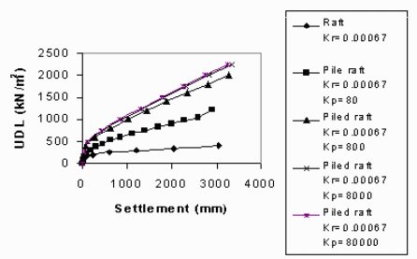

Figure A.6.1: The effect of pile stiff ness on on load-settlement curves of piled raft foundation for flexible raft (Maharaj, 2004)

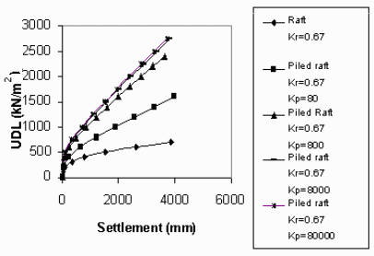

Figure A.6.2: The effect of pile stiff ness on load-settlement curves of piled raft foundation for flexible raft (Maharaj, 2004)

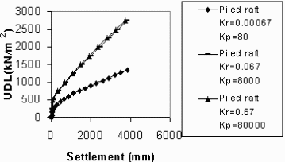

Figure A.6.3: The effect of varying raft and pile stiffness on load-settlement curves of piled raft foundation (Maharaj 2004)

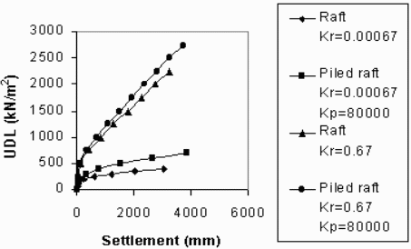

Figure A.6.4: Effect of stiff pile on load-settlement curves of piled raft foundation (flexible and stiff mat) (Maharaj, 2004)

REFERENCES

- Banerjee, P.K. and Davies, T.G. (1978). “The Behaviour of Axially and Laterally loaded Single Piles Embedded in Non-Homogenous soils”. Geotechnique, 29(3), 300-326.
- Brown, P. T. (1969). “Numerical Analysis of Uniformly Loaded Circular Rafts on Elastic Layers of Finite Depth”. Geotechnique, Vol. 19(2), 301-306.
- Burland, J.B. (1995). “Piles as Settlement Reducers”. Keynote Address, 18th Italian Congress on Soil Mechanics, Pavia, Italy.
- Butterfield, R. and Banerjee, P.K. (1971). “The Elastic Analysis of Compressible Piles and Pile Groups”. Geotechnique, Vol. 21(1), 43-60.
- Cheung, Y, K. and Zienkiewicz, O. C. (1965). “Plates and Tanks on Elastic Foundations – An Application of Finite Element Method”, International Journal of Solids Structures,Vol.1, 451-461.
- Cheung, Y. K., Tham, L. G. and Guo, D. J. (1988). “Analysis of Pile Group by Infinite Layer Method”, Geotechnique, Vol. 38, 415-431.
- Chow, Y. K. (1987). “Axial and Lateral Response of Pile Groups Embedded in Non-homogeneous Soil”, International Journal for Numerical and Analytical Methods in Geomechanics, Vol. 11( 6) , 621-638
- Chow, Y. K. and Teh, C. I. (1991). “Pile-Cap-Pile-Group Interaction in Non-homogeneous Soil”. Journal of Geotechnical Engineering, Vol. 117 (11), 1655-1667.
- Costa, J. A. and Brebbia, C. A. (1986). “On the Reduction of Domain Integrals to the Boundary for the BEM Formulation of Plates on Elastic Foundation”. Engineering Analysis, Vol. 3 (2), 123-126.
- de Paiva, J. B. and Butterfield, R. (1997). “Boundary Element Analysis of Plate-soil Interaction”. Computer and Structures, Vol. 64, No.1-4, 319-328.
- Fraser, R.A. and Wardle, L.J. (1976). “Numerical Analysis of Rectangular Rafts on Layered Foundations”. Geotechnique, Vol.26(4), 613-629.
- Gandhi, S. R and. Maharaj, D. K. (1995). “Behaviour of Piled Raft Foundations under Uniform Loading”. Indian Geotechnical Conference, December ,Bangalore, India Vol. 1, 169-172.
- Gandhi, S. R. and Maharaj, D. K. (1996). “Analysis of Piled Raft Foundation”. Proceedings of the Sixth International Conference on Piling and Deep Foundations, Bombay , pp. 1.11.1 –1.11.7.
- Gandhi, S. R and. Maharaj, D. K. (1996). “Non-linear Finite Element Analysis of Piled Raft Foundations”. Proceedings of Institution of Civil Engineers, London, 107-113.
- Gandhi, S. R and. Maharaj, D. K. (1996). “Settlement Behaviour of Piled Raft Foundations”. Indian Geotechnical Conference, December 7-11,Madras, India.
- Guo, D.J., Tham, L.G. & Cheung, Y.K. (1987). “Infinite Layer for the Analysis of a Single Pile”. Computer and Geotechnics Vol.3 (4) , 229-249.
- Guo, W. D. and Randolph, M. F. (1999). “An Efficient Approach for Settlement Prediction of Pile Groups”. Geotechnique, Vol. 49 (2),161-179.
- Hain, S. J. and Lee, I. K. (1974). “Rational Analysis of Raft Foundation”, Journal of Geotechnical Engineering, ASCE, Vol. 100, No. GT7, pp. 843-860.
- Hain, S.J. and Lee, I.K. (1978). “The Analysis of Flexible Raft-Pile Systems”. Geotechnique, Vol. 28 (1), 65-83.
- Hooper, J.A. (1973). “Observations on the Behaviour of a Piled-Raft Foundation on London Clay”. Proceedings of Institution of Civil Engineers, Vol. 55(2), 855-877.
- Horikoshi, K. and Randolph, M.F. (1998). “A Contribution to the Optimum Design of Piled Rafts”. Geotechnique, Vol. 48(2), 301-317.
- Katzenbach, R. and Reul, O. (1997). “Design and Performance of Piled Rafts”. Proceedings of 14th International Conference on Soil Mechanics and Foundation Engineering, Hamburg, Vol. 4, pp. 2253-2256.
- Katzenbach, R., Arslan, U. & Moormann, C. (1998). “Design and Safety Concept for Piled Raft Foundations”. Proceedings of the Conference on Deep Foundations on Bored and Auger Piles, Ghent, Rotterdam: Balkema, 439–448.
- Katzenbach, R., Arslan, U. & Moormann, C. (2000). “Piled Raft Foundation Projects in Germany in Design Applications of Raft Foundations”. London: Thomas Telford, pp. 323–391.
- Kay, J. N and Cavagnaro, R. L. (1983). “Settlement of Raft Foundations”. Journal of Geotechnical Engineering, ASCE, Vol. 109 (11), 1367-1382.
- Kuwabara, F. (1989). “An Elastic Analysis for Piled Raft Foundations in a Homogeneous Soil”. Soils and Foundations, Vol. 28(1), 82-92.
- Lee, I.K. (1993). “Analysis and Performance of Raft and Raft-Pile Systems”. Keynote Lecture, 3rd International Conference Case History in Geotechnical Engineering, St. Louis (also Res. Rep. R133, ADFA, Univ. NSW, Australia)
- Lee, K.M. and Xiao, Z.R. (2001). “A Simplified Non-linear approach for Pile Group Settlement Analysis in Multi-layered Soils”. Canadian Geotechnical Journal, Vol. 38, 1063– 1081.
- Liu W. and Novak M. (1991). “Soil-Pile-Cap Static Interaction Analysis by Finite and Infinite Elements”. Canadian Geotechnical Journal, Vol. 28, 771– 783.
- Maharaj, D. K. (2003a) “Load-Settlement Behaviour of Piled Raft Foundation by Three Dimensional Nonlinear Finite Element Analysis”. Electronic Journal of Geotechnical Engineering. Vol. 8, Bundle C, Paper 0334
- Maharaj, D. K. (2004) “Three Dimensional Nonlinear Finite Element Analysis to Study the Effect of Raft and Pile Stiffness on Load-Settlement Behaviour of Piled Raft Foundations ”. Electronic Journal of Geotechnical Engineering.
- Maharaj, D. K. and Anshuman (2004) “The Effect of Raft Size and Pile Length on Load-Settlement Behaviour of Axisymmetric Piled Raft Foundations ”. Electronic Journal of Geotechnical Engineering.
- Ottaviani M. (1975). “Three-dimensional Finite Element Analysis of Vertically Loaded Pile Groups”. Geotechnique, Vol. 25(2), 159– 174.
- Poulos, H.G. and Davis, E.H. (1972). “The Analysis of Piled Raft Systems”. Australian Geomechanics Journal., G2, 21-27.
- Poulos, H.G. and Davis, E.H. (1980). “Pile Foundation Analysis and Design”. John Wiley and Sons, New York.
- Poulos, H.G. (1989). “Pile Behaviour : Theory and Application”. Geotechnique, Vol. 39 (3), 365-415.
- Poulos, H.G. (1991). “Analysis of Piled Strip Foundations”. Computer Methods & Advances in Geomechanics., Balkema, Rotterdam Vol. 1, 183-191.
- Poulos, H.G. (1994). “An Approximate Numerical Analysis of Pile-Raft Interaction”. International Journal for Numerical and Analytical Methods in Geomechanics, Vol.18, 73-92.
- Poulos H. G. (2001). “Piled Raft Foundations: Design and Applications”. Geotechnique, Vol 51(2), 95– 113.
- Poulos, H.G. (2006). “Pile Group Settlement Estimation: Research to Practice”. Foundation Analysis and Design: Innovative Methods, ASCE, Vol.127, No.8, 635-641.
- Prakoso, W.A. and Kulhawy, F.H. (2000). “Contribution to Piled Raft Foundation Design”. Journal of Geotechnical and Geoenvironmental Engineering, ASCE, Vol. 127(1), 17-24.
- Randolph, M.F. and Wroth, C.P. (1978). “Analysis of Deformation of Vertically Loaded Piles”. Journal of Geotechnical and Geoenvironmental Engineering, ASCE, Vol.104 (GT12), 1465-1488.
- Randolph, M.F. and Wroth, C.P. (1979). “An Analysis of the Vertical Deformation of Pile Groups”. Geotechnique, Vol. 29 (4K), 423-429.
- Randolph, M.F. and Clancy, P. (1993). “Analysis and Design of Piled raft Foundations”. International Journal for Numerical and Analytical Methods in Geomechanics, Vol.10, 59-72.
- Randolph, M.F. (1994). “Design Methods for Pile Groups and Piled Rafts”. S.O.A. Report, 13 th International Conference of Soil Mechanics and Foundation Engineering, New Delhi, Vol. 5, 61-82.
- Randolph, M. F. and Reul, O. (2004). “Design strategies for Piled Rafts subjected to Non-Uniform Vertical Loadings”. Journal of Geotechnical and Geoenvironmental Engineering , ASCE, Vol. 130(1), 1-13.
- Rabiei Meisam (2008). “Parametric Study for Piled Raft Foundatons”. Electronic Journal of Geotechnical Engineering
- Reul, O. and Randolph, M. F. (2003). “Piled Rafts in Overconsolidated Clay: Comparison of In situ Measurements and Numerical Analyses”. Geotechnique, Vol. 53(3), 301-315.
- Russo, G. and Viggiani, C. (1998). “Factors Controlling Soil-Structure Interaction for Piled Rafts” Darmstadt Geotechnics, Darmstadt Univ. of Technology, Vol. 4, 297-322.
- Sapountzakis, E. J. and Katsikadelis, J. T. (1992). “Unilaterally Supported Plates on Elastic Foundations by the Boundary Element Method”. Journal of Applied Mechanics, Vol. 59, 580-586.
- Small, J.C. and Zhang, H.H. (2000). “Piled Raft Foundations Subjected to General Loadings”. Developments in Theoretical Geomechanics, Ed. D.W. Smith, & J.P. Carter, Balkema, Rotterdam, 431-444.
- Smith, I. M. and Wang, A. (1998). “Analysis of Piled Rafts”, International Journal for Numerical and Analytical Methods in Geomechanics, Vol. 22, 777-790.
- Sommer, H., Wittmann, P. and Ripper, P. (1985). “Piled Raft Foundation of a Tall Building in Frankfurt Clay”. Proceedings of 11th International Conference of Soil Mechanics and Foundation Engineering, San Francisco, Vol. 4: 2253-2257.
- Trochanis, A. M., Bielak, J. and Christiano, P. (1991). “Three-dimensional Nonlinear Study of Piles”. Journal of Geotechnical and Geoenvironmental Engineering, ASCE, Vol. 117(3), 429– 447.
- Van Impe, W.F. (2001). “Technical Report on Methods of Analysis for Piled Raft Foundations”. A Report Prepared on Behalf of Technical Committee TC18 on Piled Foundations.International Society for Soil Mechanics and Geotechnical Engineering
- Zhang, H. H., Small, J. C. and Chow, H. (2004). “Behaviour of Piled Raft with Piles of Different Length and Diameter”. Proceedings 9th Australia and New Zealand Conference on Geomechnics, 8-11 February , Auckland, New Zealand, Vol-1, 123-129 Computers and Geotechnics, Vol. 26(1), 1-21.

