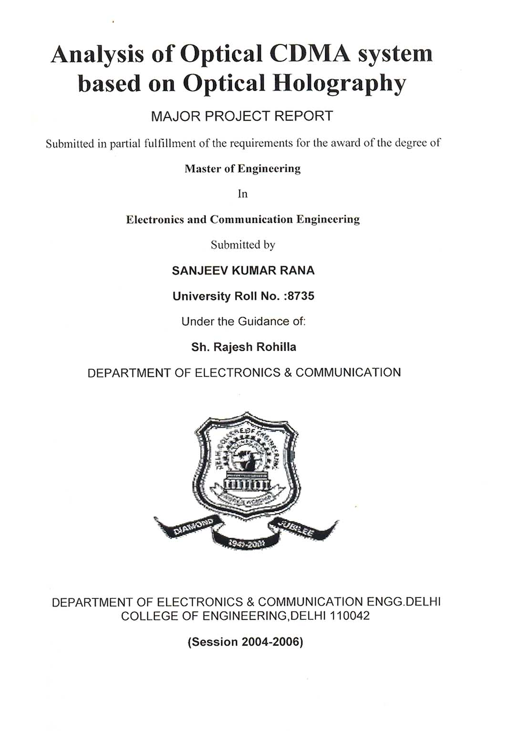
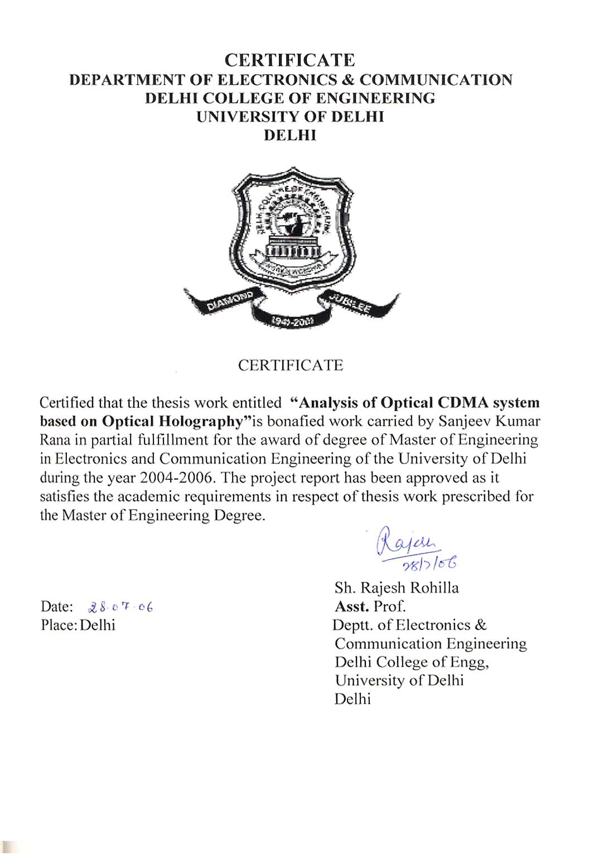
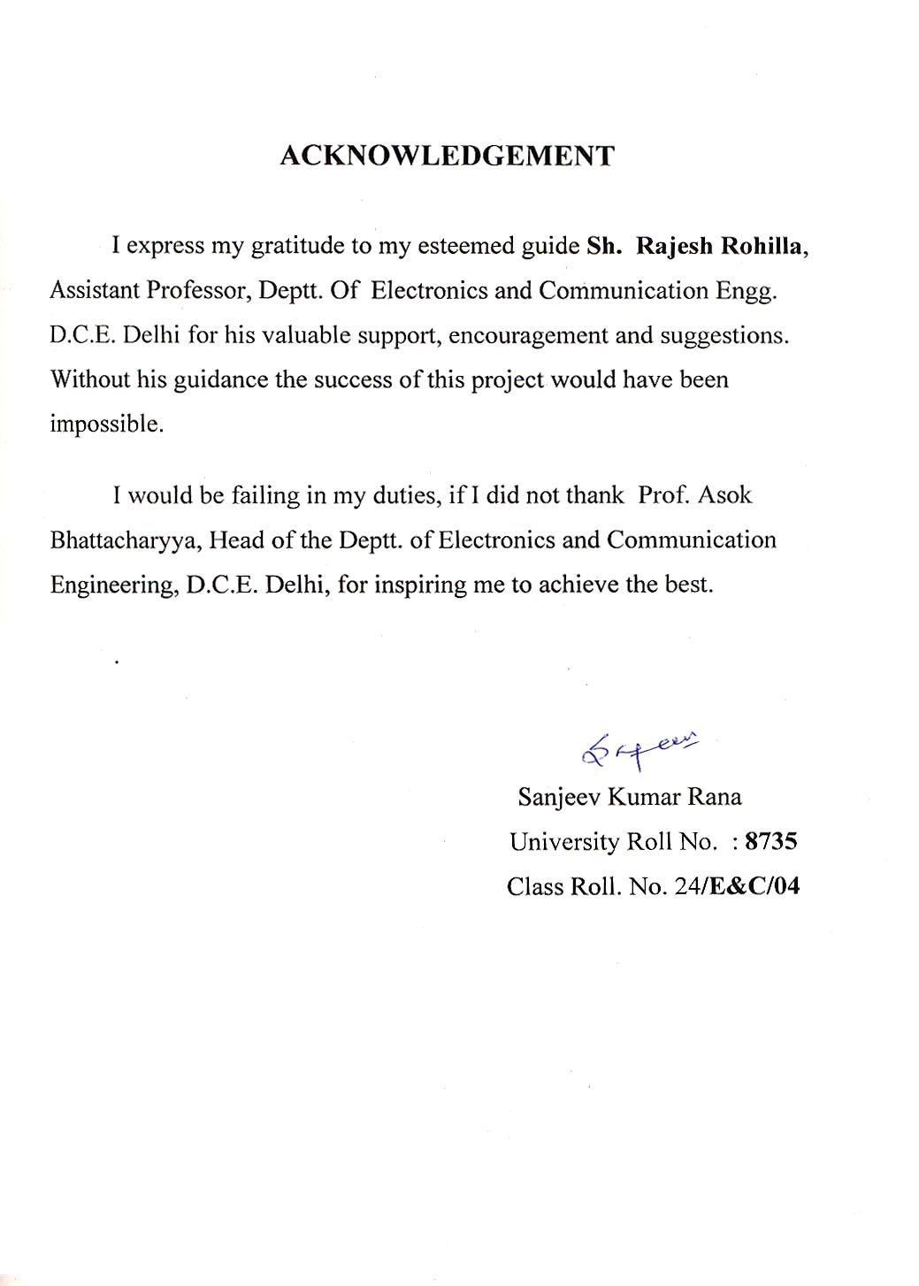

Analysis of Optical CDMA system based on Optical Holography

Abstract

In this thesis, a technique for all-optical Code Division Multiple Access system based on Optical holography is studied. This technique utilizes full advantage of optical parallelism and complex spatial filtering to realize encoding and decoding in the context of an optical CDMA. This technique allows multiple transmitters to simultaneously use same non-coherent receiving aperture.

In this technique, the energy of incoming information light signal is spread over a larger spatial domain by a two dimensional spatial encoder which consists of patterns of (0,1) or (1, -1). Subsequent decoding is obtained by a holographic filter, which spatially de-spreads the energy of information light signal and brings it to a bright focused light spot.

In this thesis, the structure of encoder and decoder is described.

Based on spatial harmonic de-composition, basic mathematical analysis for spread space holographic codes are analyzed. The analysis consists of Fourier Transform Lens and a holographic matched filter. The signal to interference ratio (SIR) and the probability of error (Pr) for multi-user environment is analyzed with respect to the number of users.

The hologram pattern contains a large amount of unnecessary components to reproduce the image. These unnecessary components can be removed by band pass filtering of hologram patterns. In this thesis, we examine the data compression of hologram pattern by transform coding and a holographic matched filter.

To obtain the bit error rate (BER) we evaluate the probability density function of multi user interference and then evaluate the BER as a function of the processing gain, number of users, the received power and the optimum threshold.

Contents:

Certificate

Acknowledgement

Abstract

Contents

List of figures

List of Abbreviation and symbols used

Chapter – 1

1.1 Introduction to CDMA

1.2 All – optical system description

1.3 Presentation of the work

Chapter – 2

2.1 Basic Principal of the Holographic CDMA technique

2.2 Principle of Encoder and Decoder in Spread Space Holographic CDMA
2.3 Holographic CDMA Encoding and Decoding Experiment

Chapter – 3

3 Distinct features of Holographic CDMA technique
3.1 Spatial domain encoding and decoding
3.2 Arbitrary modulation format
3.3 Uncoupled processing gain

Chapter – 4

4 System description and mathematical model

4.1 System Analysis

Chapter – 5

5 Performance Analysis

5.1 Signal to interference Ratio

5.2 Probability of Error

5.3 Bit Error Rate

Chapter – 6

Results

Chapter – 7

7 Problems in Holographic CDMA

7.1 Problem of Synchronization

7.2 Problem of random phase introduced by diffuser.

7.3 Problem of matching for image transformation.

Conclusion

Reference

Simulation Codes in Matlab

A 4.1 .... System Model

A 4.2 …. Analysis for Signal to interference ratio

A 4.3 …. Analysis for probability of Error

A 4.4 …. Calculation for Marcum’s Q function

A 4.5 …. Calculation of BER and plotting it with respect to the no. of users

A 4.6 …. Calculating BER for different threshold and plotting it

A 4.7 …. Plotting the BER Vs. no. of users by keeping no/m constant

List of Figures

Figure 1.1 ….. Block diagram of All-Optical CDMA system for Star Configuration

Figure 2.1(a) …. Diagram of a typical Holographic CDMA communication system

Figure 2.1(b) …. Typical example of 2-D Spread Space Holographic CDMA codes

Figure 2.2 …. Principal of Encoder and Decoder in Spread Space Holographic CDMA
Figure 2.3 …. Experimental setup of a typical holographic CDMA system

Figure 5.1 …. A typical configuration for holographic CDMA photonic switch
Figure 6.1 …. Graphical representation for the hologram of size 5 x 5 for one user
Figure 6.2 …. Graphical representation for the Fourier Transform of the Hologram
Figure 6.3 …. Graphical representation of Probability of Error with respect to the number
of users.
Figure 6.4 …. Graphical representation of Signal to interference ratio with respect to the
area of the pixels
Figure 6.5 …. Graphical representation of Probability of error with respect to the number
of users.
Figure 6.6 …. Graphical representation of the Bit Error Rate with respect to the threshold
of the matched filter
Figure 6.7 …. Graphical representation of the Bit Error Rate with respect to the no. of
users
Figure 6.8 …. Graphical representation of the Bit Error Rate with respect to the no. of
users keeping ratio of no. of pixels to the no. of users constant.

Abbreviations And Symbols Used

Abbreviations

CDMA – Code Division Multiple Access

SIR – Signal to Interference Ratio

Pr – Probability of Error

BER – Bit Error Rate

MF – Matched Filter

OOC – Optical orthogonal Codes

Pdf – Probability density function

Symbols used:

No – Number of Pixels

M – Number of Users

Ps – Transmitted Power

A – Area of Pixel

Rc,c – Correlation Function

Ith – Intensity Threshold of the Matched Filter

Q(a,b) – Marcum’s Function

Chapter 1

Introduction to CDMA

Code Division Multiple Access (CDMA) is a radically new concept in wire less communication. It has gained widespread international acceptance by cellular radio system operators as an upgrade that will dramatically increase both their system capacity and the service quality.

CDMA is a form of Spread Spectrum, a family of digital communication techniques that have been used in military applications for many years. The core principle of Spread Spectrum is the use of noise-like carrier waves and, as the name implies, bandwidth much larger than that required for simple point-to-point communication at the same data rate. Originally there were two motivations: either to resist enemy effort to jam the communication or to hide the fact that communication was even taking place, sometimes called low probability of intercept.

So, let’s first have a look at PN sequence and Spread Spectrum technique to get a better understanding of CDMA techniques:

Pseudo-Random Noise Code:

A PN code used for DS-spreading consists of N_{DS} units called chips. These chips can have 2 values: -1/1 or 0/1. As we combine every data symbol with a complete PN code, the DS processing gain is equal to the code length.

To be usable for direct –sequence spreading, a PN code must meet the following conditions:

The sequence must be build from 2-leveled numbers.

The codes must have a sharp (1-chip wide) autocorrelation peak to enable code synchronization.

The codes must have a low cross- correlation value, the lower this cross- correlation value, the more users we can allow in the system. This holds for both full-code correlation and partial code correlation. The latter because in most situations there will not be full –period correlation of two codes, it is more likely that codes will only correlate partially (due to random-access nature).

The codes should be “balanced” i.e. the difference between ones and zeros in the code may only be 1.This last requirement stands for good spectral density properties (equally spreading the energy over the whole frequency band).

Codes that can be found in practical DS-systems are: Walsh-Hadamard codes, Gold codes and Kasami codes. These code sets can be roughly divided into two classes: Orthogonal codes and non-orthogonal codes. Walsh sequences fall in the first category, while the other group contains the so called shift register sequences.

Generating Pseudo-Random Codes:

For each channel the base station generates a unique code that changes for every connection. The base station adds together all the coded transmissions for every subscriber. The subscriber unit correctly generates its own matching code and uses it to extract the appropriate signals. Note that each subscriber uses several independent channels.

In order for all this to occur, the pseudo random code must have the following properties:

1. It must be deterministic i.e. the subscriber station must be able to independently generate the code that matches the base station code.

2. It must appear random to a listener without prior knowledge of the code (i.e. it has the statistical properties of the sampled white noise).

3. The cross-correlation between any two codes must be small.

4. The codes must have a long period (i.e. a long time before the code repeat itself).

Code Correlation:

In this context, correlation has a specific mathematical meaning. In general the correlation function has the following properties:

It equals to 1 if the two codes are identical.

It equals to 0 if two codes have nothing in common.

Intermediate values indicate how much the codes have in common. The more they have in common, the harder it is for the receiver to extract the correct information signal.

There are two correlation functions:

Cross-Correlation: The correlation of two different codes. As we have said this should be as small as possible.

Auto- Correlation: The correlation of a code with a time delayed version of itself. In order to reject multi-path interference, this function should equal to 0 for any time delay other than zero.

1.2 All – optical system description

Code division multiple access (CDMA) allows multiple users to transmit and receive simultaneously with no waiting time in an asynchronous manner. This feature includes the addressability of many users in the network, ability to support the bursty traffic and natural increase in communication security. In a typical CDMA system, multiple access is achieved by assigning different, minimally interfering code sequences to different users. Users communicate by impairing their message bits upon their own unique code, which they transmit asynchronously over a communication channel. A matched filter at the receiver end ensures that data are detected only when they are matched by a proper code sequence. This approach to multiple access allow transmission without delay and handles interference as an integral part of the scheme.

Code division multiple access (CDMA) networks using optical signal processing is introduced now a days. The use of optical fiber cables and the increasing demand for the new broadband services will push the future tele-communication networks towards the all optical networks.

All optical system means that entire signal processing such as switching, multiplexing, de-multiplexing, amplification etc. is performed by the optical systems and avoid optical to electrical and electrical to optical conversion. The block diagram of All-Optical CDMA system for Star Configuration is shown below:

Figure 1.1 Block diagram of All-Optical CDMA system for Star Configuration

All optical system helps to remove the difficulties existing with complex high speed electronic switches, multiplexer & de-multiplexer etc. because optical processing is much faster then electrical signal processing. Multiple access communication over an optical channel has found considerable interest in local area networks, and more recently in inter satellite networks.

In general, all – optical CDMA techniques can be categorized into three different schemes namely:

1. Fiber–optic CDMA, a form of spread spectrum technique, designed for incoherent laser diodes or light emitting diodes using optical orthogonal codes (OOC) as address codes and ON – OFF keying for data modulation.

2. Femtosecond CDMA or coherent ultra short light pulse CDMA, a form of spread time technique, designed for mode- locked laser sources whereby each output pulse from a mode- locked laser is optically Fourier Transformed, spectrally encoded by pseudorandom sequences, and Fourier inversed before transmission to a common multiple access optical channel.

3. Holographic CDMA, a form of Spread-space technique, designed for spatial coherent laser sources and using spatially two – dimensional code masks and free space optical signal processing techniques to establish its encoding and decoding functions. This technique is an optical analogue of radio based CDMA signaling system. In this each user is characterized by a distinct speckle pattern (user’s signature), and with no loss of generality users illuminate the aperture with the same average intensity of light.

Applications of Optical Holographic CDMA:

Depending upon a particular application and the medium in which Optical CDMA is to be applied, any of the all-optical CDMA technique from the above three categories, that suit the application and the medium in the best possible way can be selected.

1. For free-space optical channels (such as free-space photonic switching and infra red wireless indoor communications), holographic CDMA may prove to be far superior to either fiber optic CDMA or femtosecond CDMA techniques by using coherent optical signal processing to exploit the many degree of freedom in the spatial dimension to achieve significantly higher signal-to-noise (SNR) and signal-to-interference ratio(SIR).

2. Spatial holographic technique has been widely used in:
- Optical pattern recognition
- Signal/Image processing
- Neural Networks.
- It has immense computational capability that is performed through 2-D free space at the speed of light.

However, for local area network (LAN) applications using single-mode fiber-optic medium, either techniques, namely, fiber-optic CDMA, or femtosecond CDMA may be suitable for use. While, holographic CDMA may prove to become extremely difficult to apply in single-mode fiber-optic medium.

1.3 Presentation of the work:

Here, the basic operation of the Optical CDMA (henceforth called as Spread-space holographic CDMA) codes has been described. First, the basic principle of the Holographic CDMA techniques is described. Then distinct features of the holographic CDMA codes like spatial domain encoding and decoding, arbitrary input modulation format, Uncoupled Processing gain etc. are discussed. In the 3rd chapter, the basic system model using the mathematical analysis is presented. The chapter 4 gives some fundamental parameters of the design namely signal –to-interference ratio and present the basic relation of the SIR with the number of users and with the area of the pixel of the spatial CDMA codes. Other then SIR, it will also describe some more performance parameters. First it gives the problem of multiple access capability of the system and finds the probability of bit error as a function of the number of users accessing the same aperture and spatial pattern. Then the probability density (PDF) of the interfering signals is evaluated and using the above density function the system bit-error-rate (BER) is obtained. The BER obtained is mainly based on the free- space photonic switch model. Chapter 5 gives the results and graphs obtained from the simulation of the holographic codes. In chapter 6 some experimental results are given, which is taken reference from the IEEE journals. In chapter 7, the basic problem by using spread- space holographic CDMA codes is described and also gives the solution of these problems. Chapter 8 concludes this thesis. In last, based on previous calculation all system is simulated through software. And will analyze the SIR, Probability of error and BER with respect to the number of users through the software simulation. In whole simulation part software used is MATLAB.

Chapter 2

Basic Principal and Features of Holographic CDMA Technique

3.1 Basic Principal of the Holographic CDMA technique:

In this technique, the energy of an incoming information light signal is spread over a large spatial domain by a two dimensional spatial encoder which consists of patterns of (0,1) or (1,-1). Here the decoding is obtained by a holographic filter which spatially despreads the energy of information light signal and brings it to a bright focused light spot. Since the processing gain for a holographic CDMA can be as high as 10⁶-10⁸, this technique can support hundreds of thousands to a few millions of users.

Figure 2.1(a) Diagram of a typical Holographic CDMA communication system

The system diagram of the basic holographic CDMA communication system is represented in figure (2.1).Like most other CDMA schemes there are ideally M transmitters and receivers and communication is established via a broadcast channel. From figure 2.1 each data or information source (digital or analog) is the input into a holographic CDMA encoder where the information signal is encoded by a 2D code mask (hologram). The broadcast channel typically transmits the encoded signal to all receivers within the network including the desired receiver. In most CDMA techniques (holographic CDMA included), all pair wise transmitters and receivers can communicate simultaneously and the desired receiver extracts its information signal in the presence of other users interfering information signals.

S1(x,y) S2(x,y)

Figure 2.1(b) Typical example of 2-D codes randomly generated for holographic CDMA

In this example, there are 1024 (32*32) pixels (code length), which corresponds to the processing gain of the system. The 2-D codes for the holographic CDMA can be obtained from binary sequences of the length, whose autocorrelation is 1 or –1/N0.

The study of 2-D codes for holographic CDMA require special attention, it must satisfy the crucial test of randomness and auto and cross correlation properties that will be required from any good designed family of 2-D codes for holographic CDMA system.

For a pseudo random array (a 2-D code with flat auto correlation function) with N0 pixels there are N0 different arrays, simply by considering each shift of the original array to be different array. Then for a holographic CDMA system in which there are ‘n’ no. of users, each shift can be assigned to a different user.

3.1 Principal of Encoder and Decoder in Spread Space Holographic CDMA:

In Spread Space Holographic CDMA, the output light of a spatially coherent source such as laser diode source is collimated and then passes through a 2-D amplitude or phase coded mask. The code (mask) consists of 3xl = No rectangular pixels where each pixel corresponds to the randomly generated binary elements {0, 1}. For an amplitude mask, a pixel with binary element “1” allows light to pass through, ideally without any attenuation, and a pixel with binary element “0” block the incoming light. On the other hand, “0” & “1” for a phase mask corresponds to the addition of 0 or pi radians to the wave front of the incident light, respectively. In the analysis, phase mask has been considered.

In a CDMA application, it is necessary that each user communicate with other users. Therefore, the mask at the transmitter must be programmable. This can be done using spatial light modulators (SLM), which work, based on liquid crystal display technology.

Figure 2.2 Principal of encoder and decoder in a spread-space holographic CDMA system

In fig. 2.2, the collimated beam which is considered as a uniform plane wave, when passing through the phase mask in the U1 plane causes each spatial position of the incident wave front to take on a different and possibly random phase shift resulting in a non uniform and statistically random wave-front. At the decoder, a Fourier-transform lens is placed in front of the phase mask to obtain the Fourier spectrum of the coded mask at the focal length of the lens, i.e., U2 plane. The holographic matched filter’s transmittivity is proportional to the conjugate Fourier spectrum of the coded mask. Therefore, at the output of the holographic matched filter the original collimated wave with spatially coherent and in-phase wave-front will appear such that the second Fourier transform lens focuses or de-spreads the collimated wave into an intense dot with a power ideally proportional to the power of the originally modulated point source. On the other hand, if the holographic matched filter transmittivity is not proportional to the conjugate Fourier-transform of the desired code, then at the output of the filter one obtains an optical signal with a spatially incoherent randomly fluctuating wave-front. Hence the second lens will not de-spread the signal back to an intense dot but instead the power of the undesired source will remain spread over a large spatial area on the detector plane (i.e. U4 plane). A photo detector with a small area (ideally twice the pixel size) can simply detect the original power of the desired optical signal whereas the other’s user’s interference signals have remained spread and will contribute a fraction of its original power to the photo-detector. All this is shown in the simulation of the system in MATLAB in last section of this report.

2.3 Holographic CDMA Encoding and Decoding Experiment

An experimental setup of a typical holographic CDMA system with two transmitters (encoders) and one receiver (decoder) is shown below:

PHSF Pinhole Spatial Filter
BE Beam Expander
BS Beam Splitter
M Mirror
F.T. Fourier Transform

Figure 2.3 Experimental setup of a typical holographic CDMA system

Holographic CDMA decoding is obtained by realizing an optimum filter which maximizes the ratio of peak signal energy to rms noise. This filter, which is known as a matched filter, is obtained by an optical method introduced by Vander Lugt. In obtaining the matched filter, whose transfer function is the complex conjugate of the code (image) spectrum, we use a modified Mach-Zehnder interferometer and a spherical lens to determine the complex conjugate Fourier transform of the desired two-dimensional code as shown below:

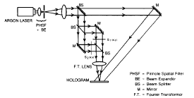

Above figure shows the experimental arrangement in constructing the matched filters or holographic filters for the two codes (images)S1(x,y) and S2(x,y). This arrangement uses a reference beam to interfere with the output of Fourier transform lens at the hologram. Let Sl(p, q) denote the output of the lens which displays the Fourier transform of S1(x , y) at its back focal plane, and R(p, q) = [R(p, q)] ej here [R(p, q)] is a constant and 4 ( p , q) is linear in phase, represents the light coming from the reference beam; the observed pattern on the holographic recording film is

where p and q represent spatial frequency. The fourth term in (1) represents the desired filter function S1*(p, q) multiplied by a linear phase factor R(p,q ) . Similarly, to construct the desired matched filter or holographic filter for code S2(x,y), we follow the same procedure as discussed in the above. Once the matched filters or the holograms for different codes are constructed then we place them at the receiving end of a Holographic CDMA system. Fig.2.3 shows an experimental setup of a holographic CDMA system with two transmitters (encoders) and one receiver (decoder), to examine the feasibility of the proposed technique From Fig. 2.3 the output

of an Argon laser at 514.5 nm is split in two paths by the first beam splitter. Each light path is spatially modulated by a different code (image) such as s ~ ( zy. ) and s2(z. y) of

Fig. 2. For our experiment we construct holographic filter for code sl(z, y) and place it behind the Fourier transform lens at a distance equal to the focal length of the lens. A second Fourier lens is placed behind the hologram such that for a properly decoded signal (image) the transmitted field distribution is a plane wave which is brought to a bright focus by the second Fourier lens.

Chapter 3

Distinct Features of Holographic CDMA Technique:

In this section, few features that are unique to holographic CDMA technique will be discussed.

3.1 Spatial Domain Encoding and Decoding:

This technique as opposed to spread-spectrum and spread-time techniques, where

the energy of the information signal is spread over a wider frequency band or over a longer time period, respectively, energy of the information signal is spread over a larger spatial domain, therefore we may refer to this technique as spread-space CDMA. Spreading of the energy of a given information signal and the subsequent dispreading of the energy is what we refer to as encoding and decoding of the information signal.

3.2 Arbitrary Input Modulation Format:

In both spread-spectrum and spread-time CDMA techniques information waveforms (modulating signals) are represented as digital signals, i.e., they exclude the use of analog signals, and all users have identical bit rate and signal format.

However, in spread-space or holographic CDMA technique the modulating signal for each user can take on any form (digital or analog), any rate, and any shape. For example, in a multi-user environment a user can be sending analog video while the other users are sending, digitized voice, analog voice, low rate data, and very high rate data signal. This implies that holographic CDMA technique remains transparent to what form of modulation format each user uses. This advantage is obtained by transferring the CDMA encoding and decoding to spatial domain while modulating the light signal in time domain.

Uncoupled Processing Gain:

Processing gain (PG) for spread-spectrum and spread-time systems is defined as the ratio of total transmitted bandwidth (encoding and decoding speed) to the information bandwidth. Processing gain is the single most important design parameter in any CDMA system. Its value puts a limit on the number of users that can operate simultaneously in a CDMA system. To increase the number of users in a CDMA system from its present value (operating at some bit-error-rate) the PG for that system must increase. There are two ways to increase the PG: by increasing the encoding and decoding speed which requires a wider channel bandwidth that may not be available, or by reducing the information rate. In optical networks where channel bandwidth is not as scarce a commodity as in other systems, one may design all-optical encoders and decoders that have speeds which are 3 to 4 orders of magnitude faster than the information source. However, in CDMA systems such as in radio cellular telephony, channel bandwidth is finite and scarce; thereby reducing the information rate may prove to be necessary. The difficulty in increasing PG, thereby increasing the number of simultaneous users, in the above CDMA techniques is due to its dependency on its input information rate. However, the uncoupling between the two-domain signal processing, i.e., spatial domain for CDMA encoding and decoding and time domain for information modulation, contributes to another and very important feature in Holographic CDMA namely the uncoupling of the PG from its input information rate. That is, input information rate for each user can be different while the PG for all the users is the same. Processing gain in a holographic CDMA is the number of pixels (code length) in a mask (code) and its value is independent of input information rate or more generally from any modulation format. The number of distinct pixels in a mask of area A can be as high as A / X where X is the wavelength of the light. For A = 1 cm' and typical operating wavelengths (1-2 microns) this corresponds to 1O⁶-1O⁸ pixels or PG for Holographic CDMA system. If compared to 10²-10³ PG for typical spread-spectrum or spread-time CDMA techniques then Holographic CDMA can potentially support 4 to 5 orders of magnitude more users. For example if we consider one to ten percent of PG to be the number of users that can be supported by any of the CDMA techniques, then holographic CDMA can in principle support as many as tens of thousands to a few millions of users in which each user can take on any input information rate and any modulation format.

Chapter 4

System Description and Mathematical Modal

In this chapter, we analyze the basic principles of the spread-space holographic code division multiple access (CDMA) technique. We describe the structure of the encoder and decoder and present a basic mathematical analysis based on spatial harmonic decomposition for the receiver’s processing module which is comprised of a Fourier transform lens and a holographic matched filter. To obtain the bit-error rate (BER) of the proposed application, we first evaluate the probability density function of multi-user interference and then evaluate the BER as a function of the processing gain, number of users, the received power, and the optimum threshold. For BER 10 ⁹, the result shows an extraordinary number of users that can be supported via holographic CDMA.

4.1 System Analysis

To obtain a mathematical representation for the encoded and decoded spread-space holographic CDMA signal, we consider a general case where the coded mask consists 1x1 = No pixel with each pixel dimension of a x a. For the case of a spatially coherent light source with an initial power Ps that is collimated by a lens and projected on to the mask, then for an ideal and loss-less system the optical field after the mask at the plane U1 of fig. 2.2 can be represented by:

$$U_{1}\left(x,y\right)=\frac{1}{a}\sqrt{\frac{\text{Ps}}{\text{No}}}\sum_{n}{\sum_{m}{e^{jφ n,m}f\left(x−\text{na}, y−\text{ma}\right)}}$$
$=\frac{1}{a}\sqrt{\frac{\text{Ps}}{N_{o}}s_{c1}\left(x, y\right)}$ (1)

Where f (x,y) = rect (x/a) rect (y/a) and by definition, rect (x/a) is a unit rectangle function of x that is extended from -a/2 to a/2, and φ_{n, m} is the random phase of the pixel denoted by n and m taking on 0 or π phase shift with equal probability and sc₁ (x, y) represents the coded mask for user 1denoted by subscript c₁ . After the Fourier transform lens at the U₂ plane we have

$$\begin{aligned}U_{2}\left(p,q\right)=\frac{a}{jλ f}\sqrt{\frac{\text{Ps}}{\text{No}}\text{sinc}}\left(\frac{aπ}{λ f}p\right)\text{sin}c\left(\frac{aπ}{λ f}q\right) \\ \sum_{n}{\sum_{m}{e^{j φ n, m}\text{exp}\left\{−j\frac{2 π}{λ f}a\left(\text{np}+\text{mq}\right)\right\}}} \left(2\right)\end{aligned}$$

where and are the spatial frequency variables and sinc(x) = sinc(x)/x is the function. As described before, the spatial filter (hologram) is proportional to the complex conjugate of the spatial Fourier transform of the coded mask. To register both the phase and amplitude, i.e., complex filter, one can use the well-known method introduced by Vander-Lugt [12]. Therefore,

in the U₃ plane, we will have$\begin{aligned}U_{3}={\text{kU}}_{2}U_{2}^{} \\ \frac{a}{λ f}\sqrt{\frac{P_{s}}{N_{o}}\text{sin}c^{2}}\left(\frac{a π}{λ f}p\right)\text{sin}c^{2}\left(\frac{a π}{λ f}q\right) \\ \sum_{n}{\sum_{m}{\sum_{n^{'}}{\sum_{m'}{e^{j\left(φ n,m−φ n\text{',} m'\right)}}}}} \\ \text{exp}\left\{−j\frac{2 π a}{ λ f}\left[\left(n−n'\right)p+\left(m−m'\right)q\right]\right\} \left(3\right)\end{aligned}$

Equation (3) contains various propagation vectors; therefore, it can be represented by the sum of its spatial harmonics.

B. Spatial Harmonic Representation

Equation (3) shows an expansion according to the spatial modes. For better understanding of this equation, we note that (3) contains No² terms that are distributed among spatial modes. If we define new variables i = n – n’ and k = m – m’, (3) can be rewritten as

$$\begin{aligned}U_{3}\left(p,q\right)=D \left(p,q\right) \sum_{i=−\left(l–1\right)}^{l−1}{\sum_{k=–(l–1)}^{l−1}{R_{c_{1},c_{1}}}(i,k) } \\ × \text{exp} \left\{–j\frac{2π}{λ f}a (\text{ip} + \text{kq})\right\} (4)\end{aligned}$$

where D (p,q) is a shape function given by

$$D (p,q) = \frac{a}{λ f}\sqrt{\frac{\text{Ps}}{N_{0}}\text{sin}c^{2}} \left(\frac{aπ}{λ f}p\right)\text{sin}c^{2} \left(\frac{aπ}{λ f}q\right) (5)$$

and Rc₁ c₁ (i,k) is the discrete autocorrelation of the coded mask c₁ defined as

$$R_{c_{{}_{1}},c_{{}_{1}}} (i,k) = \frac{1}{a^{2}} \iint{s_{c_{1}} (x,y)s∗_{c_{1}}} (x–\text{ia}, y–\text{ka}) \text{dxdy} (6)$$

where for i = k= 0, Rc_{1,}c₁ (0,0) = l ² = N₀ (processing gain of system) and for all i≠0 and j i≠0, Rc_{1,}c₁ (i,k) is a random variable with mean zero.

Equation (4) implies that, when the hologram and the mask are matched, the main part of the source power will be transferred to the zeroth harmonic where it can be detected by a photo-detector covering the area of zeroth harmonic. The representation of optical field on the detector plane for paraxial approximation can be expressed as.

$$\begin{aligned}U_{4}\left(u,v\right)=\frac{1}{\sqrt{N_{0}}} \\ × \sum_{i=−\left(l–1\right)}^{l−1}{\sum_{k=–(l–1)}^{l−1}{R_{c_{1}, c_{1}}}(i,k) U_{\text{ideal}} (u–\text{ia}, v–\text{ka}) (7) } \\ \end{aligned}$$

where U_{ideal} (u,v) is given by

$$\text{Uideal} (u,v)= \frac{\sqrt{\text{Ps}}}{a} Λ \left(\frac{u}{a}\right) Λ \left(\frac{v}{a}\right) (8)$$

Note that in (8) a phase term which is proportional to (1/j) exp (–j(π /λ f) (u²–v²))

is not considered here due to its minimal effect on our final result. And $Λ(x)$ is a triangle function defined by

$$Λ(x) =\left\{\begin{matrix}1–\left|x\right|, & \left|x\right|≤1 \\ 0, & \text{otherwise}\end{matrix}\right. (9)$$

From (7)–(9), we see that the adjacent spatial harmonics at the detector plane are separated by a distance of . The terms in (3) are distributed non-uniformly amongst spatial modes such that terms are assigned to the th spatial harmonic. The desired central harmonic (zeroth harmonic) according to (8) covers an area of .If the coded mask and the hologram (filter) are not matched,the above results do change significantly. One must replace the autocorrelation Rc₁c₁ (i,k) in (4) and (7) with the cross correlation Rc₁c₂ (i,k)of the mask c₁ and a filter corresponding to the mask c₂ which is defined as

$$R_{c_{1},c_{2}} (i,k) = \frac{1}{a^{2}} \iint{s_{c_{1}} (x,y)s∗_{c_{2}}} (x–\text{ia}, y–\text{ka}) \text{dxdy} (\text{10})$$

The statistical behavior of Rc₁c₂ (i,k) is same as Rc₁c₁ (i,k) except for i=k=0. For this case Rc₁c₂ (0,0) is also a random variable with mean zero.

At the U₄ plane, the M_{S} = (2l –1)² spatial modes cover an area of A_{fv} = 2al x 2al which corresponds to the field-of-view solid angle of Ω_{fv} receiver’s lens. On the other hand, as it is

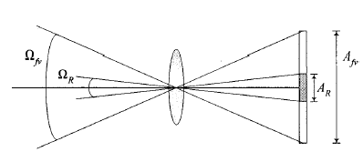

Fig. 4. The field-of-view and detector solid angles.

The ratio of Ω_{fv} / Ω_{R} is a measure of the spreading of light in the spread-space holographic CDMA technique. Shown in Fig. 4, the photo-detector area required to completely detect the zeroth harmonic is with a solid angle Ω_{R} . The ratio of Ω_{fv} / Ω_{R} is a measure of the spreading of light or the processing gain in the spread-space holographic CDMA technique, i.e.,

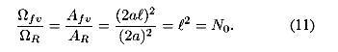

From the above mathematical equations we can modal the basic holographic CDMA system.The system based on these mathematical equations has been simulated. All the simulation work is done in MATLAB. And from the simulation , it has been tried to show the working of this proposed holographic CDMA technique and its features.

Chapter 5

Performance Analysis:

In this chapter some of the performance parameters of the optical spread-space holographic CDMA codes has been discussed. These performance parameters are helpful to check the capacity of the system. These parameters are based on the capacity of the proposed system to reject the interference from all other users in the same system. The three performance parameters to check the system capability is discussed here one by one as:

Signal to interference ratio

Probability of error

Bit error rate

5.1 Signal to Interference Ratio:

To compute the SIR, we assume there are users in the system, in which each user transmits its information to the broadcasting channel after encoding of its light source with a particular spatial code. At the receiver end, each receiver receives a copy of all users’ information.

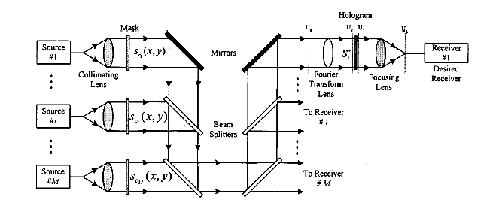

Figure 5.1 A typical configuration for holographic CDMA photonic switch

Above figure shows a simplified and typical configuration for a holographic CDMA photonic switch where for our SIR analysis we denote user 1 to be the desired user. At the output, we first assume a photo detector with an area of A_{R} = 2a × 2a, then, we obtain the effect of reducing the area of the photo-detector on the SIR.

As mentioned previously, the effective area of each spatial mode is and they are separated by 2a × 2a in each dimension resulting in mode overlaps. However, it is sufficient to consider only the adjacent modes of the central harmonic and they are represented by (i,j) where i,j ∈ {–1, 0, 1} The total optical field due to the desired signal and M–1 interfering signals received on the detector area of the first receiver is given by

$$\begin{aligned}Z = \int{\int{U_{4}(u,v) \text{dudv}} } \\ = V \left\{ l^{2}+ \left[R_{c_{1}, c_{1}} \left(0, 1) + R_{c_{1}, c_{1}} (1, 0\right)\right]\right. \\ + \frac{1}{2} \left[R_{c_{1}, c_{1}} (1, 1) +R_{c_{1}, c_{1}} (1, –1)\right] \\ + \sum_{k=2}^{M}{R_{c_{1}, c_{k}} (0, 0)} \\ + \frac{1}{2} \sum_{k=2}^{M}{[ R_{c_{1}, c_{k}} (0, 1) +R_{c_{1}, c_{k}} (0, –1) } \\ + R_{c_{1}, c_{k}} (1, 0) + R_{c_{1}, c_{k}} (–1, 0)] \\ + \frac{1}{4} \sum_{k=2}^{M}{[ R_{c_{1}, c_{k}} (1, 1) +R_{c_{1}, c_{k}} (1, –1) } \\ + R_{c_{1}, c_{k}} (–1, 1) + R_{c_{1}, c_{k}} (–1, –1)]\left.\right\} (\text{12}) \\ \end{aligned}$$

Where V is the normalized volume under U_{ideal} (u,v) defined as in (8) and we have assumed equal received power for all users. In the right-hand side of (12), the first term is the required signal, the second and third terms are the interfering effects of the adjacent modes of desired user’s signal, whereas, the fourth term shows the effects of zeroth harmonics by other M–1 interfering signals. The two remaining terms are due to the adjacent modes of other users’ signals.

For random coding, the average of the interference signal vanishes and its variance is given by (Appendix I)

$$σ\begin{matrix}2 \\ I\end{matrix} = V^{2} l^{2} \left[(M+1) \left(1+ \frac{l–1}{l} + {\left(\frac{l–1}{2l}\right)}^{2}\right)–2\right] (\text{13})$$

Yielding
$$\text{SIR} = \frac{V^{2}l^{4}}{σ\begin{matrix}2 \\ I\end{matrix} }= \frac{N_{0}}{(M+1) \left(1+ \frac{l–1}{l} + {\left(\frac{l–1}{2l}\right)}^{2}\right)–2} (\text{14})$$

It is seen that the SIR is directly related to the processing gain of spread-space holographic CDMA technique and inversely related to the number of active users in the system. However, SIR could be improved with reducing the detector’s area. To see the influence of detector size on SIR, we introduce a new parameter 0 < d ≤ 1 in such a manner that each dimension of the detector is equal to 2da instead of 2a. With similar calculation and simplifying assumptions we obtains

$$\text{SIR} = \frac{N_{0}}{(M+1) \left[1+ \frac{d^{2}}{(2–d)^{2}} \left(1+ \frac{d^{2}}{4(2–d)^{2}}\right)\right]–2} (\text{15})$$

In the limit when d approaches to zero, i.e., for a point detector receiver, SIR increases to SIR = N₀/(M–1) which is the maximum obtainable value for SIR. Although smaller detector receives less signal power, but reduction in strength of adjacent interfering harmonics due to small detector size is more noticeable, resulting to better SIR.

4.2 Probability of Error

Assume that M users, using randomly derived codes are simultaneously illuminating a common aperture in N₀ pixels. The M lasers are considered to be incoherent with respect to each other and the M codes are assumed uncorrelated. The total power received on the aperture from each laser is assumes equal. The average received intensity produced by a particular transmitter at a pixel is defined by ⟨I⟩. The M speckle pattern thus adds linearly at each pixel, i.e., the intensity at particular pixel is the sum of the intensities of each M speckle pattern at that pixel
We wish to test a particular speckle pattern to see if it is among the M active patterns. Let Ij (r,s) be the intensity due to jth active user at the pixel at coordinate (r,s) and y (r,s) is the intensity at the pixel thus
y(r,s) = I₁ (r,s) + I₂ (r,s) + I₃ (r,s) + …………+ I_{M} (r,s) (16)
and
⟨ y(r,s)⟩ = M ⟨I⟩. (17)
The testing for the presence of the particular speckle pattern, say speckle pattern s, is done using a test statistic using {z (r,s)} where z (r,s) is defined at the pixel at coordinates (r,s) as
z(r,s) = I_{x} (r,s) y (r,s) – M ⟨I⟩² (18)
where I_{x} (r,s) is the intensity of speckle pattern x at the pixel at (r,s), the total number of transmitting users, M, is estimable from the total radiometric power over the entire aperture.

It can be easily shown that
$$\left\langle z\left(r,s\right)\right\rangle = \begin{aligned}\left\{0, x∉ \left\{1,2\text{.}\text{.}\text{.}\text{.}\text{.}\text{.}\text{.}\text{.}\text{.}\text{.}\text{.}\text{.}\text{.}\text{.}\text{.}\text{.}\text{.}M\right\} | \right.\left\{ | \right.\left\{{\left\langle I\right\rangle }^{2}, x∈ \left\{1,2\text{.}\text{.}\text{.}\text{.}\text{.}\text{.}\text{.}\text{.}\text{.}\text{.}\text{.}\text{.}\text{.}\text{.}\text{.}\text{.}\text{.}M\right\} | \right.\end{aligned}$$
and
$$\left\langle σ_{z_{\left(r,s\right)}}\right\rangle = \begin{aligned}\left\{ \sqrt{M^{2}+2M {\left\langle I\right\rangle }^{2}} , x∉ \left\{1,2\text{.}\text{.}\text{.}\text{.}\text{.}\text{.}\text{.}\text{.}\text{.}\text{.}\text{.}\text{.}\text{.}\text{.}\text{.}\text{.}\text{.}M\right\} | \right.\left\{ | \right.\left\{\sqrt{M^{2}+8M + \text{11} {\left\langle I\right\rangle }^{2}}, x∈ \left\{1,2\text{.}\text{.}\text{.}\text{.}\text{.}\text{.}\text{.}\text{.}\text{.}\text{.}\text{.}\text{.}\text{.}\text{.}\text{.}\text{.}\text{.}M\right\} | \right.\end{aligned}$$
Combining all of the {z(r,s)} we appeal to the central limit theorem that implies that for the test of Z defined over all the pixels, P, of the aperture as
$Z = \sum_{r,s}{z(r,s) }$ (21)
where
$\begin{aligned}\left\langle Z\right\rangle = P \left\langle z \left(r,s\right)\right\rangle \\ \left\langle σ_{z}\right\rangle = \sqrt{P} \left\langle σ_{z_{ \left(r,s\right)}}\right\rangle \\ \end{aligned}$ (22)
For a large number of users and pixels, then, by virtue of the proceeding random coding argument, it can be shown that there exists codes that achieve an error rate, P_{e}, such that
$P_{e} ≈ \frac{1}{2} e^{–P/2N\begin{matrix}z \\ 0\end{matrix} }$ (23)
This is the final expressions for probability of error in the spread space holographic CDMA technique. This is simulated for the multi-user environment in the MATLAB and result is shown in the later chapters.

5.2 Bit error rate:

For our system performance analysis, BER, we assume the simplest network protocol, i.e., it is assumed communication between different inputs and outputs is pairwise and continuous.

And the degradation is due only to the effects of the presence of other users. The effects of quantum noise, background noise, and thermal noise are neglected. Furthermore, all users have the same effective average power at any receiver so that one user could not overwhelm the others.

We refer again to Fig. 5 where M users in the system use different coded masks as the signature codes to transmit their information. The total optical field due to M transmitters at front end of the desired receiver can be expressed as

$$U_{1} (x,y) = \frac{1}{a} \sqrt{\frac{P_{S}}{N_{0}} } \sum_{i=1}^{M}{e^{–jφ _{i}}d_{i}s_{c_{i}} (x,y) (\text{16})}$$

Where d_{i} ∈ {0,1) is the th user’s transmitted information bit for the on–off keying (OOK), φ _{i} is the initial phase of the the source, which are statistically independent and uniformly distributed over [0, 2π] and $S_{c_{i}} (x,y)$ is the mask used by the th user, which is defined equivalently as in

(1). After the Fourier transform lens in the U₂ plane, we have

$$U_{2} (p,q) = \frac{1}{a} \sqrt{\frac{P_{S}}{N_{0}} } \sum_{i=1}^{M}{e^{–jφ _{i}}d_{i}s_{c_{i}} (p,q) (\text{17})}$$

Where $S_{c_{i}} (p,q)$ represents the Fourier transform of $S_{c_{i}} (x,y)$ As usual, we consider the desired user to be the first user for which its MF is proportional to $(1/a\sqrt{N_{0}})S∗_{c_{i}} (p,q)$ After U₃ the MF in the plane, we have

$$U_{3} (p,q) = \frac{\sqrt{P_{S}}}{a^{2}N_{0}} \sum_{i=1}^{M}{e^{–jφ _{i}}d_{i}S_{c_{i}} (p,q)S∗_{c_{i}} (p,q) (\text{18})}$$

For the ideal case, the final lens takes the Fourier transform of (18), yielding

$$\begin{aligned}U_{4} (u,v) = \frac{\sqrt{P_{S}}}{a^{2}N_{0}} \sum_{i=1}^{M}{e^{–jφ _{i}}d_{i}s_{c_{i}}(u,v) ∗ s_{c_{i}}(–u\text{,–}v) } \\ = \frac{\sqrt{P_{S}}}{a^{2}N_{0}} \sum_{i=1}^{M}{e^{–jφ _{i}}d_{i} \iint{s_{c_{i}}(x_{0},y_{0})} } \\ × s_{c_{i}}(x_{0}–u, y_{0 } –v) {\text{dx}}_{0}{\text{dy}}_{0}\text{.} (\text{19})\end{aligned}$$

For a point detector receiver model, the received intensity signal incident on the detector surface can be expressed as
$$\begin{aligned}I = {\left|U_{4} (0,0)\right|}^{2} \\ = \frac{P_{S}}{(a^{2}N_{0})^{2}} \\ × | d_{1} \iint{s^{2_{c_{i}}} (x_{0}, y_{0 }) {\text{dx}}_{0}{\text{dy}}_{0} } \\ + \sum_{i=2}^{M}{e^{–jφ _{i}}d_{i} \iint{s_{c_{i}}(x_{0},y_{0})} }s_{c_{1}} (x_{0}, y_{0 }) {\text{dx}}_{0}{\text{dy}}_{0}|^{2} \left(\text{20}\right)\end{aligned}$$

and it can be simplified to

$$I = \frac{P_{S}}{N^{2_{0}}} {\left|d_{1}N_{0} + \sum_{i=2}^{M}{d_{i}e^{–jφ _{i}}x_{i} }\right|}^{2} \left(\text{21}\right)$$

Where x_{i} is the cross correlation between the first and the ith codes with zero shift. From (10) Rc_{i}c_{i} (i,k), is the cross correlation between the first and the ith code with shifts (l,k) and

expressed as

$$R_{c_{i},c_{i}} (l,k) = \frac{1}{a^{2}} \iint{s_{c_{i}} (x, y) s∗_{c_{1}} (x–\text{la}, y–\text{ka}) \text{dxdy} \left(\text{22}\right)}$$

then x_{i} = Rc_{i}c₁ (0,0) . On the other hand, x_{i} can be expressed according to the first and ith code’s components

$$x_{i} = \sum_{n}{\sum_{m}{e^{{jϕ ^{(i)}}_{n,m}}e^{–jϕ _{n,m}^{(1)}} i ≠ 1} \left(\text{23}\right)}$$

From (23), x_{i} takes on integer values between –N₀ and N₀ . The average and the variance of can be obtained by simple calculations, i.e., ${\bar{x}}_{i}=0$ and $σ^{2_{\text{xi}}}=N_{0}$ , respectively.

For our performance evaluation we first assume that during a given bit interval out of M–1 users (other than the desired user) transmit binary data “1.” Thus from (21), we have

$$\begin{aligned}I_{l} = \frac{P_{S}}{N^{2_{0}}} {\left|d_{1}N_{0} + \sum_{i=1}^{l}{e^{–{jφ}_{i}}x_{i} }\right|}^{2} \\ = \frac{P_{S}}{N^{2_{0}}}{\left|d_{1}N_{0} + {αx}_{l} – {jαy}_{l}\right|}^{2} (\text{24})\end{aligned}$$

where $α_{x_{i}}= \sum{ x_{i}\text{cos}φ_{i}}$and $α_{y_{l}}= \sum{ x_{i}\text{sin}φ_{i}}$

The pdf of the interference term in (24) is obtained by invoking the central limit theorem as in [3], yielding
$$\begin{aligned}P_{α x,α y} (α _{x_{l}},α_{y_{l}}l) = \frac{1}{2 π l σ_{c} σ_{s}} \\ × \text{exp} \left\{–\frac{(α _{x_{l}}–m)^{2}}{2lσ ^{2_{c}}}– \frac{α2 _{y_{l}}}{2{lσ}^{2_{s}}}\right\} (\text{25})\end{aligned}$$

where in general, m, $σ ^{2_{c}}$, , and $σ ^{2_{s}}$ are defined as:

$\begin{aligned}m = l \left\langle x_{i} \text{cos}φ_{i}\right\rangle (\text{26}) \\ σ ^{2_{c}}= \left\langle (x_{i} \text{cos}φ_{i})^{2}\right\rangle – (x_{i} \text{cos}φ_{i}) ^{2} \\ σ ^{2_{s}}= \left\langle (x_{i} \text{sin}φ_{i})^{2}\right\rangle (\text{27}) \end{aligned}$

${\bar{x}}_{i}=0$thus, m = 0, and for $φ_{i}$uniformly distributed between [–π,π], we obtain σ_{c} =σ_{s} = N₀/2 = σ.

Depending d₁ on two different cases will occur:

- d1 = 0; for this case (24) reduces to

$I_{l}= \frac{P_{S}}{N^{2_{0}}} (α^{2_{x_{l}}}+ α ^{2})_{y_{l}}$ (28)

and using (25), the conditional pdf is expressed as

$$P (I/{d_{1}}=0,l) = \frac{N^{2_{0}}}{2{lσ}^{2}P_{S}} e^{– ({N^{2_{0}}}/ 2{lσ}^{2}P_{S}) I} (\text{29})$$

This is a negative exponential distribution function.

2) d₁ = 0: for this case we define a new parameter α’_{x l} = N_{o}+α’_{xl} thus m=(α’_{xl})=N_{o}

and the conditional pdf is a noncentral chi-square distribution with two degrees of freedom

$$\begin{aligned}P (I/{d_{1}}=1,l) = \frac{N^{2_{0}}}{2{lσ}^{2}P_{S}} e^{– ({N^{2_{0}}}/ 2{lσ}^{2}) (1+(I/{\text{Ps}}))} \\ × I_{0 } \left(\frac{N^{2_{0}}}{{lσ}^{2}}\sqrt{\frac{I}{P_{S}}}\right) (\text{30})\end{aligned}$$

where Io(x) is the modified Bessel function of the first kind and zero order.

If the transmitted bits take on values of “0” and “1” with equal probability, the BER can be obtained as

$\begin{aligned}\text{BER}= \left(\frac{1}{2}\right) \sum_{l=1}^{M M–1}{\left(\frac{M–1}{l}\right)} [\text{exp} \left(\frac{N^{2_{0}}I_{t_{h}}}{2{lδ}^{2}P_{S}}\right) \\ + (1–Q \left(\frac{N_{0}}{δ\sqrt{l}'} \frac{N_{0}}{δ}\sqrt{\frac{I_{\text{th}}}{{\text{lP}}_{S}}}\right) \\ \end{aligned}$(31)
where Q(a,b) is Marcum’s Q function defined as

$$Q (a,b) = \int{ \text{xe} ^{–(x^{2} + a^{2})/2}}I_{0} (\text{ax}) \text{dx}\text{.} (\text{32})$$
The equation (32) gives the expression for Marcum’s Q function.

Chapter 6

Results

From the simulation results we can analyze the capability of the spread-space holographic CDMA system.

From the results we can see that when the transmitter and receiver holograms are matched, the power received by that particular receiver is ideally equal to the transmitted power. In figure 6.1, the transmitter holograms for one user of mask size 5x5 based on simulation is shown and its Fourier Transform is given in figure 6.2.

Figure 6.3 is the graphical representation of the signal to interference ratio with respect to the number of users. From this figure we can say that as the number of users increases the SIR decreases.

Figure 6.4 is the graphical representation of the signal to interference ratio with respect to the area of the pixel. From this figure we can say that when the area of the pixel is reduced, the SIR is increased.

Figure 6.5 shows the graphical representation of the probability of error with respect to the number of users. And it can be seen from the graph that as the number of users increases the probability of error increases.

Figure 6.6 shows the BER versus normalized threshold for a holographic CDMA system supporting users of different number of pixels (code length) in user’s mask. As the code length or better said the PG of the system increases, the BER decreases dramatically. It is also shown that the optimum value for the threshold of the matched filter for minimum bit error rate is 0.25.

Figure 6.7 is the graphical representation of the BER as a function of number of active users for different values of processing gain. The BER degrades as the number of users increases. However, since the PG of the system is independent of its information bit rate, hence, it allows us to increase PG to obtain the required BER for a desired number of users.

Figure 6.8 is the graphical representation of the BER with respect to Number of users, keeping the ratio of number of pixels to the number of users, constant. For each required BER, we first determine the corresponding ratio of No/M, then for each link given the maximum number of users in the system, we can obtain the minimum required processing gain.

Chapter 7

Problems in Holographic CDMA

In this chapter some more points about the CDMA system is described. First the main problems arising in the system is discussed. And then give their solution for these problems.

7.1 Problem of Synchronization:

It is clear that the capacity of this optical communication system is inherently tied to the number of independent pixels in the aperture. It is therefore also clear that the ability to successfully decode a transmission from a particular user depends upon the receiver’s ability to properly spatially register the user’s speckle pattern. The proper alignment becomes increasingly important with the number of independent pixels involved. Again, there is a direct analogy to radio based CDMA techniques. Radio-based CDMA techniques, if a signal requires a large bandwidth then it is inferred that the signal’s autocorrelation will be quit sharp about its position of direct alignment in time. Similarly, as the speckle pattern assumes more independent pixels within a fixed aperture, it is inferred that the spatial autocorrelation function of the speckle pattern will exhibit an ever increasing sharp “spike” about its proper alignment position.

There are two parts to the synchronization issue. One part is that of initial synchronization, i.e, registering a new user’s speckle pattern or code as it come on-line. The second part is the maintenance of that alignment throughout the communications as, for example, per control loops that constantly dither the mask’s position over a fractional pixel displacement and track the aberrations. Like in radio communication systems it is common to preface the traffic with a special synchronizing signal.

Solution:

For the Holographic technique, it is proposed to preface the traffic with a specific Pyramidal Synchronizing Process. This process may also be used to generate the random speckle patterns, which are a priori, provided to the users and the receiver.

The algorithm for the generation of a random speckle pattern is given in figure 8.1. The algorithm operates on an aperture of 2^{n} x 2^{n} pixels.

The pyramidal synchronizing process uses the ‘n’ iterations of the random speckle pattern process. To begin, all of the pixel lens-let phase controls are set to the same value (zero). At the final iteration, the pixel lens-let phase controls are fully randomized with respect to each other, the Pyramidal Synchronizing Process prefaces a transmission with the sequential sending of the speckle patterns corresponding to the ‘n’ iterations. What the receiver will then see is a more complex speckle pattern growing per iteration. At the start, the receiver sees a point of light, which is the result of the new transmitter transmitting with identical lens-let phase controls. The receiver sees an increase of P(I) in power falling on its aperture and determines that a new user is transmitting. The receiver registers the point of light as the centre of the new speckle pattern. After a certain dwell period, the new transmitter sends the first iteration. The receiver then searches its tree of iteratively developed speckle patterns corresponding to all of the allowed users. When the receiver has matched and registered this text iteration as before. The process is continued until the full final user speckle pattern has been matched and registered. The new user is now ready to transmit traffic.

7.2 Problem of Random Phase Introduced by Diffuser:

The second problem of a spot-diffuse infra-red links based on holographic CDMA technique is the random phase introduced by the diffuser. Usually, the surfaces of most diffusers are rough when compared with incident optical signal wave length. Therefore, each part of the image may receive an uncorrelated random phase, which degrades the spatial coherency of light source necessary for the holographic CDMA technique.

Fig. Algorithm for Generating Random Speckle Pattern of 2 ^{n} X 2 ^{n} Pixels.

Solution:

To overcome this problem, when the position of the transmitter, receiver and diffusing surface are determined and they are aligned properly, a pilot signal can be sent letting receiver to register the phase information introduced by the diffuser. In transmitting this pilot signal, the transmitter does not use any coded mask, in other words it uses a transparent mask with no phase information, therefore, receiver will receive only the introduced phase shifts of the diffuser, which can be registered on a mask (film) and used to compensate the phase effects of the concerned diffuser.

7.3 Problem of matching for Image Transformation:

Other problem associated to holographic CDMA technique is related to the image transfer optical system. When the image of a coded mask does not resemble in size or rotation to its corresponding matched filter, then the correlation process will not perform correctly, thereby reducing SIR and, consequently, degrading the system performance.

Solution:

One method to eliminate this unmatched effect, in which with the adjustment of , the size of a image mask in the receiver could be determined exactly as the original mask’s size. However, this is a mechanical method and additionally, can not eliminate the effects of rotation. Hence, the on-board reconstruction of the matched filter is proposed, i.e, reconstruction of MF according to image received to receiver but not according to mask used at transmitter. This method completely removes the problem of difference in size or rotation. In addition, this method can be combined with the above mentioned approach to eliminate the effect of diffuser’s random phase to obtain a unique procedure that is practical and applicable.

Chapter 8

Conclusion

In this thesis, an optical analogue of radio-based CDMA signaling technique that uses all the well known features of Spread Spectrum and Spread Time CDMA is discussed. Here, the coding and signaling are performed in to two separate domains namely space-domain and time-domain, resulting in additional edge over other technologies.

This technique, which is referred as holographic CDMA, takes full advantage of optical parallelism and complex spatial filtering to realize encoding and decoding. It uses coherent optical signal processing to exploit the many (hundred of thousands) degree of freedom in the spatial dimension to achieve higher signal-to-noise ratio (SNR) and signal-to-interference ratio (SIR). Here as the number of users increases the SIR decreases.

The processing gain of spread-space holographic CDMA is completely independent of the temporal characteristics of the information sources such as the type of modulation or the information bit rate and it can be as high as 10⁶-10⁸, which suggest that this technique is capable of supporting thousands to millions of users with each user taking on different modulation format.

Here, basic mathematical analysis of spread-space holographic CDMA is analyzed using MATLAB. From analysis we see that when transmitter and receiver holograms are matched, the power received by that particular receiver is ideally equal to the transmitted power i.e. when the auto-correlation between transmitted and received hologram is 1 the appropriate matched filter receiver receives the power. The BER can be controlled to a desirable amount by selecting the ratio of No/M properly where No was defined as the PG of the system and M is the total number of user which are simultaneously present in the system.

In addition to wireless indoor applications, another important application of holographic CDMA is in the area of free-space photonic switches. Recently, holography techniques have been used in demonstration of high-speed compact optical switches. From this point of view, holographic CDMA could be a promising technique because in addition to special features of holography, it profits from the inherent advantages of CDMA, resulting to an optical switch that could be far superior than any other types already proposed.

References

Mohammad Abtahi, Member, Jawed A. Salehi, “Spread-Space Holographic CDMA Technique: Basic Analysis and Applications.” IEEE Transactions on “Wireless Communication”, Vol.1.No.2, pp.311-321 April 2002.

Amer A. Hassan, John E. Hershey and Nabeel A. Riza.”Spatial Optical CDMA” IEEE Journal on “Selected Areas in Communication” Vol.13,No.3,pp.609-613 April 1995

J.A.Salehi and E.G. Peak, “Holographic CDMA”, IEEE Transactions on communication,Vol.43, pp.2434-2438,Sept.1995

R.A.Rappaport,”Wireless Communication”, Prentice Hall Inc.

J.W.Goodman, Statistical Optics. New York: Wiley, 1985.

Schwartz,M.,W. Bennet,and S.Stein,Communication System and Techniques, New York: McGraw-Hill,1966

A.M.Weiner, D.E.Learid, J.S.Patel, and J.R.Wullert, “Programmable shaping of femtosecond optical pulses by use of 128 element liquid crystal phase modulator,” IEEE J.Quantum Electron., Vol.28, pp. 908-920, Apr.1992

Figure 6.1 Graphical representation for the hologram of size 5 x 5 for one user

Figure 6.2 Graphical representation for the Fourier Transform of the Hologram

Figure 6.3 Graphical representation of SIR with respect to the number
of users.

Figure 6.4 Graphical representation of SIR with respect to the area of pixel

Figure 6.5 …. Graphical representation of Probability of error with respect to the
number of users.

Figure 6.6 …. Graphical representation of the Bit Error Rate with respect to the
threshold of the matched filter

Effect of no. of users on bit error rate

Figure 6.7 …. Graphical representation of the Bit Error Rate with respect to the no.
of users

