- CHAPTER 1
Introduction
1. 1 Introduction
In the present day global competition, there is tremendous pressure on any manufacturing unit of a company to perform at peak efficiency so that the price of the products could be kept at a low level. The pressure is exacerbated by the fact that the modern day customers want a variety of product models, and as is well known, increasing a product variety increases complexities, and decreases the efficiency of the manufacturing unit. The manufacturing unit thus has to simultaneously deal with product variety and keeping high levels of productivity. This has lead to increased application of Job Shop Production system. There are various performance factors, which are responsible for efficient working of the system. This report discusses various philosophies of a manufacturing system and different factors related to Job Shop production and supply chain system. One of the basic and significant problems, that a shop or a factory manager is encountered is a suitable scheduling of jobs on machines. One type of scheduling problem is job shop scheduling. There are different machines in a shop of which a job may require some or all these machines in some specific sequence. For solving this problem the objective is to minimize makespan. After optimizing the makespan, the jobs sequencing must be carried out for each machine. The above problem can be solved by a number of different methods such as branch and bound, cutting plane, heuristic methods etc. In the recent years researchers have used genetic algorithms, simulated annealing and machine learning methods for solving such problems.. In this report model has been coded in simulation software called “WITNESS”. After modeling these sequencing problem different parameters like machine idle time, machine busy time, number of parts shipped, has been analyzed. And then model is rebuilt to show pull supply chain system and study the different inventory level in the system.

1.2 Simulation
A simulation is an imitation of some real thing, state of affairs, or process. The act of simulating something generally entails representing certain key characteristics or behaviors of a selected physical or abstract system.
Historically, the word had negative connotations:
…for Distinction Sake, a Deceiving by Words, is commonly called a Lye, and a Deceiving by Actions, Gestures, or Behavior, is called Simulation… Robert South (1643–1716)
However, the connection between simulation and dissembling later faded out and is now only of linguistic interest.
Simulation is used in many contexts, including the modeling of natural systems or human systems in order to gain insight into their functioning. Other contexts include simulation of technology for performance optimization, safety engineering, testing, training and education. Simulation can be used to show the eventual real effects of alternative conditions and courses of action. In the manufacturing process described in this report, the process improvements involved with improved inventory levels.
Key issues in simulation include acquisition of valid source information about the referent, selection of key characteristics and behaviors, the use of simplifying approximations and assumptions within the simulation, and fidelity and validity of the simulation outcomes.
1.3 Job shop scheduling
Scheduling of different jobs of given sequence is called the job shop scheduling. In job shop problem, we assume that each job has m different operations . if some of the jobs are having less than m operations, required number of dummy operations with zero process time are assumed. In job scheduling problem, the sequences of the jobs are not same. Hence the flow of each job in job shop scheduling is not unidirectional. The time complexity function of the job shop problem is combinational in nature. Hence, heuristic approaches are popular in this area.
Job-shop scheduling is concerned with the allocation of tasks to resources. The resources are called machines and the tasks are called operations subject to precedence constraints. Starting times of operations must be determined to solve the problem, while precedence constraints are satisfied and criteria are minimized. In this study we assume that we have n jobs (J_{1,} J₂, J_{3,} J_{n}) to be processed through m machines (M₁, M₂, M₃, M_{m},). Each job visits each machine just once and all jobs are available at time zero.

Job shop system configuration

A job shop system configuration has been developed for investigation in the present study. This configuration has been determined based on the configuration of job shops considered by various researchers. Most of the studies have used between four and 8 machines. Hence, in the case study, a job shop system consisting of four machines is chosen. The machines are not identical and perform different operations. However, each machine can process different types of jobs by changing the setup.

1.4 Supply Chain Management (SCM)
Supply chain management is the process of planning, implementing, and controlling the operations of the supply chain as efficiently as possible. Supply Chain Management spans all movement and storage of raw materials, work-in-process inventory, and finished goods from point-of-origin to point-of-consumption.
The typical definition of the term supply chain management is as follows: The supply chain refers to all those activities associated with the transformation and flow of goods and services, including their attendant information flows, from the sources of materials to end users. Management refers to integration of all these activities, both internal and external to the firm.

1.5 Simulation studies in job shop and supply chain.
We begin by defining the system and its components. The system is a set of permanent and temporary entities taking into consideration the entities attributes and relationships between them. This set is directed to achieve a specified objective. Permanent entities, such as machines and manpower in a manufacturing system, are named as a server. Temporary entities are incorporated into the system represented within the simulation model and they pass and then leave the system. The attributes of each entity are considered as an entity characteristic, which is required for identifying the temporary entities. Examples of entity characteristic are arrival time, part number, and processing time of the system with each temporary entity.
Different simulation languages are available in the literature and market. One of them is Visual SLAM used in this paper for solving a job shop problem. The structure of this language is based on a network modelling. Therefore, adding or removing some elements in different sections of the model is easy (Pritsker 1996). In the above problem based on the network model, the jobs and machines are considered as entities and servers, respectively. Descriptions of network components were taken from Pritsker (1996).
Drake and Smith (1996) have introduced a framework for on-line simulation systems in operational planning, scheduling and control of manufacturing systems. They have identified five basic concepts for software design of an on-line simulation system and solved an example simulator.
Chen and Chen (1996) have presented a nine-step design procedure for a robust job shop manufacturing system under a constraint using computer simulation experiments. In this procedure, there is a budgetary limitation in this shop. Negati (1998) has modelled a computer simulation of a press shop of a car manufacturing.
Supply chains are multifaceted structures focusing on the integration of all the factors involved in the overall process of production and distribution of end products to the customers. Growing interest in supply chain systems has highlighted the need to adopt appropriate approaches that can ensure the efficient management of their complexity, enormity and broadness of scope. With the main aim of supply chain management being to optimise the performance of supply chains, attentions mainly drawn to the development of modelling frameworks that can be utilised to analyse and comprehend the dynamic behaviour of supply chains. While there have been only a few supply chain modelling attempts reported in the literature, this report proposes a modelling framework that is used to simulate the operation of a supply chain network of moderate complexity.

1.6 Research methodology
Using the WITNESS 2006 simulation package 3 jobs and 4 machines was simulated. The job shop problem which is been modelled is has been other studies.( R. Tavakkoli-Moghaddamª and M. Daneshmand-Mehr^{b} ,2005). This job shop model was selected for reasons. The model is well established and accepted as a complex operation second it is easy to validate.
The routing sequence for each product specifies how a product moves through the shop from material release to finished good. For example part2 first visit the machine2, then machine1 followed by 4, 3. Than the parts released from manufacturing job shop unit are transported to the different distributors than to retailers finally then it reaches the customer. After the model is made it is allowed to run for 14400 minutes with 600 warm up period with takt time example .002, .01, .0067,.005 and then the buffers level are been checked and get maximum size of buffers required by the unit is at different level.

CHAPTER 2

Literature Review
2.1 Introduction

In this chapter, it is intended to give a brief literature review of the work being carried out on job shop scheduling and supply chain. The sharp competition between enterprises of our days outlines the utmost importance of the high utilization of resources (both technical and human ones), low level of work in process (WIP), high throughput, in-time delivery, etc., in short: production planning and scheduling. Moreover, in manufacturing systems, difficulties arise from unexpected tasks and events, non-linearity, and a multitude of interactions, while attempting to control various activities in dynamic shop-floors. Complexity and uncertainty seriously limit the effectiveness of conventional control and (predictive) scheduling approaches. The selection of the most appropriate scheduling/rescheduling algorithms for a certain assignment is not a trivial task, which, however, can be supported by simulation-/emulation-based benchmarking.

2.2 History

The history of the job shop scheduling problem, starting more than 30 years ago, is also the history of a well known benchmark problem consisting of ten jobs and ten machines and introduced by Fisher and Thompson in 1963. This particular instance of a10-job 10-machine problem opposed its solution for 25 years leading to a competition among researchers for the most powerful solution procedure. Since then branch and bound procedures have received substantial attention from numerous researchers. Early work was performed by Brooks and White (1965), followed by Greenberg (1968), whose method was based on Manne's integer programming formulation. Further papers included Balas (1969), Charlton and Death (1970), Florian et al. (1971), Ashour et al.(1974), Ashour and Hiremath (1973), and Fisher(1973), who obtained lower bounds by the use of Lagrange multipliers. A long time the algorithm of McMahon and Florian (1975) was the best exact solution method. Instead of using the worse bounds of Charlton and Death (1970).they combined the bounds for the one-machine scheduling problem with operation release dates and the objective function to minimize maximum lateness with the enumeration of active schedules (see Giffler and Thompson, 1960), among which are also optimal ones. An alternative approach whereby at each stage one disjunctive arc of some crucial pair is selected leads to a computationally inferior method (Lageweg et al., 1977).

2.3 Scheduling: - Scheduling is the allocation of start and finish time to each particular order OR Scheduling has been defined as art of assigning resources to the tasks in order to insure the termination of these tasks in reasonable amount of time. The general problem is to find sequence, in which job pass through the resources, which constitutes a feasible and optimal schedule wrt some specific performance criteria. Proper scheduling leads to increase efficiency and capacity utilization, reduced time required to complete tasks and consequently increase profitability of an organization.
The dynamic Job shop scheduling problem is discussed by Vinod(2007).It is intended for flexible production in high variety and low volume situation. The job shop consists of M machine workstation and job arrives continuously over time. Each job requires a specific set of operations that need to be performed in specific sequence on the machine and involves certain amount of processing time. The job shop becomes a queuing system: job leaves one machine and proceeds to its route to another machine for next operation, only to find other jobs already waiting for machine to complete its current tasks; so that queue of jobs in front that machine is formed. DJSSP essentially involves deciding the order or priority for job waiting to be processed at each machine to achieve desired objectives. The standard assumption in DJSSP is that setup times are included in the processing times. Setup includes the activities such as preparing a machine or workstation to perform next machine operation. Five scheduling rules are proposed: SSPT (shortest Setup and Processing time); JSPT (Jobs with similar setup and shortest processing time; JEDD(Jobs with similar setup and earliest due date);JEMDD(Jobs with similar setup and earliest modified due date); JSSPT(Jobs with similar setup and shortest setup + processing time). The performance measure includes: Flow time Measure, Mean tardiness, Mean setup Time, Mean number of setups. Flow time measure is a very critical indicator of the lead-time and it also provides important information that can be used for setting the due dates or due date allowances. Moreover, it is proportional to the work in process levels. Mean tardiness is related to customer service or customer delivery performance. This method of job shop scheduling problem in sequence dependent setup time environment can be efficiently applied to FMS and CIM.
Bianco, etal(1999) have minimized the makespan in a multimode multiprocessor shop-scheduling problem. Each task can be undertaken by any methods in a set of pre-defined alternative modes, where each mode specifies a required set of assigned processors and a processing time. At any point of time, each processor can be used at most by only a single task. A general precedence constraint exists among tasks, and task preemption is not allowed. The problem consists of assigning to each task of each processor, a mode, a starting time, and precedence constrains to minimize the time required to complete all tasks. There are two constructive heuristic algorithms to compute a feasible solution of the problem. The first one is a deterministic algorithm that iteratively assigns execution modes and starting times to unscheduled tasks simultaneously on the basis of a partial schedule. The second one is a stochastic algorithm that schedules tasks in a given mode with probabilities proportional to task priorities. To work out the problem three lower bounds have been suggested.
Guinet (2000) has proposed a procedure for solving job shop scheduling problems. In this procedure, the objective is to minimize the maximum completion time of jobs. Here, firstly instance, the job shop problem is reduced to a flow shop problem by introducing job precedence constraints. Then, Johnson's rule is applied to solve the problem

2.4 Sequencing: Akpan (1996) has introduced a network technique that is a very useful tool for analysis of job shop sequencing problems. This technique offers a basis for finding an optimum solution. He has indicated that it is not correct to regard the network technique only as a project management tool, since it has a wider range of potential applications in other fields of engineering management. In this technique, the jobs priority on machines is determined by FCFS (First Come, First Serve) rule.
One basic and significant problems of scheduling and sequencing of jobs on machines can be solved with objective of minimizing makespan. Tavakkoli (2005) suggested a computer simulation model for job shop scheduling with objective to minimize makespan. After optimizing the makespan, the jobs sequencing must be carried out for each machine. The result obtained from the simulation output helps managers to evaluate the performance of the system by knowing machines utilization and other resources, average waiting time of jobs, and average idle time for each machine.
It is established that the performance measures of the shop are extremely sensitive to lot sizing in terms of work-in-process inventory, work centre utilization, queue time, set-up time, process time, etc. Consequently, modification of the lot size is capable of altering the production system functioning. Therefore, it is important to know the effects of the lot sizing problem on production and optimal configuration of the studied shop.

2.5Job shop scheduling
Scheduling of different jobs of given sequence is called the job shop scheduling. In job shop problem, we assume that each job has m different operations . if some of the jobs are having less than m operations, required number of dummy operations with zero process time are assumed
Job-shop scheduling is a combinatorial optimization problem. Therefore, we cannot obtain optimal solutions to the problem within reasonable running time except in the case of very small problems. Traditional approaches are mainly branch-and-bound and/or heuristic procedures [1]. Recently, some approximation approaches such as neural networks [2,3], simulated annealing[4,5], tabu search [6Ð8], and genetic algorithm [9]have been proposed for minimizing the makespanof the job shop. These met heuristic approaches require a good neighbourhood structure of the problem in order to reduce running time, and thereforemany researchers focus on the critical path of the disjunctive graph, which is a graphic representation of the job-shop scheduling problem. The makespan of the schedule is equivalent to the length of the critical path, and thus it is enough to consider only the changes of operations that minimize the length of the critical path for the minimization of the makespan

2.6 Automatic Guided Vehicle: Automated Guided Vehicle (AGV) systems have been frequently used as material handling equipment in manufacturing systems since the last two decades. The use of AGV systems has taken attention of practitioners and researchers. Saadettin(2007) studied a simulation model of a hypothetical job shop environment based on JIT philosophy. He concluded as the number of vehicle increases, flow-time of each job decreases. Also when the number of kanban increases, flow-time of each job strikingly increases. As demand rate decreases, time in system of each job also decreases. Besides, two-way interactions are detected on time in system (between number of vehicle and number of kanban, between number of vehicle and arrival rate of demand). Finally, three-way interaction occurred on time in system (among number of vehicle, number of kanban and arrival rate of demand)
Free-path transporters can move through a system without concern for delays caused by other vehicles. Guided transporters move along a fixed path and may contend with each other for space along that path. Especially, if there are multiple vehicles traveling through a system and bi-directional paths are available, vehicle routing problem emerges. Vehicle routing is known as a difficult problem in literature. To solve this problem, different policies should be developed. Also in achieving an acceptable solution to this problem, the structure of considered system plays a crucial role.
Jeong and Randhawa (2001) considered the dispatching problem associated with operations of AGVs. A multi-attribute dispatching rule for dispatching of an AGV was developed and evaluated. A neural network approach was used to obtain dynamically adjusting attribute weights based on the current status of the manufacturing system. Simulation analysis of a job shop was used to compare the multi-attribute dispatching rule with dynamically adjusting attribute weights to the same dispatching rule with fixed attribute weights and to several single attribute rules.
Kim (1999) described a heuristic procedure for the control of materials flows of AGVs in a job-shop system. The procedure was based on the idea of workload balancing; it tried to balance the workload among machines as well as the workload between the machines and the transporters. They then presented the results of simulation experiments to evaluate the performance of the proposed procedure.
According to Mahadevan and Narendran (1994), when the number of vehicles required is more than one, some of the vehicle routing problems and the traffic control problems can be solved during the design process while the others must be tackled during operation. Dispatching the vehicles in pre-determined fixed paths reduces congestion at the junction of AGV tracks.
Saadettin (2007) suggested maximum priority(MP) dispatching rule algorithm is to improve the efficiency of transportation which is executed by AGVs. While the algorithm was being developed, two types of demand strategies were taken into account. One of it was more intense, the other was less intense. Now consider such a circumstance; matching is occurred between any station’s (station x) output queue and any station’s (station y) withdrawal kanban. If station x does not have the identical item which is in output queue, station x is defined as “starve”. This reflects the more intense situation of demand. If the corresponding item is available in the input queue, second phase of demand (less intense) emerges. The purpose of this algorithm is to prioritize “starve” station(s) over other(s). Number of vehicle(NOV), Vehcile dispatching rules(VDR), Number of Kanban(NOK) and arrival rate of demand(ARD) are the four factors which affects the performance measure of the system.

2.7 Processing Time Variability: In job shop environments, workers are confronted with diversified product types with few repetitions (as opposed to the repetitive product mix of repetitive manufacturing) and thus, the learning curve for production operations is more difficult to evolve. Eventually, the lack of proficiency very often leads to more variable machine set-up and part processing times and in turn, production fluctuations. Therefore, devising strategies for reducing set-up/processing time variability is essential for the Kanban system to operate smoothly in job shop environments.
Villeda (1988) performed a simulation study of a 3-line, 4-stage repetitive production system with Kanbans. It was observed that both the output rate of the system and work centre utilization declined as variability of work centres increased. They concluded that the more variable the processing times, the larger the extent of improvement in the production rate through unbalancing work centres. In addition, they stressed that the variability in final assembly of a Kanban-based system is amplified and transmitted to the entire system.
2.8 Flexibility and Productivity:-Flexibility and productivity are the two important factors for any manufacturing system. Normally, it is argued that, as flexibility implies more options, change mechanisms and freedom of choice, it would be hampering the productivity both by way of reduced output and more inputs for more options. This proposition can be examined from two viewpoints: one from the output point of view and the other from the input. The output view point is discussed first. Less flexibility means more apparent productivity of undesired output, whereas more flexibility will facilitate more real productivity of the desired output. The normal perspective is, that in the case of a dedicated system the output would be higher as there are no changeover times required in between. But, in reality, we require many models to be produced as per the customer requirements and manufacturing more of only one model would not serve the purpose. If more than one model is to be produced on the dedicated assembly line, it would entail loss of set-up time as with every change of model a new set-up is to be created. Whereas, in case of a flexible manufacturing system many models can be processed simultaneously thereby having more desirable output and thus more productivity in real sense. Thus, with less flexibility apparently the productivity is high but more of undesired output, whereas more flexibility facilitates more real productivity of desired output.
Let us examine the same issue from the viewpoint of input required in a less flexible and more flexible system respectively. Normally, it is assumed that a dedicated manufacturing system with special purpose machines/assembly lines would be more efficient and would require less input of manpower and machines per unit product. In a dedicated system, dealing with one product, the production stages are well balanced and the skill levels of workers are quite high as the job is repetitive in nature. On the other hand, a flexible manufacturing system, dealing with multiple products at a time, would require higher inputs of technology and multiskilling on the part of the workers. Thus, on the face it appears that the productivity level of a less flexible system would be higher on account of lower inputs. However, in real terms it need not necessarily be so, because a dedicated system might be lying idle if the demand of that specific product is low, thereby having higher input costs per unit of output produced. Whereas, since a flexible system is dealing with variety, it may be able to better cope with uncertainty of demand, thereby having higher capacity utilization in real terms leading to higher productivity by way of less inputs per unit of output. In an uncertain and dynamic environment, the real productivity of a more flexible system is expected to be higher than a less flexible system
Thus, from the above discussion it can be concluded that though the apparent productivity of a less flexible system may be higher than a more flexible system in a stable environment, in real terms the situation would be reverse in an uncertain and dynamic environment, i.e. the real productivity of a more flexible system is expected to be higher than a less flexible system from both the points of the view of the output and the input.

2.9 Random variable
If a real variable X be associated with the outcome of the random variable, then since the values which X takes depend on chance, it is called a random variable or a stochastic variable or simply a variate. For instance, if a random experiment E consists of tossing a pair of dice, the sum X of the two numbers which turn up have the value 2,3,4…..12 depending upon the chance. Then X is a random variable. It is a function whose values are real numbers and depend on chance.
If in a random experiment, the event corresponding to a number a occurs, then the corresponding random variable X is said to assume the value a and the probability of the event is denoted by p(X=a). similarly the probability of the event X assuming any value in the interval a < X < b is denoted by P(a< X< b). the probability of the event X≤c is written as P(X≤c).
If a random variable takes a finite set of values, it is called a discrete variate. On the other hand, if it assumes an infinite number of uncountable values, it is called continuous variate.

Discrete Probability Distribution
Suppose a discrete variate X is the outcome of some experiment. If the probability X takes the values x_{i} is p_{i} then

P(X=x_{i})=p_{i} or p(x_{i}) for i=1,2,3…………

where (1)p(x_{i})≥0 for all values of i, (2)∑p(x_{i})=1
the set of values x_{i} with their probabilities p_{i} constitute a discrete probability distribution of the discrete variate X. Some examples of this distribution are:
- Binomial distribution
- Poisson distribution.

Continuous Probability Distribution
When a variate X takes every value in an interval, it give rise to continuous distribution of X. The distribution defined by the variates like heights or weights are continuous distributions.
A major conceptual difference, however, exists between discrete and continuous probabilities. When thinking in discrete terms, the probability associated with an event is meaningful. With continuous events, however, where the number of events is infinitely large, the probability that a specific event will occur is practically zero. For this reason, continuous probability statements must be worded somewhat differently from discrete ones. Instead of finding the probability that x equals some value, we find the probability of x falling in a small interval. Thus the probability distribution of a continuous variate x is defined by a function f(x) such that the probability of the variate x falling in the small interval x -1/2dx to x+1/2dx is f(x)dx. Symbolically it can be expressed as P(x -1/2dx ≤ x ≤x +1/2dx) f(x)dx. Then f(x) is called the probability density function and the continuous curve y=f(x) is called the probability curve.
The range of the variable may be finite or infinite. But even when the range finite, it is convenient to consider it as infinite by supposing the density function to be zero outside the given range. Thus if f(x) =Φ(x) be the density function denoted for the variate x in the interval (a,b), then it can be written as
f(x)= 0, x < a
= Φ(x), a ≤ x ≤ b
= 0, x > b
Then density function f(x) is always positive and ∫ f(x)dx=1 ( i,e the total area under the probability curve and the x- axis is unity which corresponds to the requirement that the total probability of happening of an event is unity ). Some examples of this distribution which are used in the study are
- Normal distribution
- Negative Exponential distribution
- Uniform distribution

2.10Takt Time
Lean Production uses Takt Time as the rate that a completed product needs to be finished in order to meet customer demand. If you have a Takt Time of two minutes that means every two minutes a complete product, assembly or machine is produced off the line. Every two hours, two days or two weeks, whatever your sell rate is your Takt Time. The customers buying rate establishes Takt Time. It's the rate at which the customer buys your product. So this means that over the course of a day, week, month, or year the customers you sell to are buying at a rate of one every two minutes.

2.11 Mathematical formulation for job shop problems

Job shop problems can be represented by a disjunctive graph. Consider a directed graph GZ(N,A,B).Nodes N correspond to all of the processing operations performed on n jobs. Conjunctive (solid) arcs (A) represent the precedence (routing) relationships in processing operations of a single job. Two operations belonging to two different jobs to be processed on the same machine are connected to one another by two so-called disjunctive (broken) arcs going in opposite directions. The disjunctive arcs (B) form m cliques of double arcs, one clique for each machine. In this formulation, each node (i,j) denotes that job j is on machine i. Pij is the processing time of the associated operation, and Yij is the start time of this operation. R. Tavakkoli-Moghaddam, M. Daneshmand-Mehr / Computers & Industrial Engineering 48 (2005) 811–823 813 The objective function is to minimize the maximum completion time (Cmax). The following mathematical programming model minimizes the makespan (Pinedo, 2001)

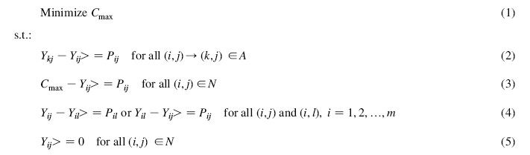
Eq. (1) represents the objective function minimizing the makespan. Eq. (2) satisfies precedence relationship in such a way that deviation of the start time on machines i and k for processing a job should be more than the processing time on machine i (machine i is prior to machine k). Eq. (3) expresses a set of all operations of job j on machine i. The third set of constraints represents sequence of different jobs to be processed on the same machine. The last set of constraints makes sure that the starting time of all operations (i,j) are positive.
2.12 Supply Chain – A supply chain consists of all parties involved, directly or indirectly, in fulfilling a customer request. The supply chain includes not only the manufacturer and suppliers, but also transporters, warehouses, retailers, and even customers themselves. Within each organization, such as a manufacturer, the supply chain includes all functions involved in receiving and filling a customer request. These function include, are not limited to, new product development, marketing, operations, distribution, finance, and customer service

A typical supply chain may involve a variety of stages. These supply chain stages include:
- Customers
- Retailers
- Wholesalers/distributors
- Manufacturers
- Component/raw material suppliers.
2.12.1 Supply Chain Management (SCM)
Supply chain management is the process of planning, implementing, and controlling the operations of the supply chain as efficiently as possible. Supply Chain Management spans all movement and storage of raw materials, work-in-process inventory, and finished goods from point-of-origin to point-of-consumption.
The typical definition of the term supply chain management is as follows: The supply chain refers to all those activities associated with the transformation and flow of goods and services, including their attendant information flows, from the sources of materials to end users. Management refers to integration of all these activities, both internal and external to the firm (Bowersox and Closs, 1996).
The definition one American professional association put forward is that Supply Chain Management encompasses the planning and management of all activities involved in sourcing, procurement, conversion, and logistics management activities. Importantly, it also includes coordination and collaboration with channel partners, which can be suppliers, intermediaries, third-party service providers, and customers. In essence, Supply Chain Management integrates supply and demand management within and across companies. Supply chain event management (abbreviated as SCEM) is a consideration of all possible occurring events and factors that can cause a disruption in a supply chain. With SCEM possible scenarios can be created and solutions can be planned.
Mohanty and Deshmukh (2004) define supply chain management as a loop:
- It starts with the customer and it ends with the customer.
- Through the loop flow all materials, finished goods, information and all transactions.
- It requires looking at the business as one continuous, seamless process.
- This process absorbs distinct function such as forecasting, purchasing, manufacturing and distribution, sales and marketing into a continuous business interaction.

Other definitions are as follows:
- Thomas and Griffin (1996): Management of material and information flows both in and between facilities such as vendors, manufacturing and assembly plants and distribution centers.
- Farley (1997): Supply chain management focuses on how firm utilize their supplier’s processes, technology capability to enhance competitive advantage, and the coordination of the manufacturing, logistics and materials management functions within an organization.
2.12.2 Objective of SCM: The objective of every supply chain should maximize the overall value generated. The value a supply chain generates is the difference between what the final product is worth to the customer and the costs the supply chain incurs in filling the customer’s request. For most commercial supply chains, value will be strongly correlated with supply chain profitability (also known as supply chain surplus), the difference between the revenue generated from the customer and the overall cost across the supply chain.
Supply chain success should be measured in terms of supply chain profitability and not in terms of the profits at individual stages. The higher the supply chain profitability, the more successful is the supply chain.
The objectives of supply chain integration are to supply superior quality goods faster, with more efficient processes and in essence be more responsive to the perceptions of the marketplace and be able to change direction at will.
Some of the consequences of supply chain integration result in:
- Reduced inventory at all sites of supply chain.
- Reduced costs.
- Faster processing speed.
- Reduced lead times.
- Reduced warehouse costs.
- Reduced obsolescence.
- Greater responsiveness to customer changes.
- Electronic links to suppliers and customers.
- Continuous flow of products and information.
- Speeding up the development cycle

2.12.3 SCM Problems and Causes
Lee and Padmanabhan[2001] ,consider a series of companies in asupply chain, each of whom orders from its immediate upstream member. In this setting, inbound orders from a downstream member serve as a valuable informational input to upstream production and inventory decisions. This claims that the information transferred in the forms of ‘orders’ tend to be distorted and can misguide upstream members in their inventory and production decisions. In particular the variance of orders may be larger than that of sales , and orders may be larger than that of sales, and distortion tends to increase as one moves upstream, a phenomenon termed “Bullwhip effect”. This paper analyses four sources of the bullwhip effect. Demand signal processing, rationing game, order batching and price variations. Action that can be taken to mitigate the detrimental impact of this distortion are also discussed.
Kathlen and Zhiang[2001] present a theoretical study of organizational performance under information distortion. Puts forward a question of how should organizations of intelligent agents be designed so that they exhibit high performance despite information distortion? Presents a formal information based network model of organizational performance given a distributed decision making environment in which agents encounter a radar detection task and further examine the performance of organizations with various designs in different task environments subjects to various types of information distortion. Further distinguishes five sources of information distortion: missing information, incorrect information, agent unavailability, communication channel breakdowns and agent turnover. This formal analysis suggests that:
  - Regardless of information distortion, performance is enhanced if there is a match between the complexity of organizational design and task environment.
  - Task environment characteristics have more effect on performance than information distortion and the organizational design.
  - The effect of information distortion can be combated by training , but only to limited extent.
  - Technology based information distortion typically is more debilitating than personnel induced information distortion.

Fangruo[2003] emphasizes on the informational flow and impact of its delays. Here he considers a supply chain whose members are divisions of the same firm. The divisions are managed by different individuals with only local information on inventory. Both material and information flow in the supply chain are subjected to the delays. Provides algorithm for two models and a cost center model.

2.12.4 Information Technology and its implication on Responsive Supply Chain.
One of the most important frontiers of current research is how Information Technology (IT) affects the organization and their supply chain. Wing[1999] outlines the client centered strategies for IT enabled supply chain management . he states that effective management is critical to success in this lucrative area. He states that successful business does more than simply deliver a product on budget and on time: it also delivers customers satisfaction. IT interfaced supply chain management must be client centered approach.
Barrie[2002] effectively discusses this issue and clears that if decision rights are centralized then the organization operates as a hierarchy- if they are decentralized then the organized acts as a market. IT makes it possible to choose where decision relevant information is located in the organization structure. IT improves the performance of a given organization design.

CHAPTER 3
Case Study Using Simulation Software “Witness”

3.1 Development of simulation model

In the present study, a discrete event simulation model is developed for the operation of the job shop production system. The simulation model is developed using the witness software and run on a PC with Pentium processor. Generally, a discrete event simulation model of a system is constructed by defining the events that can occur and then modeling the logic associated with each event to capture the changing status in the system. Executing the logic associated with each event in a time-ordered sequence produces a simulation of the system. A schematic flow chart of the logic of the simulation model is shown in figure 3.1. The discrete event model views the job shop system as consisting of entities, their associated attributes and files which contain entities with common characteristics. The entities in the job shop are jobs and machines. The Operation of the job shop is conceptualized as a succession of events centering on the jobs to be processed.
In this section simulation of one of the job shop problem of the journal is done. In which scheduling of three jobs on four machines are done given in Table 3.1. Than we analyzed some of the parameters like the makespan , machines utilization, machine idle time , total inventory etc

Table3. 1(Job shop problem data with three jobs and four machines) Pinedo, 2001
Jobs | Machine sequence | Processing times
1 | 1-2-3 | P₁₁=10 , P₂₁=8 , P₃₁=4
2 | 2-1-4-3 | P₂₂=8 , P₁₂=3 , P₄₂=5 , P₃₂=6
3 | 1-2-4 | P₁₃=4 , P₂₃=7 , P₄₃=3

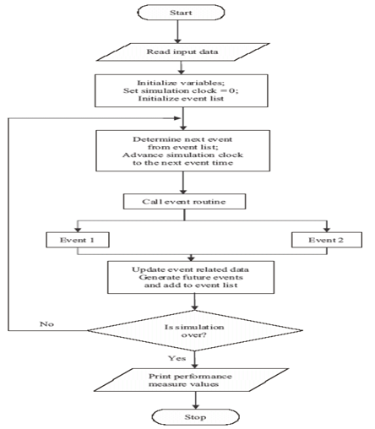

Figure 3.1: Flow chart of simulation logic
3.2 Job shop problem: In the above table the jobs column shows the number of jobs to be processed with machine sequence they should follow is given in the next column. In the processing time column the processing time of a particular job on particular machine is given.
The actual job shop model is shown in figure3.2. In this jobs are named as part001, part002, part003 which are passive in nature i,e they got to be pulled from the machines. The four machines are shown with machine001, machine002, machine003, machine004, on which the operations are done.

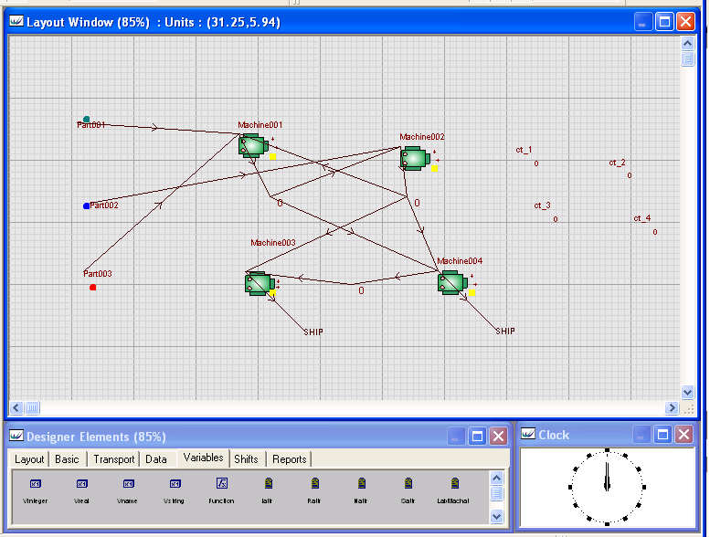
Figure 3.2(Job shop model with 3 jobs and 4 machines)

Simple Job Shop Model: Model is run for 28 minutes (I.e. for its optimum makespan)
In this when the model is allowed to run for 28 min which is its optimum makespan. Three parts each of kind (I.e. part001, part002, part003) are shipped. And the Gantt chart obtained shows the idle and utilization of each machine. Buffers are used as in process inventory, in this model buffers001, buffers002, buffers003 are used to store the parts. Some of the tables of output are shown in the table 1 table 2 and the Gantt chart is shown in the figure3.4. Here in this the Gantt chart obtained is same as obtained by heuristic method.

Table3. 2(Performance parameters of Machines obtained in Job shop model)
Name | Machine001 | Machine002 | Machine003 | Machine004
% Idle | 0 | 7.14 | 64.29 | 71.43
% Busy | 100 | 92.86 | 35.71 | 28.57
% Filling | 0 | 0 | 0 | 0
% Emptying | 0 | 0 | 0 | 0
% Blocked | 0 | 0 | 0 | 0
% Cycle Wait Labor | 0 | 0 | 0 | 0
% Setup | 0 | 0 | 0 | 0
% Setup Wait Labor | 0 | 0 | 0 | 0
% Broken Down | 0 | 0 | 0 | 0
% Repair Wait Labor | 0 | 0 | 0 | 0
No. Of Operations | 4 | 3 | 2 | 2

Table3. 3(Parameters of Parts obtained in Job shop model)
Name | Part001 | Part002 | Part003
No. Entered | 2 | 2 | 2
No. Shipped | 1 | 1 | 1
No. Scrapped | 0 | 0 | 0
No. Assembled | 0 | 0 | 0
No. Rejected | 0 | 0 | 0
W.I.P. | 1 | 1 | 1
Avg W.I.P. | 1.18 | 1.11 | 0.68
Avg Time | 16.5 | 15.5 | 9.5
Sigma Rating | 6 | 6 | 6

Table3. 4(Parameters of Buffers obtained in Job shop model)
Name | Buffers001 | Buffers002 | Buffers003
Total Out | 3 | 3 | 1
Now In | 1 | 0 | 0
Max | 2 | 1 | 1
Min | 0 | 0 | 0
Total In | 4 | 3 | 1
Avg Size | 0.18 | 0.21 | 0
Avg Time | 1.25 | 2 | 0

Figure3.3 (Clustered chart of job shop model)
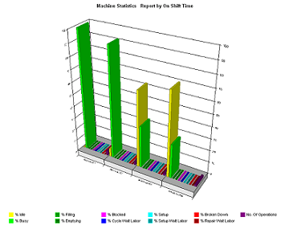

Figure3.4 (Gantt chart of job shop model)
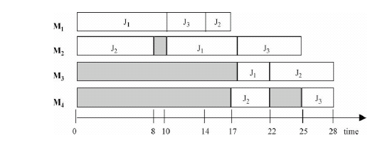
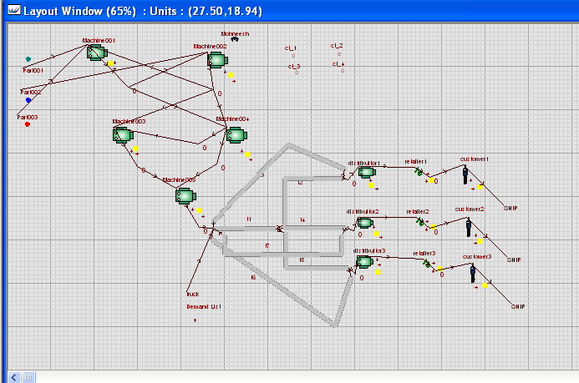
Figure3.5 (Job shop model as manufacturing unit in supply chain with 3 distributors , 3 retalior , 3 customer)

3.3 Job shop with Supply Chain:- In continuation with above model in this model 3 distribuitors, 3 retaliors and 3 customers have been added with a truck used to transpotation , shown in figure3. 5.
Now this model has truck which carry 10 parts at a time from store 3 and transport it to the buffers004, buffers005, buffers006 in this sequence respectively. On the other side customer pull the parts from buffers007, buffers008, buffers009 according to their requriment . and retaliors pull parts from distributors and push them to respective buffers . and for this model 600 minutes has been taken as the warmup period .
Some other parameters which remain fixed through out the model:

- Cycle time of the distributor1=25minutes
- Cycle time of the distributor2=35minutes
- Cycle time of the distributor3=40minutes
- Cycle time of the retailor1=50minutes
- Cycle time of the retailor2=70minutes
- Cycle time of the retailor3=80minutes

3.3.1 Requirement rate of the customer is Determinstic:- Cases determined that after a fixed interval customer has requirement of the finished part
For this we are taking four cases in which takt time (I,e demand rate of the customers) are harmonic in nature. Example if demand rate is 1part in 50 minutes than takt time is 1/50 .
3.3.1.1 Case 1( when the model is run for 14400min with 600min warmup time and cycle time of customer is 50min) when the model is run following data are obtained .
Table3. 5(Parameters of Parts for takt time 0.02, deterministic model)
Name | Part001 | Part002 | Part003
No. Entered | 916 | 665 | 913
No. Shipped | 162 | 161 | 323
No. Scrapped | 0 | 0 | 0
No. Assembled | 0 | 0 | 0
No. Rejected | 0 | 0 | 0
W.I.P. | 754 | 504 | 590
Avg W.I.P. | 394.04 | 265.15 | 311.29
Avg Time | 5936.34 | 5502.46 | 4705.11
Sigma Rating | 6 | 6 | 6

Table3. 6 (Parameters of Buffers for takt time 0.02, deterministic model)
Name | Buffers001 | Buffers002 | Buffers003 | Buffers004 | Buffers005 | Buffers006
Total Out | 1924 | 1923 | 641 | 276 | 197 | 173
Now In | 500 | 1 | 0 | 163 | 237 | 263
Max | 501 | 2 | 1 | 165 | 241 | 266
Min | 19 | 0 | 0 | 6 | 10 | 5
Total In | 2424 | 1924 | 641 | 439 | 434 | 436
Avg Size | 259.57 | 0.33 | 0.03 | 84.89 | 125.41 | 136.38
Avg Time | 1477.75 | 2.4 | 0.6 | 2668.47 | 3987.8 | 4316.77

Table3. 7(Parameters of Buffers and Stores for takt time 0.02, deterministic model)
Name | Buffers007 | Buffers008 | Buffers009 | store1 | store2 | store3
Total Out | 276 | 197 | 173 | 641 | 641 | 1287
Now In | 0 | 0 | 0 | 667 | 0 | 0
Max | 1 | 1 | 1 | 667 | 1 | 5
Min | 0 | 0 | 0 | 25 | 0 | 0
Total In | 276 | 197 | 173 | 1308 | 641 | 1287
Avg Size | 0 | 0 | 0 | 346.8 | 0 | 1.13
Avg Time | 0 | 0 | 0 | 3658.88 | 0 | 12.14

Table3. 8 (Performance Parameters of Customers and Distributors for takt time 0.02, deterministic model)
Name | customer1 | customer2 | customer3 | distribuitor1 | distribuitor2 | distribuitor3
% Idle | 0 | 28.57 | 37.6 | 0 | 0 | 0
% Busy | 100 | 71.43 | 62.4 | 50 | 49.96 | 49.94
% Blocked | 0 | 0 | 0 | 50 | 50.04 | 50.06
No. Of Operations | 276 | 198 | 172 | 276 | 197 | 172

Table3. 9 (Performance Parameters of Machines for takt time 0.02, deterministic model)
Name | Machine001 | Machine002 | Machine003 | Machine004 | Machine005
% Idle | 0 | 0 | 56.06 | 65.43 | 100
% Busy | 100 | 100 | 43.94 | 34.57 | 0
No. Of Operations | 2404 | 1924 | 1283 | 1282 | 1282

Table3. 10 (Performance Parameters of retailers for takt time 0.02, deterministic model)
Name | retailer1 | retailer2 | retailer3
% Idle | 0 | 0 | 0
% Busy | 100 | 100 | 100
No. Of Operations | 276 | 197 | 173

Table3. 11 (Performance Parameters of Paths for takt time 0.02, deterministic model)
Name | t1 | t2 | t3 | t4 | t5 | t6 | t7
% Empty | 28.06 | 96.81 | 93.77 | 96.88 | 96.81 | 93.77 | 93.91
% Busy | 71.94 | 3.19 | 6.23 | 3.12 | 3.19 | 6.23 | 6.09
No. On | 128 | 43 | 43 | 42 | 43 | 43 | 42

Table3. 12 (Performance Parameters of Truck for takt time 0.02, deterministic model)
Name | % Idle | % Demand | % Transfer | % Loaded | % Blocked | Distance | Loads
Truck | 37.34 | 0 | 53.16 | 9.51 | 0 | 3850 | 128

3.3.1.2 Case 2( when the model is run for 14400min with 600min warmup time and cycle time of customer is 100min) When the model is run following data are obtained.
Table3. 13(Parameters of parts for takt time 0.01, deterministic model)
Name | Part001 | Part002 | Part003
No. Entered | 918 | 666 | 916
No. Shipped | 105 | 102 | 207
No. Scrapped | 0 | 0 | 0
No. Assembled | 0 | 0 | 0
No. Rejected | 0 | 0 | 0
W.I.P. | 813 | 564 | 709
Avg W.I.P. | 424.91 | 295.24 | 372.25
Avg Time | 6387.47 | 6117.56 | 5608.06
Sigma Rating | 6 | 6 | 6

Table3. 14(Parameters of Buffers for takt time 0.01, deterministic model)
Name | Buffers001 | Buffers002 | Buffers003 | Buffers004 | Buffers005 | Buffers006
Total Out | 1924 | 1923 | 641 | 276 | 197 | 173
Now In | 500 | 1 | 0 | 163 | 237 | 263
Max | 501 | 2 | 1 | 165 | 241 | 266
Min | 19 | 0 | 0 | 6 | 10 | 5
Total In | 2424 | 1924 | 641 | 439 | 434 | 436
Avg Size | 259.57 | 0.33 | 0.03 | 84.89 | 125.41 | 136.38
Avg Time | 1477.75 | 2.4 | 0.6 | 2668.47 | 3987.8 | 4316.77
Table3. 15(Parameters of Buffers for takt time 0.01, deterministic model)
Name | Buffers007 | Buffers008 | Buffers009 | store1 | store2 | store3
Total Out | 138 | 138 | 138 | 641 | 641 | 1287
Now In | 142 | 60 | 35 | 667 | 0 | 0
Max | 143 | 61 | 35 | 667 | 1 | 5
Min | 4 | 1 | 0 | 25 | 0 | 0
Total In | 280 | 198 | 173 | 1308 | 641 | 1287
Avg Size | 73.02 | 30.65 | 17.58 | 346.8 | 0 | 1.13
Avg Time | 3598.72 | 2136.53 | 1402.26 | 3658.88 | 0 | 12.14

Table3.16 (Parameters of Customers and Distributors for takt time 0.01, deterministic model)
Name | customer1 | customer2 | customer3 | distribuitor1 | distribuitor2 | distribuitor3
% Idle | 0 | 0 | 0 | 0 | 0 | 0
% Busy | 100 | 100 | 100 | 50 | 49.96 | 49.94
% Blocked | 0 | 0 | 0 | 50 | 50.04 | 50.06
No. Of Operations | 138 | 138 | 138 | 276 | 197 | 172

Table3. 17(Performance parameters of Machines for takt time 0.01, deterministic model)
Name | Machine001 | Machine002 | Machine003 | Machine004 | Machine005
% Idle | 0 | 0 | 56.06 | 65.43 | 100
% Busy | 100 | 100 | 43.94 | 34.57 | 0
No. Of Operations | 2404 | 1924 | 1283 | 1282 | 1282

Table3. 18(Parameters of retailers for takt time 0.01, deterministic model)
Name | retailer1 | retailer2 | retailer3
% Idle | 0 | 0 | 0
% Busy | 100 | 100 | 100
No. Of Operations | 276 | 197 | 173

3.3.1.3 Case 3( when the model is run for 14400min with 600min warmup time and takt time .0067) When the model is run following data are obtained .

Table3. 19(Parameters of Parts for takt time 0.0067, deterministic model)
Name | Part001 | Part002 | Part003
No. Entered | 918 | 668 | 918
No. Shipped | 69 | 69 | 138
No. Scrapped | 0 | 0 | 0
No. Assembled | 0 | 0 | 0
No. Rejected | 0 | 0 | 0
W.I.P. | 849 | 599 | 780
Avg W.I.P. | 442.79 | 313.17 | 408.06
Avg Time | 6656.3 | 6469.6 | 6134.17
Sigma Rating | 6 | 6 | 6

Table3. 20(Parameters of Buffers for takt time 0.0067, deterministic model)
Name | Buffers001 | Buffers002 | Buffers003 | Buffers004 | Buffers005 | Buffers006
Total Out | 1924 | 1923 | 641 | 276 | 197 | 173
Now In | 500 | 1 | 0 | 163 | 237 | 263
Max | 501 | 2 | 1 | 165 | 241 | 266
Min | 19 | 0 | 0 | 6 | 10 | 5
Total In | 2424 | 1924 | 641 | 439 | 434 | 436
Avg Size | 259.57 | 0.33 | 0.03 | 84.89 | 125.41 | 136.38
Avg Time | 1477.75 | 2.4 | 0.6 | 2668.47 | 3987.8 | 4316.77

Table3. 21(Parameters of Buffers and Stores for takt time 0.0067, deterministic model)
Name | Buffers007 | Buffers008 | Buffers009 | store1 | store2 | store3
Total Out | 92 | 92 | 92 | 641 | 641 | 1287
Now In | 190 | 107 | 82 | 667 | 0 | 0
Max | 190 | 107 | 82 | 667 | 1 | 5
Min | 6 | 2 | 0 | 25 | 0 | 0
Total In | 282 | 199 | 174 | 1308 | 641 | 1287
Avg Size | 97.36 | 54.5 | 41.02 | 346.8 | 0 | 1.13
Avg Time | 4764.26 | 3779.19 | 3253.17 | 3658.88 | 0 | 12.14

Table3. 22(Performance parameters of Customers and Distributors for takt time 0.0067, deterministic model)
Name | customer1 | customer2 | customer3 | distribuitor1 | distribuitor2 | distribuitor3
% Idle | 0 | 0 | 0 | 0 | 0 | 0
% Busy | 100 | 100 | 100 | 50 | 49.96 | 49.94
% Blocked | 0 | 0 | 0 | 50 | 50.04 | 50.06
No. Of Operations | 92 | 92 | 92 | 276 | 197 | 172
Table3. 23 (Performance parameters of Machines for takt time 0.0067, deterministic model)
Name | Machine001 | Machine002 | Machine003 | Machine004 | Machine005
% Idle | 0 | 0 | 56.06 | 65.43 | 100
% Busy | 100 | 100 | 43.94 | 34.57 | 0
No. Of Operations | 2404 | 1924 | 1283 | 1282 | 1282

Table3. 24(Performance parameters of retailers for takt time 0.0067, deterministic model)
Name | retailer1 | retailer2 | retailer3
% Idle | 0 | 0 | 0
% Busy | 100 | 100 | 100
No. Of Operations | 276 | 197 | 173

3.3.1.4 Case 4( when the model is run for 14400min with 600min warmup time and takt time .005) When the model is run following data are obtained .
Table3. 25(Parameters of Parts for takt time 0.005, deterministic model)
Name | Part001 | Part002 | Part003
No. Entered | 918 | 668 | 918
No. Shipped | 52 | 52 | 103
No. Scrapped | 0 | 0 | 0
No. Assembled | 0 | 0 | 0
No. Rejected | 0 | 0 | 0
W.I.P. | 866 | 616 | 815
Avg W.I.P. | 451.74 | 322.12 | 425.96
Avg Time | 6790.87 | 6654.58 | 6403.33
Sigma Rating | 6 | 6 | 6

Table3. 26(Parameters of Buffers for takt time 0.005, deterministic model)
Name | Buffers001 | Buffers002 | Buffers003 | Buffers004 | Buffers005 | Buffers006
Total Out | 1924 | 1923 | 641 | 276 | 197 | 173
Now In | 500 | 1 | 0 | 163 | 237 | 263
Max | 501 | 2 | 1 | 165 | 241 | 266
Min | 19 | 0 | 0 | 6 | 10 | 5
Total In | 2424 | 1924 | 641 | 439 | 434 | 436
Avg Size | 259.57 | 0.33 | 0.03 | 84.89 | 125.41 | 136.38
Avg Time | 1477.75 | 2.4 | 0.6 | 2668.47 | 3987.8 | 4316.77
Table3. 27(Parameters of Buffers and Stores for takt time 0.005, deterministic model)
Name | Buffers007 | Buffers008 | Buffers009 | store1 | store2 | store3
Total Out | 69 | 69 | 69 | 641 | 641 | 1287
Now In | 213 | 130 | 105 | 667 | 0 | 0
Max | 214 | 131 | 105 | 667 | 1 | 5
Min | 6 | 2 | 1 | 25 | 0 | 0
Total In | 282 | 199 | 174 | 1308 | 641 | 1287
Avg Size | 109.53 | 66.42 | 52.74 | 346.8 | 0 | 1.13
Avg Time | 5359.8 | 4605.89 | 4182.66 | 3658.88 | 0 | 12.14

Table3. 28(Performance parameters of Customers and Distributors for takt time 0.005, deterministic model)
Name | customer1 | customer2 | customer3 | distribuitor1 | distribuitor2 | distribuitor3
% Idle | 0 | 0 | 0 | 0 | 0 | 0
% Busy | 100 | 100 | 100 | 50 | 49.96 | 49.94
% Blocked | 0 | 0 | 0 | 50 | 50.04 | 50.06
No. Of Operations | 69 | 69 | 69 | 276 | 197 | 172

Table3. 29(Performance parameters of Machines for takt time 0.005, eterministic model)
Name | Machine001 | Machine002 | Machine003 | Machine004 | Machine005
% Idle | 0 | 0 | 56.06 | 65.43 | 100
% Busy | 100 | 100 | 43.94 | 34.57 | 0
No. Of Operations | 2404 | 1924 | 1283 | 1282 | 1282

Table3. 30(Performance parameters of retailers for takt time 0.005, deterministic model)
Name | retailer1 | retailer2 | retailer3
% Idle | 0 | 0 | 0
% Busy | 100 | 100 | 100
No. Of Operations | 276 | 197 | 173

3.3.2 Requirement rate of the customer is Probabilistic:- Cases in which requirement rate of the the customer is not fixed rather it probabilistic in nature.For this we are taking twelve cases in which cycle time of customer are arithmetic in nature.(example normal(50,5)min ,normal(100,10)min, normal(150,15)min , normal(200,20)min).
What is a normal distribution?
The normal distribution is pattern for the distribution of a set of data which follows a bell shaped curve. This distribution is sometimes called the Gaussian distribution in honor of Carl Friedrich Gauss, a famous mathematician. This is commonly used distribution because it resemblance with the practical situation.
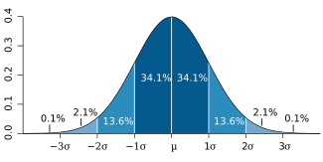
Figure3.6 (Normal distribution density curve)
Dark blue is less than one standard deviation from the mean For the normal distribution, this accounts for about 68% of the set (dark blue) while two standard deviations from the mean (medium and dark blue) account for about 95% and three standard deviations (light, medium, and dark blue) account for about 99.7%.
About 68% of values drawn from a normal distribution are within one standard deviation σ > 0 away from the mean μ; about 95% of the values are within two standard deviations and about 99.7% lie within three standard deviations. This is known as the "68-95-99.7 rule" or the "empirical rule."
The probability density function in the interval (-∞,+∞) is

F(x) = 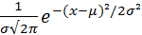

Where μ and σ are the mean and standard deviation respectively.
The bell shaped curve has several properties:
- The curve concentrated in the center and decreases on either side. This means that the data has less of a tendency to produce unusually extreme values, compared to some other distributions.
- The bell shaped curve is symmetric. This tells you that he probability of deviations from the mean are comparable in either direction.
When you want to describe probability for a continuous variable, you do so by describing a certain area. A large area implies a large probability and a small area implies a small probability. Some people don't like this, because it forces them to remember a bit of geometry (or in more complex situations, calculus). But the relationship between probability and area is also useful, because it provides a visual interpretation for probability.
3.3.2.1 Case 5( when the model is run for 14400min with 600min warmup time and cycle time the customer is normal(50,2.5)) That is when cycle time follow normal distribution with mean 50 and standard deviation 2,.5 (which is 5%of mean ) than we obtained the following data.

Table3. 31(Parameters of Parts for normal (50, 2.5) distribution)
Name | Part001 | Part002 | Part003
No. Entered | 916 | 665 | 915
No. Shipped | 162 | 160 | 324
No. Scrapped | 0 | 0 | 0
No. Assembled | 0 | 0 | 0
No. Rejected | 0 | 0 | 0
W.I.P. | 754 | 505 | 591
Avg W.I.P. | 394.23 | 265.34 | 311.68
Avg Time | 5939.34 | 5506.34 | 4700.71
Sigma Rating | 6 | 6 | 6

Table3. 32(Parameters of Buffers for normal (50, 2.5) distribution)
Name | Buffers001 | Buffers002 | Buffers003 | Buffers004 | Buffers005 | Buffers006
Total Out | 1924 | 1923 | 641 | 276 | 197 | 173
Now In | 500 | 1 | 0 | 163 | 237 | 263
Max | 501 | 2 | 1 | 165 | 241 | 266
Min | 19 | 0 | 0 | 6 | 10 | 5
Total In | 2424 | 1924 | 641 | 439 | 434 | 436
Avg Size | 259.57 | 0.33 | 0.03 | 84.89 | 125.41 | 136.38
Avg Time | 1477.75 | 2.4 | 0.6 | 2668.47 | 3987.8 | 4316.77

Table3. 33(Parameters of Buffers and Stores for normal (50, 2.5) distribution)
Name | Buffers007 | Buffers008 | Buffers009 | store1 | store2 | store3
Total Out | 276 | 197 | 173 | 641 | 641 | 1287
Now In | 1 | 0 | 0 | 667 | 0 | 0
Max | 2 | 1 | 1 | 667 | 1 | 5
Min | 0 | 0 | 0 | 25 | 0 | 0
Total In | 277 | 197 | 173 | 1308 | 641 | 1287
Avg Size | 0.77 | 0 | 0 | 346.8 | 0 | 1.13
Avg Time | 38.27 | 0 | 0 | 3658.88 | 0 | 12.14
Table3. 34(Parameters of Customers and Distributors for normal (50, 2.5) distribution)
Name | customer1 | customer2 | customer3 | distribuitor1 | distribuitor2 | distribuitor3
% Idle | 0 | 28.14 | 37.18 | 0 | 0 | 0
% Busy | 100 | 71.86 | 62.82 | 50 | 49.96 | 49.94
% Blocked | 0 | 0 | 0 | 50 | 50.04 | 50.06
No. Of Operations | 276 | 197 | 173 | 276 | 197 | 172

Table3. 35(Performance parameters of Machines for normal (50, 2.5) distribution)
Name | Machine001 | Machine002 | Machine003 | Machine004 | Machine005
% Idle | 0 | 0 | 56.06 | 65.43 | 100
% Busy | 100 | 100 | 43.94 | 34.57 | 0
No. Of Operations | 2404 | 1924 | 1283 | 1282 | 1282

Table3. 36(Performance parameters of retailers for normal (50, 2.5) distribution)
Name | retailer1 | retailer2 | retailer3
% Idle | 0 | 0 | 0
% Busy | 100 | 100 | 100
No. Of Operations | 276 | 197 | 173

3.3.2.2 Case 6( when the model is run for 14400min with 600min warmup time and cycle time the customer is normal(50,5)) That is when requirement rate follow normal distribution with mean 50 and standard deviation 5 (which is 10%of mean ) than we obtained the following data.

Table3. 37(Parameters of Parts for normal (50, 5) distribution)
Name | Part001 | Part002 | Part003
No. Entered | 916 | 665 | 915
No. Shipped | 162 | 159 | 324
No. Scrapped | 0 | 0 | 0
No. Assembled | 0 | 0 | 0
No. Rejected | 0 | 0 | 0
W.I.P. | 754 | 506 | 591
Avg W.I.P. | 394.43 | 265.53 | 312.07
Avg Time | 5942.35 | 5510.17 | 4706.6
Sigma Rating | 6 | 6 | 6

Table3. 38(Parameters of Buffers for normal (50, 5) distribution)
Name | Buffers001 | Buffers002 | Buffers003 | Buffers004 | Buffers005 | Buffers006
Total Out | 1924 | 1923 | 641 | 276 | 197 | 173
Now In | 500 | 1 | 0 | 163 | 237 | 263
Max | 501 | 2 | 1 | 165 | 241 | 266
Min | 19 | 0 | 0 | 6 | 10 | 5
Total In | 2424 | 1924 | 641 | 439 | 434 | 436
Avg Size | 259.57 | 0.33 | 0.03 | 84.89 | 125.41 | 136.38
Avg Time | 1477.75 | 2.4 | 0.6 | 2668.47 | 3987.8 | 4316.77

Table3. 39(Parameters of Buffers and Stores for normal (50, 5) distribution)
Name | Buffers007 | Buffers008 | Buffers009 | store1 | store2 | store3
Total Out | 275 | 197 | 173 | 641 | 641 | 1287
Now In | 2 | 0 | 0 | 667 | 0 | 0
Max | 3 | 1 | 1 | 667 | 1 | 5
Min | 0 | 0 | 0 | 25 | 0 | 0
Total In | 277 | 197 | 173 | 1308 | 641 | 1287
Avg Size | 1.53 | 0 | 0 | 346.8 | 0 | 1.13
Avg Time | 76.45 | 0 | 0 | 3658.88 | 0 | 12.14

Table3. 40(Performance parameters of Customers and Distributors for normal (50, 5) distribution)
Name | customer1 | customer2 | customer3 | distribuitor1 | distribuitor2 | distribuitor3
% Idle | 0 | 27.74 | 36.74 | 0 | 0 | 0
% Busy | 100 | 72.26 | 63.26 | 50 | 49.96 | 49.94
% Blocked | 0 | 0 | 0 | 50 | 50.04 | 50.06
No. Of Operations | 275 | 197 | 173 | 276 | 197 | 172

Table3. 41(Performance parameters of Machines for normal (50, 5) distribution)
Name | Machine001 | Machine002 | Machine003 | Machine004 | Machine005
% Idle | 0 | 0 | 56.06 | 65.43 | 100
% Busy | 100 | 100 | 43.94 | 34.57 | 0
No. Of Operations | 2404 | 1924 | 1283 | 1282 | 1282

Table3. 42(Performance parameters of retailers for normal (50, 5) distribution)
Name | retailer1 | retailer2 | retailer3
% Idle | 0 | 0 | 0
% Busy | 100 | 100 | 100
No. Of Operations | 276 | 197 | 173

3.3.2.3 Case 7( when the model is run for 14400min with 600min warmup time and cycle time of customer is normal(100,5)) That is when requirement rate follow normal distribution with mean 100 and standard deviation 5 (which is 5%of mean ) than we obtained the following data.

Table3. 43(Parameters of Parts for normal (100, 5) distribution)
Name | Part001 | Part002 | Part003
No. Entered | 918 | 666 | 916
No. Shipped | 105 | 101 | 205
No. Scrapped | 0 | 0 | 0
No. Assembled | 0 | 0 | 0
No. Rejected | 0 | 0 | 0
W.I.P. | 813 | 565 | 711
Avg W.I.P. | 425.29 | 295.6 | 373
Avg Time | 6393.19 | 6125.14 | 5619.37
Sigma Rating | 6 | 6 | 6

Table3. 44(Parameters of Buffers for normal (100, 5) distribution)
Name | Buffers001 | Buffers002 | Buffers003 | Buffers004 | Buffers005 | Buffers006
Total Out | 1924 | 1923 | 641 | 276 | 197 | 173
Now In | 500 | 1 | 0 | 163 | 237 | 263
Max | 501 | 2 | 1 | 165 | 241 | 266
Min | 19 | 0 | 0 | 6 | 10 | 5
Total In | 2424 | 1924 | 641 | 439 | 434 | 436
Avg Size | 259.57 | 0.33 | 0.03 | 84.89 | 125.41 | 136.38
Avg Time | 1477.75 | 2.4 | 0.6 | 2668.47 | 3987.8 | 4316.77

Table3. 45(Parameters of Buffers and Stores for normal (100, 5) distribution)
Name | Buffers007 | Buffers008 | Buffers009 | store1 | store2 | store3
Total Out | 137 | 137 | 137 | 641 | 641 | 1287
Now In | 143 | 61 | 36 | 667 | 0 | 0
Max | 143 | 61 | 36 | 667 | 1 | 5
Min | 4 | 1 | 0 | 25 | 0 | 0
Total In | 280 | 198 | 173 | 1308 | 641 | 1287
Avg Size | 73.59 | 30.86 | 18.3 | 346.8 | 0 | 1.13
Avg Time | 3627.08 | 2150.8 | 1459.41 | 3658.88 | 0 | 12.14

Table3. 46(Performance parameters of Customers and Distributors for normal (100, 5) distribution)
Name | customer1 | customer2 | customer3 | distribuitor1 | distribuitor2 | distribuitor3
% Idle | 0 | 0 | 0 | 0 | 0 | 0
% Busy | 100 | 100 | 100 | 50 | 49.96 | 49.94
% Blocked | 0 | 0 | 0 | 50 | 50.04 | 50.06
No. Of Operations | 137 | 137 | 137 | 276 | 197 | 172

Table3. 47(Performance parameters of Machines for normal (100, 5) distribution)
Name | Machine001 | Machine002 | Machine003 | Machine004 | Machine005
% Idle | 0 | 0 | 56.06 | 65.43 | 100
% Busy | 100 | 100 | 43.94 | 34.57 | 0
No. Of Operations | 2404 | 1924 | 1283 | 1282 | 1282

Table3. 48(Performance parameters of retailers for normal (100, 5) distribution)
Name | retailer1 | retailer2 | retailer3
% Idle | 0 | 0 | 0
% Busy | 100 | 100 | 100
No. Of Operations | 276 | 197 | 173
3.3.2.4 Case 8 (when the model is run for 14400min with 600min warmup time and cycle time the customer is normal(100,10)) That is when requirement rate follow normal distribution with mean 100 and standard deviation 10 (which is 10%of mean ) than we obtained the following data.

Table3. 49(Parameters of Parts for normal (100, 10) distribution)
Name | Part001 | Part002 | Part003
No. Entered | 918 | 666 | 916
No. Shipped | 104 | 101 | 204
No. Scrapped | 0 | 0 | 0
No. Assembled | 0 | 0 | 0
No. Rejected | 0 | 0 | 0
W.I.P. | 814 | 565 | 712
Avg W.I.P. | 425.66 | 295.97 | 373.74
Avg Time | 6398.83 | 6132.67 | 5630.51
Sigma Rating | 6 | 6 | 6

Table3. 50(Parameters of Buffers for normal (100, 10) distribution)
Name | Buffers001 | Buffers002 | Buffers003 | Buffers004 | Buffers005 | Buffers006
Total Out | 1924 | 1923 | 641 | 276 | 197 | 173
Now In | 500 | 1 | 0 | 163 | 237 | 263
Max | 501 | 2 | 1 | 165 | 241 | 266
Min | 19 | 0 | 0 | 6 | 10 | 5
Total In | 2424 | 1924 | 641 | 439 | 434 | 436
Avg Size | 259.57 | 0.33 | 0.03 | 84.89 | 125.41 | 136.38
Avg Time | 1477.75 | 2.4 | 0.6 | 2668.47 | 3987.8 | 4316.77

Table3. 51(Parameters of Buffers and Stores for normal (100, 10) distribution)
Name | Buffers007 | Buffers008 | Buffers009 | store1 | store2 | store3
Total Out | 136 | 137 | 136 | 641 | 641 | 1287
Now In | 144 | 61 | 37 | 667 | 0 | 0
Max | 144 | 62 | 38 | 667 | 1 | 5
Min | 4 | 1 | 0 | 25 | 0 | 0
Total In | 280 | 198 | 173 | 1308 | 641 | 1287
Avg Size | 74.16 | 31.06 | 19 | 346.8 | 0 | 1.13
Avg Time | 3655.16 | 2164.81 | 1515.83 | 3658.88 | 0 | 12.14

Table3. 52(Performance parameters of Customers and Distributors for normal (100, 10) distribution)
Name | customer1 | customer2 | customer3 | distribuitor1 | distribuitor2 | distribuitor3
% Idle | 0 | 0 | 0 | 0 | 0 | 0
% Busy | 100 | 100 | 100 | 50 | 49.96 | 49.94
% Blocked | 0 | 0 | 0 | 50 | 50.04 | 50.06
No. Of Operations | 136 | 137 | 136 | 276 | 197 | 172

Table3. 53(Performance parameters of Machines for normal (100, 10) distribution)
Name | Machine001 | Machine002 | Machine003 | Machine004 | Machine005
% Idle | 0 | 0 | 56.06 | 65.43 | 100
% Busy | 100 | 100 | 43.94 | 34.57 | 0
No. Of Operations | 2404 | 1924 | 1283 | 1282 | 1282

Table3. 54(Performance parameters of retailers for normal (100, 10) distribution)
Name | retailer1 | retailer2 | retailer3
% Idle | 0 | 0 | 0
% Busy | 100 | 100 | 100
No. Of Operations | 276 | 197 | 173

3.3.2.5 Case 9 (when the model is run for 14400min with 600min warmup time and cycle time the customer is normal(150,7.5)) That is when requirement rate follow normal distribution with mean 150 and standard deviation 7.5 (which is 5%of mean ) than we obtained the following data.

Table3. 55(Parameters of Parts for normal (150, 7.5) distribution)
Name | Part001 | Part002 | Part003
No. Entered | 918 | 668 | 918
No. Shipped | 69 | 69 | 137
No. Scrapped | 0 | 0 | 0
No. Assembled | 0 | 0 | 0
No. Rejected | 0 | 0 | 0
W.I.P. | 849 | 599 | 781
Avg W.I.P. | 443.05 | 313.42 | 408.58
Avg Time | 6660.28 | 6474.83 | 6142.11
Sigma Rating | 6 | 6 | 6

Table3. 56(Parameters of Buffers for normal (150, 7.5) distribution)
Name | Buffers001 | Buffers002 | Buffers003 | Buffers004 | Buffers005 | Buffers006
Total Out | 1924 | 1923 | 641 | 276 | 197 | 173
Now In | 500 | 1 | 0 | 163 | 237 | 263
Max | 501 | 2 | 1 | 165 | 241 | 266
Min | 19 | 0 | 0 | 6 | 10 | 5
Total In | 2424 | 1924 | 641 | 439 | 434 | 436
Avg Size | 259.57 | 0.33 | 0.03 | 84.89 | 125.41 | 136.38
Avg Time | 1477.75 | 2.4 | 0.6 | 2668.47 | 3987.8 | 4316.77

Table3. 57(Parameters of Buffers and Stores for normal (150, 7.5) distribution)
Name | Buffers007 | Buffers008 | Buffers009 | store1 | store2 | store3
Total Out | 91 | 92 | 92 | 641 | 641 | 1287
Now In | 191 | 107 | 82 | 667 | 0 | 0
Max | 191 | 107 | 82 | 667 | 1 | 5
Min | 5 | 2 | 1 | 25 | 0 | 0
Total In | 282 | 199 | 174 | 1308 | 641 | 1287
Avg Size | 97.73 | 54.55 | 41.64 | 346.8 | 0 | 1.13
Avg Time | 4782.73 | 3782.75 | 3302.15 | 3658.88 | 0 | 12.14

Table3. 58(Performance parameters of Customers and Distributors for normal (150, 7.5) distribution)
Name | customer1 | customer2 | customer3 | distribuitor1 | distribuitor2 | distribuitor3
% Idle | 0 | 0 | 0 | 0 | 0 | 0
% Busy | 100 | 100 | 100 | 50 | 49.96 | 49.94
% Blocked | 0 | 0 | 0 | 50 | 50.04 | 50.06
No. Of Operations | 91 | 92 | 92 | 276 | 197 | 172

Table3. 59(Performance parameters of Machines for normal (150, 7.5) distribution)
Name | Machine001 | Machine002 | Machine003 | Machine004 | Machine005
% Idle | 0 | 0 | 56.06 | 65.43 | 100
% Busy | 100 | 100 | 43.94 | 34.57 | 0
No. Of Operations | 2404 | 1924 | 1283 | 1282 | 1282

Table3. 60(Performance Parameters of retailers for normal (150, 7.5) distribution)
Name | retailer1 | retailer2 | retailer3
% Idle | 0 | 0 | 0
% Busy | 100 | 100 | 100
No. Of Operations | 276 | 197 | 173

3.3.2.6 Case 10 (when the model is run for 14400min with 600min warmup time and requirement rate is normal(150,15)) That is when cycle time the customer follow normal distribution with mean 150 and standard deviation 15 (which is 10%of mean ) than we obtained the following data.

Table3. 61(Parameters of Parts for normal (150, 15) distribution)
Name | Part001 | Part002 | Part003
No. Entered | 918 | 668 | 918
No. Shipped | 68 | 69 | 136
No. Scrapped | 0 | 0 | 0
No. Assembled | 0 | 0 | 0
No. Rejected | 0 | 0 | 0
W.I.P. | 850 | 599 | 782
Avg W.I.P. | 443.31 | 313.67 | 409.1
Avg Time | 6664.19 | 6480.07 | 6149.87
Sigma Rating | 6 | 6 | 6

Table3. 62(Parameters of Buffers for normal (150, 15) distribution)
Name | Buffers001 | Buffers002 | Buffers003 | Buffers004 | Buffers005 | Buffers006
Total Out | 1924 | 1923 | 641 | 276 | 197 | 173
Now In | 500 | 1 | 0 | 163 | 237 | 263
Max | 501 | 2 | 1 | 165 | 241 | 266
Min | 19 | 0 | 0 | 6 | 10 | 5
Total In | 2424 | 1924 | 641 | 439 | 434 | 436
Avg Size | 259.57 | 0.33 | 0.03 | 84.89 | 125.41 | 136.38
Avg Time | 1477.75 | 2.4 | 0.6 | 2668.47 | 3987.8 | 4316.77

Table3. 63(Parameters of Buffers and Stores for normal (150, 15) distribution)
Name | Buffers007 | Buffers008 | Buffers009 | store1 | store2 | store3
Total Out | 90 | 92 | 91 | 641 | 641 | 1287
Now In | 192 | 107 | 83 | 667 | 0 | 0
Max | 192 | 108 | 83 | 667 | 1 | 5
Min | 5 | 1 | 1 | 25 | 0 | 0
Total In | 282 | 199 | 174 | 1308 | 641 | 1287
Avg Size | 98.1 | 54.6 | 42.25 | 346.8 | 0 | 1.13
Avg Time | 4800.65 | 3786.3 | 3350.76 | 3658.88 | 0 | 12.14

Table3. 64(Performance parameters of Customers and Distributors for normal (150, 15) distribution)
Name | customer1 | customer2 | customer3 | distribuitor1 | distribuitor2 | distribuitor3
% Idle | 0 | 0 | 0 | 0 | 0 | 0
% Busy | 100 | 100 | 100 | 50 | 49.96 | 49.94
% Blocked | 0 | 0 | 0 | 50 | 50.04 | 50.06
No. Of Operations | 90 | 92 | 91 | 276 | 197 | 172

Table3. 65(Performance parameters of Machines for normal (150, 15) distribution)
Name | Machine001 | Machine002 | Machine003 | Machine004 | Machine005
% Idle | 0 | 0 | 56.06 | 65.43 | 100
% Busy | 100 | 100 | 43.94 | 34.57 | 0
No. Of Operations | 2404 | 1924 | 1283 | 1282 | 1282

Table3. 66(Performance parameters of retailers for normal (150, 15) distribution)
Name | retailer1 | retailer2 | retailer3
% Idle | 0 | 0 | 0
% Busy | 100 | 100 | 100
No. Of Operations | 276 | 197 | 173
3.3.2.7 Case 11 (when the model is run for 14400min with 600min warmup time and cycle time the customer is normal(200,10)) That is when requirement rate follow normal distribution with mean 200 and standard deviation 5 (which is 5%of mean ) than we obtained the following data.

Table3. 67(Parameters of Parts for normal (200, 10) distribution)
Name | Part001 | Part002 | Part003
No. Entered | 918 | 668 | 918
No. Shipped | 52 | 51 | 103
No. Scrapped | 0 | 0 | 0
No. Assembled | 0 | 0 | 0
No. Rejected | 0 | 0 | 0
W.I.P. | 866 | 617 | 815
Avg W.I.P. | 451.97 | 322.34 | 426.41
Avg Time | 6794.3 | 6659.05 | 6410.11
Sigma Rating | 6 | 6 | 6

Table3. 68(Parameters of Buffers for normal (200, 10) distribution)
Name | Buffers001 | Buffers002 | Buffers003 | Buffers004 | Buffers005 | Buffers006
Total Out | 1924 | 1923 | 641 | 276 | 197 | 173
Now In | 500 | 1 | 0 | 163 | 237 | 263
Max | 501 | 2 | 1 | 165 | 241 | 266
Min | 19 | 0 | 0 | 6 | 10 | 5
Total In | 2424 | 1924 | 641 | 439 | 434 | 436
Avg Size | 259.57 | 0.33 | 0.03 | 84.89 | 125.41 | 136.38
Avg Time | 1477.75 | 2.4 | 0.6 | 2668.47 | 3987.8 | 4316.77

Table3. 69(Parameters of Buffers and Stores for normal (200, 10) distribution)
Name | Buffers007 | Buffers008 | Buffers009 | store1 | store2 | store3
Total Out | 68 | 69 | 69 | 641 | 641 | 1287
Now In | 214 | 130 | 105 | 667 | 0 | 0
Max | 214 | 131 | 106 | 667 | 1 | 5
Min | 6 | 2 | 1 | 25 | 0 | 0
Total In | 282 | 199 | 174 | 1308 | 641 | 1287
Avg Size | 109.75 | 66.46 | 53.36 | 346.8 | 0 | 1.13
Avg Time | 5370.85 | 4609.08 | 4232.13 | 3658.88 | 0 | 12.14

Table3. 70(Parameters of Customers and Distributors for normal (200, 10) distribution)
Name | customer1 | customer2 | customer3 | distribuitor1 | distribuitor2 | distribuitor3
% Idle | 0 | 0 | 0 | 0 | 0 | 0
% Busy | 100 | 100 | 100 | 50 | 49.96 | 49.94
% Blocked | 0 | 0 | 0 | 50 | 50.04 | 50.06
No. Of Operations | 68 | 69 | 69 | 276 | 197 | 172
Table3. 71(Performance parameters of Machines for normal (200, 10) distribution)
Name | Machine001 | Machine002 | Machine003 | Machine004 | Machine005
% Idle | 0 | 0 | 56.06 | 65.43 | 100
% Busy | 100 | 100 | 43.94 | 34.57 | 0
No. Of Operations | 2404 | 1924 | 1283 | 1282 | 1282

Table3. 72(Performance parameters of retailers for normal (200, 10) distribution)
Name | retailer1 | retailer2 | retailer3
% Idle | 0 | 0 | 0
% Busy | 100 | 100 | 100
No. Of Operations | 276 | 197 | 173

3.3.2.8 Case 12 (when the model is run for 14400min with 600min warmup time and cycle time the customer is normal(200,20)) That is when requirement rate follow normal distribution with mean 200 and standard deviation 5 (which is 10%of mean ) than we obtained the following data.

Table3. 73(Parameters of Parts for normal (200, 20) distribution)
Name | Part001 | Part002 | Part003
No. Entered | 918 | 668 | 918
No. Shipped | 51 | 51 | 102
No. Scrapped | 0 | 0 | 0
No. Assembled | 0 | 0 | 0
No. Rejected | 0 | 0 | 0
W.I.P. | 867 | 617 | 816
Avg W.I.P. | 452.19 | 322.55 | 426.86
Avg Time | 6797.59 | 6663.52 | 6416.89
Sigma Rating | 6 | 6 | 6

Table3. 74(Parameters of Buffers for normal (200, 20) distribution)
Name | Buffers001 | Buffers002 | Buffers003 | Buffers004 | Buffers005 | Buffers006
Total Out | 1924 | 1923 | 641 | 276 | 197 | 173
Now In | 500 | 1 | 0 | 163 | 237 | 263
Max | 501 | 2 | 1 | 165 | 241 | 266
Min | 19 | 0 | 0 | 6 | 10 | 5
Total In | 2424 | 1924 | 641 | 439 | 434 | 436
Avg Size | 259.57 | 0.33 | 0.03 | 84.89 | 125.41 | 136.38
Avg Time | 1477.75 | 2.4 | 0.6 | 2668.47 | 3987.8 | 4316.77
Table3. 75(Parameters of Buffers and Stores for normal (200, 20) distribution)
Name | Buffers007 | Buffers008 | Buffers009 | store1 | store2 | store3
Total Out | 68 | 68 | 68 | 641 | 641 | 1287
Now In | 214 | 131 | 106 | 667 | 0 | 0
Max | 214 | 131 | 106 | 667 | 1 | 5
Min | 6 | 2 | 1 | 25 | 0 | 0
Total In | 282 | 199 | 174 | 1308 | 641 | 1287
Avg Size | 109.98 | 66.51 | 53.98 | 346.8 | 0 | 1.13
Avg Time | 5381.91 | 4612.26 | 4280.87 | 3658.88 | 0 | 12.14

Table3. 76(Performance parameters of Customers and Distributors for normal (200, 20) distribution)
Name | customer1 | customer2 | customer3 | distribuitor1 | distribuitor2 | distribuitor3
% Idle | 0 | 0 | 0 | 0 | 0 | 0
% Busy | 100 | 100 | 100 | 50 | 49.96 | 49.94
% Blocked | 0 | 0 | 0 | 50 | 50.04 | 50.06
No. Of Operations | 68 | 68 | 68 | 276 | 197 | 172

Table3. 77(Performance parameters of Machines for normal (200, 20) distribution)
Name | Machine001 | Machine002 | Machine003 | Machine004 | Machine005
% Idle | 0 | 0 | 56.06 | 65.43 | 100
% Busy | 100 | 100 | 43.94 | 34.57 | 0
No. Of Operations | 2404 | 1924 | 1283 | 1282 | 1282

Table3. 78(Performance parameters of retailers for normal (200, 20) distribution)
Name | retailer1 | retailer2 | retailer3
% Idle | 0 | 0 | 0
% Busy | 100 | 100 | 100
No. Of Operations | 276 | 197 | 173

3.3.2.9 Case 13 (when the model is run for 14400min with 600min warmup time and cycle time the customer is negexp(50). That is when requirement rate follow negative exponential distribution with mean 50 mins, than we obtained the following data

A continuous random variable which often occurs in practice is the Negative Exponential Distribution. A continuous random variable X is said to be exponentially distributed if it has a probability density function.
F(x) = λe-^{λx} x ≥ 0
F(x) = 0 x < 0
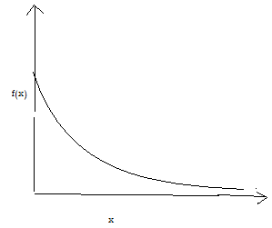
Figure3.7(Negative exponential density curve)

Table3. 79(Parameters of Parts for negexp(50) distribution)
Name | Part001 | Part002 | Part003
No. Entered | 916 | 665 | 914
No. Shipped | 159 | 158 | 317
No. Scrapped | 0 | 0 | 0
No. Assembled | 0 | 0 | 0
No. Rejected | 0 | 0 | 0
W.I.P. | 757 | 507 | 597
Avg W.I.P. | 395.77 | 266.89 | 314.78
Avg Time | 5962.43 | 5538.4 | 4752.76
Sigma Rating | 6 | 6 | 6

Table3. 80(Parameters of Buffers for negexp(50) distribution)
Name | Buffers001 | Buffers002 | Buffers003 | Buffers004 | Buffers005 | Buffers006
Total In | 2424 | 1924 | 641 | 439 | 434 | 436
Total Out | 1924 | 1923 | 641 | 276 | 197 | 173
Now In | 500 | 1 | 0 | 163 | 237 | 263
Max | 501 | 2 | 1 | 165 | 241 | 266
Min | 19 | 0 | 0 | 6 | 10 | 5
Avg Size | 259.57 | 0.33 | 0.03 | 84.89 | 125.41 | 136.38
Avg Time | 1477.75 | 2.4 | 0.6 | 2668.47 | 3987.8 | 4316.77
Table3. 81(Parameters of Buffers and Stores for negexp(50) distribution)
Name | Buffers007 | Buffers008 | Buffers009 | store1 | store2 | store3
Total Out | 277 | 197 | 173 | 1308 | 641 | 1287
Now In | 264 | 197 | 173 | 641 | 641 | 1287
Max | 13 | 0 | 0 | 667 | 0 | 0
Min | 17 | 6 | 3 | 667 | 1 | 5
Total In | 0 | 0 | 0 | 25 | 0 | 0
Avg Size | 6.11 | 0.58 | 0.29 | 346.8 | 0 | 1.13
Avg Delay Time | 304.41 | 40.86 | 23.1 | 3658.88 | 0 | 12.14

Table3. 82(Performance parameters of Customers and Distributors for negexp(50) distribution)
Name | customer1 | customer2 | customer3 | distribuitor1 | distribuitor2 | distribuitor3
% Idle | 4.2 | 27.16 | 37.01 | 0 | 0 | 0
% Busy | 95.8 | 72.84 | 62.99 | 50 | 49.96 | 49.94
% Blocked | 0 | 0 | 0 | 50 | 50.04 | 50.06
No. Of Operations | 264 | 197 | 173 | 276 | 197 | 172

Table3. 83(Performance parameters of Machines for negexp(50) distribution)
Name | Machine001 | Machine002 | Machine003 | Machine004 | Machine005
% Idle | 0 | 0 | 56.06 | 65.43 | 100
% Busy | 100 | 100 | 43.94 | 34.57 | 0
No. Of Operations | 2404 | 1924 | 1283 | 1282 | 1282

Table3. 84(Performance parameters of retailers for negexp(50) distribution)
Name | retailer1 | retailer2 | retailer3
% Idle | 0 | 0 | 0
% Busy | 100 | 100 | 100
No. Of Operations | 276 | 197 | 173

3.3.2.10 Case 14 (when the model is run for 14400min with 600min warmup time and cycle time the customer is negexp(100). That is when requirement rate follow negative exponential distribution with mean 100 mins, than we obtained the following data

Table3. 85(Parameters of Parts for negexp(100) distribution)
Name | Part001 | Part002 | Part003
No. Entered | 916 | 667 | 916
No. Shipped | 100 | 100 | 200
No. Scrapped | 0 | 0 | 0
No. Assembled | 0 | 0 | 0
No. Rejected | 0 | 0 | 0
W.I.P. | 816 | 567 | 716
Avg W.I.P. | 427.37 | 297.75 | 377.24
Avg Time | 6438.61 | 6160.37 | 5683.25
Sigma Rating | 6 | 6 | 6

Table3. 86(Parameters of Buffers for negexp(100) distribution)
Name | Buffers001 | Buffers002 | Buffers003 | Buffers004 | Buffers005 | Buffers006
Total In | 2424 | 1924 | 641 | 439 | 434 | 436
Total Out | 1924 | 1923 | 641 | 276 | 197 | 173
Now In | 500 | 1 | 0 | 163 | 237 | 263
Max | 501 | 2 | 1 | 165 | 241 | 266
Min | 19 | 0 | 0 | 6 | 10 | 5
Avg Size | 259.57 | 0.33 | 0.03 | 84.89 | 125.41 | 136.38
Avg Time | 1477.75 | 2.4 | 0.6 | 2668.47 | 3987.8 | 4316.77

Table3. 87(Parameters of Buffers and Stores for negexp(100) distribution)
Name | Buffers007 | Buffers008 | Buffers009 | store1 | store2 | store3
Total Out | 279 | 197 | 174 | 1308 | 641 | 1287
Now In | 145 | 130 | 125 | 641 | 641 | 1287
Max | 134 | 67 | 49 | 667 | 0 | 0
Min | 134 | 67 | 49 | 667 | 1 | 5
Total In | 3 | 0 | 1 | 25 | 0 | 0
Avg Size | 68.95 | 32.88 | 29.4 | 346.8 | 0 | 1.13
Avg Delay Time | 3410.31 | 2303.26 | 2331.71 | 3658.88 | 0 | 12.14

Table3. 88(Performance parameters of Customers and Distributors for negexp(100) distribution)
Name | customer1 | customer2 | customer3 | distribuitor1 | distribuitor2 | distribuitor3
% Idle | 0 | 0.42 | 0 | 0 | 0 | 0
% Busy | 100 | 99.58 | 100 | 50 | 49.96 | 49.94
% Blocked | 0 | 0 | 0 | 50 | 50.04 | 50.06
No. Of Operations | 145 | 130 | 125 | 276 | 197 | 172

Table3. 89(Performance parameters of Machines for negexp(100) distribution)
Machine001 | Machine002 | Machine003 | Machine004 | Machine005
0 | 0 | 56.06 | 65.43 | 100
100 | 100 | 43.94 | 34.57 | 0
2404 | 1924 | 1283 | 1282 | 1282

Table3. 90(Performance parameters of retailers for negexp(100) distribution)
Name | retailer1 | retailer2 | retailer3
% Idle | 0 | 0 | 0
% Busy | 100 | 100 | 100
No. Of Operations | 276 | 197 | 173

3.3.2.11 Case 15 (when the model is run for 14400min with 600min warmup time and cycle time the customer is negexp(150). That is when requirement rate follow negative exponential distribution with mean 150 mins, than we obtained the following data

Table3. 91(Parameters of Parts for negexp(150) distribution)
Name | Part001 | Part002 | Part003
No. Entered | 918 | 667 | 917
No. Shipped | 66 | 63 | 127
No. Scrapped | 0 | 0 | 0
No. Assembled | 0 | 0 | 0
No. Rejected | 0 | 0 | 0
W.I.P. | 852 | 604 | 790
Avg W.I.P. | 445.01 | 315.45 | 412.63
Avg Time | 6689.64 | 6526.64 | 6209.76
Sigma Rating | 6 | 6 | 6

Table3. 92(Parameters of Buffers for negexp(150) distribution)
Name | Buffers001 | Buffers002 | Buffers003 | Buffers004 | Buffers005 | Buffers006
Total In | 2424 | 1924 | 641 | 439 | 434 | 436
Total Out | 1924 | 1923 | 641 | 276 | 197 | 173
Now In | 500 | 1 | 0 | 163 | 237 | 263
Max | 501 | 2 | 1 | 165 | 241 | 266
Min | 19 | 0 | 0 | 6 | 10 | 5
Avg Size | 259.57 | 0.33 | 0.03 | 84.89 | 125.41 | 136.38
Avg Time | 1477.75 | 2.4 | 0.6 | 2668.47 | 3987.8 | 4316.77

Table3. 93(Parameters of Buffers and Stores for negexp(150) distribution)
Name | Buffers007 | Buffers008 | Buffers009 | store1 | store2 | store3
Total Out | 281 | 198 | 174 | 1308 | 641 | 1287
Now In | 94 | 89 | 73 | 641 | 641 | 1287
Max | 187 | 109 | 101 | 667 | 0 | 0
Min | 187 | 110 | 102 | 667 | 1 | 5
Total In | 5 | 0 | 1 | 25 | 0 | 0
Avg Size | 94.93 | 54.12 | 52.91 | 346.8 | 0 | 1.13
Avg Delay Time | 4661.87 | 3772.33 | 4195.93 | 3658.88 | 0 | 12.14

Table3. 94(Performance parameters of Customers and Distributors for negexp(150) distribution)
Name | customer1 | customer2 | customer3 | distribuitor1 | distribuitor2 | distribuitor3
% Idle | 0 | 0 | 0 | 0 | 0 | 0
% Busy | 100 | 100 | 100 | 50 | 49.96 | 49.94
% Blocked | 0 | 0 | 0 | 50 | 50.04 | 50.06
No. Of Operations | 94 | 89 | 73 | 276 | 197 | 172

Table3. 95(Performance parameters of Machines for negexp(150) distribution)
Name | Machine001 | Machine002 | Machine003 | Machine004 | Machine005
% Idle | 0 | 0 | 56.06 | 65.43 | 100
% Busy | 100 | 100 | 43.94 | 34.57 | 0
No. Of Operations | 2404 | 1924 | 1283 | 1282 | 1282

Table3. 96(Performance parameters of retailers for negexp(150) distribution)
Name | retailer1 | retailer2 | retailer3
% Idle | 0 | 0 | 0
% Busy | 100 | 100 | 100
No. Of Operations | 276 | 197 | 173

3.3.2.12 Case 16 (when the model is run for 14400min with 600min warmup time and cycle time the customer is negexp(200). That is when requirement rate follow negative exponential distribution with mean 200 mins, than we obtained the following data

Table3. 97(Parameters of Parts for negexp(200) distribution)
Name | Part001 | Part002 | Part003
No. Entered | 918 | 667 | 917
No. Shipped | 49 | 48 | 96
No. Scrapped | 0 | 0 | 0
No. Assembled | 0 | 0 | 0
No. Rejected | 0 | 0 | 0
W.I.P. | 869 | 619 | 821
Avg W.I.P. | 452.89 | 323.41 | 428.51
Avg Time | 6808.17 | 6691.29 | 6448.64
Sigma Rating | 6 | 6 | 6

Table3. 98(Parameters of Buffers for negexp(200) distribution )
Name | Buffers001 | Buffers002 | Buffers003 | Buffers004 | Buffers005 | Buffers006
Total In | 2424 | 1924 | 641 | 439 | 434 | 436
Total Out | 1924 | 1923 | 641 | 276 | 197 | 173
Now In | 500 | 1 | 0 | 163 | 237 | 263
Max | 501 | 2 | 1 | 165 | 241 | 266
Min | 19 | 0 | 0 | 6 | 10 | 5
Avg Size | 259.57 | 0.33 | 0.03 | 84.89 | 125.41 | 136.38
Avg Time | 1477.75 | 2.4 | 0.6 | 2668.47 | 3987.8 | 4316.77

Table3. 99(Parameters of Buffers and Stores for negexp(200) distribution)
Name | Buffers007 | Buffers008 | Buffers009 | store1 | store2 | store3
Total Out | 281 | 198 | 174 | 1308 | 641 | 1287
Now In | 72 | 70 | 51 | 641 | 641 | 1287
Max | 209 | 128 | 123 | 667 | 0 | 0
Min | 209 | 128 | 123 | 667 | 1 | 5
Total In | 5 | 1 | 1 | 25 | 0 | 0
Avg Size | 107.09 | 64.77 | 61.82 | 346.8 | 0 | 1.13
Avg Delay Time | 5259.3 | 4513.99 | 4902.6 | 3658.88 | 0 | 12.14

Table3. 100(Performance parameters of Customers and Distributors for negexp(200) distribution)
Name | customer1 | customer2 | customer3 | distribuitor1 | distribuitor2 | distribuitor3
% Idle | 0 | 0 | 0 | 0 | 0 | 0
% Busy | 100 | 100 | 100 | 50 | 49.96 | 49.94
% Blocked | 0 | 0 | 0 | 50 | 50.04 | 50.06
No. Of Operations | 72 | 70 | 51 | 276 | 197 | 172
Table3. 101(Performance parameters of Machines for negexp(200) distribution)
Name | Machine001 | Machine002 | Machine003 | Machine004 | Machine005
% Idle | 0 | 0 | 56.06 | 65.43 | 100
% Busy | 100 | 100 | 43.94 | 34.57 | 0
No. Of Operations | 2404 | 1924 | 1283 | 1282 | 1282

Table3. 102(Performance parameters of retailers for negexp(200) distribution)
Name | retailer1 | retailer2 | retailer3
% Idle | 0 | 0 | 0
% Busy | 100 | 100 | 100
No. Of Operations | 276 | 197 | 173

3.3.2.14 Case 17(when the model is run for 14400min with 600min warmup time and cycle time the customer is uniform(45,55)) That is when requirement rate follow uniform distribution. Than we obtained the following data.
Uniform distribution is one for which the probability of occurrence is the same for all values of X. It is sometimes called a rectangular distribution. For example, if a fair die is thrown, the probability of obtaining any one of the six possible outcomes is 1/6. Since all outcomes are equally probable, the distribution is uniform. The uniform distribution is the simplest continuous distribution in probability. It has constant probability density on an interval (α,β) and zero probability density elsewhere. The distribution is specified by two parameters: the end points α and β. We denote the distribution U(α,β). Its probability density function (PDF) is:

p(x) = 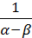 α < x < β
p(x) = 0 otherwise

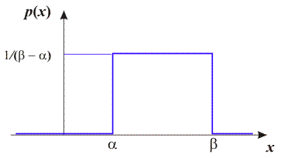
Figure3.8(Uniform distribution density curve)

Table3. 103(Parameters of Parts for uniform (45, 55) distribution)
Name | Part001 | Part002 | Part003
No. Entered | 916 | 665 | 914
No. Shipped | 162 | 161 | 323
No. Scrapped | 0 | 0 | 0
No. Assembled | 0 | 0 | 0
No. Rejected | 0 | 0 | 0
W.I.P. | 754 | 504 | 591
Avg W.I.P. | 394.08 | 265.2 | 311.37
Avg Time | 5937.03 | 5503.31 | 4701.18
Sigma Rating | 6 | 6 | 6

Table3. 104(Parameters of Buffers for uniform (45, 55) distribution)
Name | Buffers001 | Buffers002 | Buffers003 | Buffers004 | Buffers005 | Buffers006
Total Out | 1924 | 1923 | 641 | 276 | 197 | 173
Now In | 500 | 1 | 0 | 163 | 237 | 263
Max | 501 | 2 | 1 | 165 | 241 | 266
Min | 19 | 0 | 0 | 6 | 10 | 5
Total In | 2424 | 1924 | 641 | 439 | 434 | 436
Avg Size | 259.57 | 0.33 | 0.03 | 84.89 | 125.41 | 136.38
Avg Time | 1477.75 | 2.4 | 0.6 | 2668.47 | 3987.8 | 4316.77

Table3. 105(Parameters of Buffers and Stores for uniform (45, 55) distribution)
Name | Buffers007 | Buffers008 | Buffers009 | store1 | store2 | store3
Total Out | 276 | 197 | 173 | 641 | 641 | 1287
Now In | 1 | 0 | 0 | 667 | 0 | 0
Max | 1 | 1 | 1 | 667 | 1 | 5
Min | 0 | 0 | 0 | 25 | 0 | 0
Total In | 277 | 197 | 173 | 1308 | 641 | 1287
Avg Size | 0.18 | 0 | 0 | 346.8 | 0 | 1.13
Avg Time | 8.74 | 0 | 0 | 3658.88 | 0 | 12.14

Table3. 106(Performance parameters of Customers and Distributors for uniform (45, 55) distribution)
Name | customer1 | customer2 | customer3 | distribuitor1 | distribuitor2 | distribuitor3
% Idle | 0.46 | 28.74 | 37.7 | 0 | 0 | 0
% Busy | 99.54 | 71.26 | 62.3 | 50 | 49.96 | 49.94
% Blocked | 0 | 0 | 0 | 50 | 50.04 | 50.06
No. Of Operations | 276 | 198 | 172 | 276 | 197 | 172

Table3. 107(Performance parameters of Machines for uniform (45, 55) distribution)
Name | Machine001 | Machine002 | Machine003 | Machine004 | Machine005
% Idle | 0 | 0 | 56.06 | 65.43 | 100
% Busy | 100 | 100 | 43.94 | 34.57 | 0
No. Of Operations | 2404 | 1924 | 1283 | 1282 | 1282

Table3. 108(Performance parameters of retailers for uniform (45, 55) distribution)
Name | retailer1 | retailer2 | retailer3
% Idle | 0 | 0 | 0
% Busy | 100 | 100 | 100
No. Of Operations | 276 | 197 | 173

3.3.2.16 Case 18 (when the model is run for 14400min with 600min warmup time and cycle time the customer is uniform(90,110)) That is when requirement rate follow uniform distribution. Than we obtained the following data.

Table3. 109(Parameters of Parts for uniform (90, 110) distribution)
Name | Part001 | Part002 | Part003
No. Entered | 918 | 666 | 917
No. Shipped | 105 | 102 | 209
No. Scrapped | 0 | 0 | 0
No. Assembled | 0 | 0 | 0
No. Rejected | 0 | 0 | 0
W.I.P. | 813 | 564 | 708
Avg W.I.P. | 424.7 | 295.03 | 371.83
Avg Time | 6384.44 | 6113.24 | 5595.72
Sigma Rating | 6 | 6 | 6

Table3. 110(Parameters of Buffers for uniform (90, 110) distribution)
Name | Buffers001 | Buffers002 | Buffers003 | Buffers004 | Buffers005 | Buffers006
Total Out | 1924 | 1923 | 641 | 276 | 197 | 173
Now In | 500 | 1 | 0 | 163 | 237 | 263
Max | 501 | 2 | 1 | 165 | 241 | 266
Min | 19 | 0 | 0 | 6 | 10 | 5
Total In | 2424 | 1924 | 641 | 439 | 434 | 436
Avg Size | 259.57 | 0.33 | 0.03 | 84.89 | 125.41 | 136.38
Avg Time | 1477.75 | 2.4 | 0.6 | 2668.47 | 3987.8 | 4316.77

Table3. 111(Parameters of Buffers and Stores for uniform (90, 110) distribution)
Name | Buffers007 | Buffers008 | Buffers009 | store1 | store2 | store3
Total Out | 139 | 138 | 139 | 641 | 641 | 1287
Now In | 142 | 60 | 34 | 667 | 0 | 0
Max | 142 | 60 | 35 | 667 | 1 | 5
Min | 4 | 1 | 0 | 25 | 0 | 0
Total In | 281 | 198 | 173 | 1308 | 641 | 1287
Avg Size | 72.91 | 30.85 | 16.67 | 346.8 | 0 | 1.13
Avg Time | 3580.46 | 2150.33 | 1329.58 | 3658.88 | 0 | 12.14

Table3. 112(Performance parameters of Customers and Distributors for uniform (90, 110) distribution)
Name | customer1 | customer2 | customer3 | distribuitor1 | distribuitor2 | distribuitor3
% Idle | 0 | 0 | 0 | 0 | 0 | 0
% Busy | 100 | 100 | 100 | 50 | 49.96 | 49.94
% Blocked | 0 | 0 | 0 | 50 | 50.04 | 50.06
No. Of Operations | 139 | 138 | 139 | 276 | 197 | 172

Table3. 113(Performance parameters of Machines for uniform (90, 110) distribution)
Name | Machine001 | Machine002 | Machine003 | Machine004 | Machine005
% Idle | 0 | 0 | 56.06 | 65.43 | 100
% Busy | 100 | 100 | 43.94 | 34.57 | 0
No. Of Operations | 2404 | 1924 | 1283 | 1282 | 1282

Table3. 114(Performance parameters of retailers for uniform (90, 110) distribution)
Name | retailer1 | retailer2 | retailer3
% Idle | 0 | 0 | 0
% Busy | 100 | 100 | 100
No. Of Operations | 276 | 197 | 173

3.3.2.18 Case 19 (when the model is run for 14400min with 600min warmup time and cycle time the customer is uniform(135,165)) That is when requirement rate follow uniform distribution. Than we obtained the following data.

Table3. 115(Performance parameters of Part for uniform (135,165) distribution)
Name | Part001 | Part002 | Part003
No. Entered | 918 | 668 | 918
No. Shipped | 70 | 70 | 138
No. Scrapped | 0 | 0 | 0
No. Assembled | 0 | 0 | 0
No. Rejected | 0 | 0 | 0
W.I.P. | 848 | 598 | 780
Avg W.I.P. | 442.61 | 313 | 407.71
Avg Time | 6653.67 | 6466.07 | 6128.9
Sigma Rating | 6 | 6 | 6

Table3. 116(Parameters of Buffers for uniform (135,165) distribution)
Name | Buffers001 | Buffers002 | Buffers003 | Buffers004 | Buffers005 | Buffers006
Total Out | 1924 | 1923 | 641 | 276 | 197 | 173
Now In | 500 | 1 | 0 | 163 | 237 | 263
Max | 501 | 2 | 1 | 165 | 241 | 266
Min | 19 | 0 | 0 | 6 | 10 | 5
Total In | 2424 | 1924 | 641 | 439 | 434 | 436
Avg Size | 259.57 | 0.33 | 0.03 | 84.89 | 125.41 | 136.38
Avg Time | 1477.75 | 2.4 | 0.6 | 2668.47 | 3987.8 | 4316.77
Table3. 117(Parameters of Buffers and Stores for uniform (135,165) distribution)
Name | Buffers007 | Buffers008 | Buffers009 | store1 | store2 | store3
Total Out | 93 | 92 | 93 | 641 | 641 | 1287
Now In | 189 | 107 | 81 | 667 | 0 | 0
Max | 189 | 108 | 81 | 667 | 1 | 5
Min | 6 | 2 | 0 | 25 | 0 | 0
Total In | 282 | 199 | 174 | 1308 | 641 | 1287
Avg Size | 97.34 | 54.72 | 40.13 | 346.8 | 0 | 1.13
Avg Time | 4763.22 | 3794.33 | 3182.35 | 3658.88 | 0 | 12.14

Table3. 118(Performance parameters of Customers and Distributors for uniform (135,165) distribution)
Name | customer1 | customer2 | customer3 | distribuitor1 | distribuitor2 | distribuitor3
% Idle | 0 | 0 | 0 | 0 | 0 | 0
% Busy | 100 | 100 | 100 | 50 | 49.96 | 49.94
% Blocked | 0 | 0 | 0 | 50 | 50.04 | 50.06
No. Of Operations | 93 | 92 | 93 | 276 | 197 | 172

Table3. 119(Performance parameters of Machines for uniform (135,165) distribution)
Name | Machine001 | Machine002 | Machine003 | Machine004 | Machine005
% Idle | 0 | 0 | 56.06 | 65.43 | 100
% Busy | 100 | 100 | 43.94 | 34.57 | 0
No. Of Operations | 2404 | 1924 | 1283 | 1282 | 1282

Table3. 120(Performance parameters of retailers for uniform (135,165) distribution)
Name | retailer1 | retailer2 | retailer3
% Idle | 0 | 0 | 0
% Busy | 100 | 100 | 100
No. Of Operations | 276 | 197 | 173

3.3.2.20 Case 20 (when the model is run for 14400min with 600min warmup time and cycle time the customer is uniform(180,220)) That is when requirement rate follow uniform distribution. Than we obtained the following data.

Table3. 121(Parameters of Parts for uniform (180,220) distribution)
Name | Part001 | Part002 | Part003
No. Entered | 918 | 668 | 919
No. Shipped | 52 | 53 | 104
No. Scrapped | 0 | 0 | 0
No. Assembled | 0 | 0 | 0
No. Rejected | 0 | 0 | 0
W.I.P. | 866 | 615 | 815
Avg W.I.P. | 451.61 | 322 | 425.71
Avg Time | 6788.97 | 6652.14 | 6392.53
Sigma Rating | 6 | 6 | 6

Table3. 122(Parameters of Buffers for uniform (180,220) distribution)
Name | Buffers001 | Buffers002 | Buffers003 | Buffers004 | Buffers005 | Buffers006
Total Out | 1924 | 1923 | 641 | 276 | 197 | 173
Now In | 500 | 1 | 0 | 163 | 237 | 263
Max | 501 | 2 | 1 | 165 | 241 | 266
Min | 19 | 0 | 0 | 6 | 10 | 5
Total In | 2424 | 1924 | 641 | 439 | 434 | 436
Avg Size | 259.57 | 0.33 | 0.03 | 84.89 | 125.41 | 136.38
Avg Time | 1477.75 | 2.4 | 0.6 | 2668.47 | 3987.8 | 4316.77

Table3. 123(Parameters of Buffers and Stores for uniform (180,220) distribution)
Name | Buffers007 | Buffers008 | Buffers009 | store1 | store2 | store3
Total Out | 70 | 68 | 71 | 641 | 641 | 1287
Now In | 213 | 131 | 103 | 667 | 0 | 0
Max | 213 | 131 | 103 | 667 | 1 | 5
Min | 6 | 2 | 1 | 25 | 0 | 0
Total In | 283 | 199 | 174 | 1308 | 641 | 1287
Avg Size | 109.62 | 66.63 | 51.94 | 346.8 | 0 | 1.13
Avg Time | 5345.19 | 4620.33 | 4119.44 | 3658.88 | 0 | 12.14

Table3. 124(Performance parameters of Customers and Distributors for uniform (180,220) distribution)
Name | customer1 | customer2 | customer3 | distribuitor1 | distribuitor2 | distribuitor3
% Idle | 0 | 0 | 0 | 0 | 0 | 0
% Busy | 100 | 100 | 100 | 50 | 49.96 | 49.94
% Blocked | 0 | 0 | 0 | 50 | 50.04 | 50.06
No. Of Operations | 70 | 68 | 71 | 276 | 197 | 172

Table3. 125(Performance parameters of Machines for uniform (180,220) distribution)
Name | Machine001 | Machine002 | Machine003 | Machine004 | Machine005
% Idle | 0 | 0 | 56.06 | 65.43 | 100
% Busy | 100 | 100 | 43.94 | 34.57 | 0
No. Of Operations | 2404 | 1924 | 1283 | 1282 | 1282

Table3. 126(Performance parameters of retailers for uniform (180,220) distribution)
Name | retailer1 | retailer2 | retailer3
% Idle | 0 | 0 | 0
% Busy | 100 | 100 | 100
No. Of Operations | 276 | 197 | 173

- CHAPTER4
Result and Discussion

Figure4.1(Effect of Takt time on number of parts shipped for deterministic case)
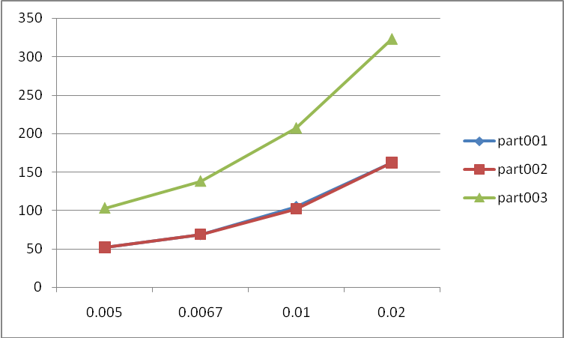
This graph shows that number of parts shipped increases as the takt time increases and increase rate is high in case of part003. Increase in number of parts shipped is because customer demand rate increases. And the rate of increase is almost same part001 and part002. Further it could be analyzed that the percentage increase in takt time is 75% whereas percentage increase in rate of number of parts shipped is 67% for part001 and part002 and is 68% for part003.

Figure4. 2(Effect of Takt time on number of parts shipped for normal distribution)
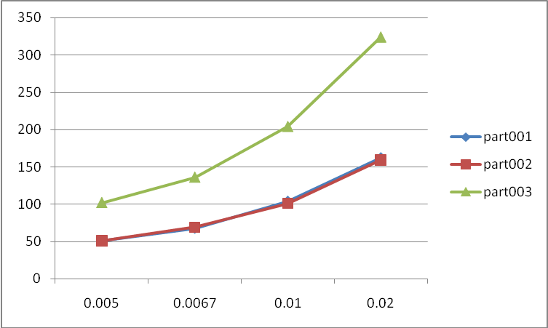
This graph shows that number of parts shipped increases as the demand rate (takt time) of the customer following normal distribution increases and increase rate is high for part003

Figure4. 3(Comparison between total numbers of parts shipped in different distributions)
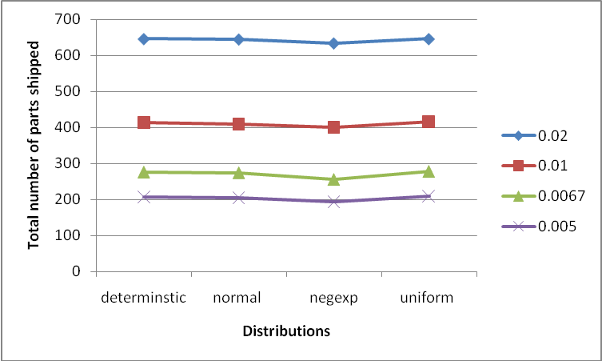
This graph predicts that almost all the distributions have same output except negative exponential distribution which has minimum output.

Figure4. 4(Effect of Takt time on percentage busy of customers)
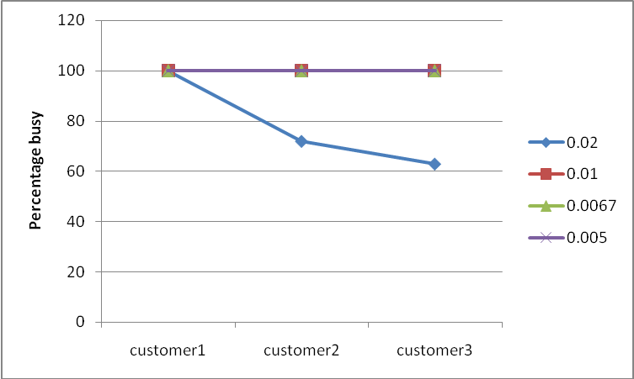
Here in this graph we could see that all the customer remain 100%busy for all cases except for case when the takt time is 0.02 that is when requirement rate is 1 part in 50 min. And this analysis remain same for both determinstic as well as probabilistic model. For takt time 0.01,0.0067,0.005 all customers remain 100%busy but the number of operations done by them increases as takt time decreases.

Figure4. 5(Effect of takt time on size of buffers required for deterministic case)
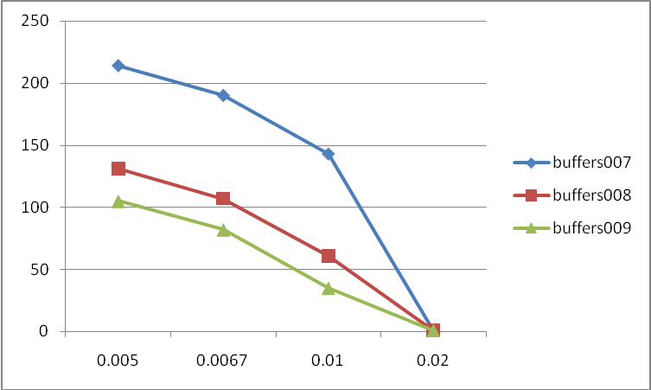
The above graph shows the maximum size of buffers require for different takt time of customer It can also been seen that as the takt time increases buffer size decreases and decrease rate is much high in case of buffers007. It can be predicted that for a given takt time buffers007 must have the maximum size.

Figure4. 6(Effect of takt time on size of buffers007 required for different distributions)
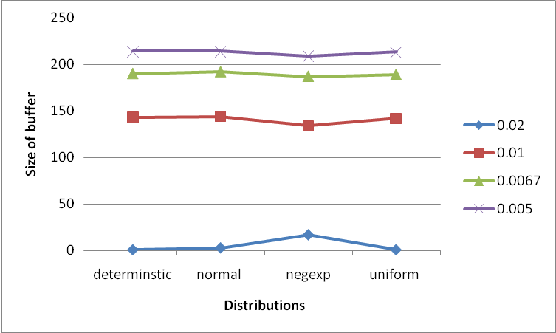
The above graph shows the maximum size for buffers007 require for different distribution. This graph shows that the size of buffers007 require is almost same for all distribution except negative exponential, which is large if takt time is 0.005 and is less if takt time is .0067,.001,.002 as compare to other.

Figure4. 7(Effect of takt time on size of buffers008 required for different distributions)
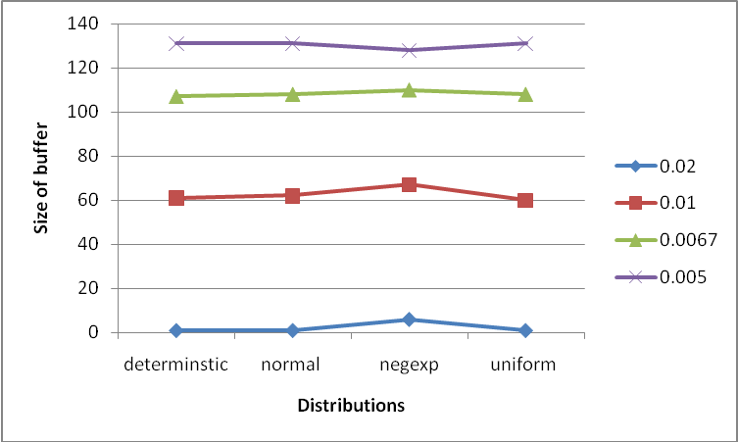
This graph shows that maximum size buffers008 require almost remain same but there is deflection in case of negative exponential distribution.

Figure4. 8(Effect of takt time on size of buffers009 required for different distributions)
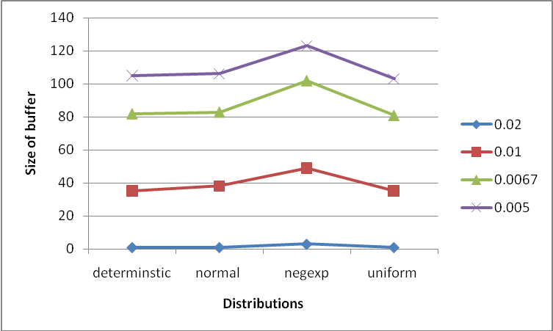
This graph shows that the buffers009 size required for different requirement rate of the customer remain almost same for different distribution but is high for negative exponential distribution for all takt time. And it could also interpret that for demand rate 1 part in 100 minutes (I.e. takt time .01) there is much deflection.
- CHAPTER 5
Conclusion and Scope for Future Work

This present report shows the results of a simulation study of Job shop production system. “WITNESS2006” simulation package was used for this study since it offers sufficient flexibility. The study deals with the performance evaluation of the system under different condition (e.g. run time). Some interesting results have been observed through extensive simulation experiments. The following conclusion can be drawn from the study:

- Simulation is a useful and powerful tool for manufacturing system analysis and evaluation. Very important information can easily be generated from simulation runs. It may be difficult to acquire the same information if other analysis tools were used.
- We could analyze that for the model we studied the customer requirement rate following the negative exponential give the minimum output. That is the number shipped by the system.
- This simulation study shows that number of buffers used and their size is an important factor to consider in system. Optimal number and size is obtained for each case in the model. And the buffers size require for the in process inventory very fluctuating for the negative exponential distribution.
- Flow of materials in the system should neither block nor congested. But in our case study we could see that distributor1, distributor 2 and distributors3 are blocked for this we need to double the all retailer. That is needed to have two retailers instead of one at each place.
- The extension of this experiment can be taken to minimize the makespan of any given job shop system through Witness simulation package.

- CHAPTER 6

References
- Akpan, E. (1996). Job shop sequencing problems via network scheduling technique. International Journal of Operations and Production Management, 16 (3), pp 76–86.
- Ashour, S., Moore. T.E., and Chin, K.-Y. (1974), " An implicit enumeration algorithm for the non pre-emptive shop scheduling problem", AIIE Transactions 6, 62-72
- Baker, K.R., Magazine, M.J., and Nuttle, H.L.W. (1986). The effect of commonality on safety stocks in a simple inventory model. Management Science, 32 (8), pp. 982–988.
- Balas, E. (1969), "Machine sequencing via disjunctive graphs: An implicit enumeration algorithm", Operations Research 17,941-957.
- Bianco, L., Dellolmo, P., Giordani, S., and Speranza, M.G. (1999). Minimizing makespan in a multimode multiprocessor shop scheduling problem. Naval Research Logistics, 46, pp 895–911.
- Brooks, G.H., and White, C.R. (1965), " An algorithm for finding optimal or near-optimal solutions to the production scheduling problem", Journal of Industrial Engineering 16, 34-
- Browne, J., Dubois D., Rathmill, K., Sethi P., and Stecke, K.E. (1984). Classification of flexible manufacturing systems. The FMS Magazine, pp 114–117.
- Brucker, P., Thomas, H., and Hurink,J. (1997). A branch and bound algorithm for single machine scheduling problem with positive and negative time lags. Discrete applied mathematics, 94, pp 77-99.
- Chen, L.-H., & Chen, Y.-H. (1996). A design procedure for a robust job shop manufacturing system under a constraint using computer simulation experiments. Computers and Industrial Engineering
- Farely, G.A., (1997), “Discovering supply chain management : a roundtable discussion ”, American production and inventory control society – The performance advantage, vol 7(1), pp 38-39.
- Florian, M., Trtpant, P., and McMahon, G. (1971), " An implicit enumeration algorithm for the machine sequencing problem", Management Science 17, B782-B792.
- Fonseca, D.J., Navaressa, D.O., and Moynihan, G.P. (2003). Simulation metamodeling through artificial neural network. Engineering application of artificial intelligence, 16, pp 177-183.
- Gerchak, Y., and Henig, M. (1986). An inventory model with component commonality. Journal of Operation Research, 5, pp 157–160.
- Giffier, B., and Thompson, G.L. (1960), "Algorithms for solving production scheduling problems", Operations Research 8,487-503
- Goldam, L., Nagel, R.L., and Presis. (1995). Agile Competitors and Virtual Organizations - Strategies for Enriching the Customer.
- Greenberg, H.H. (1968), '°A branch and bound solution to the general scheduling problem", Operations Research 16, 353-361
- Guinet, A. (2000). Efficiency of reductions of job shop to flow shop problems. European Journal of Operational Research, 125, pp. 469–485.
- Gupta, A. B., and Singh, T.P. (2001). Flexibility in an Automobile Manufacturing Enterprise. Global Journal of Flexible systems Management.
- Habch, G., and Labrune, (1995). Study of lot sizes on job shop systems performance using simulation. Simulation practice and Theory, 2, pp 277-289.
- Haibin,Y., and Wie. L. (2001). Neural network and genetic algorithm based hybrid approach to job expanded job shop scheduling. Computer and industrial engineering, 39, pp 337-356.
- Huang, P.Y., Rees, L.P. and Taylor, B.W. (1983). A simulation analysis of the Japanese just-in-time technique (with Kanbans) for a multiline, multistage production system, Decision Sciences, 14, pp 326–344.
- Jeong, B.H., and Randhawa. S.U. (2001). A multi-attribute dispatching rule for automated guided vehicle systems. International Journal of Production Research, 39, pp. 2817–2832.
- Kaplan, A.M., and Haenlein, M. (2006). Toward a parsimonious definition of traditional and electronic mass customization. Journal of Product Innovation Management, 23, pp 163-182.
- Kuroda, M., and Kawada, A. (1999). Adaptive input control for job shop type production systems with varying demand using inverse queuing network analysis. International Journal of Production Economics, 41, pp 217-225.
- Lageweg, B., Lenstra, J.K., and Rinnooy Kan, A,H.G. (1977),"Job-shop scheduling by implicit enumeration", Management Science 24, 441-450.
- Mahadevan, B., and Narendran, T.T. (1994). A hybrid modeling approach to the design of an AGV-based material handling system for an FMS, International Journal of Production Research, 32, pp 2015–2030.
- Mamalis, A.G., and Malagardis, I. (1996). Determination of due dates in job shop scheduling by simulated annealing. Computer Integrated manufacturing Systems, 9, pp 65-72.
- Mayer, M., and Nusswald, M. (2001). Improving manufacturing costs and lead time with quality oriented operating curves. Journal of Material Processing Technology, 119, pp 83-89.
- Mekler, V.A. (1993). Set-up cost reduction in the dynamic lot-size model. Journal of Operations Management, 11, pp 35-43.
- Monch, L., and Driebel, R. (2005). A distributed shifting bottleneck heuristic for complex job shops. Computer and Industrial Engineering, 49, pp 363-380.
- Mohanty, R.P., and Deshmukh, S.G., (2004), “A study on implementation of supply chain management in India”, Working paper.
- Mohanty, R.P., and Deshmukh, S.G., “Supply chain management: theories and practices”, 2005 – edition, Biztantra Publication, Delhi
- Nejati, M. (1998). Press shop modelling in automobile manufacturer industry by computer simulation. MS Eng Thesis. Faculty of engineering, University of Tehran (in Persian).
- Pinedo, M. (2001). Scheduling theory, algorithms and systems (2nd ed.). Englewood Cliffs, NJ: Prentice-Hall.
- Tavakkoli.R., Moghaddam., and Daneshmand, M. (2005). A computer simulation model for job shop scheduling problems minimizing makespan. Computer and Industrial Engineering, 48, pp 811-823
- Thomas, J.D. and Grifin, P.M., (1996), “Coordinated supply chain management”, European Journal of Operation Research, vol 94, pp 11-15.
- Tsuyoshi Satake, Katsumi Morikawa, Katsuhiko Takahashi, Nobuto Nakamura(1999). Simulated annealing approach for minimizing the makespan of the general job-shop
- Villeda, R., Dudek, R., and Smith, M.L. (1988). Increasing the production rate of a just-in-time production system with variable operation times. International Journal of Production Research, 26, pp 1749–1768.

