A
DISSERTATION REPORT
On

ANALYSIS OF A STRUCTURE SUPPORTED BY ELASTIC FOUNDATION
Submitted to
DELHI COLLEGE OF ENGINEERING DELHI
In partial fulfillment of the requirement for the Degree of

MASTER OF ENGINEERING
IN
STRUCTURAL ENGINEERING

Under the supervision of: Submitted By:
Dr. A.K.GUPTA ANURAG GUPTA
Assistant Professor M.E. (STRUCTURE ENGG.)
Dept. of CIVILENGG. ROLL.NO.06/STR/05
DELHI - 110042

DEPARTMENT OF CIVIL ENGINEERING,
DELHI COLLEGE OF ENGINEERING
DELHI
2005-07

DEPARTMENT OF CIVIL ENGINEERING
DELHI COLLEGE OF ENGINEERING
DELHI-110042

CERTIFICATE

This is to certify that the dissertation report entitled “ANALYSIS OF STRUCTURE SUPPORTED BY ELASTIC FOUNDATION which is being submitted by ANURAG GUPTA, in partial fulfillment for the award of the degree of Master of Engineering in Structural Engineering from the Delhi College of Engineering Delhi, is a bonafide work done by him under my guidance and supervision.

(Dr. A. K. GUPTA)
Astt. Professor
Dept. of CIVIL Engineering,
D.C.E.
DELHI-110042

ACKNOWLEDGEMENT

I feel immense pleasure in conveying my heartiest thanks and profound gratitude to my learned guide Dr. A. K. GUPTA, Professor, Department of CIVIL Engineering, DELHI COLLEGE OF ENGINEERING, DELHI who at the cost of his precious time, provided me with his generous guidance, valuable help and endless encouragement by taking personal interest and attention. No words can fully convey my feelings of respect and regard for him.
I would also like to express my gratitude towards PROF. S. K. SINGH, Head, Department of CIVIL Engineering, for allowing me to work on this topic and providing a conducive environment to facilitate this study.
I conclude this acknowledgement by thanking all those, who have directly and indirectly helped me during the course of this project.

ANURAG GUPTA

CONTENTS

 | Acknowledgement | iii
 | Abstract | iv
 | List of Tables | vii
 | List of Figures | viii
1. | INTRODUCTION | 1-2
 | 1.1 Soil – Structure Interaction | 1
 | 1.2 Objective of the Study | 2
2. | PREVIOUS WORK | 3-5
3. | TYPES OF FOUNDATION MODELS | 6-10
 | 3.1 Winkler Model | 6
 | 3.1.1 Description of the Winkler Model | 7
 | 3.2 Two-Parameter Model | 8
 | 3.3 Pasternak Model | 9
 | 3.4 Timoshenko Model | 10
4. | MODULUS OF SUBGRADE REACTION | 11-17
 | 4.1 Definition | 11
 | 4.2 Determination of Modulus of Subgrade Reaction | 13
5. | PROBLEM DEFINITION AND STRUCTURAL MODELLING | 18-24
 | 5.1 Structural Model | 18
 | 5.2 Supporting Soil | 20
 | 5.3 Design Loads: | 21
 | 5.3.1 Dead Load (IS: 875 – 1987 Part I) | 21
 | 5.3.2 Imposed Load (IS: 875 – 1987 Part II) | 21
 | 5.3.3 Seismic Load (IS: 1893 – 2002) | 21
 | 5.4 Seismic Load Calculation by STAAD | 23
 | 5.5 Load Combinations | 23
6. | SETTLEMENT OF RAFT SLAB | 25-28
7. | RESULTS AND DISCUSION | 29-52
 | 7.1 Bending Moments | 30
 | 7.1.1 Bending Moments for Exterior Column | 30
 | 7.1.2 Bending Moments for Interior Column | 32
 | 7.1.3 Bending Moments at Support of Beam connected with Ext. Column | 34
 | 7.1.4 Bending Moments at Support of Beam connected with Int. Column | 37
 | 7.2 Storey Drift | 40
 | 7.2.1 Storey Drift noted along height of Exterior Column | 42
 | 7.2.2 Storey Drift noted along height of Interior Column | 44
 | 7.4 Bending Moments in the Raft Slab along X-Direction | 49
8. | CONCLUSIONS AND RECOMMENDATIONS | 53-55
 | 8.1 Conclusions | 53
 | 8.2 Recommendations | 55
 | REFERENCES / BIBLIOGRAPHY | 56-57

ABSTRACT

This study presents an analysis of beams, columns and raft, in a multistoried building structure, supported by elastic foundation. The structure is analyzed using STAAD pro software for three different values of modulus of subgrade reaction ‘K’ pertaining to different soil types, and it has been compared with the structure having fixed supports representing rigid base.

The analysis highlights the fact that significant alteration of displacements, design forces and moments occur in the beams, columns and raft. The analysis also brings out the fact that settlement in a raft foundation depends on the stiffness of the soil. The settlement of raft at different values of modulus of subgrade reactions were analysed and compare with rigid support raft. It was concluded that as the modulus of subgrade reaction values increases, the settlement of raft decreases.

The objective of this research is to develop a workable approach for the analysis of plates on elastic foundations that will provide the designer with realistic stress values for use in The design of the plate or, more specifically, reinforced concrete raft slabs.

Further, the objective of the study is also to developed not only a realistic procedure for the analysis of plates on elastic foundation, but a practical and easily applied procedure as well. Hence in order to incorporate the elasticity of soil that will provide approximate solution as close to practical design problem, the analysis is carried out using software STAAD Pro.
LIST OF TABLES

Table
4.1 | Values of modulus of subgrade reaction K | 16
7.1 | Bending moments in exterior column for EQX | 30
7.2 | Bending moments in exterior column for 1.5(DL+LL) | 31
7.3 | Bending moments in interior column for EQX | 32
7.4 | Bending moments in interior column for 1.5(DL+LL) | 33
7.5 | Bending moments in exterior beam for EQX | 34
7.6 | Bending moments in exterior beam for 1.5(DL+LL) | 35
7.7 | Bending moments in exterior beam for 1.2(DL+LL+EQX) | 36
7.8 | Bending moments in interior beam for EQX | 37
7.9 | Bending moments in interior beam for 1.5(DL+LL) | 38
7.10 | Bending moments in interior beam for 1.2(DL+LL+EQX) | 39
7.11 | Storey drift along exterior column for EQX | 42
7.12 | Storey drift along exterior column for 1.2(DL+LL+EQX) | 43
7.13 | Storey drift along interior column for EQX | 44
7.14 | Storey drift along interior column for 1.2(DL+LL+EQX) | 45
7.15 | Settlement of raft with spring support K=10000, for load case of 1.5(DL+LL) | 47
7.16 | Settlement of raft with spring support K=45000, for load case of 1.5(DL+LL | 47
7.17 | Settlement of raft with spring support K=90000, for load case of 5(DL+LL) | 48
7.18 | Settlement of raft slab with fixed support for load case of 1.5 (DL+LL) | 48

LIST OF FIGURES

3.1 | Deformation of a uniformly loaded plate, using the Winkler model | 8
3.2 | Illustration of the assumption of various methods for providing for | 8
 | interaction among the foundation spring elements
3.3 | Element of Timoshenko beam on elastic foundation | 10
4.1 | Modulus of subgrade reaction (K) | 11
4.2 | Determination of modulus of subgrade reaction | 12
5.1 | Plan of the structure | 18
5.2 | 3D – View of the structure | 19
5.3 | Partial plan of the raft with Spring Supports | 20
5.4 | Layout of Raft Slab with Finite Number of Plates Supporting Columns | 20
6.1 | Settlement of Raft Slab with Spring Support for load case of 1.5 (DL+LL) load | 28
6.2 | Settlement of Raft Slab with Fix Support for load case of 1.5 (DL+LL) load | 28
7.1 | BMD for seismic force in X-direction | 29
7.2 | Bending moment variation in exterior column for EQX load | 30
7.3 | Bending moment variation in exterior column for 1.5 (DL+LL) load | 31
7.4 | Bending moment variation in interior column for EQX load | 32
7.5 | Bending moment variation in interior column for 1.5 (DL+LL) load | 33
7.6 | Bending moment variation in exterior beam for EQX load | 34
7.7 | Bending moment variation in exterior beam for 1.5 (DL+LL) load | 35
7.8 | Bending moment variation in ext. beam for 1.2 (DL+LL+EQX) load | 36
7.9 | Bending moment variation in interior beam for EQX load | 37
7.10 | Bending moment variation in interior beam for 1.5 (DL+LL) load | 38
7.11 | Bending moment variation in int. beam for 1.2 (DL+LL+EQX) load | 39
7.12 | Deflected shape of the structure with fixed & spring supports for EQX | 41
7.13 | Storey drift along height of exterior column for EQX load | 42
7.14 | Storey drift along height of ext. column for 1.2 (DL+LL+EQX) load | 43
7.15 | Storey drift along height of interior column for EQX load | 44
7.16 | Storey drift along height of int. column for 1.2 (DL+LL+EQX) load | 45
7.17 | Settlement of raft slab with spring support for load case of 1.5(DL+LL) | 46
7.18 | Settlement of raft slab with fixed support for load case of 1.5(DL+LL) | 46
7.19 | BM variations in raft slab for k = 10000 kN/m³ in EQX loading case | 50
7.20 | BM variations in raft slab for k = 45000 kN/m³ in EQX loading case | 50
7.21 | BM variations in raft slab for k = 95000 kN/m³ in EQX loading case | 51
7.22 | BM variations in raft slab for fixed supports in EQX loading case | 51
7.23 | BM variations in raft slab for k = 10000 kN/m³ in 1.2(DL+LL+EQX) | 52
7.24 | BM variations in raft slab for k = 45000 kN/m³ in 1.2(DL+LL+EQX) | 52
7.25 | BM variations in raft slab for k = 95000 kN/m³ in 1.2(DL+LL+EQX) | 53
7.26 | BM variations in raft slab for fixed supports in 1.2(DL+LL+EQX) | 53

Chapter 1

INTRODUCTION

1.1 Soil – Structure Interaction
Successful application of the principles of structural engineering are directly linked to the ability of the engineer to model the structure and its support conditions in order to perform an accurate analysis and thereby a correct design. Soil is a very complex material for the modeling. It is very difficult to model the soil-structure interaction problem and hence arriving at a realistic model is complicated in foundation analysis.
In particular, concrete building slabs, supported directly by the soil medium, is a very common construction system. It is used in residential, commercial, industrial, and institutional structures. In some of these structures, very heavy slab loads occur, such as in libraries, grain storage buildings, warehouses, etc… A mat foundation, which is commonly used in the support of multi-story building columns, is another example of a heavily loaded concrete plates supported directly by the soil medium. In all these structures, it is very important to be able to compute plate displacements and consequent stresses with an acceptable degree of accuracy in order to ensure a safe and economical design.
Ultimately, all structural loads must be transferred to the supporting soil medium, and both the structure to act together to resist and support the loads. The integral nature of the foundation and soil actions is further complicated by the complexity of the soil medium itself. Soil is truly a non-homogeneous and an anisotropic medium that behaves in a non linear manner, while concrete and steel structures can be adequately modeled and analyzed, assuming isotropic and linear behavior. In addition, the properties of structural building materials are well known so that the stiffness of the structure may be readily determined from the given member sizes and structure geometry.
On the other hand, soil properties are very difficult to determine because in addition to the previously mentioned characteristics, it is a soft material, which makes it very difficult to obtain samples for testing that will produce laboratory results paralleling its actual in-ground behavior. Among other problems, the type of soil affects the ability to obtain representative samples. Variations in sampling techniques among laboratories further complicate the problem. Two additional complicating factors are soil material properties are stress dependant, and the soil continuum will in practice consists of layers of materials with different constitutive relations and material properties. Because of these factors, the true properties and constitutive relations of the soil continuum are essentially unknown and indeterminable. As a result, it is necessary to make a number of simplifying assumptions to analyze the soil-structure interaction.
1.2 Objectives of the Study
The major objective of this research is to develop a workable approach for the analysis of plates on elastic foundations that will provide the designer with realistic stress values for use in the design of the plate or, more specifically, reinforced concrete raft slabs.
One of the primary goals of the study is to develop not only a realistic procedure for the analysis of plates on elastic foundation, but a practical and easily applied procedure as well. The solution of this type of soil engineering problem, which involves equilibrium equations together with constitutive relations, compatibility considerations, and complex boundary conditions, would require such an effort that a purely mathematical and theoretical approach is impractical and that’s why structural engineers go for simplified assumption of rigid foundation.
Hence in order to incorporate the elasticity of soil that will provide approximate solutions as close to the exact solutions as required for practical engineering design problems, the analysis is carried out using universally used software STAAD Pro. In this analysis, to model elastic foundation three different values of modulus of subgrade reaction k have been chosen and then the results from each analysis is compared with that of the fixed supports analysis.

Chapter 2

PREVIOUS WORK

In the work done by X. P. Shi, S. A. Tan, and T. F. Fwa (1994), the thick-plate equations and their solution for the problem concerning the bending of a rectangular plate with four free edges resting on the Pasternak foundation are described. They used the basic equations obtained from Reissner's 1945 theory, and are modified to include the Pasternak foundation. The solutions of the basic equations are arrived at by superposing the solutions of three elemental plates, one with four guided support edges, the other two with two guided support edges and two free edges acted upon by an unknown bending moment. They have examined the solution for convergence and validation with the help of numerical examples. It shows that the presented solution can be used as a good mechanical model for the analysis of the plate structures supported by elastic foundation, where the transverse shear deformation and the local effects in the plates and the transverse connection in the foundation must be considered.
A simplified structural analysis model for mat foundation with grid beam as stiffeners was presented by Gin-Show Liou and S. C. Lai (1996). In this model, they assumed that the mat foundation is supported by Winkler type of subgrade reaction springs. They used yield-line theory of slab to lump the Winkler springs under slabs to the corresponding locations under the adjacent floor beams of the slabs. The total analysis model for mat foundation was simplified to be a grid beam system on an elastic foundation with a segmental linear varied spring constant, which is subjected to loadings from the columns of the building structure. Gin-Show Liou and S. C. Lai showed that the proposed analysis model can be easily implemented to a computer program, and the results are quite close to those by the finite-element analysis.
The behavior of flexible rectangular plates resting on tensionless elastic foundation has been analyzed by Ramesh C. Mishra and Sekhar K. Chakrabarti (1996) using finite-element method (FEM) technique. A nine-noded Mindlin element has been adopted for modeling the plate to account for transverse shear effects. They found that in case of small ratio of plate dimension to thickness, the shear effect dominates, and deflections are highly underestimated if analyzed assuming thin plate behavior. The contacting region is only dependent on the relative stiffness and plate thickness.
Using non-dimensional parameters for the analysis of a slab on a layered soil medium, Ayse T. Daloglu and C. V. Girija Vallabhan (2000) developed a method to evaluate an equivalent modulus of subgrade reaction K to be used in the Winkler model. Here, a constant value of Poisson’s ratio for the soil, ns = 0.25 is used. Graphs are provided from which an equivalent value of K can be computed as soon as the complete geometry and the properties of the overall system are known. According to Ayse T. Daloglu and C. V. Girija Vallabhan, if one uses a constant value of the modulus of subgrade reaction for a uniformly distributed load, the displacements are uniform and there are no bending moments and shear forces in the slab. They have suggested that in order to get realistic results, higher values of K have to be used closer to the edges of the slab.
Jian-Hua Yin (2000) has derived governing ordinary differential equations for a reinforced Timoshenko beam on an elastic foundation. While deriving the expressions for calculating the overall bending stiffness and shear stiffness of the reinforced beam, the location, tension stiffness, and shear stiffness of the reinforcement have been taken into consideration. An analytical solution is obtained for a point load on an infinite Timoshenko beam on an elastic foundation. Special attention is paid to the calculation of settlement and reinforcement tension. A finite-element (FE) model is established for the same infinite beam problem. Results from the proposed TB model (Timoshenko beam on elastic foundation) are compared with results from the FE model and the PB model (Winkler model based on pure bending beam theory). Based on results obtained, Jian-Hua Yin proved that the TB model, predicts larger settlement and less tension force in the distance at or near the point load, as compared with the PB model. The differences between results from the TB model and the PB model are large. However, the results from the TB model are comparable to results from the FE model. He also found that the TB model and its solution for an infinite beam on an elastic foundation under point load can be used to calculate the settlement/deflection of the beam and reinforcement tension and are far more efficient than FE modeling for the same problem. According to Jian-Hua Yin, the TB model is superior over the Winkler foundation model.
L. T. Stavridis (2002) has represented the interaction of an arbitrary structure with its foundation soil by representing the stratified soil with the end of a linear elastic half space model with specific geometrical and elastic properties for its layers. The proposed procedure is based on a purely analytical treatment of the underlying soil model, as well as on the use of a structural model with fictitious supports inserted at the contact nodes of the foundation elements with the soil surface. The analysis of the structural model was carried out with the use of a general purpose finite element program. This approach provides a flexible framework to perform parametric studies to include the variability of soil properties. L. T. Stavridis concluded that in the case of flexible beams resting on stiff soil and loaded by a limited number of concentrated loads, the differences in the bending response are practically insignificant.
It is commonly accepted that for the analysis of problem of beams on elastic foundation, Timoshenko beam theory is more accurate than the Bernoulli-Euler theory. On the other hand, the Winkler hypothesis is extensively used by research workers because of its simplicity. A summary of foundation models introduced by numerous investigators is given by Kerr (1964).

Chapter 3

TYPES OF FOUNDATION MODELS

The behavior of plate-foundation systems is a complex phenomenon. In order to simplify the problem, the plate-foundation system is idealized as a thin elastic plate resting on a linearly elastic foundation. A number of models have been developed for describing the behavior of the linearly elastic foundations. But one of the important questions is what type of foundation model should be chosen. Different types of foundation models used by investigators are as follows:
- Winkler Model
- Two-Parameter Model
- Pasternak Model
- Elastic Half-Space Model
Winkler model and two-parameter model are most commonly used by the research workers.
3.1 Winkler Model
Winkler first studied the beam on elastic springs. The model he developed is known as Winkler foundation model. This model is the oldest and simplest elastic foundation model. The beam in Winkler foundation model is based on the pure bending beam theory commonly used in structural analysis. In this model it is assumed that the displacement at any point on the surface of the foundation is directly proportional to the foundation surface pressure acting at that point and is independent of pressure applied at other locations. The Winkler foundation model is advantageous in obtaining fast solutions to more complicated structure/soil interaction problem. However Winkler foundation model has two major limitations:

- No interaction between the springs is considered.
- The spring constant may depend on a number of parameters, such as stiffness of beam, geometry of beam, soil profile, and behavior.
Despite of these two major limitations, the Winkler foundation model has found the application in the analysis of soil/structure interaction problems, e.g., footings on soil, lateral loaded piles in soil.
Winkler has proposed a very popular method of modeling the soil-structure interaction. In this method, the vertical translations of the soil ‘w’, at a point is assumed to depend only upon the contact pressure ‘p’, acting at the point in the idealized elastic foundation and a proportionality constant, K.
p = Kw………..…………………………… (3.1)
The proportionality constant, K, is commonly called the modulus of subgrade reaction. The model was first used to analyze the deflections and resultant stresses in railroad tracks. In the intervening years, it has been applied to many different soil-structure interaction problems.
3.1.1 Description of the Winkler Model
Application of the Winkler model involves the solution of a fourth-order differential equation. For plates, the equation to be solved is of the form
$D∇^{4}w+\text{Kw}=q$ …………...…….…..………… (3.2)
where, D = the plate flexural rigidity
k = the modulus of subgrade reaction
q = the pressure on the plate
The model consists of linearly elastic springs with a stiffness of “K”, placed at discrete intervals below the plate, where K is the modulus of subgrade reaction of the soil. The model is also frequently referred to as a “one parameter model”.
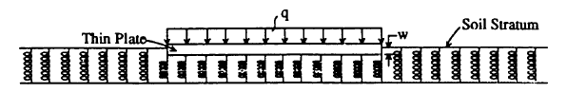
Fig. 3.1 Deformation of a uniformly loaded plate, using the Winkler model
3.2 Two-Parameter Model

Two-parameter models are defined by two independent elastic constants, one of which describes the interaction among the separated springs. Various ways are used to develop the connection among the springs in the two-parameter models such as an elastic membrane in the Filonenko Borodich model, an elastic thin plate in the Hetenyi model and an elastic shear layer in the Pasternak model.
As mentioned earlier, several researchers, recognizing the inherent problems with the Winkler model, attempted to make the model more realistic by assuming some form of interaction among the spring elements that represent the soil continuum.
Filonenko-Borodich (1940) developed a model that improved upon the Winkler model y connecting the top ends of the springs with an elastic membrane stretched to a constant tension, T. Refer to Fig. 2.
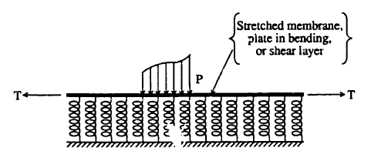
Fig. 3.2 Illustration of the assumption of various methods for providing for interaction among the foundation spring elements.
In this model, the modulus of subgrade reaction is given by:
…………..….…...…………… (3.3)
Where, is the Laplace operator, and all other terms were previously defined. However, no method is provided for the computation of k and T.
Hetenyi (1964 and 1950) created an interaction among the springs in the foundation by imbedding an additional plate with flexural rigidity, D*, in the Winkler foundation in a manner shown in Fig. 1.2. According to this model, the modulus of subgrade reaction is given by:
……………….….…..……… (3.4)
Where, all terms have been previously defined. However, no method is provided for determining the values of k and D*.
Pasternak (1954) improved upon the Winkler model by connecting the ends of the springs to a plate, or “shear layer,” consisting of incompressible, vertical elements, which can deform only by lateral shear. According to this model, the modulus of subgrade reaction is given by:
……………..…….…..…..…… (3.5)
Even though “G” represents the shear modulus of the elastic foundation, no unique method is provided for the determination of K.
3.3 Pasternak Model
Pasternak foundation model suggested by Pasternak is a pure shearing model for the analysis of beams on elastic foundation. In the Pasternak model, no bending is considered, and the settlement is totally controlled by shear deformation of the beam. The concept of Pasternak model was originally proposed for a soil model in order to improve the discontinuities of vertical displacements between adjacent springs of the Winkler model by Pasternak.
3.4 Timoshenko Model
Another foundation model used for the solution of beam on elastic springs is derived by Timoshenko which is based on the Timoshenko beam theory. This model proposed by Timoshenko considers both bending and shearing.

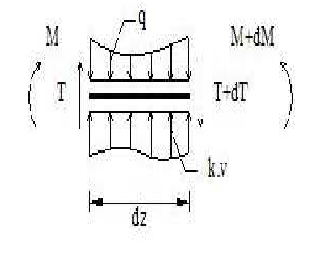
Fig. 3.3 Element of Timoshenko beam on elastic foundation
The Timoshenko beam model attracts the attention of research workers than the Winkler model and Pasternak model. Timoshenko beam model has applications for structure/soil interaction analysis especially for geosynthetic/fiber-glass reinforcement in foundation soils.

Chapter 4

MODULUS OF SUBGRADE REACTION
4.1 Definition
The modulus of subgrade reaction is a relationship between soil pressure and deflection that is widely used in structural analysis of foundation members. It is used for continuous footings, mats and various types of piling. The modulus of subgrade reaction is calculated from plate load test using following equation
…………………...…..…..…………. (4.1)
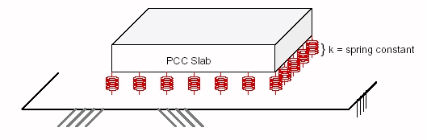
Fig. 4.1 Modulus of subgrade reaction (K)
The modulus of subgrade reaction is determined from plate load test data from the plots of q versus δ shown in Fig. 4.2 (b). If this type of curve is used to obtained K in the above equation, it is evident that the value depends on whether it is a tangent or secant modulus and the location of the coordinates of q and δ.
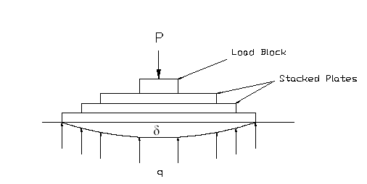
(a) Arrangement of Plate Load Test
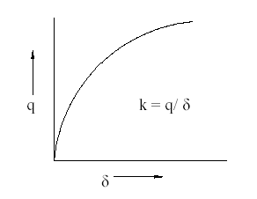
(b) Plot of q v/s δ
Fig. 4.2 Determination of modulus of subgrade reaction
It is difficult to make a plate load test, except for very small plates because it is impracticable to provide reaction load of more than 400 kN. Even with small plates of say 450, 600, and 750 mm diameter it is difficult to obtain δ since the plate tends to be less than rigid so that it becomes difficult to obtain a constant deflection across the plate. Stacking the smaller plates concentric with the larger ones tends to increase the rigidity, but in any case the plot is of load divided by plate contact area and the average measured deflection.
We can divide the q-δ curve into several regions so that K takes the value of the slope in the several regions. However, this tends to more accurate results but most analysis proceeds on the basis of estimated values or at best an approximate load test. Sometimes a plot of q versus δ may also be called a p-y curve, which is generally taken for a strip where q is pressure/ unit of length.
A number of persons do not like to use the concept of a modulus of subgrade reaction. Instead of using modulus of subgrade reaction, use of modulus of elasticity (Es) and Poisson’s ratio (u) in Finite Element Analysis is preferred by most research workers. Due to its greater ease of use and the substantial saving in computer computation time, the modulus of subgrade reaction method is becoming popular.

4.2 Determination of Modulus of Subgrade Reaction
The solution of problems of plates on elastic foundation involves tremendous computational difficulties. In addition to that the relative difficulties involved in estimating value of modulus of subgrade reaction K, the concept of elastic foundation has not enjoyed by practicing engineers.
Determination of the numerical value of modulus of subgrade reaction ‘K’ is a major problem. Numerous researchers have worked on developing techniques for the determination of K. However, Terzaghi has contributed significantly for calculating the value of modulus of subgrade reaction. His work showed that the value of k depends upon the dimensions of the area acted upon by the subgrade reaction, and he incorporated size effects in his equations. He has proposed that K for full sized footing could be obtained from the plate load tests using the following equations:
For footing on clay:
K = k₁ x B_{f}………….…….…..…..…………. (4.2)
For footings on sand (including size effect)
………………….…..…..…….. (4.3)
For a rectangular footing on sand of dimensions b x mb
………………….…..…..……. (4.4)
where,
K = desired value of modulus of subgrade reaction for full sized footings
k₁ = value of k from a plate load test.
B_{f} = footing width
Boit showed the problem of an infinite beam with a concentrated load resting on a three-dimensional subgrade by evaluating the maximum bending moment in the beam. He found that he could obtain a good correlation with the Winkler model for the maximum moment case by setting value of K as follows:
………………....….. (4.5)
Where,
Es = modulus of elasticity of the soil
v_{s} = Poisson’s ratio of the soil
B = modulus of elasticity of the beam
I = moment of inertia of the beam
Later work by Vesic (1961) showed that K depends upon the stiffness of the soil, as well as the stiffness of the structure, so that similar size structures of different stiffness will yield different values of K for the same applied load. Vesic’s work extended Boit’s solution by providing the distribution of deflection, moment, shear and pressure along the beam. When Vesic divided the pressure along the beam be deflection at the same point along the beam, he found the ratio between the two to be nearly constant. He found the continuum solution correlated with the Winkler model by setting
…………………….…….... (4.6)
where all terms were previously defined.
Value of Es can be computed from the number of blow counts, N as follows:
Es = 500 x (N + 15) ... for sands
Es = 1200 x (N + 6) ... for gravels
Since the twelfth root of any value x 0.65 will be close to 1, for all practical purposes the Vasic’s equation reduced to,
$K=\frac{\text{Es}}{B\left(1−v_{s}^{2}\right)}$…………….………………......... (4.7)
Since one does not often have values of Es, or plate-load test with which to compute K, other approximations are useful. Approximations are quite satisfactory if the computed deflection (directly dependent on K) can be tolerated for any reasonable value. It has also been found that the bending moments, where K has greatest application, are relatively intensive to the subgrade modulus since the flexural rigidity of the member is so much larger than the effective rigidity of the soil. Hence considering this, we can use the following methods for approximating K based on the values of the allowable bearing capacity q_{a}:
K = 40F × q_{a} (in kN/m³) …………..…………….…... (4.8)
Equation 4.7 is based on reasoning that q_{a} is based on the ultimate soil pressure divided by safety factor F and the ultimate soil pressure is at about a settlement of 25 mm.
The most general form for either a horizontal or vertical modulus of subgrade reaction is
K = A + BZ^{n}………………..……………..…... (4.9)
Where,
A = constant for either horizontal or vertical members
B = coefficient for depth
Z = depth of interest below ground
n = exponent to give K the best fit (if load-test data available)
Either A or B in this equation may be zero. At the ground surface A is zero for a vertical K but at any small depth A>0. For footing and mats A>0 and B=0.
Above equation can be used with the proper interpretation of the bearing capacity equation which is as follows:
q_{ult} = cN_{c}s_{c} + γZN_{q}s_{q} + 0.5γBN_{γ}s_{γ}………..……………(4.10)
Observing that
A = C (cN_{c}s_{c} + 0.5γBN_{γ}s_{γ})
BZ¹ = C (γZNqsq) Z¹
C = 40
The following table may be used to estimate the values of K to determine about the correct order of magnitude of the subgrade modulus obtained using one of the approximations given here. Obviously if a computed value is two or three times larger than the table range, the computations should be checked for a possible gross error.

Table 4.1 Values of modulus of subgrade reaction K

Type of Soil | K (kN/m³)
Loose sand | 4800-16000
Medium dense sand | 9600-80000
Dense sand | 64000-128000
Clayey medium dense sand | 32000-80000
Silty medium dense sand | 24000-48000
Clayey soil: q_{u} ≤ 200 k Pa | 12000-24000
200 < q_{u} ≤ 400 k Pa | 24000-48000
q_{u} > 800 k Pa | >48000

Even using these values of K found for the special cases described, an exact correlation with the Winkler model was not obtained for the corresponding values of all the variables for the continuum model. Using the continuum solution as a reference, Vesic described this lack of correlation as an “error” in the Winkler model, which he found to be a function of the ratio of the characteristics length to the width of the beam. In addition to these factors, the value of K is also dependent upon the load distribution, the depth of the soil continuum and any layering effects present in the continuum. Clearly, there is no unique value for K, and in many instances it may not be determinable, even considering field testing.

Chapter 5

PROBLEM DEFINITION AND STRUCTURAL MODELLING

5.1 Structural Model
To examine the effects of soil-structure interaction on the design forces, the structure as shown in Fig. 5.1 to Fig. 5.2ss is considered. Three-dimensional structure is modeled for the analysis utilizing the STAAD Pro software. The plan dimensions of the building are 16.38m x 31.16m. The structure has 10 stories with height of 3m each. The raft is modeled with the structure. The total area of the raft is divided into finite number of plates. The soil under the raft slab is represented by a set of springs for which the spring constants k, adjusted to reflect the corresponding soil type.
s
Fig. 5.1 Plan of the structure
Member sizes used for the structures are as follows:
Beam – 300 × 450 mmssss
Column – 450 × 600 mm …for ground and 1st floor
300 × 600 mm …for 2nd floor to 5th floor
300 × 450 mm …for 6th floor to 9th floor
Raft Slab
The columns of the structure are founded on raft slab. The raft slab is divided into finite number of plates with plan dimension of 1.0 × 1.0 m approximately and having thickness of 600 mm for analysis purpose. The raft slab is projected 1.0 m from the face of exterior columns on all four sides of the structure.
Fig. 5.2 3D – View of the structure
5.2 Supporting Soil
STAAD has a facility for automatic generation of spring supports to model footings and foundation mats. This command is specified under the SUPPORT command. The same structure analyzed for three different sub base soil conditions, namely; soft soil, medium soil and stiff soil. The modulus of subgrade reaction constant k for each soil type is taken as: 10,000 kN/m³, 45,000 kN/m³, and 95,000 kN/m³, representing soft, medium, and stiff soil, respectively.

Fig. 5.3 Partial plan of the raft with spring supports

Fig. 5.4 Layout of raft slab with finite number
of plates supporting columns

5.3 Design Loads:
A building has to perform many functions satisfactorily. Hence it should be designed for the minimum requirements recommended for these functions. The minimum requirements pertaining to the structural safety are being covered in IS: 875 (Part I to V). This code has provided the minimum design loads which have been considered as part of dead load, imposed load, wind loads, snow loads and other loads. Following are the design load which has been considered for the analysis of the structure.

5.3.1 Dead Load (IS: 875 – 1987 Part I)
The dead load has been calculated for each floor and consists of the self weight of slab, floor finish, self weight of beams and columns.
Self weight of floor slabs = 0.15 × 25 = 3.75 kN/m²
Weight of floor finish = 0.05 × 24 = 1.2 kN/ m²
Dead load of wall (115 mm thick) = 18.85 × 0.115 × 3 = 6.5 kN/m
Dead load of parapet wall = 18.85 × 0.115 × 1.0 = 2.2 kN/m

5.3.2 Imposed Load (IS: 875 – 1987 Part II)
The magnitude of minimum imposed load which has to be considered for the structural safety is provided in IS: 875 -1987 (Part II). Imposed load depends on the occupancy class of the building. Here imposed load of intensity 3 kN/m² has been adopted considering the structure as a residential building and the same is applied on each floor.

5.3.3 Seismic Load (IS: 1893 – 2002)
STAAD Pro offers facilities for determining the lateral loads acting on structures due to seismic forces, using the rules available in several national codes and widely accepted publications. The codes and publications allow for equivalent static force methods to be used in place of more complex methods like response spectrum and time history analysis.
The total design lateral force or design seismic base shear V_{b} is computed in accordance with the IS: 1893 (Part 1) -2002 equation 7.5.3 as follows:
V_{b} = A_{h} x W………………………..……… (5.1)
Where,
$\text{Ah}=\frac{Z}{2}∗\frac{I}{R}∗\frac{\text{Sa}}{g}$………………………..…… (5.2)
A_{h} = Design horizontal acceleration spectrum as per 6.4.2, using the fundamental natural period Ta as per 7.6 in the considered direction of vibration.
Z = Seismic zone coefficient. Refer Table 2 of IS: 1893(Part 1)-2002.
R = Response reduction factor. Refer Table 7 of IS: 1893 (Part 1) -2002.
I = Importance factor depending upon the functional use of the structures characterized by hazardous consequences of its failure, post-earthquake functional needs, historical value, or economic importance. Refer Table 6 of IS: 1893(Part 1)-2002.
Sa/g = Average response acceleration coefficient for rock or soil sites as given by Fig. 2 and Table 3 of IS: 1893(Part 1)-2002 and it is based on appropriate natural periods and damping of the structure.
W = Seismic weight of the structure as per 7.4.2.
Ta = Fundamental natural period of vibration in seconds, of all buildings, including moment resisting frame buildings with brick infill panels, may be estimated by the empirical expression:
$\text{Ta}=\frac{0\text{.}\text{09}}{\sqrt{d}}$………………………..……… (5.3)
d = Base dimension of the building at the plinth level in m, along the considered direction of the lateral force
Calculation of base shear is carried out for structure located in seismic zone II. The values of abovementioned parameters for zone II are as follows:
Z = 0.10
I = 1.0 considering the structure is of general category.
R = 3 for OMRF.
Sa/g = 2.5 considering medium soil.
5.4 Seismic Load Calculation by STAAD
STAAD utilizes the following procedure to generate the lateral seismic loads.
- User provides seismic zone co-efficient and desired "1893(Part-1)-2002specs" through the DEFINE 1893 LOAD command.
- Program calculates the structure period (T).
- Program calculates Sa/g utilizing T.
- Program calculates V_{b} from the above equation. W is obtained from SELFWEIGHT, JOINT WEIGHT(s) and MEMBER WEIGHT(S) provided by the user through the DEFINE 1893 LOAD command.
- The total lateral seismic load (base shear) is then distributed by the program among different levels of the structure per the IS: 1893 procedures.
5.5 Load Combinations
Combinations of the various loads is necessary to ensure the required safety and economy in the design of a structure, keeping in view the probability of their acting together and their disposition in relation to other loads and severity of stresses or deformations caused by combinations of the various loads. Various loads should be combined in accordance with the stipulations in the relevant design codes. In the absence of such recommendations, different load combinations have been given in IS: 875(Part 5) – 1987.
The load combination produces the most unfavorable effect in the building, foundation or structural member concerned may be adopted.
The primary loading considered to form different combination are as follows:
- ELX
- ELZ
- DL
- LL
Where,
ELX = Earth-quack Load in X-direction
ELZ = Earth-quack Load in Z-direction
DL = Dead Load
LL = Live Load
In this study, the structure is analyzed for following load combinations:

- 1.5 (DL + IL)
- 1.2(DL + IL + ELX)
- 1.2 (DL + IL – ELX)
- 1.2 (DL + IL + ELZ)
- 1.2 (DL + IL - ELZ)
- 1.5 (DL + ELX)
- 1.5 (DL – ELX)
- 1.5 (DL + ELZ)
- 1.5 (DL - ELZ)
- 0.9 DL + 1.5 ELX
- 0.9 DL - 1.5 ELX
- 0.9 DL + 1.5 ELZ
- 0.9 DL - 1.5 ELZ

CHAPTER-6
Settlement of the Raft Slab

The deformations of the base slab resulting from the different loading and soil conditions are shown in Fig. 6.1. In this case, the deformation of the raft slab refers to settlement of the underlying soil. As expected, the deflection mode due to 1.5(DL+LL), Fig. 6.1, indicates that the settlement is uneven. The raft slab exhibited dish shaped settlement below columns whereas it shows upward deflection of raft slab with convex up in between columns. The upward deflection indicates that tension may develop at top of slab and which is also the region of loss of contact with soil. These results are consistent with the load distribution in each load case and they are as we expect it to be. It is also noticed that the magnitude of deflection, in each load case, is inversely proportional to the spring constant K of the soil. It has shown that such deformations can have a significant influence on the design forces in the columns, beams and the raft slab itself.
Here we done the Finite Element analysis for a settlement in the raft at different values of spring constant K, and compare the settlement results with fixed support in a raft slab. And we found that as the value of spring constant K increases (modulus of sub-grade reaction) the raft settlement is decreases. And in a fixed support there is no settlement.
(6.1 a )

SETTLEMENT OF SOIL LAYER
- The settlement is defined as the compression of a soil layer due to the loading applied at near its top surface.
- The total settlement of a soil layer consists of three parts :
  - Immediate or Elastic Compression, S_{e}
  - Compression due to Primary Consolidation, S_{c(p)}
  - Compression due to Secondary Consolidation, S_{c(s)}
- The immediate or elastic compression can be calculated using the elastic theory if the elastic modulus of the soil layer is known.

- Consolidation theory is used to estimate the compression due to primary and secondary consolidation.

(6.1b)

Fig. 6.1 Settlement of raft slab with spring support for load case of 1.5(DL+LL)

Fig. 6.2 Settlement of raft slab with fixed support for load case of
1.5 (DL+LL)

Chapter 7

RESULTS AND DISCUSION

The analysis of the structure is carried out for 19 different load cases. The interactive behavior of the structure–raft–soil system under 2 load cases i.e.., EQX, 1.5(DL+LL) are discussed below.

Fig. 7.1 BMD for seismic force in X-direction

7.1 Bending Moments
7.1.1 Bending Moments for Exterior Column
Case I – EQX:
Table 7.1 Bending moments in exterior column for EQX
Floor Level | Mz | Mz (K=10000) | Mz(K=45000) | Mz(K=95000)
-1 | -41.31 | -23.84 | -31.38 | -35.32
0 | -21.09 | -18.08 | -19.48 | -19.67
1 | 13.48 | 11.23 | 12.61 | 13.05
2 | 5.65 | 3.79 | 4.67 | 5.05
3 | 23.8 | 20.35 | 22.47 | 23.01
4 | 23.34 | 20.03 | 22.07 | 22.58
5 | 22.74 | 19.56 | 21.53 | 22.02
6 | 20.42 | 17.47 | 19.26 | 19.73
7 | 19.08 | 16.47 | 18.1 | 18.49
8 | 16.42 | 14.13 | 15.55 | 15.9
9 | 13 | 11.12 | 12.26 | 12.55
10 | 6.82 | 5.49 | 6.19 | 6.42
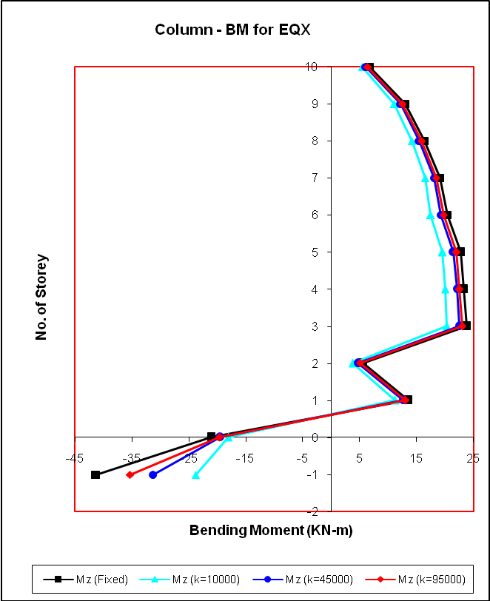
Fig. 7.2 Bending moment variation in exterior column for EQX load.
Case II – 1.5(DL+LL):
Table 7.2 Bending moments in exterior column for 1.5(DL+LL)
Floor Level | Mz (Fixed) | Mz (K=10000) | Mz (K=45000) | Mz (K=95000)
-1 | -4.98 | 188.21 | 136.32 | 105.72
0 | 1.41 | -2.19 | 1.53 | 2.55
1 | 6.97 | -0.26 | 3.7 | 4.72
2 | 11.32 | 10.33 | 12.65 | 12.91
3 | 15.93 | 16.5 | 17.82 | 17.76
4 | 20.61 | 20.06 | 21.92 | 22.03
5 | 23.22 | 22.4 | 24.34 | 24.47
6 | 30.78 | 28.88 | 31.55 | 31.86
7 | 25.01 | 24.24 | 25.76 | 25.89
8 | 27.65 | 26.62 | 28.26 | 28.43
9 | 26.71 | 26.06 | 27.35 | 27.45
10 | 37.8 | 34.9 | 37.8 | 38.26
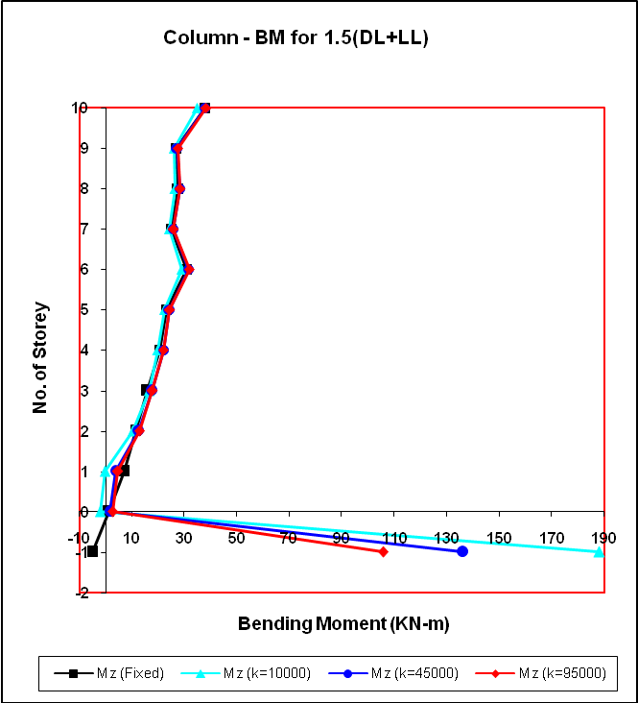
Fig. 7.3 Bending moment variation in exterior column for 1.5 (DL+LL) load.
7.1.2 Bending Moments for Interior Column
Case I – EQX:
Table 7.3 Bending moments in interior column for EQX
Floor Level | Mz (Fixed) | Mz (K=10000) | Mz (K=45000) | Mz (K=95000)
-1 | -51.11 | -52.88 | -52.94 | -51.83
0 | -12.26 | -6.93 | -8.65 | -9.26
1 | 27.49 | 26.61 | 27.87 | 27.94
2 | 35.42 | 32.73 | 34.82 | 35.12
3 | 43.16 | 39.53 | 42.25 | 42.66
4 | 44.73 | 40.81 | 43.68 | 44.14
5 | 43.25 | 39.37 | 42.18 | 42.64
6 | 42.56 | 38.83 | 41.53 | 41.97
7 | 33.45 | 30.38 | 32.58 | 32.95
8 | 28.6 | 26.08 | 27.9 | 28.2
9 | 21.55 | 19.76 | 21.07 | 21.27
10 | 13.32 | 12.55 | 13.16 | 13.22
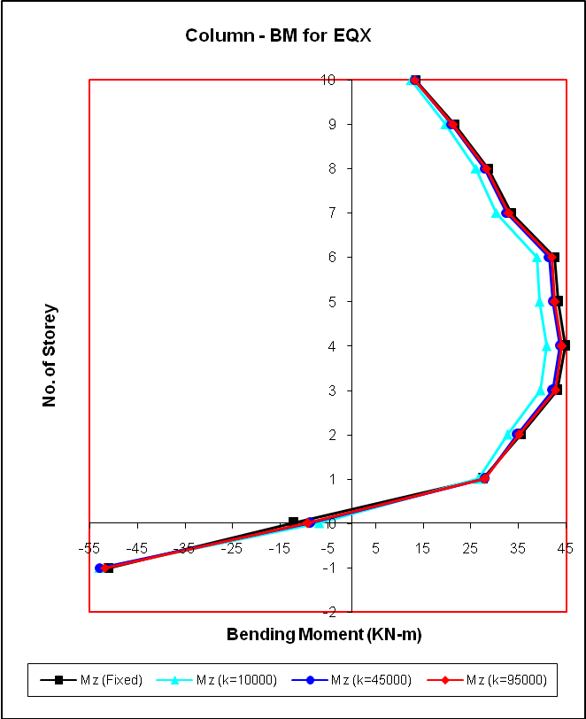
Fig. 7.4 Bending moment variation in interior column for EQX load.
Case II – 1.5(DL+LL):
Table 7.4 Bending moments in interior column for 1.5(DL+LL)
Floor Level | Mz (Fixed) | Mz (K=10000) | Mz (K=45000) | Mz (K=95000)
-1 | 3.05 | 49.82 | 66.09 | 54.44
0 | -3.68 | -12.56 | -15.24 | -12.77
1 | 35.8 | 61.82 | 46.6 | 42.32
2 | 52.46 | 71.73 | 58.72 | 55.59
3 | 42.53 | 58.29 | 47.55 | 44.92
4 | 44.39 | 60.4 | 49.78 | 47.05
5 | 43 | 58.45 | 48.39 | 45.71
6 | 53.3 | 70.84 | 59.67 | 56.61
7 | 32.3 | 43.23 | 36.17 | 34.22
8 | 35.48 | 46.65 | 39.55 | 37.56
9 | 35.79 | 46.69 | 39.9 | 37.94
10 | 40.61 | 53.79 | 45.76 | 43.45
Fig. 7.5 Bending moment variation in interior column for 1.5 (DL+LL) load.
7.1.3 Bending Moments at Support of Beam connected with Exterior Column
Case I – EQX
Table 7.5 Bending moments in exterior beam for EQX
Floor Level | Mz (Fixed) | Mz (K=10000) | Mz (K=45000) | Mz (K=95000)
0 | 18.48 | 15.13 | 17.25 | 17.97
1 | 30.92 | 25.37 | 28.54 | 29.52
2 | 36.12 | 30.13 | 33.62 | 34.62
3 | 40.31 | 34.19 | 37.87 | 38.85
4 | 38.5 | 32.74 | 36.22 | 37.13
5 | 35.84 | 30.5 | 33.73 | 34.57
6 | 33.04 | 28.16 | 31.12 | 31.88
7 | 28.35 | 24.16 | 26.7 | 27.35
8 | 21.91 | 18.15 | 20.52 | 21.07
9 | 13.76 | 11.31 | 12.68 | 13.1
10 | 6 | 4.67 | 5.36 | 5.6
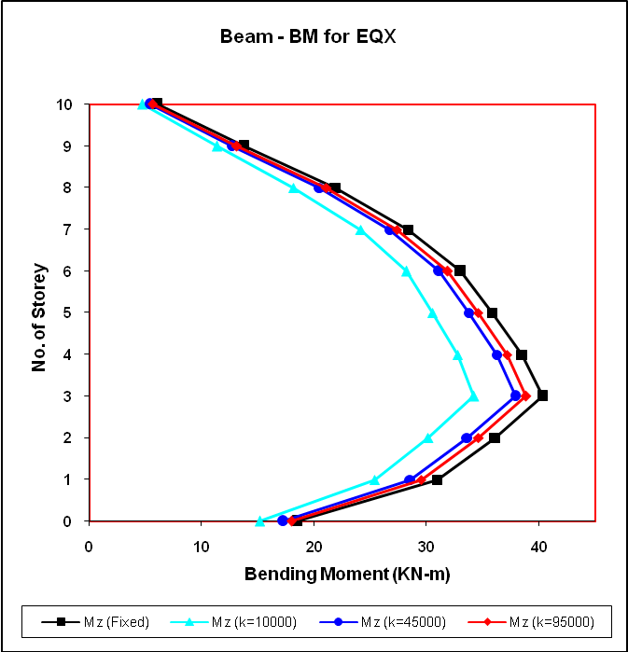
Fig. 7.6 Bending moment variation in exterior beam for EQX load.

Case II – 1.5(DL+LL)
Table 7.6 Bending moments in exterior beam for 1.5(DL+LL)
Floor Level | Mz (Fixed) | Mz (K=10000) | Mz (K=45000) | Mz (K=95000)
0 | 11.94 | 8.39 | 13.68 | 14.38
1 | 97.66 | 90.57 | 97.3 | 98.7
2 | 105.29 | 100.86 | 106.55 | 107.54
3 | 115.27 | 110.57 | 116.08 | 117.08
4 | 122.36 | 117.08 | 122.79 | 123.83
5 | 128.15 | 122.57 | 128.33 | 129.37
6 | 130.76 | 125.46 | 130.81 | 131.78
7 | 131.07 | 126.38 | 131.04 | 131.89
8 | 133.08 | 128.22 | 132.85 | 133.7
9 | 134.24 | 128.62 | 133.61 | 134.57
10 | 94.2 | 89.6 | 93.42 | 94.22
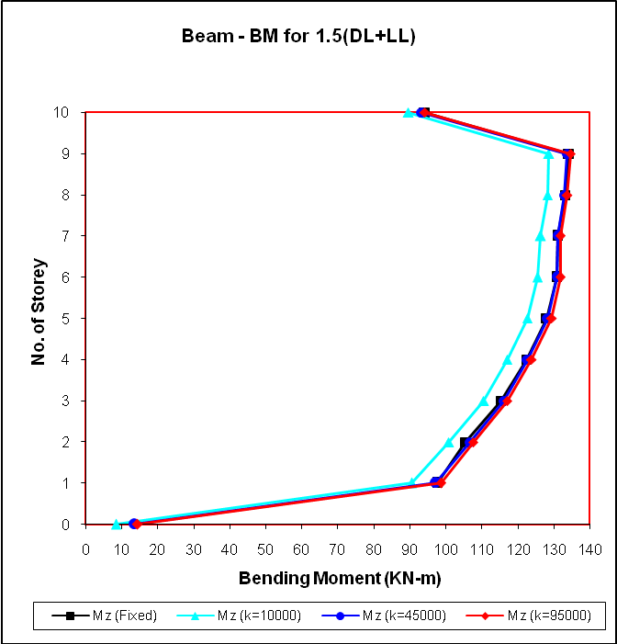
Fig. 7.7 Bending moment variation in exterior beam for 1.5 (DL+LL) load.
Case III – 1.2(DL+LL+EQX)
Table 7.7 Bending moments in exterior beam for 1.2(DL+LL+EQX)
Floor Level | Mz (Fixed) | Mz (K=10000) | Mz (K=45000) | Mz (K=95000)
0 | -12.63 | -11.44 | -9.76 | -10.06
1 | 41.02 | 42.02 | 43.59 | 43.54
2 | 40.90 | 44.54 | 44.9 | 44.49
3 | 43.85 | 47.43 | 47.42 | 47.05
4 | 51.68 | 54.37 | 54.77 | 54.5
5 | 59.52 | 61.45 | 62.19 | 62.02
6 | 64.97 | 66.58 | 67.31 | 67.17
7 | 70.84 | 72.12 | 72.8 | 71.69
8 | 80.17 | 80.38 | 81.66 | 81.69
9 | 90.88 | 89.31 | 91.68 | 91.94
10 | 68.15 | 66.07 | 68.31 | 68.65
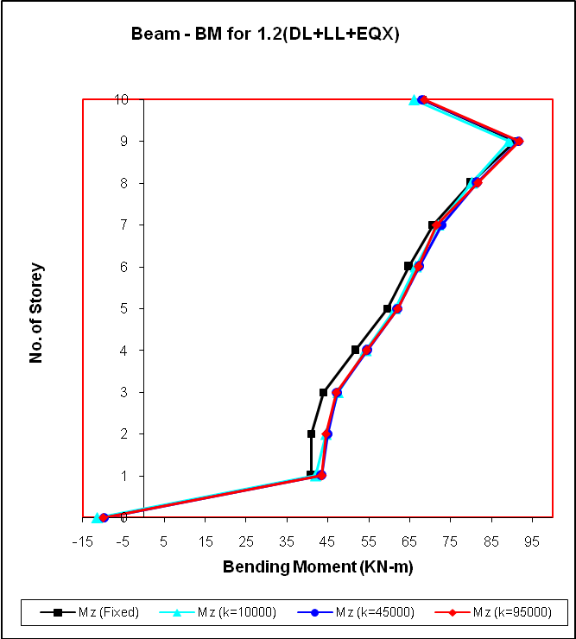
Fig. 7.8 Bending moment variation in ext. beam for 1.2 (DL+LL+EQX) load.
7.1.4 Bending Moments at Support of Beam connected with Interior Column
Case I – EQX
Table 7.8 Bending moments in interior beam for EQX
Floor Level | Mz (Fixed) | Mz (K=10000) | Mz (K=45000) | Mz (K=95000)
0 | 18.63 | 16.25 | 17.9 | 18.45
1 | 33.57 | 28.96 | 31.72 | 32.51
2 | 39.32 | 34.05 | 37.22 | 38.07
3 | 43.24 | 37.73 | 41.12 | 41.97
4 | 41.84 | 36.52 | 39.79 | 40.6
5 | 39.07 | 34.11 | 37.14 | 37.9
6 | 34.98 | 30.5 | 33.23 | 33.91
7 | 28.44 | 24.69 | 26.93 | 27.52
8 | 21.82 | 18.84 | 20.56 | 21.04
9 | 13.61 | 11.56 | 12.65 | 13
10 | 5.12 | 3.93 | 4.45 | 4.69
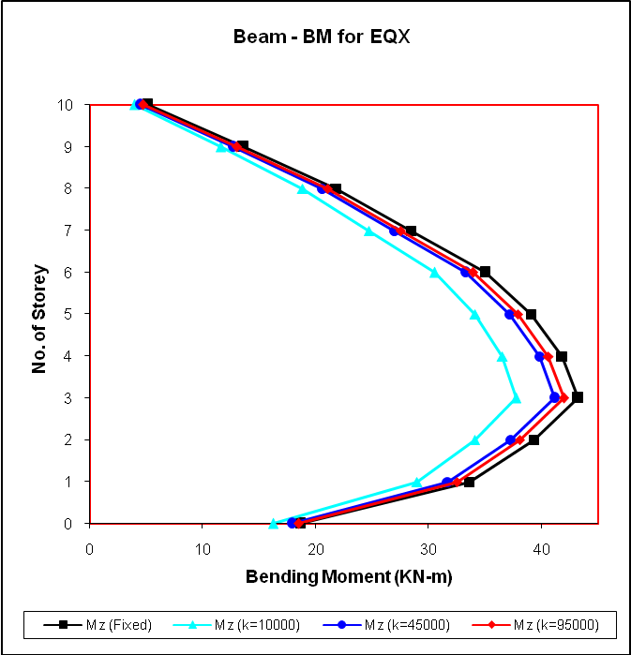
Fig. 7.9 Bending moment variation in interior beam for EQX load.
Case II – 1.5(DL+LL)
Table 7.9 Bending moments in interior beam for 1.5(DL+LL)
Floor Level | Mz (Fixed) | Mz (K=10000) | Mz (K=45000) | Mz (K=95000)
0 | 6.63 | 42.16 | 21.32 | 14.52
1 | 141.81 | 186.2 | 161.81 | 153.05
2 | 141.17 | 179.49 | 158.04 | 150.38
3 | 137.83 | 172.54 | 153.2 | 146.22
4 | 136.94 | 169.43 | 151.48 | 144.92
5 | 136.63 | 167.33 | 150.49 | 144.28
6 | 132.2 | 159.56 | 144.69 | 139.11
7 | 125.8 | 149.05 | 136.6 | 131.79
8 | 126.9 | 149.37 | 137.44 | 132.8
9 | 128.2 | 150.37 | 138.74 | 134.18
10 | 83.99 | 100.13 | 92.06 | 88.63
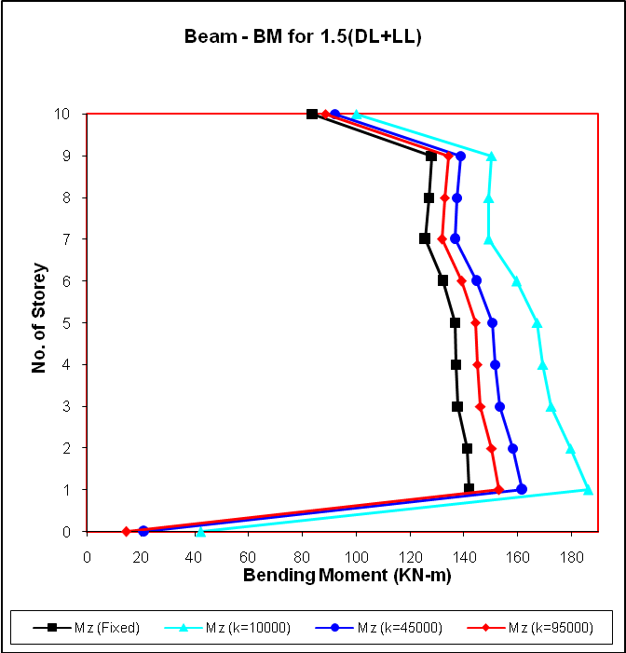
Fig. 7.10 Bending moment variation in interior beam for 1.5 (DL+LL) load.
Case III – 1.2(DL+LL+EQX)
Table 7.10 Bending moments in interior beam for 1.2(DL+LL+EQX)
Floor Level | Mz (Fixed) | Mz (K=10000) | Mz (K=45000) | Mz (K=95000)
0 | 27.66 | 53.23 | 38.53 | 33.75
1 | 153.73 | 183.71 | 167.51 | 161.45
2 | 160.12 | 184.45 | 171.1 | 165.98
3 | 162.15 | 183.31 | 171.91 | 167.33
4 | 159.76 | 179.37 | 168.93 | 164.66
5 | 156.18 | 174.8 | 164.96 | 160.9
6 | 147.73 | 164.25 | 155.63 | 151.98
7 | 134.76 | 148.87 | 141.6 | 138.46
8 | 127.7 | 142.1 | 136.63 | 131.49
9 | 118.89 | 134.17 | 126.17 | 122.94
10 | 73.34 | 84.82 | 78.99 | 76.54
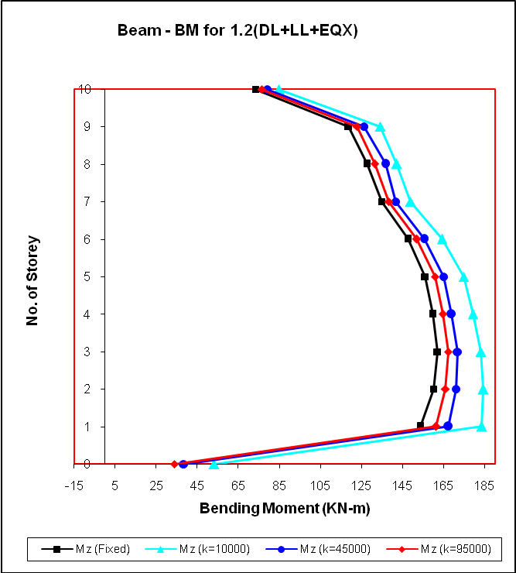
Fig. 7.11 Bending moment variation in int. beam for 1.2 (DL+LL+EQX) load.

7.2 Storey Drift
The variation of storey displacements along the height of columns has been displayed in Figs. 7.12 to 7.15. The storey drift observations are carried out only for loading cases of EQX and 1.2(DL+LL+EQX). Consideration is given to mainly these two loading cases because they can give us the basic idea of the deflected of the structure. The results of displacement noted for interior column and exterior column are approximately similar. Hence we can say that the rate of change of displacement for whole structure is approximately same.
The structure supported by elastic foundation and subjected to only seismic forces (EQX) shows higher values of storey drift as compared to that with fixed support. As value of modulus of subgrade reaction K increases, storey drifts increases and vice-versa. Whereas, structure loaded with dead load and live load along with seismic forces i.e., loading case of 1.2(DL+LL+EQX), the results of storey drift are not very distinguishable for the structure with fixed supports and elastic supports. Fig. 7.13 and Fig. 7.15 shows that as gravity load increases, displacements at upper stories comes down and it also becomes less than that observed for structure with rigid base.
(a) (b)
Fig. 7.12 Deflected shape of the structure with fixed & spring supports for EQX.

7.2.1 Storey Drift noted along height of Exterior Column
Case I – EQX:
Table 7.11 Storey drift along exterior column for EQX
Floor Level | Fixed | K=10000 | K=45000 | K=95000
0 | 0.259 | 0.528 | 0.368 | 0.333
1 | 1.718 | 2.325 | 1.935 | 1.858
2 | 3.573 | 4.46 | 3.87 | 3.758
3 | 6.111 | 7.203 | 6.464 | 6.326
4 | 8.722 | 10.01 | 9.127 | 8.964
5 | 11.224 | 12.72 | 11.686 | 11.496
6 | 13.581 | 15.3 | 14.103 | 13.884
7 | 16.076 | 17.998 | 16.65 | 16.405
8 | 18.183 | 20.352 | 18.824 | 18.547
9 | 19.774 | 22.246 | 20.498 | 20.182
10 | 20.755 | 23.603 | 21.586 | 21.22
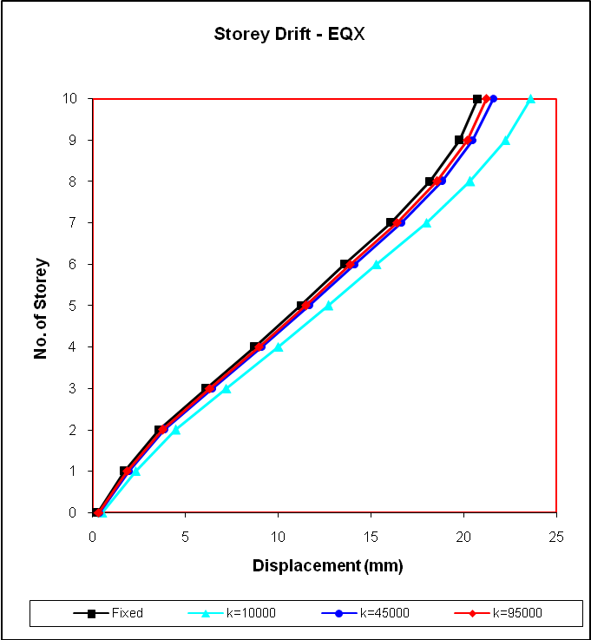
Fig. 7.13 Storey drift along height of exterior column for EQX load.
Case II – 1.2(DL+LL+EQX):
Table 7.12 Storey drift along exterior column for 1.2(DL+LL+EQX)
Floor Level | Fixed | K=10000 | K=45000 | K=95000
0 | 0.294 | 0.303 | 0.26 | 0.258
1 | 1.906 | 2.138 | 2.006 | 1.97
2 | 3.941 | 4.152 | 4.24 | 3.987
3 | 6.727 | 6.772 | 6.726 | 6.708
4 | 9.561 | 9.462 | 9.488 | 9.484
5 | 12.235 | 12.027 | 12.105 | 12.109
6 | 14.733 | 14.443 | 14.558 | 14.567
7 | 17.308 | 16.89 | 17.07 | 17.09
8 | 19.457 | 18.968 | 19.179 | 19.202
9 | 21.03 | 20.559 | 20.748 | 20.762
10 | 22.036 | 21.72 | 21.807 | 21.792
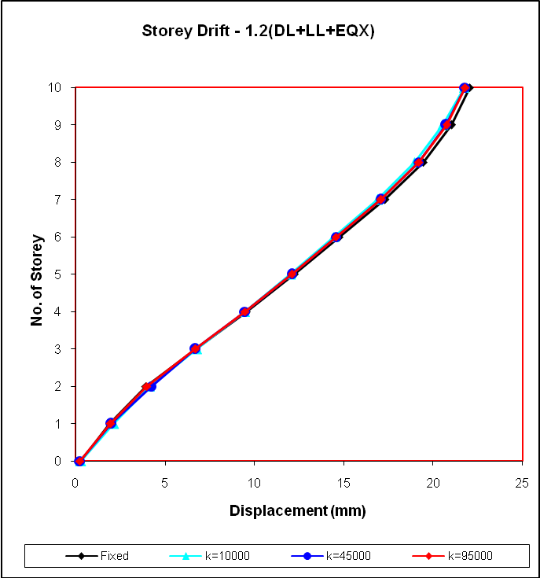
Fig. 7.14 Storey drift along height of ext. column for 1.2 (DL+LL+EQX) load.

7.2.2 Storey Drift noted along height of Interior Column
Case I – EQX:
Table 7.13 Storey drift along interior column for EQX
Floor Level | Fixed | K=10000 | K=45000 | K=95000
0 | 0.262 | 0.499 | 0.352 | 0.324
1 | 1.781 | 2.364 | 1.986 | 1.915
2 | 3.758 | 4.614 | 4.043 | 3.938
3 | 6.22 | 7.296 | 6.567 | 6.432
4 | 8.75 | 10.003 | 9.156 | 8.993
5 | 11.202 | 12.7 | 11.664 | 11.457
6 | 13.497 | 15.221 | 14.021 | 13.801
7 | 16.007 | 17.934 | 16.583 | 16.337
8 | 18.103 | 20.278 | 18.746 | 18.469
9 | 19.687 | 22.165 | 20.413 | 20.096
10 | 20.667 | 23.51 | 21.495 | 21.13
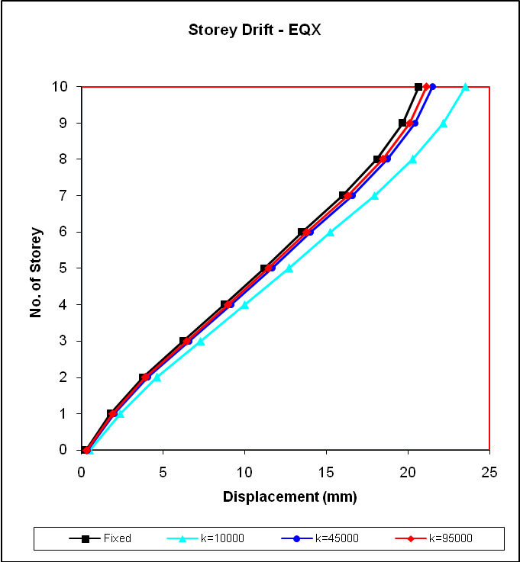
Fig. 7.15 Storey drift along height of interior column for EQX load.
Case II – 1.2(DL+LL+EQX):
Table 7.14 Storey drift along interior column for 1.2(DL+LL+EQX)
Floor Level | Fixed | K=10000 | K=45000 | K=95000
0 | 0.309 | 0.307 | 0.321 | 0.327
1 | 2.008 | 2.127 | 2.068 | 2.054
2 | 4.186 | 4.282 | 4.218 | 4.204
3 | 6.9 | 6.9 | 6.872 | 6.865
4 | 9.643 | 9.536 | 9.554 | 9.554
5 | 12.257 | 12.055 | 12.116 | 12.122
6 | 14.646 | 14.354 | 14.453 | 14.466
7 | 17.222 | 16.828 | 16.974 | 16.993
8 | 19.306 | 18.852 | 19.017 | 19.038
9 | 20.834 | 20.385 | 20.531 | 20.544
10 | 21.755 | 21.357 | 21.456 | 21.461
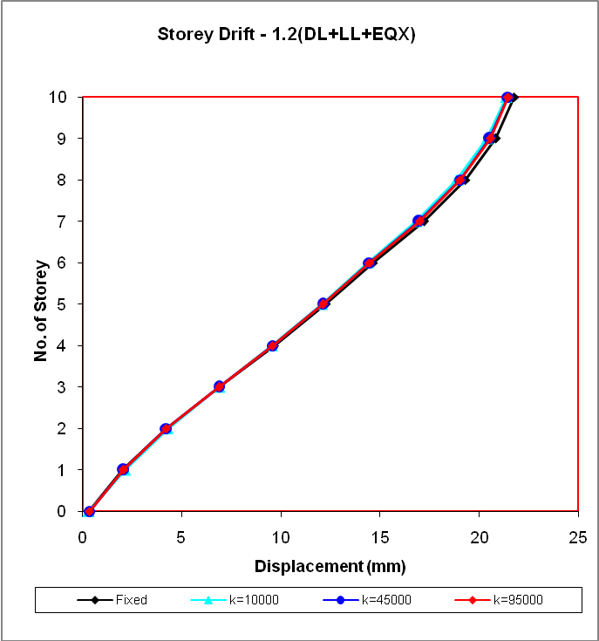
Fig. 7.16 Storey drift along height of int. column for 1.2 (DL+LL+EQX) load.

Analysis results of Settlement of slab

Fig. 7.17 Settlement of raft slab with spring support for load case of 1.5(DL+LL)

Fig. 7.18 Settlement of raft slab with fixed support for load case of
1.5 (DL+LL)
Table-7.15 Settlement of raft with spring support K=10000, for load case of 1.5(DL+LL)
 | A | Horizontal | Horizontal | Vertical | Horizontal | Resultant | Rotational | H | I
 | Node | L/C | X mm | Y mm | Z mm | mm | rX rad | rY rad | rZ rad
Max X | 1 | 1 1.5 (DL + LL) | 0 | -12.496 | 0 | 12.496 | 0 | 0 | 0
Min X | 1 | 1 1.5 (DL + LL) | 0 | -12.496 | 0 | 12.496 | 0 | 0 | 0
Max Y | 209 | 1 1.5 (DL + LL) | 0 | -11.741 | 0 | 11.741 | 0 | 0 | 0
Min Y | 288 | 1 1.5 (DL + LL) | 0 | -13.704 | 0 | 13.704 | 0 | 0 | 0
Max Z | 1 | 1 1.5 (DL + LL) | 0 | -12.496 | 0 | 12.496 | 0 | 0 | 0
Min Z | 1 | 1 1.5 (DL + LL) | 0 | -12.496 | 0 | 12.496 | 0 | 0 | 0
Max rX | 220 | 1 1.5 (DL + LL) | 0 | -12.625 | 0 | 12.625 | 0 | 0 | 0
Min rX | 356 | 1 1.5 (DL + LL) | 0 | -12.534 | 0 | 12.534 | 0 | 0 | 0
Max rY | 1 | 1 1.5 (DL + LL) | 0 | -12.496 | 0 | 12.496 | 0 | 0 | 0
Min rY | 1 | 1 1.5 (DL + LL) | 0 | -12.496 | 0 | 12.496 | 0 | 0 | 0
Max rZ | 275 | 1 1.5 (DL + LL) | 0 | -12.145 | 0 | 12.145 | 0 | 0 | 0
Min rZ | 228 | 1 1.5 (DL + LL) | 0 | -12.117 | 0 | 12.117 | 0 | 0 | 0
Max Rst | 288 | 1 1.5 (DL + LL) | 0 | -13.704 | 0 | 13.704 | 0 | 0 | 0

Table-7.16Settlement of raft with spring support K=45000, for load case of 1.5(DL+LL)

 | A | Horizontal | Horizontal | Vertical | Horizontal | Resultant | Rotational | H | I
 | Node | L/C | X mm | Y mm | Z mm | mm | rX rad | rY rad | rZ rad
Max X | 1 | 1 1.5 (DL + LL) | 0 | -2.906 | 0 | 2.906 | 0 | 0 | 0
Min X | 1 | 1 1.5 (DL + LL) | 0 | -2.906 | 0 | 2.906 | 0 | 0 | 0
Max Y | 226 | 1 1.5 (DL + LL) | 0 | -2.27 | 0 | 2.27 | 0 | 0 | 0
Min Y | 288 | 1 1.5 (DL + LL) | 0 | -3.824 | 0 | 3.824 | 0 | 0 | 0
Max Z | 1 | 1 1.5 (DL + LL) | 0 | -2.906 | 0 | 2.906 | 0 | 0 | 0
Min Z | 1 | 1 1.5 (DL + LL) | 0 | -2.906 | 0 | 2.906 | 0 | 0 | 0
Max rX | 220 | 1 1.5 (DL + LL) | 0 | -2.845 | 0 | 2.845 | 0 | 0 | 0
Min rX | 356 | 1 1.5 (DL + LL) | 0 | -2.75 | 0 | 2.75 | 0 | 0 | 0
Max rY | 1 | 1 1.5 (DL + LL) | 0 | -2.906 | 0 | 2.906 | 0 | 0 | 0
Min rY | 1 | 1 1.5 (DL + LL) | 0 | -2.906 | 0 | 2.906 | 0 | 0 | 0
Max rZ | 275 | 1 1.5 (DL + LL) | 0 | -2.609 | 0 | 2.609 | 0 | 0 | 0
Min rZ | 228 | 1 1.5 (DL + LL) | 0 | -2.56 | 0 | 2.56 | 0 | 0 | 0
Max Rst | 288 | 1 1.5 (DL + LL) | 0 | -3.824 | 0 | 3.824 | 0 | 0 | 0

Table 7.17 Settlement of raft with spring support K=90000, for load case of 1.5(DL+LL)

 | A | Horizontal | Horizontal | Vertical | Horizontal | Resultant | Rotational | H | I
 | Node | L/C | X mm | Y mm | Z mm | mm | rX rad | rY rad | rZ rad
Max X | 1 | 1 1.5 (DL + LL) | 0 | -1.431 | 0 | 1.431 | 0 | 0 | 0
Min X | 1 | 1 1.5 (DL + LL) | 0 | -1.431 | 0 | 1.431 | 0 | 0 | 0
Max Y | 226 | 1 1.5 (DL + LL) | 0 | -0.92 | 0 | 0.92 | 0 | 0 | 0
Min Y | 288 | 1 1.5 (DL + LL) | 0 | -2.24 | 0 | 2.24 | 0 | 0 | 0
Max Z | 1 | 1 1.5 (DL + LL) | 0 | -1.431 | 0 | 1.431 | 0 | 0 | 0
Min Z | 1 | 1 1.5 (DL + LL) | 0 | -1.431 | 0 | 1.431 | 0 | 0 | 0
Max rX | 220 | 1 1.5 (DL + LL) | 0 | -1.331 | 0 | 1.331 | 0 | 0 | 0
Min rX | 356 | 1 1.5 (DL + LL) | 0 | -1.265 | 0 | 1.265 | 0 | 0 | 0
Max rY | 1 | 1 1.5 (DL + LL) | 0 | -1.431 | 0 | 1.431 | 0 | 0 | 0
Min rY | 1 | 1 1.5 (DL + LL) | 0 | -1.431 | 0 | 1.431 | 0 | 0 | 0
Max rZ | 275 | 1 1.5 (DL + LL) | 0 | -1.207 | 0 | 1.207 | 0 | 0 | 0
Min rZ | 228 | 1 1.5 (DL + LL) | 0 | -1.159 | 0 | 1.159 | 0 | 0 | 0
Max Rst | 288 | 1 1.5 (DL + LL) | 0 | -2.24 | 0 | 2.24 | 0 | 0 | 0

Table 7.18 Settlement of raft slab with fixed support for load case of 1.5 (DL+LL)

 | A | Horizontal | Horizontal | Vertical | Horizontal | Resultant | Rotational | H | I
 | Node | L/C | X mm | Y mm | Z mm | mm | rX rad | rY rad | rZ rad
Max X | 1 | 1 1.5 (DL + LL) | 0 | 0 | 0 | 0 | 0 | 0 | 0
Min X | 1 | 1 1.5 (DL + LL) | 0 | 0 | 0 | 0 | 0 | 0 | 0
Max Y | 493 | 1 1.5 (DL + LL) | 0 | 0 | 0 | 0 | 0 | 0 | 0
Min Y | 19 | 1 1.5 (DL + LL) | 0 | 0 | 0 | 0 | 0 | 0 | 0
Max Z | 1 | 1 1.5 (DL + LL) | 0 | 0 | 0 | 0 | 0 | 0 | 0
Min Z | 1 | 1 1.5 (DL + LL) | 0 | 0 | 0 | 0 | 0 | 0 | 0
Max rX | 6 | 1 1.5 (DL + LL) | 0 | 0 | 0 | 0 | 0 | 0 | 0
Min rX | 482 | 1 1.5 (DL + LL) | 0 | 0 | 0 | 0 | 0 | 0 | 0
Max rY | 1 | 1 1.5 (DL + LL) | 0 | 0 | 0 | 0 | 0 | 0 | 0
Min rY | 1 | 1 1.5 (DL + LL) | 0 | 0 | 0 | 0 | 0 | 0 | 0
Max rZ | 102 | 1 1.5 (DL + LL) | 0 | 0 | 0 | 0 | 0 | 0 | 0
Min rZ | 86 | 1 1.5 (DL + LL) | 0 | 0 | 0 | 0 | 0 | 0 | 0
Max Rst | 19 | 1 1.5 (DL + LL) | 0 | 0 | 0 | 0 | 0 | 0 | 0
Note-This vertical settlement shows the deformation of raft due to different stiffness of soils.
7.3 Bending Moments in the Raft Slab along X-Direction (Mx)

The values of bending moments in the raft slab along with bending moment contours are given in Fig. 7.19 to Fig. 7.26. The study of moment distribution in raft slab has been carried out for structure subjected to EQX and 1.2(DL+LL+EQX) loading conditions. A glance at these values reveals that the moments have been affected by the change in the values of the modulus of subgrade reaction K.

For loading condition of 1.2(DL+LL+EQX), negative bending moments shows hogging bending moments which produces tension at the top and positive bending moments indicate sagging bending moments producing tension at bottom face of raft slab. From Figs. 7.23 to 7.25, we can say that as K increases, hogging bending moments reduced. But the sagging moments goes on increasing as stiffness of soil increases.

Case I – EQX
K = 10000 kN/m³
Fig. 7.19 BM variations in raft slab for K = 10000 kN/m³ in EQX loading case.
K = 45000 kN/m³
Fig. 7.20 BM variations in raft slab for K = 45000 kN/m³ in EQX loading case.
K = 95000 kN/m³
Fig. 7.21 BM variations in raft slab for K = 95000 kN/m³ in EQX loading case.
Fixed Support
Fig. 7.22 BM variations in raft slab for fixed supports in EQX loading case.
Case II –1.2(DL+LL+EQX)
K = 10000 kN/m³
Fig. 7.23 BM variations in raft slab for K = 10000 kN/m³ in 1.2(DL+LL+EQX).
K = 45000 kN/m³
Fig. 7.24 BM variations in raft slab for K = 45000 kN/m³ in 1.2(DL+LL+EQX).
K = 95000 kN/m³
Fig. 7.25 BM variations in raft slab for K = 95000 kN/m³ in 1.2(DL+LL+EQX).

Fixed Support
Fig. 7.26 BM variations in raft slab for fixed supports in 1.2(DL+LL+EQX).

Chapter 8

CONCLUSIONS AND RECOMMENDATIONS

8.1 Conclusions
The effects of soil-structure interaction on the analysis of a three-dimensional multistoried structure have been demonstrated. The analysis was performed utilizing the STAAD Pro software. The soil reactions were represented by the use of elastic springs under the raft slab. Based on the findings and the discussion of the different loading and modulus of subgrade reaction K, the following conclusions can be made.

- A redistribution of forces and moments has been found to occur in the entire structure. As shown in Figs. 7.2 to 7.11, due to consideration of the interactive behavior between soil and structure, redistribution of forces and moments takes place in columns and beams. It has been also noted from Fig. 7.19 to Fig. 7.26, redistribution of moments can occur in raft slab.

- Behavior of the structure is mainly dependant on the type of soil strata. It has been observed that the stiff stratum at the base does not change the design forces significantly. Fig. 7.4 shows that the bending moments in columns increased by 30% to 35% approximately for structure supported on soft soil. In case of medium stiff soil, bending moments increased up to 15%. Whereas, for stiff soils increase in bending moment has been noted about 10% approximately. Hence we can say that as the stiffness of the soil strata increase, structure behavior becomes similar to that observed for rigid supports.

- As per the discussion in section 7.1 of chapter 7, for seismic forces, magnitude of bending moments in the columns and beams of the structure provided with elastic supports are 10% to 20% less than that of the structure with fixed supports. The reason behind this difference is clear from the Fig. 7.12. The figure shows that in case of soft soils, the structure deflects as a whole body. The relative displacements between successive floors are less than that observed for the structure with rigid base. Hence due to the flexibility offered by soil, moments are lesser for structure resting on soft soils.

- Since softer soil allows more vertical displacements as that can be seen from the Fig. 7.17, under the gravity loadings bending moments in beams and columns increases significantly for structure with elastic foundation. Hence the additional bending moments due to the differential settlement of raft slab resulted into the increase in bending moments.

- One of the important observations of this study is that elastic foundation analysis has been resulted in a larger bending moment at the base of the columns. As shown in Fig. 7.3 and Fig. 7.5, the magnitudes of bending moments, at the base of the structure, abruptly increase for elastic supports. Generally this portion of the structure is not given consideration in most of the practical designs which are based on the assumption of rigid support system. This behavior demonstrates the direct relationship between bending moments in the columns and the deformations of the raft slab for the different loading and soil conditions.

- Very significant increase can occur in displacements of the structure for the soft soils subjected to lateral forces due to earth-quake. Fig. 7.13 and Fig. 7.15, show that for EQX forces deflection increased by 10% to 13% at the 10th floor of the structure supported on soft soil. But due to gravity loads deflections becomes less than that observed for the case of fixed supports.

- The raft slab behaves as a flexible foundation and experiences an uneven settlements depending upon load transferred by column. As we have discussed in section 7.3, the differential settlement of the raft slab under gravity loadings is directly proportional to the soil stiffness. The softer the soil, the more the differential settlement and which is responsible for the changes in forces and bending moments as shown in Figs. 7.19 to 7.26.
8.2 Recommendations
Based on the discussion and findings in this study, the following recommendations can be made.

- The soil-structure interaction must be considered in the design of structures.
- At the design stage, specific effort must be made to find the realistic value of modulus of subgrade reaction depending on the type of soil. So that we can get the exact design forces for optimum design solution.

REFERENCES / BIBLIOGRAPHY

- Bowles J. E., Foundation Analysis and Design, McGraw-Hill, Inc., 1982.
- Civalek O., “Nonlinear analysis of thin rectangular plates on Winkler–Pasternak elastic foundations by DSC–HDQ methods,” Applied Mathematical Modeling 31, 2007. p. 606–624.
- Daloglu A. T. and Vallabhan C. V. G., “Values of K for slab on Winkler foundation” Journal of Geotechnical and Geo-environmental Engineering, Vol. 126, No. 5, 2000. p. 361-371.
- Fwa T.F., Shi X.P. and Tan S.A., “Use of Pasternak foundation model in concrete pavement analysis” Journal of Transportation Engineering, Vol. 122, No. 4, 1996, p. 323-328.
- Horvath J. S., “Modulus of subgrade reaction: new perspective,” Journal of Geotechnical Engineering, Vol. 109, No. 12, 1983, p. 1591-1596.
- Kasmalkar B. J., Foundation Engineering, Pune Vidyarthi Griha Publication, 1991.
- Kerr A. D., “Elastic and visco-elastic foundation models.” Journal of Applied Mechanics, ASCE, 31, 1964. p. 491-498.
- Liou G. S. and Lai S.C., “Structural analysis model for mat foundations,” Journal of Structural Engineering, Vol. 122, No.9, 1996. p. 1114-1117.
- Mishra R. C. and Chakrabarti S. K., “Rectangular plates resting on tensionless elastic foundation: some new results”, Journal of Engineering Mechanics, Vol. 122, No.4, 1996. p. 385-387.
- Nasreddin el Mezaini, “Effects of soil-structure interaction on the analysis of cylindrical tanks” Practice Periodical on Structural Design and Construction, Vol. 11, No.1, 2006. p. 50-57.
- Shi X.P., Tan S.A. and Fwa T.F., “Rectangular thick plate with free edges on Pasternak foundation” Journal of Engineering Mechanics, Vol. 120, No.5, 1994. p. 971-988.
- STAAD Pro 2004, Structural Analysis and Design Package, Research Engineers.
- Stavridis L. T., “Simplified analysis of layered soil-structure interaction,” Journal of Structural Engineering, Vol.128, No. 2, 2002. p. 224-230.
- Timoshenko S. P. and Goodlier, J. N., Theory of Elasticity, McGraw-Hill, Inc., 1970.
- Viladkar M. N., Karisiddappa, Bhargava P. and Godbole P.N., 2006, “Static soil–structure interaction response of hyperbolic cooling towers to symmetrical wind loads,” Engineering Structures, Volume 28, Issue 9, Pages 1236-1251.
- Wang C. M., Xiang Y. and Wang Q., 2001, “Axisymmetric buckling of reddy circular plates on Pasternak foundation,” Journal of Engineering Mechanics, Vol. 127, No. 3.
- Yang W., Weiss W. J. and Shah S. P., “Predicting shrinkage stress field in concrete slab on elastic subgrade” Journal of Engineering Mechanics, Vol. 126, No.1, 2000. p. 35-42.
- Yin J-H., “Comparative modeling study of reinforced beam on elastic foundation.” Journal of Geotechnical and Geo-environmental Engineering, ASCE, 126(3), 2000. p. 265-271.

INDIAN STANDARD CODES
IS875-1980: Indian Standard Code of Practice for Structural Safety of Buildings Loading Standard.
IS1893-1984: Indian Standard Code of Practice for Criteria for Earthquake Resistance Design of Structures.

